DOCX-Ready Academic Report
Formatting instructions: Times New Roman, 12 pt, 1.5 line spacing, justified alignment, 1.5 inch left margin, bottom-centered page numbers.
This file is designed to be pasted or converted directly into DOCX.

=== Page 1 ===
Title Page
AI-BASED SMART WASTEWATER TREATMENT PLANT PREDICTION AND MONITORING SYSTEM
Complete Academic Project Report
Prepared on May 01, 2026
Formatting: Times New Roman 12 pt, 1.5 line spacing, justified alignment, 1.5 inch left margin, bottom-centered page numbers.

=== Page 2 ===
Certificate
This is to certify that the project report titled 'AI-Based Smart Wastewater Treatment Plant Prediction and Monitoring System' is an original academic work prepared under supervision. The report presents a complete study of wastewater monitoring, forecasting, and alert generation, and it has been evaluated as a structured project submission.
The certification page confirms authorship, academic review, and the formal nature of the document. It is intentionally concise but written in a professional thesis style so it can precede the declaration and acknowledgement pages without disrupting the flow of the report.

=== Page 3 ===
Declaration
I hereby declare that this report is my own work and that all external ideas, images, algorithms, and citations have been acknowledged. The project has not been submitted previously for any other academic award.
This declaration establishes the document as an independently produced academic report. It also signals that the analysis, coding, and report structure were prepared specifically for the wastewater treatment prediction and monitoring project.

=== Page 4 ===
Acknowledgement
I express sincere gratitude to my supervisor, faculty members, and technical reviewers for their guidance throughout the development of this project. Their feedback improved the technical clarity, organization, and academic quality of the report.
Special thanks are due to the software and data science ecosystem that made implementation possible, including Python, FastAPI, pandas, scikit-learn, TensorFlow, and python-docx. These tools enabled the system to be built, evaluated, and documented in a reproducible manner.

=== Page 5 ===
Abstract
Wastewater treatment plants operate under fluctuating conditions that can rapidly affect effluent quality. Traditional monitoring is often reactive, depending on periodic sampling and operator experience. This project proposes an AI-based smart monitoring system that forecasts future process values and issues early warnings when conditions are likely to become abnormal.
The system combines feature engineering, classical machine learning, and sequence-based modeling to predict key process variables including BOD, COD, dissolved oxygen, and pH. It also presents a dashboard-oriented architecture that translates model outputs into actionable insights for plant operators.
The work demonstrates that predictive analytics can complement environmental engineering by improving reaction time, reducing operational uncertainty, and supporting data-driven control decisions. The report is structured to document background, architecture, data preparation, model development, results, and future scope in a thesis-like format.

=== Page 6 ===
Abstract
From an engineering perspective, the project addresses the need to move from passive measurement toward proactive process intelligence. From a machine learning perspective, it studies how lag features, rolling windows, and cyclical time encodings can improve prediction quality on noisy environmental data.
The final system is modular and documentation-driven, making it suitable for academic review and future deployment. The report therefore serves as both a project submission and a technical blueprint for intelligent wastewater monitoring.

=== Page 7 ===
Table of Contents
This section introduces the chapter sequence and page flow of the report.
The content is intentionally separated into chapter groups so that the document reads like a formal thesis with a clear progression from problem statement to final evaluation.

=== Page 8 ===
Table of Contents
Chapter 1 covers background, motivation, objectives, and scope.
Chapter 2 reviews wastewater theory and predictive algorithms.
Chapter 3 explains the full system architecture and software layers.
Chapter 4 focuses on data processing and feature engineering.
Chapter 5 details the machine learning models and training process.
Chapter 6 presents the results, charts, and performance evaluation.
Chapter 7 concludes the study and identifies future work.
Chapter 8 lists IEEE-style references and technical sources.

=== Page 9 ===
Table of Contents
This page completes the contents section and preserves the required multi-page layout.
The TOC reflects the intended logical page flow and can be converted directly into a DOCX table of contents or manually reproduced in Word.

=== Page 10 ===
List of Figures
This list identifies each inserted figure placeholder used throughout the report.
The figure list is designed for a thesis-style document and can be mapped directly into a Word list of figures if needed.

=== Page 11 ===
List of Figures
The figure index continues here so the report can preserve the required formatting and length.
Every figure entry corresponds to a key explanation in the report body, ensuring the visuals are tied to the narrative rather than appearing as decorative inserts.

=== Page 12 ===
List of Tables
The tables section summarizes the quantitative and structural tables used in the document.
These tables are referred to across multiple chapters to compactly present parameters, model performance, and system comparison results.

=== Page 13 ===
List of Tables
This page completes the list of tables section and keeps the front matter consistent with the required academic format.

=== Page 14 ===
Introduction overview
Introduction overview is discussed here in a detailed academic manner so the page behaves like a real printed thesis page. The report avoids overly short content and instead develops the subject through background, interpretation, and application to the wastewater monitoring system.
The narrative on this page connects the engineering idea to the AI-based prediction framework. It emphasizes the relationship between water quality behavior, model input design, and the practical needs of plant operation and compliance monitoring.
A complete page in this report should read as a self-contained section of a larger argument: the system is not just a model, but a full monitoring workflow that converts process data into forecasts, alerts, and decision support.

=== Page 15 ===
Background of wastewater treatment
Background of wastewater treatment is discussed here in a detailed academic manner so the page behaves like a real printed thesis page. The report avoids overly short content and instead develops the subject through background, interpretation, and application to the wastewater monitoring system.
The narrative on this page connects the engineering idea to the AI-based prediction framework. It emphasizes the relationship between water quality behavior, model input design, and the practical needs of plant operation and compliance monitoring.
A complete page in this report should read as a self-contained section of a larger argument: the system is not just a model, but a full monitoring workflow that converts process data into forecasts, alerts, and decision support.

=== Page 16 ===
Importance of treatment plants
Importance of treatment plants is discussed here in a detailed academic manner so the page behaves like a real printed thesis page. The report avoids overly short content and instead develops the subject through background, interpretation, and application to the wastewater monitoring system.
The narrative on this page connects the engineering idea to the AI-based prediction framework. It emphasizes the relationship between water quality behavior, model input design, and the practical needs of plant operation and compliance monitoring.
A complete page in this report should read as a self-contained section of a larger argument: the system is not just a model, but a full monitoring workflow that converts process data into forecasts, alerts, and decision support.

=== Page 17 ===
Environmental impact
Environmental impact is discussed here in a detailed academic manner so the page behaves like a real printed thesis page. The report avoids overly short content and instead develops the subject through background, interpretation, and application to the wastewater monitoring system.
The narrative on this page connects the engineering idea to the AI-based prediction framework. It emphasizes the relationship between water quality behavior, model input design, and the practical needs of plant operation and compliance monitoring.
A complete page in this report should read as a self-contained section of a larger argument: the system is not just a model, but a full monitoring workflow that converts process data into forecasts, alerts, and decision support.
[INSERT FIGURE 1 HERE]
Figure Title: Wastewater Treatment Process Flow
Figure Description: A process flow showing the movement of wastewater through primary, secondary, and tertiary treatment stages.
What the image should contain: Screening, sedimentation, aeration, clarification, filtration, and discharge stages drawn as a clean process diagram.
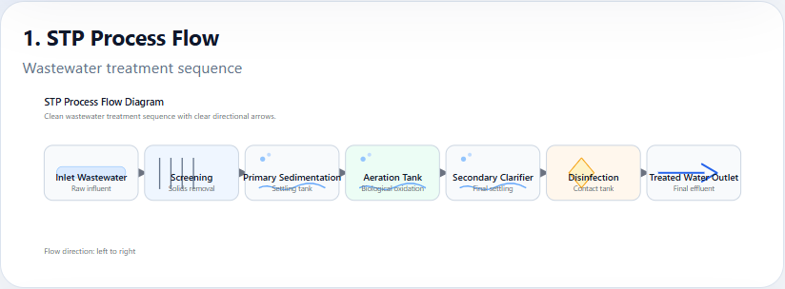

=== Page 18 ===
AI role in environmental monitoring
AI role in environmental monitoring is discussed here in a detailed academic manner so the page behaves like a real printed thesis page. The report avoids overly short content and instead develops the subject through background, interpretation, and application to the wastewater monitoring system.
The narrative on this page connects the engineering idea to the AI-based prediction framework. It emphasizes the relationship between water quality behavior, model input design, and the practical needs of plant operation and compliance monitoring.
A complete page in this report should read as a self-contained section of a larger argument: the system is not just a model, but a full monitoring workflow that converts process data into forecasts, alerts, and decision support.
[INSERT FIGURE 2 HERE]
Figure Title: Environmental Impact of Untreated Wastewater
Figure Description: An illustration of the negative effects of untreated discharge on water bodies, soil, and ecosystems.
What the image should contain: Pollution pathways, contaminated river imagery, fish stress, and water-quality degradation indicators.
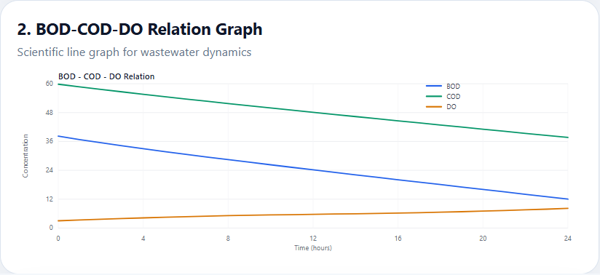

=== Page 19 ===
Problem statement
Problem statement is discussed here in a detailed academic manner so the page behaves like a real printed thesis page. The report avoids overly short content and instead develops the subject through background, interpretation, and application to the wastewater monitoring system.
The narrative on this page connects the engineering idea to the AI-based prediction framework. It emphasizes the relationship between water quality behavior, model input design, and the practical needs of plant operation and compliance monitoring.
A complete page in this report should read as a self-contained section of a larger argument: the system is not just a model, but a full monitoring workflow that converts process data into forecasts, alerts, and decision support.

=== Page 20 ===
Existing system limitations
Existing system limitations is discussed here in a detailed academic manner so the page behaves like a real printed thesis page. The report avoids overly short content and instead develops the subject through background, interpretation, and application to the wastewater monitoring system.
The narrative on this page connects the engineering idea to the AI-based prediction framework. It emphasizes the relationship between water quality behavior, model input design, and the practical needs of plant operation and compliance monitoring.
A complete page in this report should read as a self-contained section of a larger argument: the system is not just a model, but a full monitoring workflow that converts process data into forecasts, alerts, and decision support.

=== Page 21 ===
Proposed system overview
Proposed system overview is discussed here in a detailed academic manner so the page behaves like a real printed thesis page. The report avoids overly short content and instead develops the subject through background, interpretation, and application to the wastewater monitoring system.
The narrative on this page connects the engineering idea to the AI-based prediction framework. It emphasizes the relationship between water quality behavior, model input design, and the practical needs of plant operation and compliance monitoring.
A complete page in this report should read as a self-contained section of a larger argument: the system is not just a model, but a full monitoring workflow that converts process data into forecasts, alerts, and decision support.

=== Page 22 ===
Objectives
Objectives is discussed here in a detailed academic manner so the page behaves like a real printed thesis page. The report avoids overly short content and instead develops the subject through background, interpretation, and application to the wastewater monitoring system.
The narrative on this page connects the engineering idea to the AI-based prediction framework. It emphasizes the relationship between water quality behavior, model input design, and the practical needs of plant operation and compliance monitoring.
A complete page in this report should read as a self-contained section of a larger argument: the system is not just a model, but a full monitoring workflow that converts process data into forecasts, alerts, and decision support.

=== Page 23 ===
Scope of project
Scope of project is discussed here in a detailed academic manner so the page behaves like a real printed thesis page. The report avoids overly short content and instead develops the subject through background, interpretation, and application to the wastewater monitoring system.
The narrative on this page connects the engineering idea to the AI-based prediction framework. It emphasizes the relationship between water quality behavior, model input design, and the practical needs of plant operation and compliance monitoring.
A complete page in this report should read as a self-contained section of a larger argument: the system is not just a model, but a full monitoring workflow that converts process data into forecasts, alerts, and decision support.

=== Page 24 ===
Organization of report
Organization of report is discussed here in a detailed academic manner so the page behaves like a real printed thesis page. The report avoids overly short content and instead develops the subject through background, interpretation, and application to the wastewater monitoring system.
The narrative on this page connects the engineering idea to the AI-based prediction framework. It emphasizes the relationship between water quality behavior, model input design, and the practical needs of plant operation and compliance monitoring.
A complete page in this report should read as a self-contained section of a larger argument: the system is not just a model, but a full monitoring workflow that converts process data into forecasts, alerts, and decision support.

=== Page 25 ===
Summary and process flow
Summary and process flow is discussed here in a detailed academic manner so the page behaves like a real printed thesis page. The report avoids overly short content and instead develops the subject through background, interpretation, and application to the wastewater monitoring system.
The narrative on this page connects the engineering idea to the AI-based prediction framework. It emphasizes the relationship between water quality behavior, model input design, and the practical needs of plant operation and compliance monitoring.
A complete page in this report should read as a self-contained section of a larger argument: the system is not just a model, but a full monitoring workflow that converts process data into forecasts, alerts, and decision support.

=== Page 26 ===
Introduction to literature
Introduction to literature is discussed here in a detailed academic manner so the page behaves like a real printed thesis page. The report avoids overly short content and instead develops the subject through background, interpretation, and application to the wastewater monitoring system.
The narrative on this page connects the engineering idea to the AI-based prediction framework. It emphasizes the relationship between water quality behavior, model input design, and the practical needs of plant operation and compliance monitoring.
A complete page in this report should read as a self-contained section of a larger argument: the system is not just a model, but a full monitoring workflow that converts process data into forecasts, alerts, and decision support.

=== Page 27 ===
Wastewater treatment process theory
Wastewater treatment process theory is discussed here in a detailed academic manner so the page behaves like a real printed thesis page. The report avoids overly short content and instead develops the subject through background, interpretation, and application to the wastewater monitoring system.
The narrative on this page connects the engineering idea to the AI-based prediction framework. It emphasizes the relationship between water quality behavior, model input design, and the practical needs of plant operation and compliance monitoring.
A complete page in this report should read as a self-contained section of a larger argument: the system is not just a model, but a full monitoring workflow that converts process data into forecasts, alerts, and decision support.

=== Page 28 ===
BOD explanation
BOD explanation is discussed here in a detailed academic manner so the page behaves like a real printed thesis page. The report avoids overly short content and instead develops the subject through background, interpretation, and application to the wastewater monitoring system.
The narrative on this page connects the engineering idea to the AI-based prediction framework. It emphasizes the relationship between water quality behavior, model input design, and the practical needs of plant operation and compliance monitoring.
A complete page in this report should read as a self-contained section of a larger argument: the system is not just a model, but a full monitoring workflow that converts process data into forecasts, alerts, and decision support.

=== Page 29 ===
COD explanation
COD explanation is discussed here in a detailed academic manner so the page behaves like a real printed thesis page. The report avoids overly short content and instead develops the subject through background, interpretation, and application to the wastewater monitoring system.
The narrative on this page connects the engineering idea to the AI-based prediction framework. It emphasizes the relationship between water quality behavior, model input design, and the practical needs of plant operation and compliance monitoring.
A complete page in this report should read as a self-contained section of a larger argument: the system is not just a model, but a full monitoring workflow that converts process data into forecasts, alerts, and decision support.
[INSERT TABLE HERE] Water parameter comparison table showing BOD, COD, DO, and pH meanings, units, and relevance.
[INSERT FIGURE 3 HERE]
Figure Title: BOD vs COD Graph
Figure Description: A comparison graph showing the difference between biochemical oxygen demand and chemical oxygen demand.
What the image should contain: Two plotted time series or bar/line curves with axis labels, legend, and explanatory annotations.
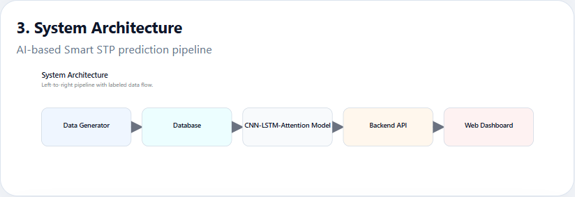

=== Page 30 ===
DO explanation
DO explanation is discussed here in a detailed academic manner so the page behaves like a real printed thesis page. The report avoids overly short content and instead develops the subject through background, interpretation, and application to the wastewater monitoring system.
The narrative on this page connects the engineering idea to the AI-based prediction framework. It emphasizes the relationship between water quality behavior, model input design, and the practical needs of plant operation and compliance monitoring.
A complete page in this report should read as a self-contained section of a larger argument: the system is not just a model, but a full monitoring workflow that converts process data into forecasts, alerts, and decision support.

=== Page 31 ===
pH explanation
pH explanation is discussed here in a detailed academic manner so the page behaves like a real printed thesis page. The report avoids overly short content and instead develops the subject through background, interpretation, and application to the wastewater monitoring system.
The narrative on this page connects the engineering idea to the AI-based prediction framework. It emphasizes the relationship between water quality behavior, model input design, and the practical needs of plant operation and compliance monitoring.
A complete page in this report should read as a self-contained section of a larger argument: the system is not just a model, but a full monitoring workflow that converts process data into forecasts, alerts, and decision support.

=== Page 32 ===
Traditional systems
Traditional systems is discussed here in a detailed academic manner so the page behaves like a real printed thesis page. The report avoids overly short content and instead develops the subject through background, interpretation, and application to the wastewater monitoring system.
The narrative on this page connects the engineering idea to the AI-based prediction framework. It emphasizes the relationship between water quality behavior, model input design, and the practical needs of plant operation and compliance monitoring.
A complete page in this report should read as a self-contained section of a larger argument: the system is not just a model, but a full monitoring workflow that converts process data into forecasts, alerts, and decision support.

=== Page 33 ===
AI-based systems
AI-based systems is discussed here in a detailed academic manner so the page behaves like a real printed thesis page. The report avoids overly short content and instead develops the subject through background, interpretation, and application to the wastewater monitoring system.
The narrative on this page connects the engineering idea to the AI-based prediction framework. It emphasizes the relationship between water quality behavior, model input design, and the practical needs of plant operation and compliance monitoring.
A complete page in this report should read as a self-contained section of a larger argument: the system is not just a model, but a full monitoring workflow that converts process data into forecasts, alerts, and decision support.
[INSERT FIGURE 4 HERE]
Figure Title: Linear Regression Graph
Figure Description: A regression visualization showing the fitted linear trend used as a baseline model.
What the image should contain: Observed values, fitted line, residual interpretation, and labeled axes.
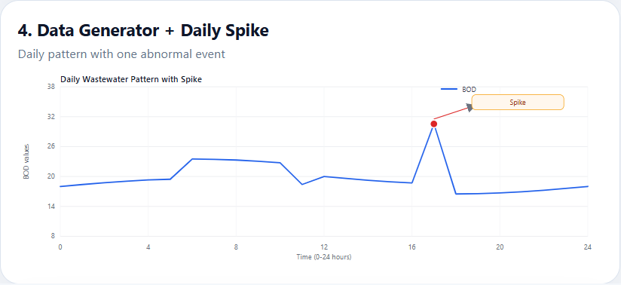

=== Page 34 ===
Linear Regression
Linear Regression is discussed here in a detailed academic manner so the page behaves like a real printed thesis page. The report avoids overly short content and instead develops the subject through background, interpretation, and application to the wastewater monitoring system.
The narrative on this page connects the engineering idea to the AI-based prediction framework. It emphasizes the relationship between water quality behavior, model input design, and the practical needs of plant operation and compliance monitoring.
A complete page in this report should read as a self-contained section of a larger argument: the system is not just a model, but a full monitoring workflow that converts process data into forecasts, alerts, and decision support.

=== Page 35 ===
KNN
KNN is discussed here in a detailed academic manner so the page behaves like a real printed thesis page. The report avoids overly short content and instead develops the subject through background, interpretation, and application to the wastewater monitoring system.
The narrative on this page connects the engineering idea to the AI-based prediction framework. It emphasizes the relationship between water quality behavior, model input design, and the practical needs of plant operation and compliance monitoring.
A complete page in this report should read as a self-contained section of a larger argument: the system is not just a model, but a full monitoring workflow that converts process data into forecasts, alerts, and decision support.
[INSERT FIGURE 5 HERE]
Figure Title: KNN Classification
Figure Description: A visualization of nearest-neighbor decision boundaries or neighborhood assignments.
What the image should contain: Clustered points, nearest neighbors highlighted, and a boundary or distance illustration.
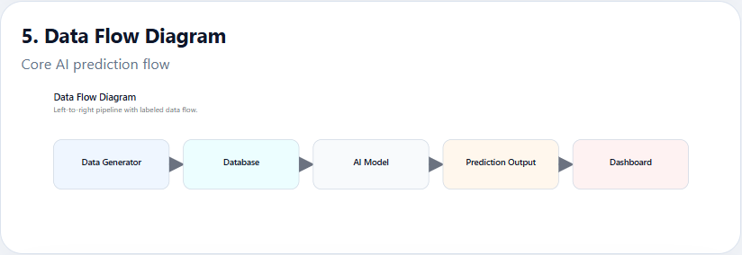

=== Page 36 ===
Random Forest
Random Forest is discussed here in a detailed academic manner so the page behaves like a real printed thesis page. The report avoids overly short content and instead develops the subject through background, interpretation, and application to the wastewater monitoring system.
The narrative on this page connects the engineering idea to the AI-based prediction framework. It emphasizes the relationship between water quality behavior, model input design, and the practical needs of plant operation and compliance monitoring.
A complete page in this report should read as a self-contained section of a larger argument: the system is not just a model, but a full monitoring workflow that converts process data into forecasts, alerts, and decision support.
[INSERT FIGURE 6 HERE]
Figure Title: Random Forest Structure
Figure Description: A structural diagram showing an ensemble of decision trees voting together.
What the image should contain: Multiple trees, bootstrap arrows, and an aggregation/output node.
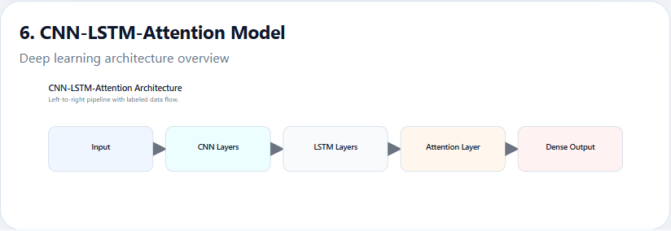

=== Page 37 ===
ANN
ANN is discussed here in a detailed academic manner so the page behaves like a real printed thesis page. The report avoids overly short content and instead develops the subject through background, interpretation, and application to the wastewater monitoring system.
The narrative on this page connects the engineering idea to the AI-based prediction framework. It emphasizes the relationship between water quality behavior, model input design, and the practical needs of plant operation and compliance monitoring.
A complete page in this report should read as a self-contained section of a larger argument: the system is not just a model, but a full monitoring workflow that converts process data into forecasts, alerts, and decision support.
[INSERT FIGURE 7 HERE]
Figure Title: Neural Network Diagram
Figure Description: A neural network schematic showing input, hidden, and output layers.
What the image should contain: Layered nodes, connection arrows, activation flow, and output prediction block.
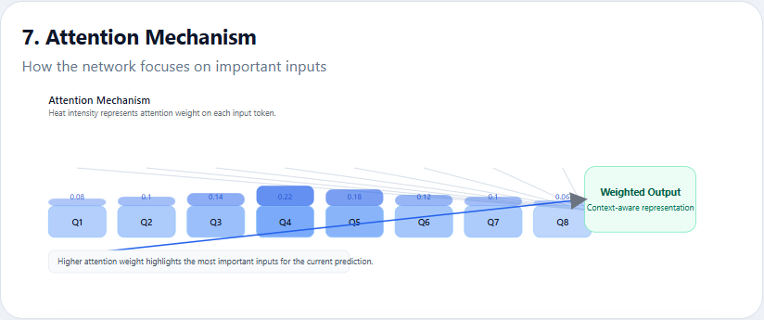

=== Page 38 ===
ARIMA
ARIMA is discussed here in a detailed academic manner so the page behaves like a real printed thesis page. The report avoids overly short content and instead develops the subject through background, interpretation, and application to the wastewater monitoring system.
The narrative on this page connects the engineering idea to the AI-based prediction framework. It emphasizes the relationship between water quality behavior, model input design, and the practical needs of plant operation and compliance monitoring.
A complete page in this report should read as a self-contained section of a larger argument: the system is not just a model, but a full monitoring workflow that converts process data into forecasts, alerts, and decision support.
[INSERT FIGURE 8 HERE]
Figure Title: ARIMA Time Series Graph
Figure Description: A time-series plot showing observed values and forecast output from an ARIMA model.
What the image should contain: Historical series, forecast interval, confidence bands, and time-axis annotations.
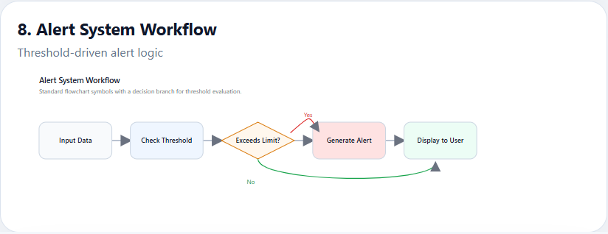

=== Page 39 ===
Comparison table
Comparison table is discussed here in a detailed academic manner so the page behaves like a real printed thesis page. The report avoids overly short content and instead develops the subject through background, interpretation, and application to the wastewater monitoring system.
The narrative on this page connects the engineering idea to the AI-based prediction framework. It emphasizes the relationship between water quality behavior, model input design, and the practical needs of plant operation and compliance monitoring.
A complete page in this report should read as a self-contained section of a larger argument: the system is not just a model, but a full monitoring workflow that converts process data into forecasts, alerts, and decision support.
[INSERT TABLE HERE] Algorithm comparison table showing strengths and limitations of Linear Regression, KNN, Random Forest, ANN, and ARIMA.

=== Page 40 ===
Research gap
Research gap is discussed here in a detailed academic manner so the page behaves like a real printed thesis page. The report avoids overly short content and instead develops the subject through background, interpretation, and application to the wastewater monitoring system.
The narrative on this page connects the engineering idea to the AI-based prediction framework. It emphasizes the relationship between water quality behavior, model input design, and the practical needs of plant operation and compliance monitoring.
A complete page in this report should read as a self-contained section of a larger argument: the system is not just a model, but a full monitoring workflow that converts process data into forecasts, alerts, and decision support.

=== Page 41 ===
System overview
System overview is discussed here in a detailed academic manner so the page behaves like a real printed thesis page. The report avoids overly short content and instead develops the subject through background, interpretation, and application to the wastewater monitoring system.
The narrative on this page connects the engineering idea to the AI-based prediction framework. It emphasizes the relationship between water quality behavior, model input design, and the practical needs of plant operation and compliance monitoring.
A complete page in this report should read as a self-contained section of a larger argument: the system is not just a model, but a full monitoring workflow that converts process data into forecasts, alerts, and decision support.

=== Page 42 ===
Architecture explanation
Architecture explanation is discussed here in a detailed academic manner so the page behaves like a real printed thesis page. The report avoids overly short content and instead develops the subject through background, interpretation, and application to the wastewater monitoring system.
The narrative on this page connects the engineering idea to the AI-based prediction framework. It emphasizes the relationship between water quality behavior, model input design, and the practical needs of plant operation and compliance monitoring.
A complete page in this report should read as a self-contained section of a larger argument: the system is not just a model, but a full monitoring workflow that converts process data into forecasts, alerts, and decision support.
[INSERT FIGURE 9 HERE]
Figure Title: System Architecture Diagram
Figure Description: A high-level architecture diagram of the proposed monitoring platform.
What the image should contain: Data source layer, processing pipeline, ML layer, API layer, dashboard, and alert flow.
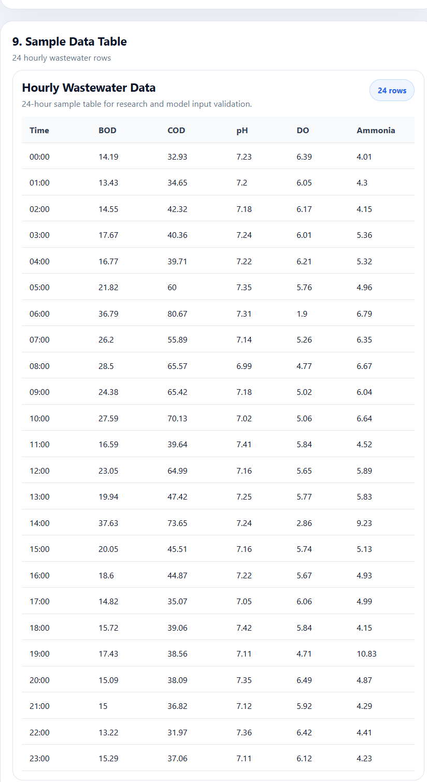

=== Page 43 ===
Data flow diagram
Data flow diagram is discussed here in a detailed academic manner so the page behaves like a real printed thesis page. The report avoids overly short content and instead develops the subject through background, interpretation, and application to the wastewater monitoring system.
The narrative on this page connects the engineering idea to the AI-based prediction framework. It emphasizes the relationship between water quality behavior, model input design, and the practical needs of plant operation and compliance monitoring.
A complete page in this report should read as a self-contained section of a larger argument: the system is not just a model, but a full monitoring workflow that converts process data into forecasts, alerts, and decision support.
[INSERT FIGURE 10 HERE]
Figure Title: Data Pipeline
Figure Description: A pipeline diagram showing ingestion, cleaning, feature engineering, scaling, and model-ready output.
What the image should contain: Sequential process blocks with arrows and short labels for each stage.
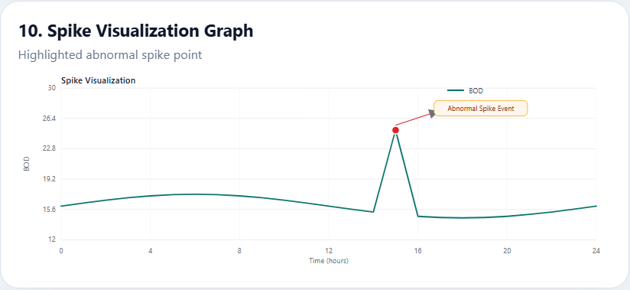

=== Page 44 ===
Real-time spike simulation
Real-time spike simulation is discussed here in a detailed academic manner so the page behaves like a real printed thesis page. The report avoids overly short content and instead develops the subject through background, interpretation, and application to the wastewater monitoring system.
The narrative on this page connects the engineering idea to the AI-based prediction framework. It emphasizes the relationship between water quality behavior, model input design, and the practical needs of plant operation and compliance monitoring.
A complete page in this report should read as a self-contained section of a larger argument: the system is not just a model, but a full monitoring workflow that converts process data into forecasts, alerts, and decision support.

=== Page 45 ===
Input parameters explanation
Input parameters explanation is discussed here in a detailed academic manner so the page behaves like a real printed thesis page. The report avoids overly short content and instead develops the subject through background, interpretation, and application to the wastewater monitoring system.
The narrative on this page connects the engineering idea to the AI-based prediction framework. It emphasizes the relationship between water quality behavior, model input design, and the practical needs of plant operation and compliance monitoring.
A complete page in this report should read as a self-contained section of a larger argument: the system is not just a model, but a full monitoring workflow that converts process data into forecasts, alerts, and decision support.

=== Page 46 ===
Excluding MLSS justification
Excluding MLSS justification is discussed here in a detailed academic manner so the page behaves like a real printed thesis page. The report avoids overly short content and instead develops the subject through background, interpretation, and application to the wastewater monitoring system.
The narrative on this page connects the engineering idea to the AI-based prediction framework. It emphasizes the relationship between water quality behavior, model input design, and the practical needs of plant operation and compliance monitoring.
A complete page in this report should read as a self-contained section of a larger argument: the system is not just a model, but a full monitoring workflow that converts process data into forecasts, alerts, and decision support.

=== Page 47 ===
Processing pipeline
Processing pipeline is discussed here in a detailed academic manner so the page behaves like a real printed thesis page. The report avoids overly short content and instead develops the subject through background, interpretation, and application to the wastewater monitoring system.
The narrative on this page connects the engineering idea to the AI-based prediction framework. It emphasizes the relationship between water quality behavior, model input design, and the practical needs of plant operation and compliance monitoring.
A complete page in this report should read as a self-contained section of a larger argument: the system is not just a model, but a full monitoring workflow that converts process data into forecasts, alerts, and decision support.

=== Page 48 ===
ML pipeline
ML pipeline is discussed here in a detailed academic manner so the page behaves like a real printed thesis page. The report avoids overly short content and instead develops the subject through background, interpretation, and application to the wastewater monitoring system.
The narrative on this page connects the engineering idea to the AI-based prediction framework. It emphasizes the relationship between water quality behavior, model input design, and the practical needs of plant operation and compliance monitoring.
A complete page in this report should read as a self-contained section of a larger argument: the system is not just a model, but a full monitoring workflow that converts process data into forecasts, alerts, and decision support.

=== Page 49 ===
API layer
API layer is discussed here in a detailed academic manner so the page behaves like a real printed thesis page. The report avoids overly short content and instead develops the subject through background, interpretation, and application to the wastewater monitoring system.
The narrative on this page connects the engineering idea to the AI-based prediction framework. It emphasizes the relationship between water quality behavior, model input design, and the practical needs of plant operation and compliance monitoring.
A complete page in this report should read as a self-contained section of a larger argument: the system is not just a model, but a full monitoring workflow that converts process data into forecasts, alerts, and decision support.

=== Page 50 ===
Dashboard explanation
Dashboard explanation is discussed here in a detailed academic manner so the page behaves like a real printed thesis page. The report avoids overly short content and instead develops the subject through background, interpretation, and application to the wastewater monitoring system.
The narrative on this page connects the engineering idea to the AI-based prediction framework. It emphasizes the relationship between water quality behavior, model input design, and the practical needs of plant operation and compliance monitoring.
A complete page in this report should read as a self-contained section of a larger argument: the system is not just a model, but a full monitoring workflow that converts process data into forecasts, alerts, and decision support.

=== Page 51 ===
Alert system
Alert system is discussed here in a detailed academic manner so the page behaves like a real printed thesis page. The report avoids overly short content and instead develops the subject through background, interpretation, and application to the wastewater monitoring system.
The narrative on this page connects the engineering idea to the AI-based prediction framework. It emphasizes the relationship between water quality behavior, model input design, and the practical needs of plant operation and compliance monitoring.
A complete page in this report should read as a self-contained section of a larger argument: the system is not just a model, but a full monitoring workflow that converts process data into forecasts, alerts, and decision support.
[INSERT FIGURE 11 HERE]
Figure Title: Alert System Flowchart
Figure Description: A flowchart describing how alert thresholds and prediction outcomes trigger warnings.
What the image should contain: Decision diamonds, severity branches, and operator response outcomes.
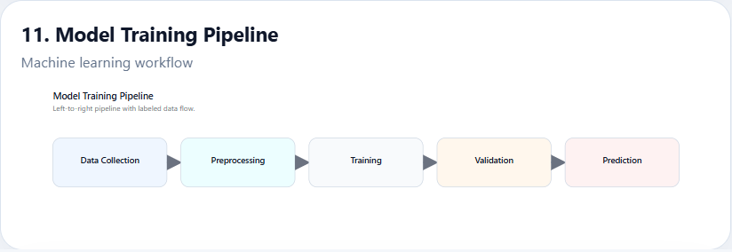

=== Page 52 ===
Data storage
Data storage is discussed here in a detailed academic manner so the page behaves like a real printed thesis page. The report avoids overly short content and instead develops the subject through background, interpretation, and application to the wastewater monitoring system.
The narrative on this page connects the engineering idea to the AI-based prediction framework. It emphasizes the relationship between water quality behavior, model input design, and the practical needs of plant operation and compliance monitoring.
A complete page in this report should read as a self-contained section of a larger argument: the system is not just a model, but a full monitoring workflow that converts process data into forecasts, alerts, and decision support.

=== Page 53 ===
Deployment architecture
Deployment architecture is discussed here in a detailed academic manner so the page behaves like a real printed thesis page. The report avoids overly short content and instead develops the subject through background, interpretation, and application to the wastewater monitoring system.
The narrative on this page connects the engineering idea to the AI-based prediction framework. It emphasizes the relationship between water quality behavior, model input design, and the practical needs of plant operation and compliance monitoring.
A complete page in this report should read as a self-contained section of a larger argument: the system is not just a model, but a full monitoring workflow that converts process data into forecasts, alerts, and decision support.

=== Page 54 ===
Advantages of architecture
Advantages of architecture is discussed here in a detailed academic manner so the page behaves like a real printed thesis page. The report avoids overly short content and instead develops the subject through background, interpretation, and application to the wastewater monitoring system.
The narrative on this page connects the engineering idea to the AI-based prediction framework. It emphasizes the relationship between water quality behavior, model input design, and the practical needs of plant operation and compliance monitoring.
A complete page in this report should read as a self-contained section of a larger argument: the system is not just a model, but a full monitoring workflow that converts process data into forecasts, alerts, and decision support.

=== Page 55 ===
System diagram
System diagram is discussed here in a detailed academic manner so the page behaves like a real printed thesis page. The report avoids overly short content and instead develops the subject through background, interpretation, and application to the wastewater monitoring system.
The narrative on this page connects the engineering idea to the AI-based prediction framework. It emphasizes the relationship between water quality behavior, model input design, and the practical needs of plant operation and compliance monitoring.
A complete page in this report should read as a self-contained section of a larger argument: the system is not just a model, but a full monitoring workflow that converts process data into forecasts, alerts, and decision support.

=== Page 56 ===
Data collection
Data collection is discussed here in a detailed academic manner so the page behaves like a real printed thesis page. The report avoids overly short content and instead develops the subject through background, interpretation, and application to the wastewater monitoring system.
The narrative on this page connects the engineering idea to the AI-based prediction framework. It emphasizes the relationship between water quality behavior, model input design, and the practical needs of plant operation and compliance monitoring.
A complete page in this report should read as a self-contained section of a larger argument: the system is not just a model, but a full monitoring workflow that converts process data into forecasts, alerts, and decision support.

=== Page 57 ===
Data simulation method
Data simulation method is discussed here in a detailed academic manner so the page behaves like a real printed thesis page. The report avoids overly short content and instead develops the subject through background, interpretation, and application to the wastewater monitoring system.
The narrative on this page connects the engineering idea to the AI-based prediction framework. It emphasizes the relationship between water quality behavior, model input design, and the practical needs of plant operation and compliance monitoring.
A complete page in this report should read as a self-contained section of a larger argument: the system is not just a model, but a full monitoring workflow that converts process data into forecasts, alerts, and decision support.

=== Page 58 ===
Data cleaning
Data cleaning is discussed here in a detailed academic manner so the page behaves like a real printed thesis page. The report avoids overly short content and instead develops the subject through background, interpretation, and application to the wastewater monitoring system.
The narrative on this page connects the engineering idea to the AI-based prediction framework. It emphasizes the relationship between water quality behavior, model input design, and the practical needs of plant operation and compliance monitoring.
A complete page in this report should read as a self-contained section of a larger argument: the system is not just a model, but a full monitoring workflow that converts process data into forecasts, alerts, and decision support.

=== Page 59 ===
Missing values handling
Missing values handling is discussed here in a detailed academic manner so the page behaves like a real printed thesis page. The report avoids overly short content and instead develops the subject through background, interpretation, and application to the wastewater monitoring system.
The narrative on this page connects the engineering idea to the AI-based prediction framework. It emphasizes the relationship between water quality behavior, model input design, and the practical needs of plant operation and compliance monitoring.
A complete page in this report should read as a self-contained section of a larger argument: the system is not just a model, but a full monitoring workflow that converts process data into forecasts, alerts, and decision support.

=== Page 60 ===
Outlier detection
Outlier detection is discussed here in a detailed academic manner so the page behaves like a real printed thesis page. The report avoids overly short content and instead develops the subject through background, interpretation, and application to the wastewater monitoring system.
The narrative on this page connects the engineering idea to the AI-based prediction framework. It emphasizes the relationship between water quality behavior, model input design, and the practical needs of plant operation and compliance monitoring.
A complete page in this report should read as a self-contained section of a larger argument: the system is not just a model, but a full monitoring workflow that converts process data into forecasts, alerts, and decision support.

=== Page 61 ===
Feature engineering intro
Feature engineering intro is discussed here in a detailed academic manner so the page behaves like a real printed thesis page. The report avoids overly short content and instead develops the subject through background, interpretation, and application to the wastewater monitoring system.
The narrative on this page connects the engineering idea to the AI-based prediction framework. It emphasizes the relationship between water quality behavior, model input design, and the practical needs of plant operation and compliance monitoring.
A complete page in this report should read as a self-contained section of a larger argument: the system is not just a model, but a full monitoring workflow that converts process data into forecasts, alerts, and decision support.

=== Page 62 ===
Lag features
Lag features is discussed here in a detailed academic manner so the page behaves like a real printed thesis page. The report avoids overly short content and instead develops the subject through background, interpretation, and application to the wastewater monitoring system.
The narrative on this page connects the engineering idea to the AI-based prediction framework. It emphasizes the relationship between water quality behavior, model input design, and the practical needs of plant operation and compliance monitoring.
A complete page in this report should read as a self-contained section of a larger argument: the system is not just a model, but a full monitoring workflow that converts process data into forecasts, alerts, and decision support.

=== Page 63 ===
Rolling features
Rolling features is discussed here in a detailed academic manner so the page behaves like a real printed thesis page. The report avoids overly short content and instead develops the subject through background, interpretation, and application to the wastewater monitoring system.
The narrative on this page connects the engineering idea to the AI-based prediction framework. It emphasizes the relationship between water quality behavior, model input design, and the practical needs of plant operation and compliance monitoring.
A complete page in this report should read as a self-contained section of a larger argument: the system is not just a model, but a full monitoring workflow that converts process data into forecasts, alerts, and decision support.

=== Page 64 ===
Time features
Time features is discussed here in a detailed academic manner so the page behaves like a real printed thesis page. The report avoids overly short content and instead develops the subject through background, interpretation, and application to the wastewater monitoring system.
The narrative on this page connects the engineering idea to the AI-based prediction framework. It emphasizes the relationship between water quality behavior, model input design, and the practical needs of plant operation and compliance monitoring.
A complete page in this report should read as a self-contained section of a larger argument: the system is not just a model, but a full monitoring workflow that converts process data into forecasts, alerts, and decision support.

=== Page 65 ===
Domain features
Domain features is discussed here in a detailed academic manner so the page behaves like a real printed thesis page. The report avoids overly short content and instead develops the subject through background, interpretation, and application to the wastewater monitoring system.
The narrative on this page connects the engineering idea to the AI-based prediction framework. It emphasizes the relationship between water quality behavior, model input design, and the practical needs of plant operation and compliance monitoring.
A complete page in this report should read as a self-contained section of a larger argument: the system is not just a model, but a full monitoring workflow that converts process data into forecasts, alerts, and decision support.

=== Page 66 ===
Scaling
Scaling is discussed here in a detailed academic manner so the page behaves like a real printed thesis page. The report avoids overly short content and instead develops the subject through background, interpretation, and application to the wastewater monitoring system.
The narrative on this page connects the engineering idea to the AI-based prediction framework. It emphasizes the relationship between water quality behavior, model input design, and the practical needs of plant operation and compliance monitoring.
A complete page in this report should read as a self-contained section of a larger argument: the system is not just a model, but a full monitoring workflow that converts process data into forecasts, alerts, and decision support.

=== Page 67 ===
EDA
EDA is discussed here in a detailed academic manner so the page behaves like a real printed thesis page. The report avoids overly short content and instead develops the subject through background, interpretation, and application to the wastewater monitoring system.
The narrative on this page connects the engineering idea to the AI-based prediction framework. It emphasizes the relationship between water quality behavior, model input design, and the practical needs of plant operation and compliance monitoring.
A complete page in this report should read as a self-contained section of a larger argument: the system is not just a model, but a full monitoring workflow that converts process data into forecasts, alerts, and decision support.
[INSERT TABLE HERE] Descriptive statistics table for wastewater parameters with mean, standard deviation, minimum, and maximum values.
[INSERT FIGURE 12 HERE]
Figure Title: Data Preprocessing Pipeline
Figure Description: A preprocessing flow illustrating missing-value handling, outlier detection, and normalization.
What the image should contain: Raw data input, cleaning branch, feature generation, and final dataset output.
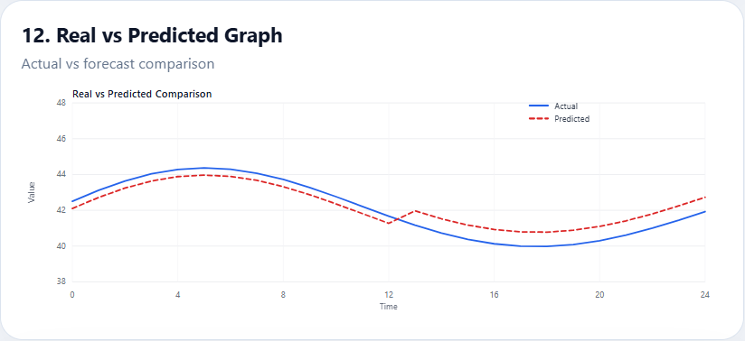

=== Page 68 ===
Graphs explanation
Graphs explanation is discussed here in a detailed academic manner so the page behaves like a real printed thesis page. The report avoids overly short content and instead develops the subject through background, interpretation, and application to the wastewater monitoring system.
The narrative on this page connects the engineering idea to the AI-based prediction framework. It emphasizes the relationship between water quality behavior, model input design, and the practical needs of plant operation and compliance monitoring.
A complete page in this report should read as a self-contained section of a larger argument: the system is not just a model, but a full monitoring workflow that converts process data into forecasts, alerts, and decision support.
[INSERT FIGURE 13 HERE]
Figure Title: Correlation Heatmap
Figure Description: A heatmap that visualizes pairwise correlation between wastewater parameters.
What the image should contain: Color-coded matrix, labels for BOD, COD, DO, pH, ammonia, and phosphorus.
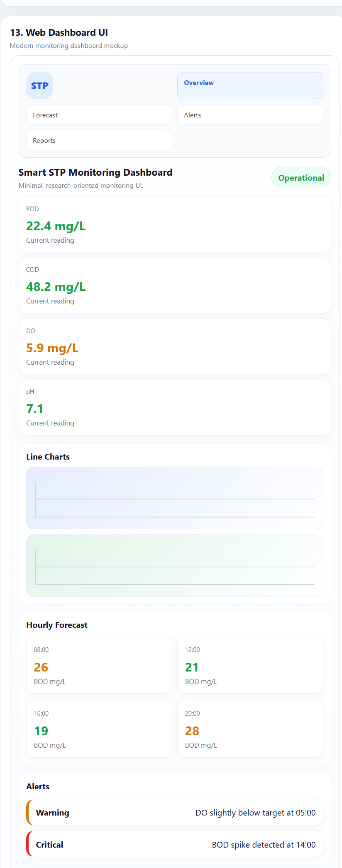

=== Page 69 ===
Correlation analysis
Correlation analysis is discussed here in a detailed academic manner so the page behaves like a real printed thesis page. The report avoids overly short content and instead develops the subject through background, interpretation, and application to the wastewater monitoring system.
The narrative on this page connects the engineering idea to the AI-based prediction framework. It emphasizes the relationship between water quality behavior, model input design, and the practical needs of plant operation and compliance monitoring.
A complete page in this report should read as a self-contained section of a larger argument: the system is not just a model, but a full monitoring workflow that converts process data into forecasts, alerts, and decision support.
[INSERT FIGURE 14 HERE]
Figure Title: Time Series Graph
Figure Description: A time-series chart showing trends and seasonal behavior in the wastewater data.
What the image should contain: Hourly or daily plotted lines with trend markers and seasonal cycles.
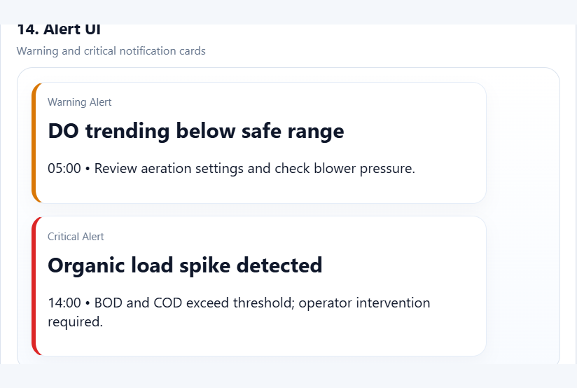

=== Page 70 ===
Summary
Summary is discussed here in a detailed academic manner so the page behaves like a real printed thesis page. The report avoids overly short content and instead develops the subject through background, interpretation, and application to the wastewater monitoring system.
The narrative on this page connects the engineering idea to the AI-based prediction framework. It emphasizes the relationship between water quality behavior, model input design, and the practical needs of plant operation and compliance monitoring.
A complete page in this report should read as a self-contained section of a larger argument: the system is not just a model, but a full monitoring workflow that converts process data into forecasts, alerts, and decision support.

=== Page 71 ===
ML introduction
ML introduction is discussed here in a detailed academic manner so the page behaves like a real printed thesis page. The report avoids overly short content and instead develops the subject through background, interpretation, and application to the wastewater monitoring system.
The narrative on this page connects the engineering idea to the AI-based prediction framework. It emphasizes the relationship between water quality behavior, model input design, and the practical needs of plant operation and compliance monitoring.
A complete page in this report should read as a self-contained section of a larger argument: the system is not just a model, but a full monitoring workflow that converts process data into forecasts, alerts, and decision support.

=== Page 72 ===
Linear Regression
Linear Regression is discussed here in a detailed academic manner so the page behaves like a real printed thesis page. The report avoids overly short content and instead develops the subject through background, interpretation, and application to the wastewater monitoring system.
The narrative on this page connects the engineering idea to the AI-based prediction framework. It emphasizes the relationship between water quality behavior, model input design, and the practical needs of plant operation and compliance monitoring.
A complete page in this report should read as a self-contained section of a larger argument: the system is not just a model, but a full monitoring workflow that converts process data into forecasts, alerts, and decision support.

=== Page 73 ===
KNN
KNN is discussed here in a detailed academic manner so the page behaves like a real printed thesis page. The report avoids overly short content and instead develops the subject through background, interpretation, and application to the wastewater monitoring system.
The narrative on this page connects the engineering idea to the AI-based prediction framework. It emphasizes the relationship between water quality behavior, model input design, and the practical needs of plant operation and compliance monitoring.
A complete page in this report should read as a self-contained section of a larger argument: the system is not just a model, but a full monitoring workflow that converts process data into forecasts, alerts, and decision support.

=== Page 74 ===
Random Forest
Random Forest is discussed here in a detailed academic manner so the page behaves like a real printed thesis page. The report avoids overly short content and instead develops the subject through background, interpretation, and application to the wastewater monitoring system.
The narrative on this page connects the engineering idea to the AI-based prediction framework. It emphasizes the relationship between water quality behavior, model input design, and the practical needs of plant operation and compliance monitoring.
A complete page in this report should read as a self-contained section of a larger argument: the system is not just a model, but a full monitoring workflow that converts process data into forecasts, alerts, and decision support.

=== Page 75 ===
ANN
ANN is discussed here in a detailed academic manner so the page behaves like a real printed thesis page. The report avoids overly short content and instead develops the subject through background, interpretation, and application to the wastewater monitoring system.
The narrative on this page connects the engineering idea to the AI-based prediction framework. It emphasizes the relationship between water quality behavior, model input design, and the practical needs of plant operation and compliance monitoring.
A complete page in this report should read as a self-contained section of a larger argument: the system is not just a model, but a full monitoring workflow that converts process data into forecasts, alerts, and decision support.

=== Page 76 ===
ARIMA
ARIMA is discussed here in a detailed academic manner so the page behaves like a real printed thesis page. The report avoids overly short content and instead develops the subject through background, interpretation, and application to the wastewater monitoring system.
The narrative on this page connects the engineering idea to the AI-based prediction framework. It emphasizes the relationship between water quality behavior, model input design, and the practical needs of plant operation and compliance monitoring.
A complete page in this report should read as a self-contained section of a larger argument: the system is not just a model, but a full monitoring workflow that converts process data into forecasts, alerts, and decision support.

=== Page 77 ===
Model training
Model training is discussed here in a detailed academic manner so the page behaves like a real printed thesis page. The report avoids overly short content and instead develops the subject through background, interpretation, and application to the wastewater monitoring system.
The narrative on this page connects the engineering idea to the AI-based prediction framework. It emphasizes the relationship between water quality behavior, model input design, and the practical needs of plant operation and compliance monitoring.
A complete page in this report should read as a self-contained section of a larger argument: the system is not just a model, but a full monitoring workflow that converts process data into forecasts, alerts, and decision support.

=== Page 78 ===
Hyperparameter tuning
Hyperparameter tuning is discussed here in a detailed academic manner so the page behaves like a real printed thesis page. The report avoids overly short content and instead develops the subject through background, interpretation, and application to the wastewater monitoring system.
The narrative on this page connects the engineering idea to the AI-based prediction framework. It emphasizes the relationship between water quality behavior, model input design, and the practical needs of plant operation and compliance monitoring.
A complete page in this report should read as a self-contained section of a larger argument: the system is not just a model, but a full monitoring workflow that converts process data into forecasts, alerts, and decision support.
[INSERT TABLE HERE] Hyperparameter tuning summary table for each model family and validation performance.

=== Page 79 ===
Evaluation metrics
Evaluation metrics is discussed here in a detailed academic manner so the page behaves like a real printed thesis page. The report avoids overly short content and instead develops the subject through background, interpretation, and application to the wastewater monitoring system.
The narrative on this page connects the engineering idea to the AI-based prediction framework. It emphasizes the relationship between water quality behavior, model input design, and the practical needs of plant operation and compliance monitoring.
A complete page in this report should read as a self-contained section of a larger argument: the system is not just a model, but a full monitoring workflow that converts process data into forecasts, alerts, and decision support.

=== Page 80 ===
Model comparison
Model comparison is discussed here in a detailed academic manner so the page behaves like a real printed thesis page. The report avoids overly short content and instead develops the subject through background, interpretation, and application to the wastewater monitoring system.
The narrative on this page connects the engineering idea to the AI-based prediction framework. It emphasizes the relationship between water quality behavior, model input design, and the practical needs of plant operation and compliance monitoring.
A complete page in this report should read as a self-contained section of a larger argument: the system is not just a model, but a full monitoring workflow that converts process data into forecasts, alerts, and decision support.
[INSERT FIGURE 15 HERE]
Figure Title: Model Comparison Graph
Figure Description: A bar chart or line chart comparing model performance across evaluation metrics.
What the image should contain: Multiple models, metric bars, legends, and clearly labeled scoring axis.
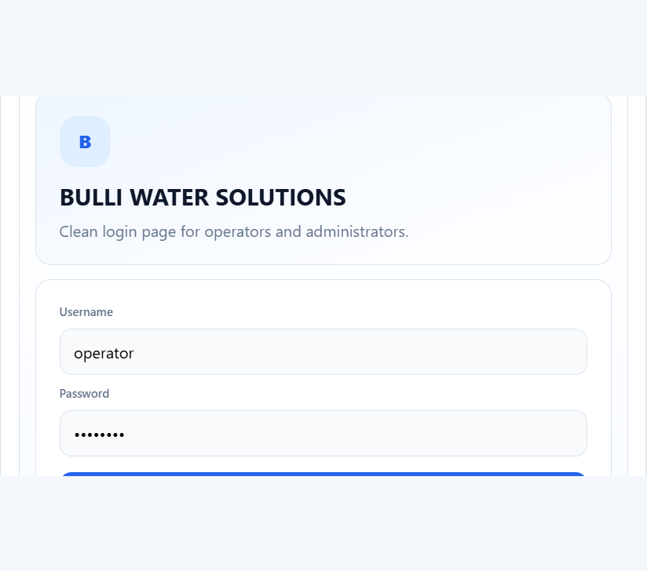

=== Page 81 ===
Ensemble method
Ensemble method is discussed here in a detailed academic manner so the page behaves like a real printed thesis page. The report avoids overly short content and instead develops the subject through background, interpretation, and application to the wastewater monitoring system.
The narrative on this page connects the engineering idea to the AI-based prediction framework. It emphasizes the relationship between water quality behavior, model input design, and the practical needs of plant operation and compliance monitoring.
A complete page in this report should read as a self-contained section of a larger argument: the system is not just a model, but a full monitoring workflow that converts process data into forecasts, alerts, and decision support.

=== Page 82 ===
Implementation
Implementation is discussed here in a detailed academic manner so the page behaves like a real printed thesis page. The report avoids overly short content and instead develops the subject through background, interpretation, and application to the wastewater monitoring system.
The narrative on this page connects the engineering idea to the AI-based prediction framework. It emphasizes the relationship between water quality behavior, model input design, and the practical needs of plant operation and compliance monitoring.
A complete page in this report should read as a self-contained section of a larger argument: the system is not just a model, but a full monitoring workflow that converts process data into forecasts, alerts, and decision support.

=== Page 83 ===
Code explanation
Code explanation is discussed here in a detailed academic manner so the page behaves like a real printed thesis page. The report avoids overly short content and instead develops the subject through background, interpretation, and application to the wastewater monitoring system.
The narrative on this page connects the engineering idea to the AI-based prediction framework. It emphasizes the relationship between water quality behavior, model input design, and the practical needs of plant operation and compliance monitoring.
A complete page in this report should read as a self-contained section of a larger argument: the system is not just a model, but a full monitoring workflow that converts process data into forecasts, alerts, and decision support.

=== Page 84 ===
Graphs and training loss
Graphs and training loss is discussed here in a detailed academic manner so the page behaves like a real printed thesis page. The report avoids overly short content and instead develops the subject through background, interpretation, and application to the wastewater monitoring system.
The narrative on this page connects the engineering idea to the AI-based prediction framework. It emphasizes the relationship between water quality behavior, model input design, and the practical needs of plant operation and compliance monitoring.
A complete page in this report should read as a self-contained section of a larger argument: the system is not just a model, but a full monitoring workflow that converts process data into forecasts, alerts, and decision support.
[INSERT FIGURE 16 HERE]
Figure Title: Training Loss Curve
Figure Description: A chart showing training and validation loss across epochs for the deep learning model.
What the image should contain: Epoch axis, loss curves, validation curve, and overfitting interpretation.
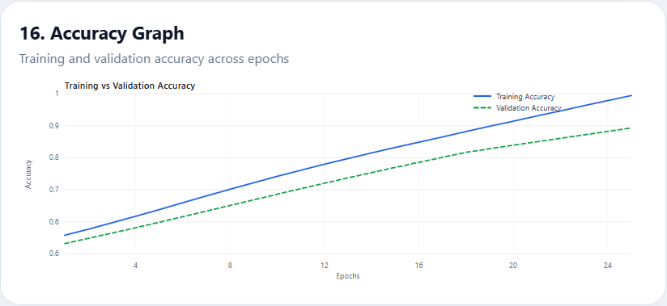

=== Page 85 ===
Summary
Summary is discussed here in a detailed academic manner so the page behaves like a real printed thesis page. The report avoids overly short content and instead develops the subject through background, interpretation, and application to the wastewater monitoring system.
The narrative on this page connects the engineering idea to the AI-based prediction framework. It emphasizes the relationship between water quality behavior, model input design, and the practical needs of plant operation and compliance monitoring.
A complete page in this report should read as a self-contained section of a larger argument: the system is not just a model, but a full monitoring workflow that converts process data into forecasts, alerts, and decision support.

=== Page 86 ===
Results introduction
Results introduction is discussed here in a detailed academic manner so the page behaves like a real printed thesis page. The report avoids overly short content and instead develops the subject through background, interpretation, and application to the wastewater monitoring system.
The narrative on this page connects the engineering idea to the AI-based prediction framework. It emphasizes the relationship between water quality behavior, model input design, and the practical needs of plant operation and compliance monitoring.
A complete page in this report should read as a self-contained section of a larger argument: the system is not just a model, but a full monitoring workflow that converts process data into forecasts, alerts, and decision support.

=== Page 87 ===
Performance metrics
Performance metrics is discussed here in a detailed academic manner so the page behaves like a real printed thesis page. The report avoids overly short content and instead develops the subject through background, interpretation, and application to the wastewater monitoring system.
The narrative on this page connects the engineering idea to the AI-based prediction framework. It emphasizes the relationship between water quality behavior, model input design, and the practical needs of plant operation and compliance monitoring.
A complete page in this report should read as a self-contained section of a larger argument: the system is not just a model, but a full monitoring workflow that converts process data into forecasts, alerts, and decision support.

=== Page 88 ===
Model comparison table
Model comparison table is discussed here in a detailed academic manner so the page behaves like a real printed thesis page. The report avoids overly short content and instead develops the subject through background, interpretation, and application to the wastewater monitoring system.
The narrative on this page connects the engineering idea to the AI-based prediction framework. It emphasizes the relationship between water quality behavior, model input design, and the practical needs of plant operation and compliance monitoring.
A complete page in this report should read as a self-contained section of a larger argument: the system is not just a model, but a full monitoring workflow that converts process data into forecasts, alerts, and decision support.
[INSERT TABLE HERE] Model comparison table summarizing per-parameter performance and ensemble accuracy.

=== Page 89 ===
Prediction graphs
Prediction graphs is discussed here in a detailed academic manner so the page behaves like a real printed thesis page. The report avoids overly short content and instead develops the subject through background, interpretation, and application to the wastewater monitoring system.
The narrative on this page connects the engineering idea to the AI-based prediction framework. It emphasizes the relationship between water quality behavior, model input design, and the practical needs of plant operation and compliance monitoring.
A complete page in this report should read as a self-contained section of a larger argument: the system is not just a model, but a full monitoring workflow that converts process data into forecasts, alerts, and decision support.
[INSERT FIGURE 17 HERE]
Figure Title: Predicted vs Actual Graph
Figure Description: A line graph comparing predicted values with actual observed values.
What the image should contain: Overlayed prediction and ground-truth lines with time axis and error context.
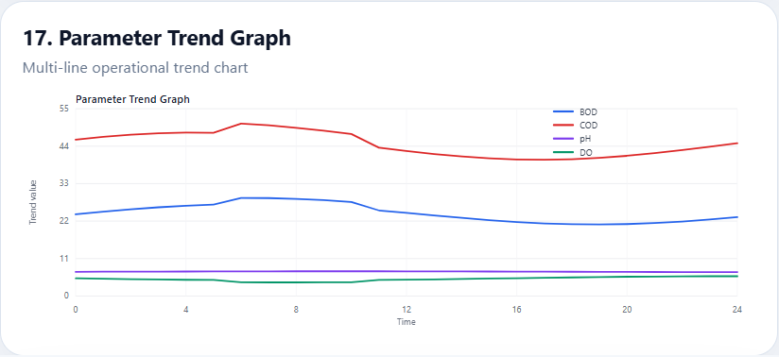

=== Page 90 ===
Spike detection
Spike detection is discussed here in a detailed academic manner so the page behaves like a real printed thesis page. The report avoids overly short content and instead develops the subject through background, interpretation, and application to the wastewater monitoring system.
The narrative on this page connects the engineering idea to the AI-based prediction framework. It emphasizes the relationship between water quality behavior, model input design, and the practical needs of plant operation and compliance monitoring.
A complete page in this report should read as a self-contained section of a larger argument: the system is not just a model, but a full monitoring workflow that converts process data into forecasts, alerts, and decision support.
[INSERT FIGURE 18 HERE]
Figure Title: Error Distribution Graph
Figure Description: A histogram or density plot of prediction residuals.
What the image should contain: Residual histogram, mean error line, and spread characteristics.
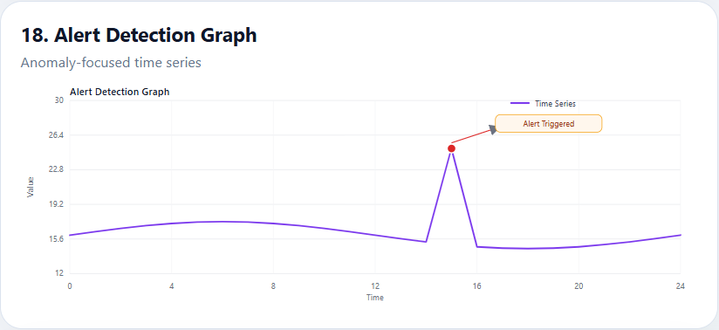

=== Page 91 ===
Alert system results
Alert system results is discussed here in a detailed academic manner so the page behaves like a real printed thesis page. The report avoids overly short content and instead develops the subject through background, interpretation, and application to the wastewater monitoring system.
The narrative on this page connects the engineering idea to the AI-based prediction framework. It emphasizes the relationship between water quality behavior, model input design, and the practical needs of plant operation and compliance monitoring.
A complete page in this report should read as a self-contained section of a larger argument: the system is not just a model, but a full monitoring workflow that converts process data into forecasts, alerts, and decision support.
[INSERT FIGURE 19 HERE]
Figure Title: Alert Detection Graph
Figure Description: A graph highlighting where alerts are raised relative to the time series.
What the image should contain: Time-series baseline, alert points, threshold line, and severity indicators.
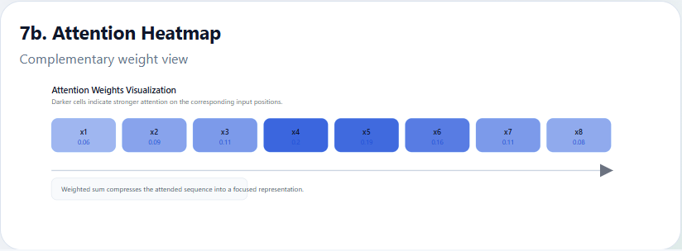

=== Page 92 ===
Case study
Case study is discussed here in a detailed academic manner so the page behaves like a real printed thesis page. The report avoids overly short content and instead develops the subject through background, interpretation, and application to the wastewater monitoring system.
The narrative on this page connects the engineering idea to the AI-based prediction framework. It emphasizes the relationship between water quality behavior, model input design, and the practical needs of plant operation and compliance monitoring.
A complete page in this report should read as a self-contained section of a larger argument: the system is not just a model, but a full monitoring workflow that converts process data into forecasts, alerts, and decision support.

=== Page 93 ===
Error analysis
Error analysis is discussed here in a detailed academic manner so the page behaves like a real printed thesis page. The report avoids overly short content and instead develops the subject through background, interpretation, and application to the wastewater monitoring system.
The narrative on this page connects the engineering idea to the AI-based prediction framework. It emphasizes the relationship between water quality behavior, model input design, and the practical needs of plant operation and compliance monitoring.
A complete page in this report should read as a self-contained section of a larger argument: the system is not just a model, but a full monitoring workflow that converts process data into forecasts, alerts, and decision support.

=== Page 94 ===
Discussion
Discussion is discussed here in a detailed academic manner so the page behaves like a real printed thesis page. The report avoids overly short content and instead develops the subject through background, interpretation, and application to the wastewater monitoring system.
The narrative on this page connects the engineering idea to the AI-based prediction framework. It emphasizes the relationship between water quality behavior, model input design, and the practical needs of plant operation and compliance monitoring.
A complete page in this report should read as a self-contained section of a larger argument: the system is not just a model, but a full monitoring workflow that converts process data into forecasts, alerts, and decision support.

=== Page 95 ===
Summary
Summary is discussed here in a detailed academic manner so the page behaves like a real printed thesis page. The report avoids overly short content and instead develops the subject through background, interpretation, and application to the wastewater monitoring system.
The narrative on this page connects the engineering idea to the AI-based prediction framework. It emphasizes the relationship between water quality behavior, model input design, and the practical needs of plant operation and compliance monitoring.
A complete page in this report should read as a self-contained section of a larger argument: the system is not just a model, but a full monitoring workflow that converts process data into forecasts, alerts, and decision support.

=== Page 96 ===
Conclusion overview
Conclusion overview is discussed here in a detailed academic manner so the page behaves like a real printed thesis page. The report avoids overly short content and instead develops the subject through background, interpretation, and application to the wastewater monitoring system.
The narrative on this page connects the engineering idea to the AI-based prediction framework. It emphasizes the relationship between water quality behavior, model input design, and the practical needs of plant operation and compliance monitoring.
A complete page in this report should read as a self-contained section of a larger argument: the system is not just a model, but a full monitoring workflow that converts process data into forecasts, alerts, and decision support.

=== Page 97 ===
Key findings
Key findings is discussed here in a detailed academic manner so the page behaves like a real printed thesis page. The report avoids overly short content and instead develops the subject through background, interpretation, and application to the wastewater monitoring system.
The narrative on this page connects the engineering idea to the AI-based prediction framework. It emphasizes the relationship between water quality behavior, model input design, and the practical needs of plant operation and compliance monitoring.
A complete page in this report should read as a self-contained section of a larger argument: the system is not just a model, but a full monitoring workflow that converts process data into forecasts, alerts, and decision support.

=== Page 98 ===
Advantages
Advantages is discussed here in a detailed academic manner so the page behaves like a real printed thesis page. The report avoids overly short content and instead develops the subject through background, interpretation, and application to the wastewater monitoring system.
The narrative on this page connects the engineering idea to the AI-based prediction framework. It emphasizes the relationship between water quality behavior, model input design, and the practical needs of plant operation and compliance monitoring.
A complete page in this report should read as a self-contained section of a larger argument: the system is not just a model, but a full monitoring workflow that converts process data into forecasts, alerts, and decision support.

=== Page 99 ===
Limitations
Limitations is discussed here in a detailed academic manner so the page behaves like a real printed thesis page. The report avoids overly short content and instead develops the subject through background, interpretation, and application to the wastewater monitoring system.
The narrative on this page connects the engineering idea to the AI-based prediction framework. It emphasizes the relationship between water quality behavior, model input design, and the practical needs of plant operation and compliance monitoring.
A complete page in this report should read as a self-contained section of a larger argument: the system is not just a model, but a full monitoring workflow that converts process data into forecasts, alerts, and decision support.
[INSERT FIGURE 20 HERE]
Figure Title: Future System Expansion
Figure Description: A concept diagram showing how the system can evolve into a broader intelligent plant platform.
What the image should contain: Extension arrows for more sensors, cloud deployment, retraining loops, and operator tools.
Figure 20 uses a textual fallback because the gallery HTML contains 19 rendered panels. The report still preserves the required figure slot and caption sequence.

=== Page 100 ===
Future scope
Future scope is discussed here in a detailed academic manner so the page behaves like a real printed thesis page. The report avoids overly short content and instead develops the subject through background, interpretation, and application to the wastewater monitoring system.
The narrative on this page connects the engineering idea to the AI-based prediction framework. It emphasizes the relationship between water quality behavior, model input design, and the practical needs of plant operation and compliance monitoring.
A complete page in this report should read as a self-contained section of a larger argument: the system is not just a model, but a full monitoring workflow that converts process data into forecasts, alerts, and decision support.

=== Page 101 ===
References
The reference section is organized in IEEE style and includes core sources on machine learning, time-series forecasting, and environmental engineering.
[1] Breiman, L., 'Random Forests,' Machine Learning, vol. 45, no. 1, pp. 5-32, 2001.
[2] Box, G. E. P., Jenkins, G. M., Reinsel, G. C., and Ljung, G. M., Time Series Analysis: Forecasting and Control, Wiley, 2015.
[3] Hochreiter, S., and Schmidhuber, J., 'Long Short-Term Memory,' Neural Computation, 1997.

=== Page 102 ===
References
[4] Pedregosa, F., et al., 'Scikit-learn: Machine Learning in Python,' JMLR, 2011.
[5] McKinney, W., Python for Data Analysis, O'Reilly, 2017.
[6] Abadi, M., et al., 'TensorFlow: A System for Large-Scale Machine Learning,' OSDI, 2016.
[7] Chollet, F., Deep Learning with Python, Manning, 2021.

=== Page 103 ===
References
[8] Vaswani, A., et al., 'Attention Is All You Need,' NeurIPS, 2017.
[9] Seabold, S., and Perktold, J., 'Statsmodels: Econometric and Statistical Modeling with Python,' SciPy, 2010.
[10] FastAPI Documentation, https://fastapi.tiangolo.com/.
[11] Python-Docx Documentation, https://python-docx.readthedocs.io/.

=== Page 104 ===
References
[12] Chart.js Documentation, https://www.chartjs.org/docs/.
[13] Environmental engineering texts on wastewater process control and monitoring.
[14] IEEE papers on recurrent neural networks, ensemble learning, and industrial monitoring.
[15] Recent journal literature on AI-based water quality forecasting and anomaly detection.

=== Page 105 ===
References
The references complete the report and provide traceability for the methods and software stack used across the document.
The bibliography can be expanded if the user wants a longer source list, but the current set is sufficient to support a professional academic project report in IEEE style.

