FINAL PROJECT SQL QUERIES:

1)Write a query to display the names (first_name, last_name) using alias name “First Name", "Last Name"``

QUERY: SELECT first_name AS FirstName,last_name AS LastName FROM hr.employees;

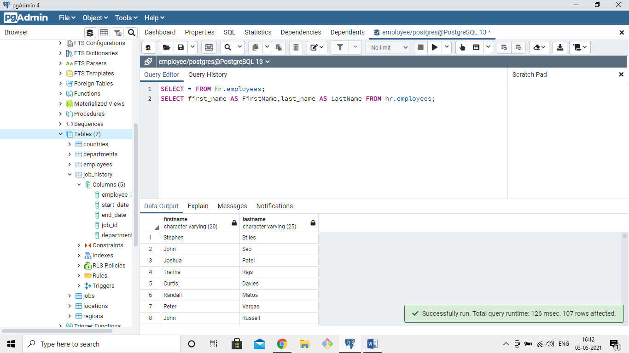

2) Write a query to get unique department ID from employee table

QUERY:SELECT * FROM hr.employees;

SELECT DISTINCT department_id FROM hr.employees

WHERE department_id IS NOT NULL

ORDER BY department_id;

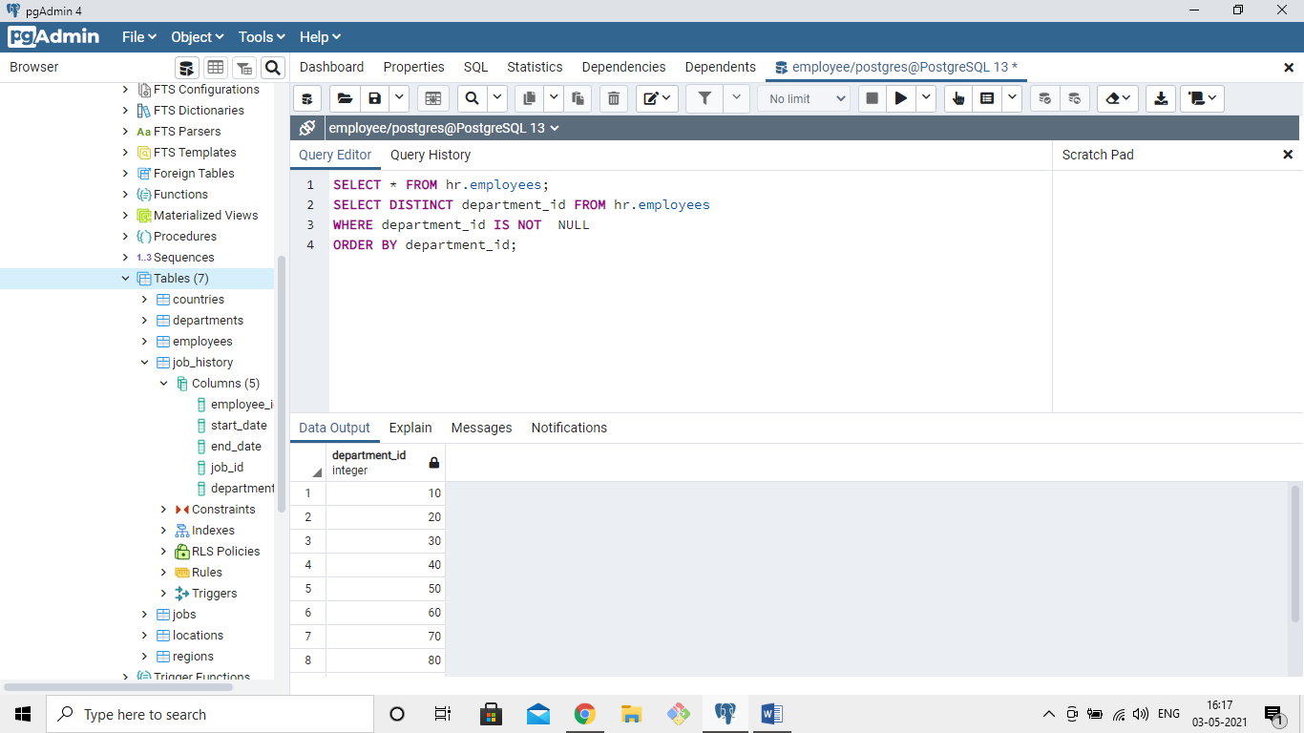

3)Write a query to get all employee details from the employee table order by first name, descending

QUERY: SELECT * FROM hr.employees;

SELECT * FROM hr.employees

ORDER BY first_name DESC;

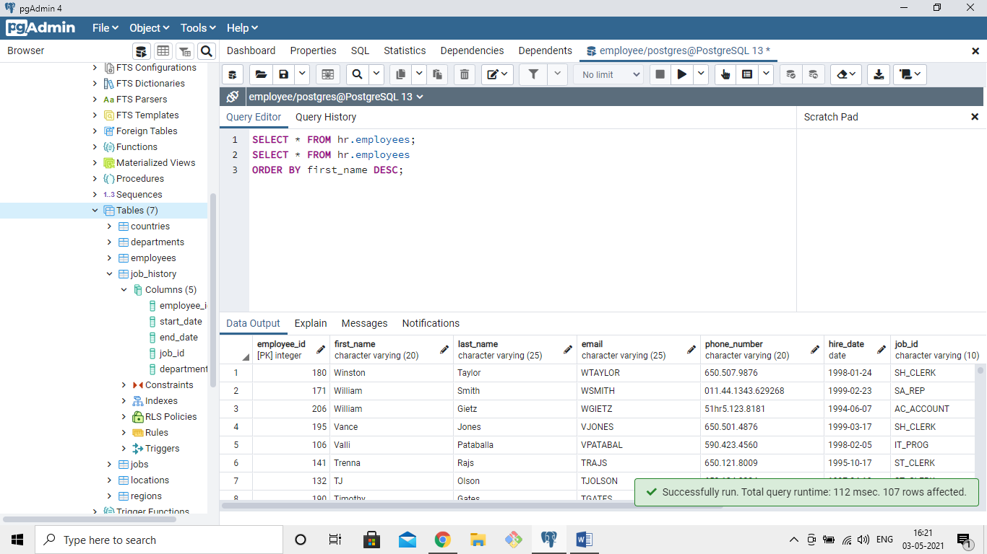

4)  Write a query to get the names (first_name, last_name), salary, PF of all the employees (PF is calculated as 15% of salary)

QUERY:SELECT * FROM hr.employees;

SELECT first_name,last_name,salary,salary*.15 AS PF

FROM hr.employees;````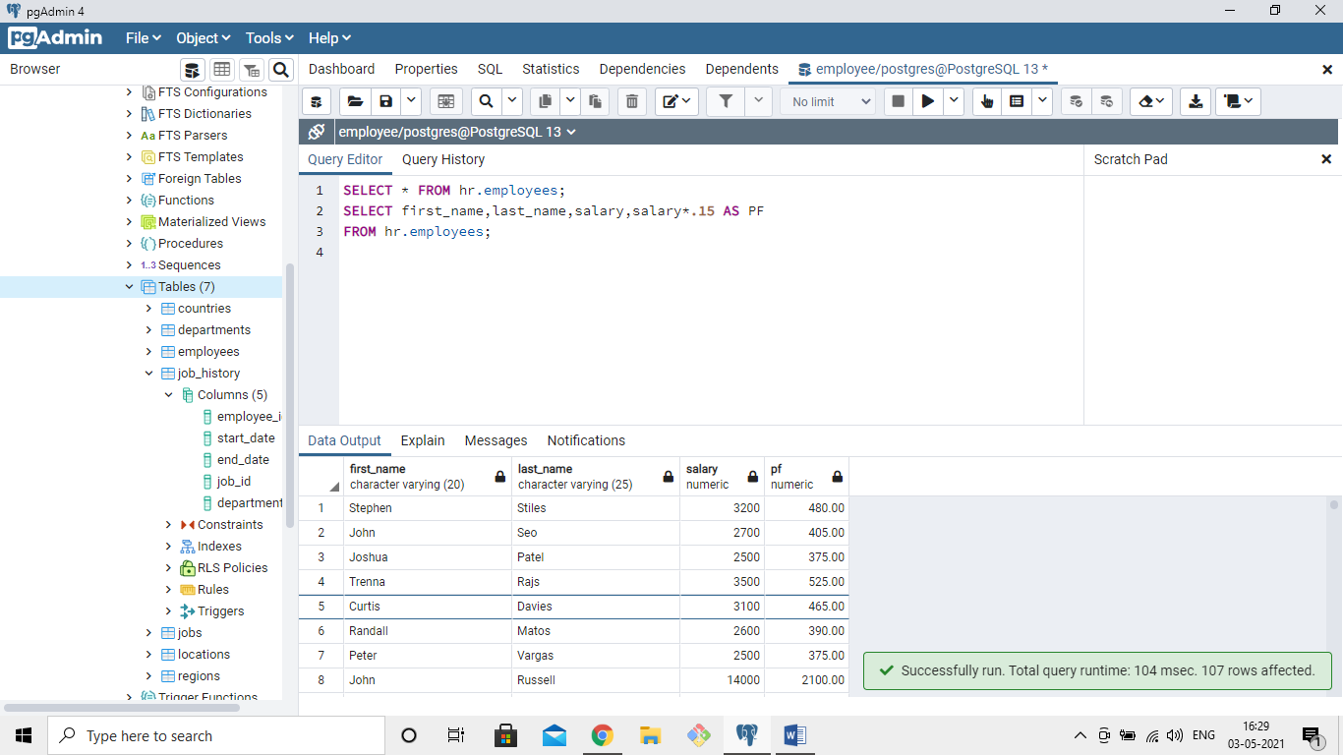

5) Write a query to get the employee ID, names (first_name, last_name), salary in ascending order of salary

QUERY: SELECT * FROM hr.employees;

SELECT employee_id,first_name,last_name,salary FROM hr.employees

ORDER BY salary ASC;

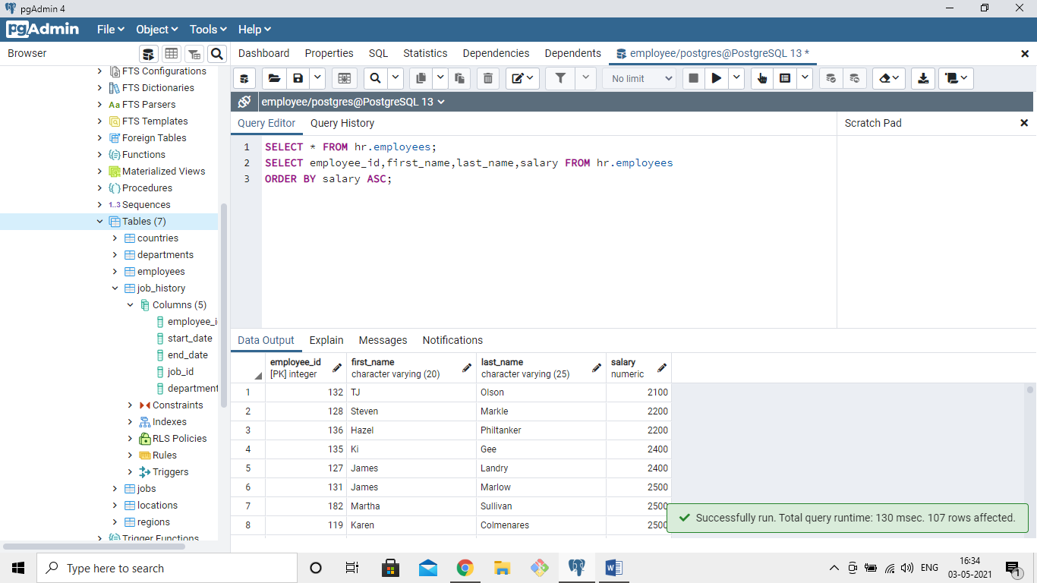

6)  Write a query to get the total salaries payable to employees

QUERY: SELECT * FROM hr.employees;

SELECT SUM(salary) FROM hr.employees;

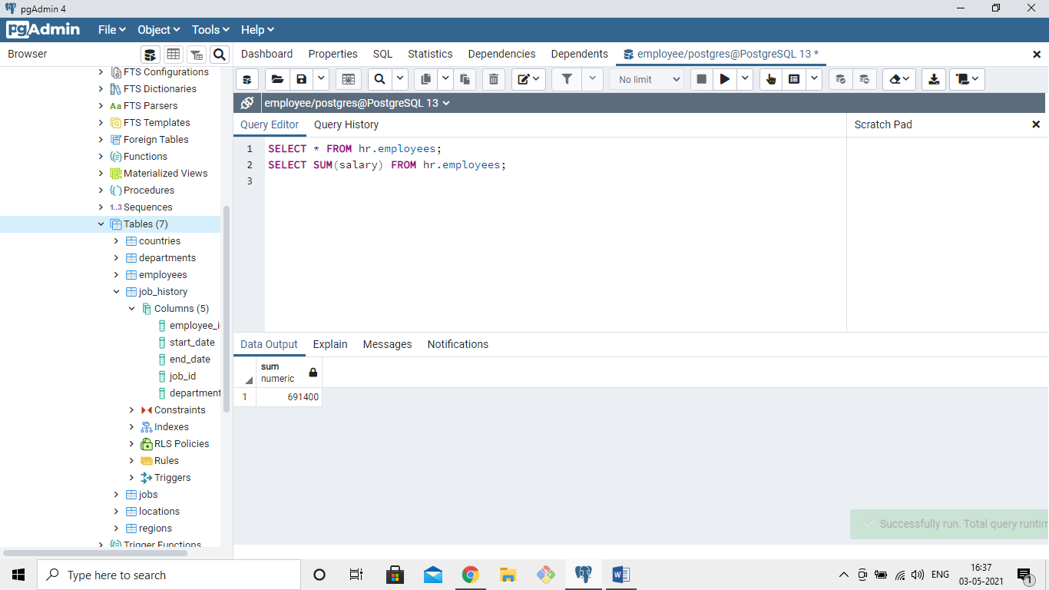

7) Write a query to get the maximum and minimum salary from employees table

QUERY:SELECT * FROM hr.employees;

SELECT MAX(salary) AS max_of_salary,MIN(salary) AS min_of_salary FROM hr.employees;

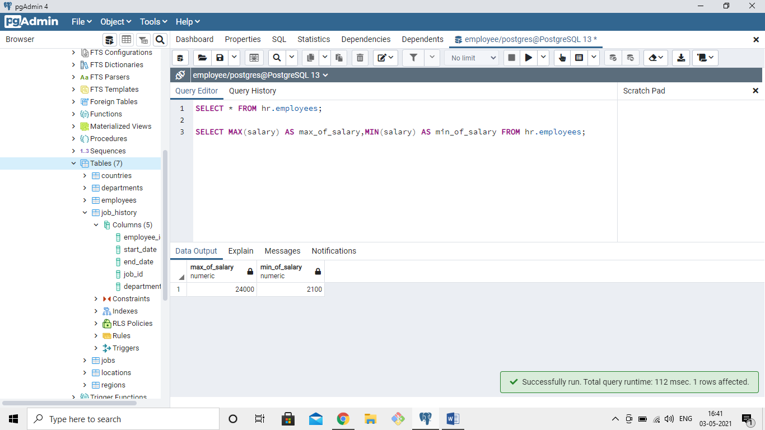

8)Write a query to get the average salary and number of employees in the employees table

QUERY: SELECT * FROM hr.employees;

SELECT AVG(salary) AS avg_of_salary ,COUNT(employee_id)

FROM hr.employees;

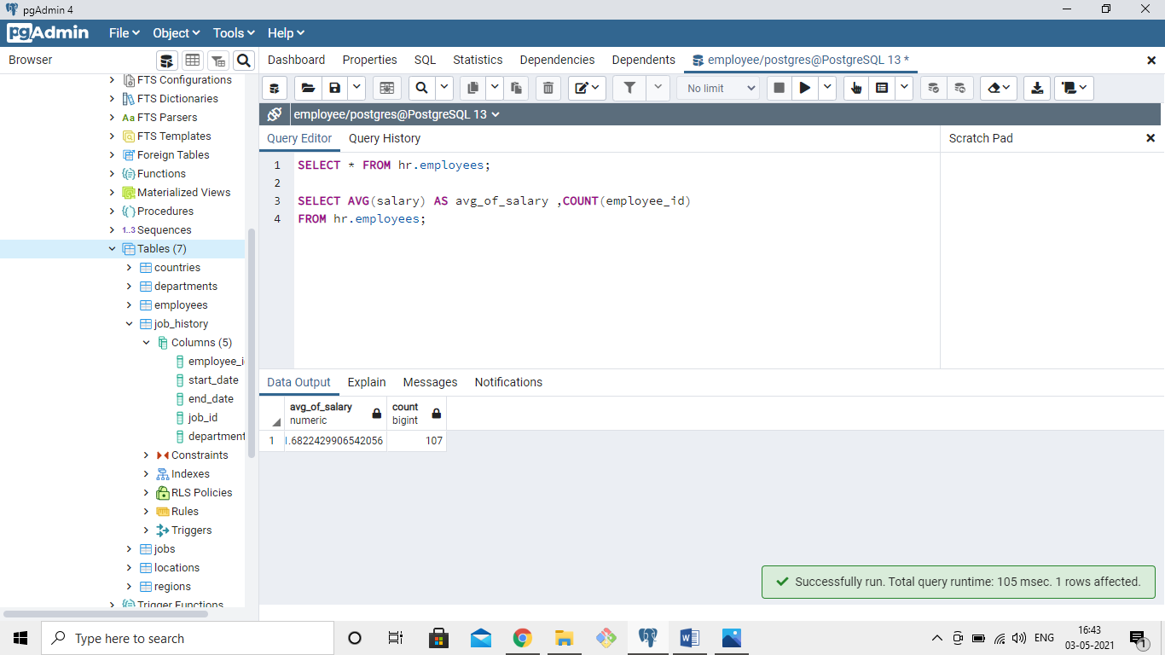

9) Write a query to get the number of employees working with the company

QUERY: SELECT COUNT(*) FROM hr.employees;

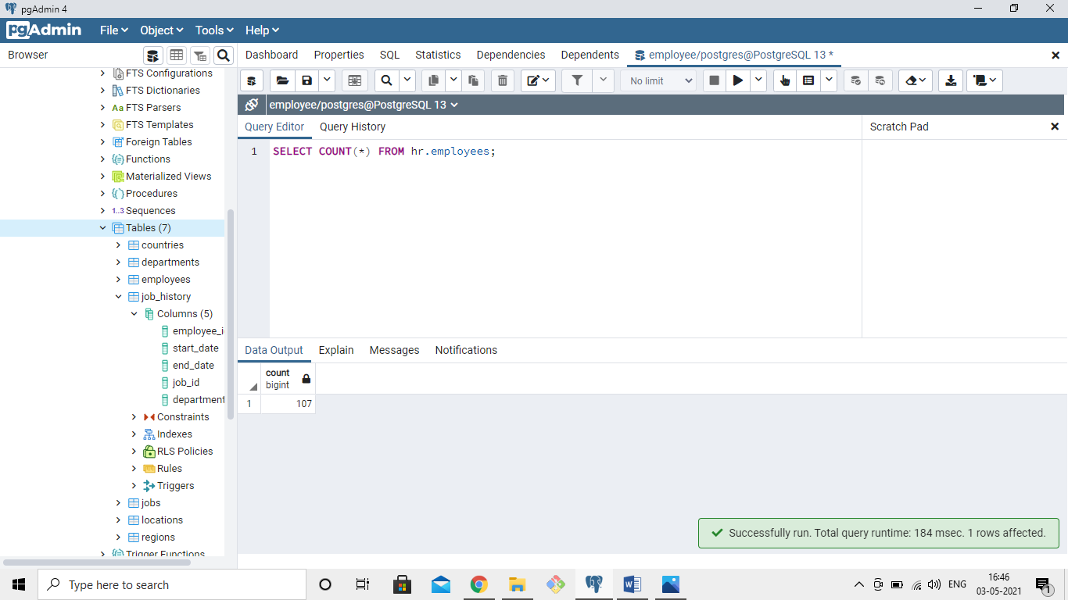`

`

10)Write a query to get the number of jobs available in the employees table

QUERY: SELECT * FROM hr.employees;

SELECT COUNT(DISTINCT(job_id)) FROM hr.employees;

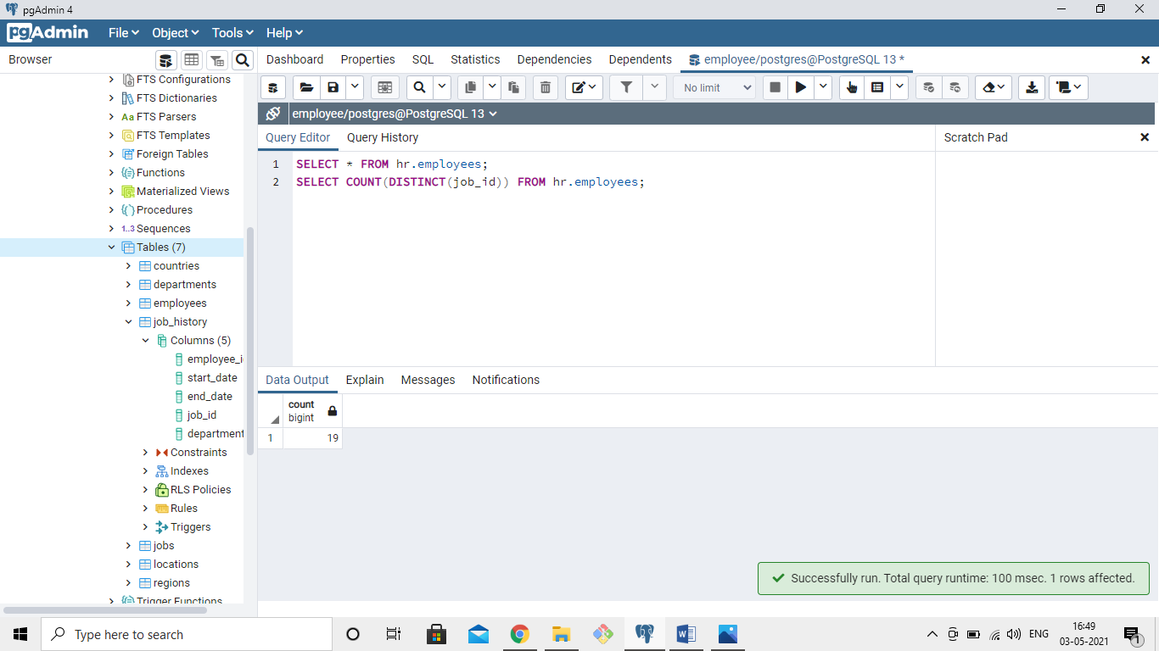

11)  Write a query get all first name from employees table in upper case

QUERY: SELECT * FROM hr.employees;

SELECT UPPER(first_name) FROM hr.employees;

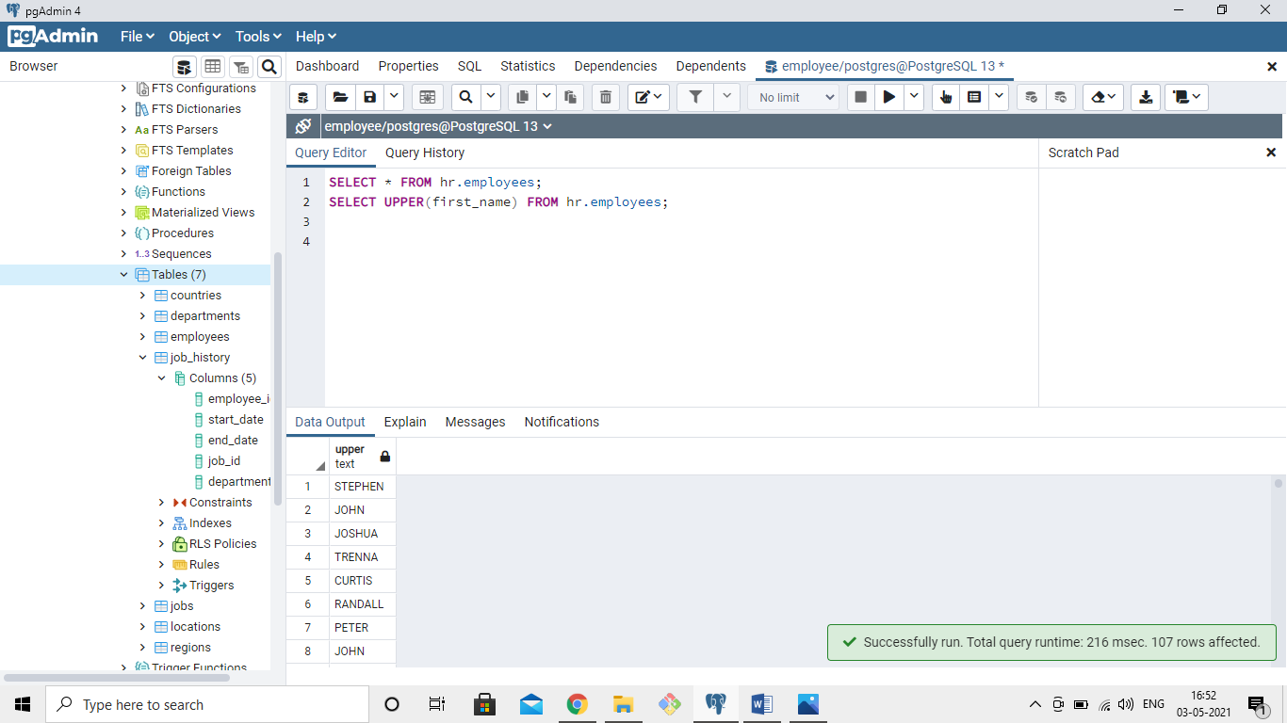

12)Write a query to get first name from employees table after removing white spaces from both side

QUERY:SELECT * FROM hr.employees;

SELECT TRIM(first_name) FROM hr.employees;

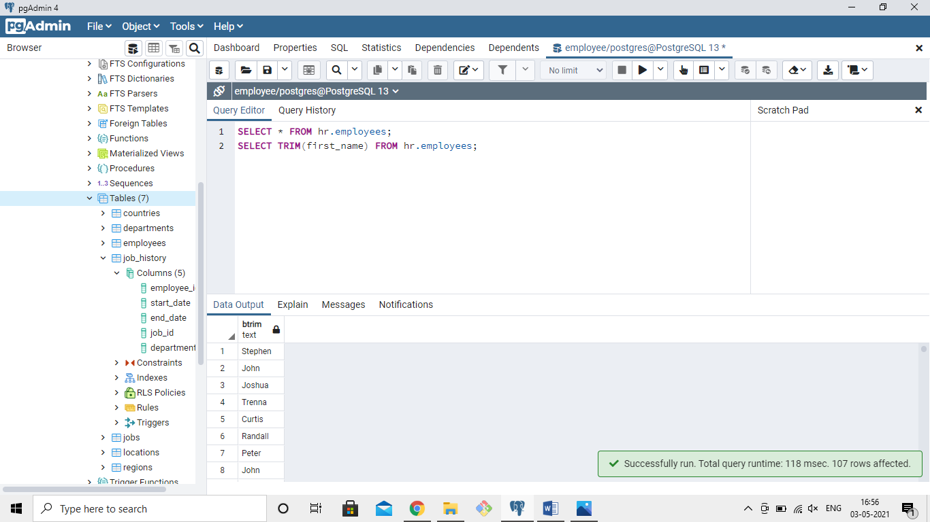

13) Write a query to get the length of the employee names (first_name, last_name) from employees table

QUERY: SELECT * FROM hr.employees;

SELECT first_name,last_name ,LENGTH(first_name)+LENGTH(last_name) AS total_length

FROM hr.employees;

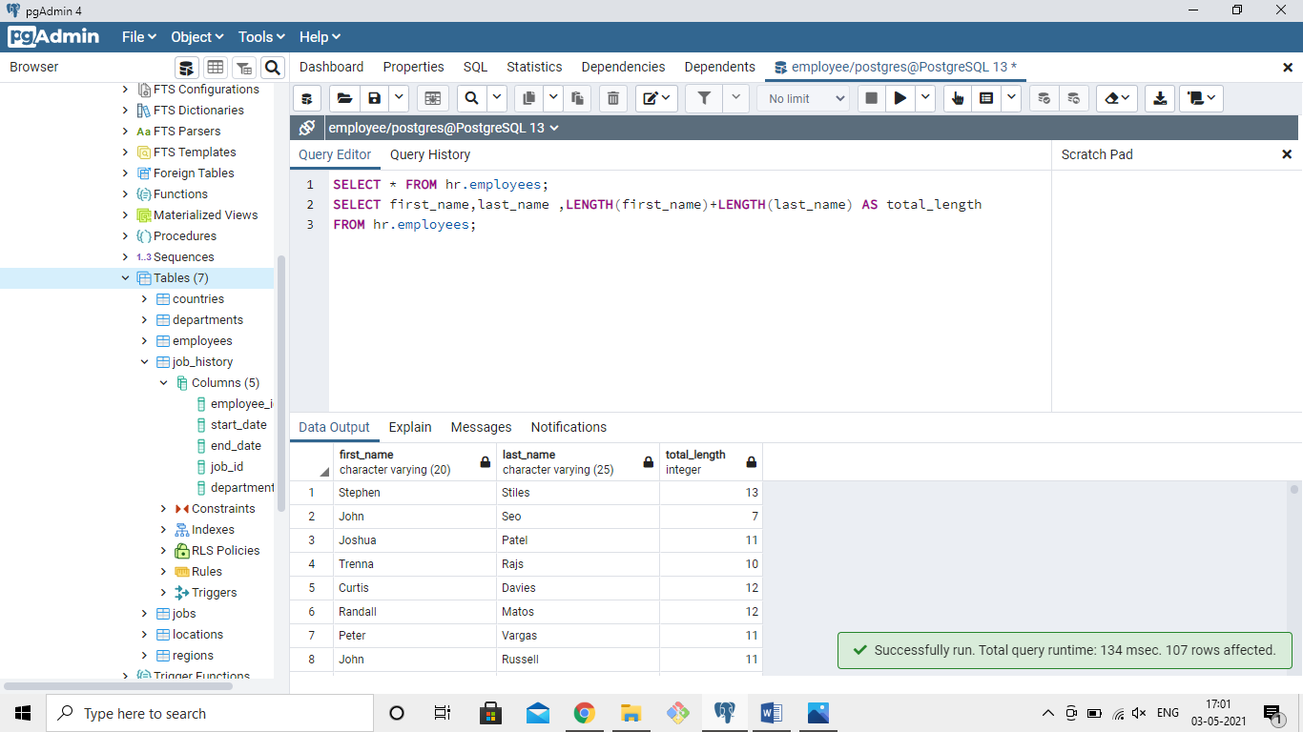

14) Write a query to display the name (first_name, last_name) and salary for all employees whose salary is not in the range $10,000 through $15,000

QUERY:

SELECT first_name,last_name,salary FROM hr.employees

WHERE salary NOT BETWEEN 10000 AND 15000;

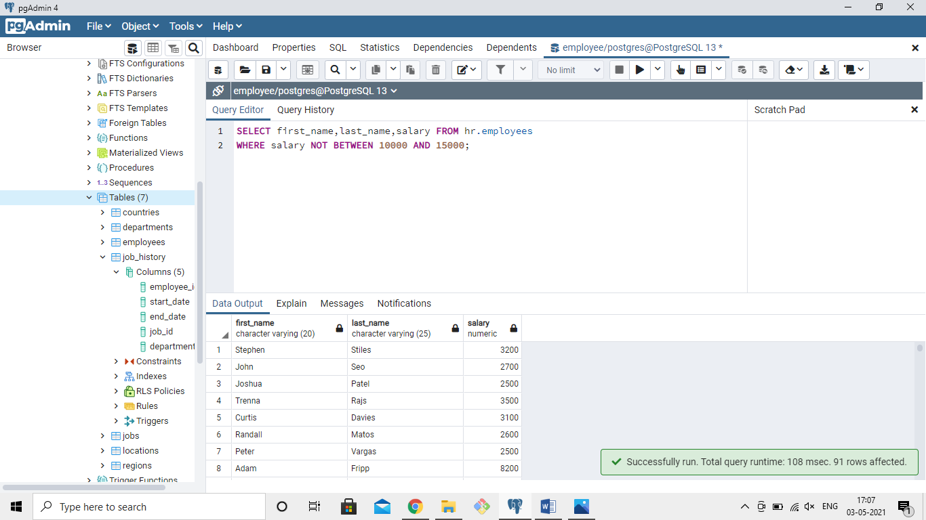

15) Write a query to display the name (first_name, last_name) and salary for all employees whose salary is not in the range $10,000 through $15,000 and are in department 30 or 100

QUERY: SELECT * FROM hr.employees;

SELECT first_name,last_name,salary FROM hr.employees

WHERE salary NOT BETWEEN 10000 AND 15000

AND department_id IN(30,100);

