SQL QUERIES

-- 1)How can you retrieve all the information from the cd.facilities table?

SELECT * FROM cd.facilities;

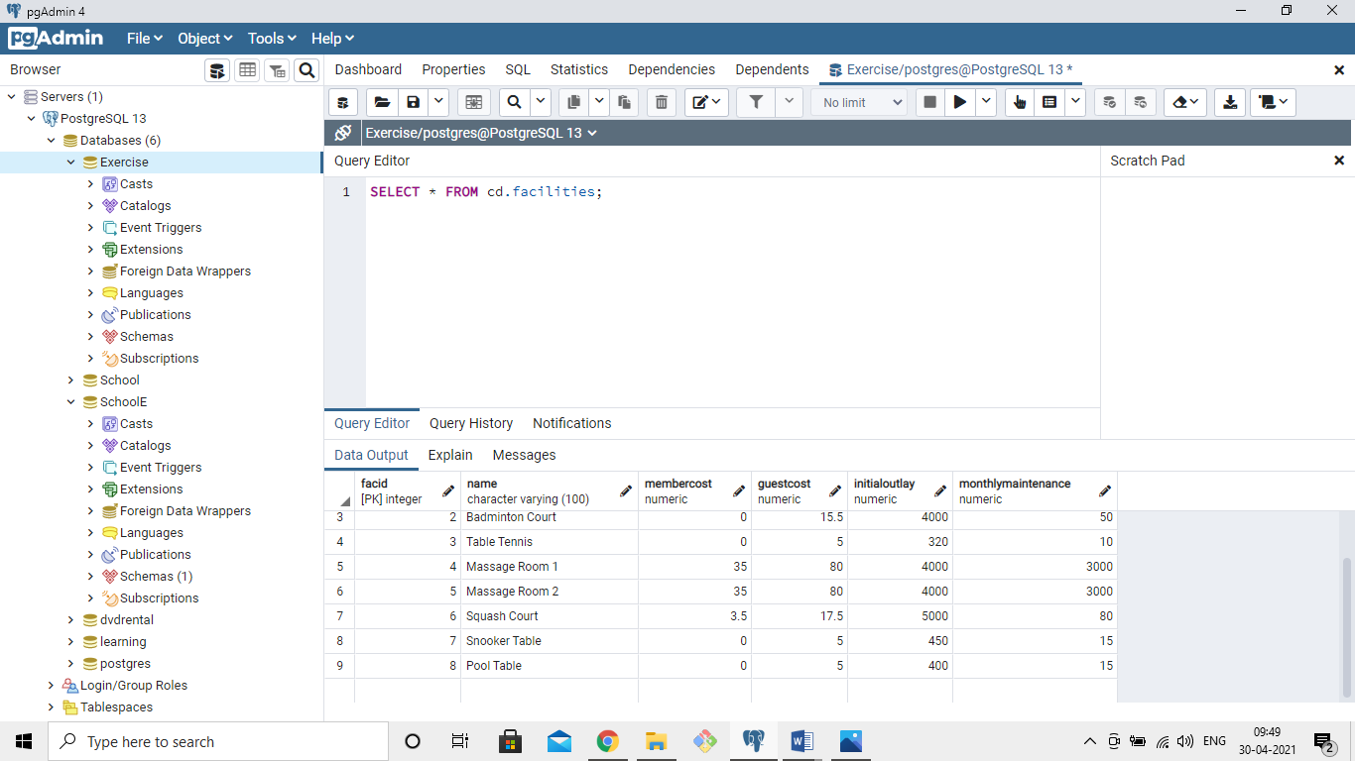

2)You want to print out a list of all of the facilities and their cost to members. How would you retrieve a list of only facility names and costs?

SELECT name,membercost FROM cd.facilities;

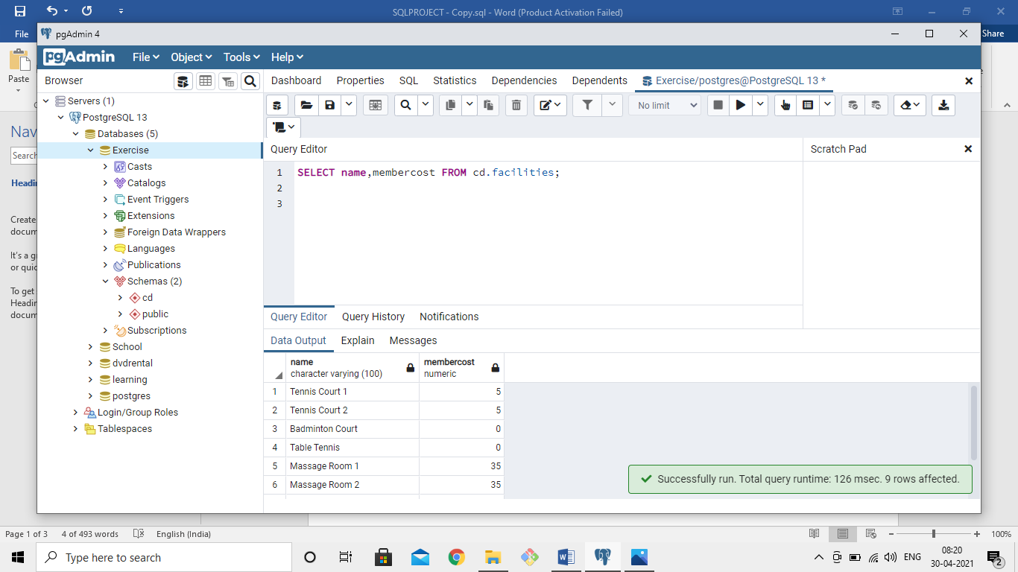

3)How can you produce a list of facilities that charge a fee to members?

Select * FROM cd.facilities

WHERE membercost!=0;

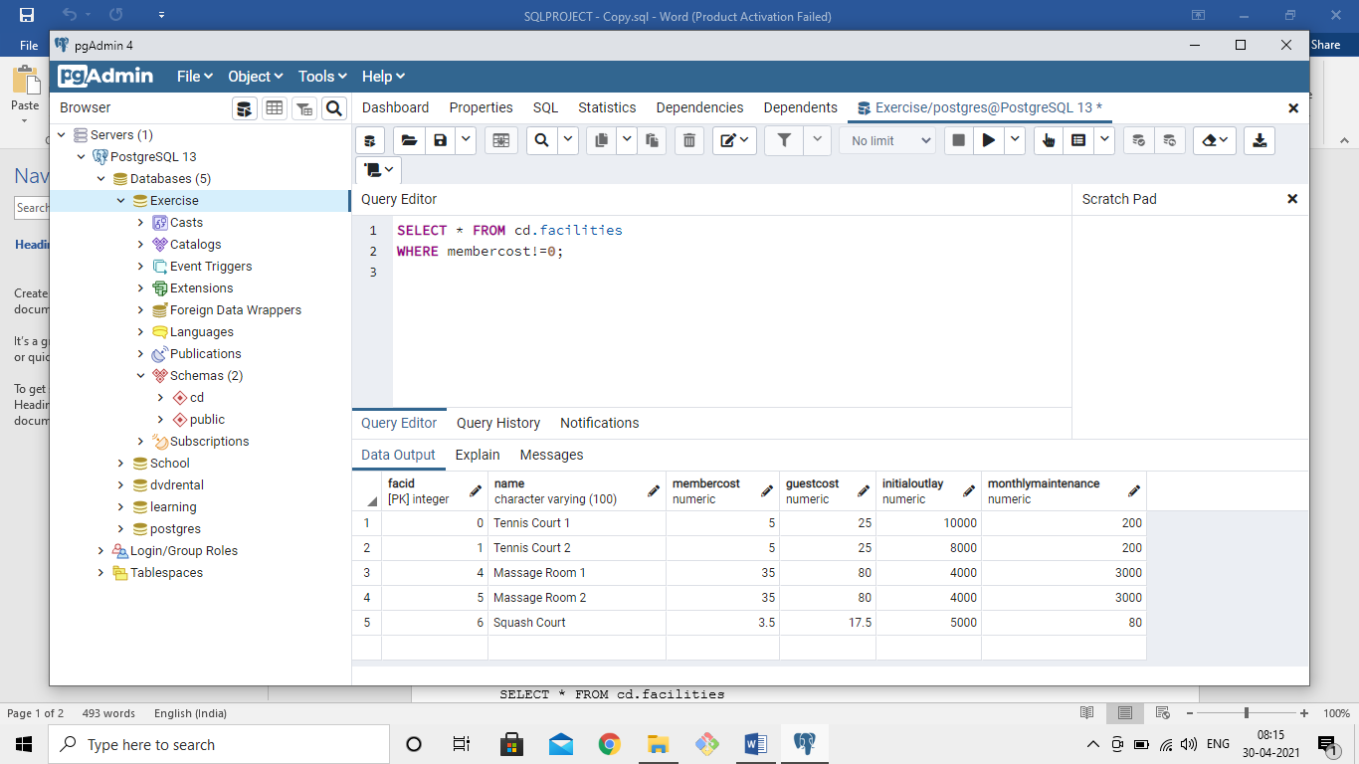

4)How can you produce a list of facilities that charge a fee to members, and that fee is less than 1/50th of the monthly maintenance cost? Return the facid, facility name, member cost, and monthly maintenance of the facilities in question.

SELECT facid,name,membercost,monthlymaintenance FROM cd.facilities

WHERE membercost>0 AND membercost < monthlymaintenance/50;

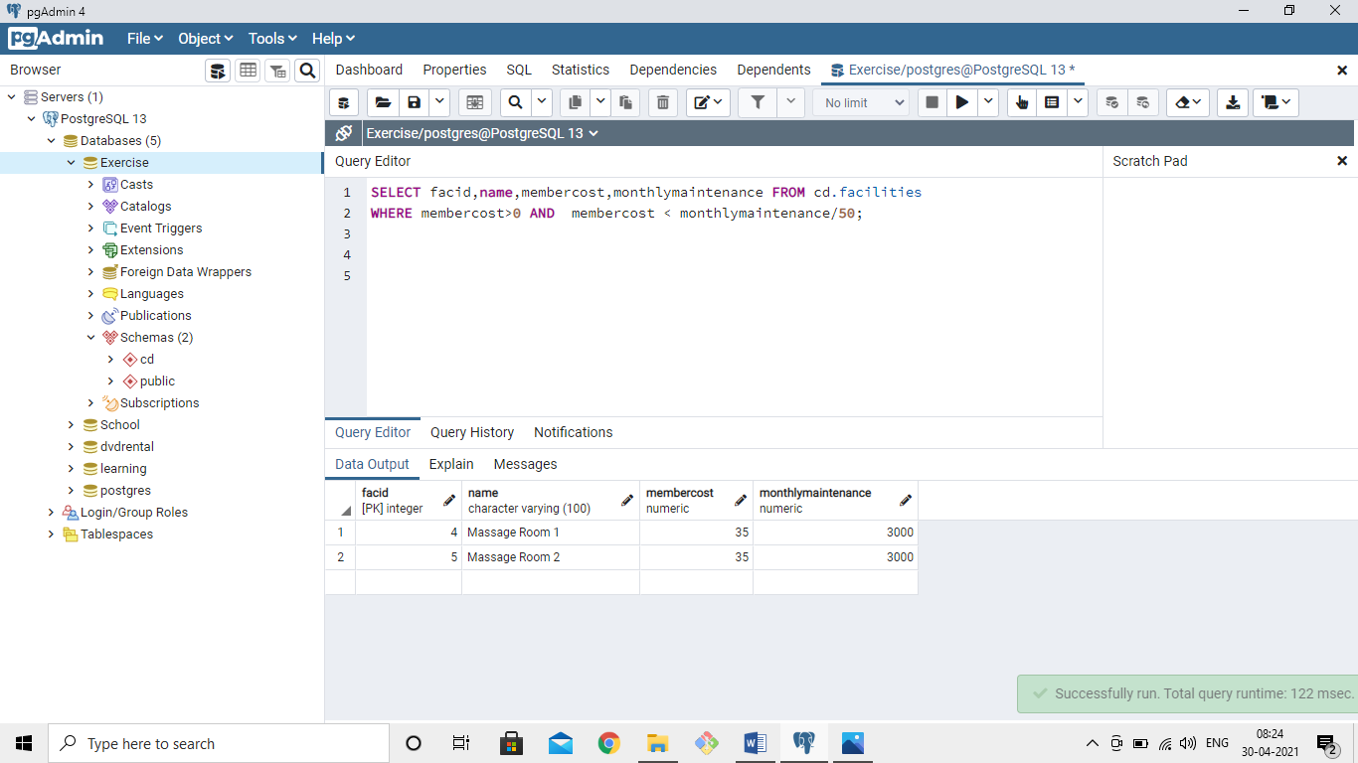

5)How can you produce a list of all facilities with the word 'Tennis' in their name?

SELECT * FROM cd.facilities

WHERE name LIKE '%Tennis%';

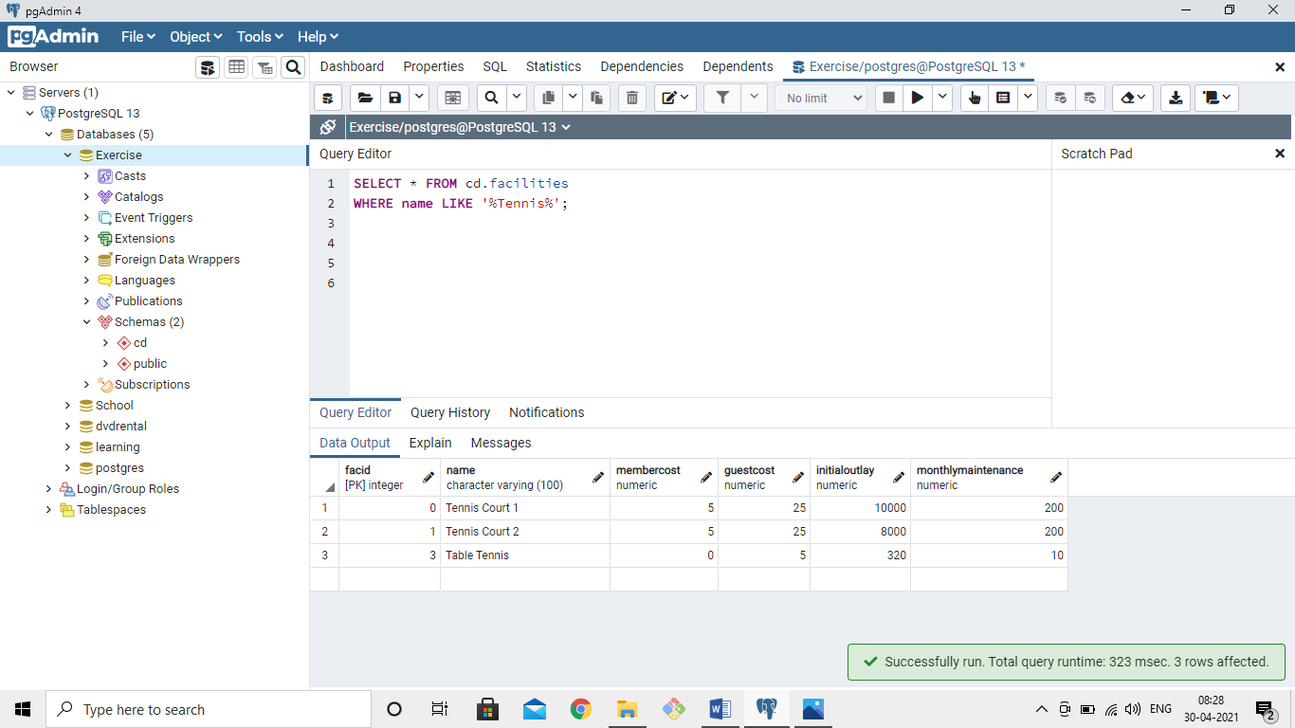

6)How can you retrieve the details of facilities with ID 1 and 5? Try to do it without using the OR operator.

SELECT * FROM cd.facilities

WHERE facid=1 OR facid=5;

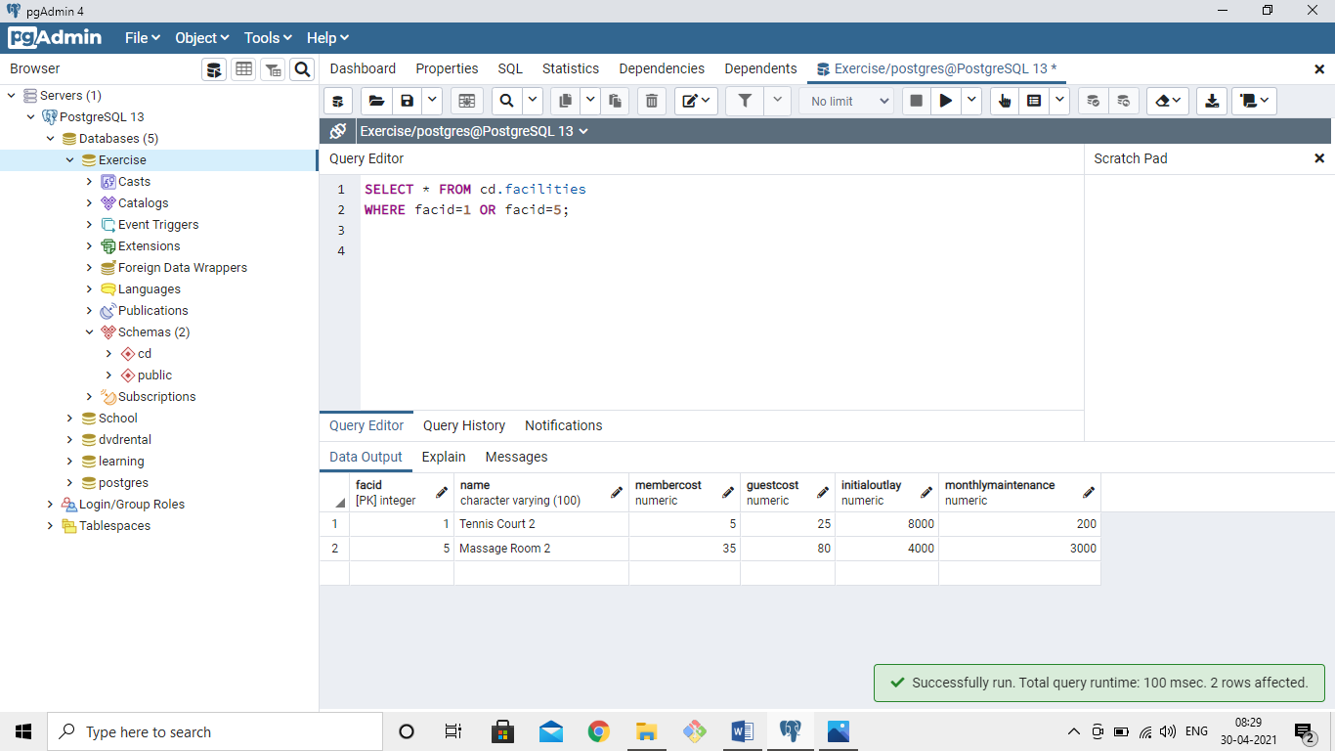

7)How can you produce a list of members who joined after the start of September 2012? Return the memid, surname, firstname, and joindate of the members in question.

SELECT memid,surname,firstname,joindate FROM cd.members

WHERE joindate

BETWEEN '2012-09-01' AND '2012-09-30';

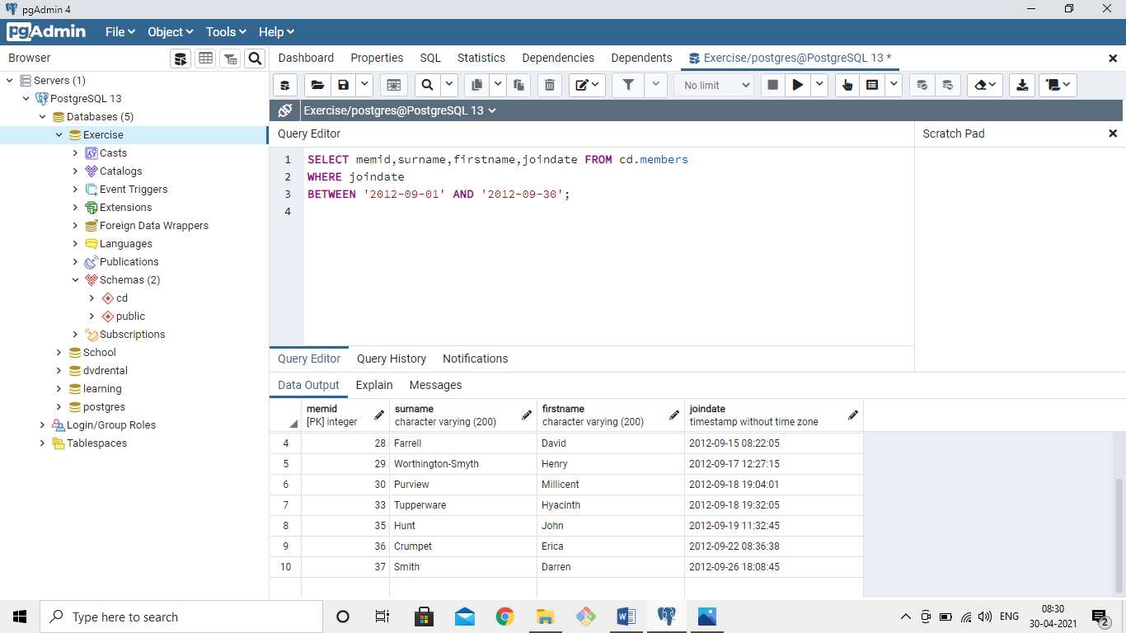

8)How can you produce an ordered list of the first 10 surnames in the members table? The list must not contain duplicates.

SELECT DISTINCT surname FROM cd.members

ORDER BY surname ASC

LIMIT 10;

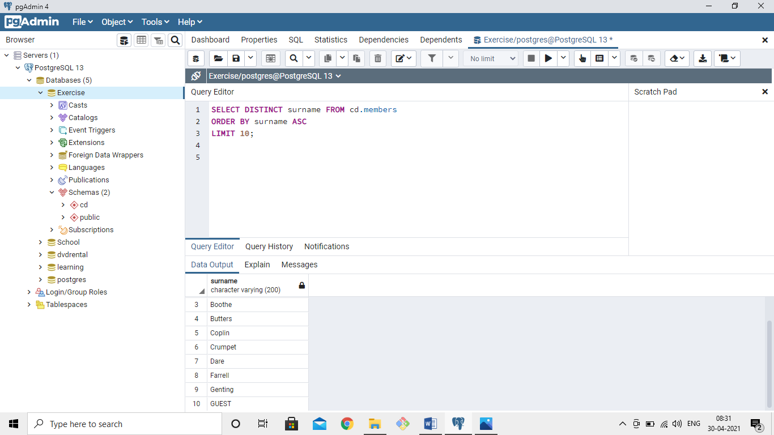

9)You'd like to get the signup date of your last member. How can you retrieve this information?

SELECT MAX(joindate) FROM cd.members;

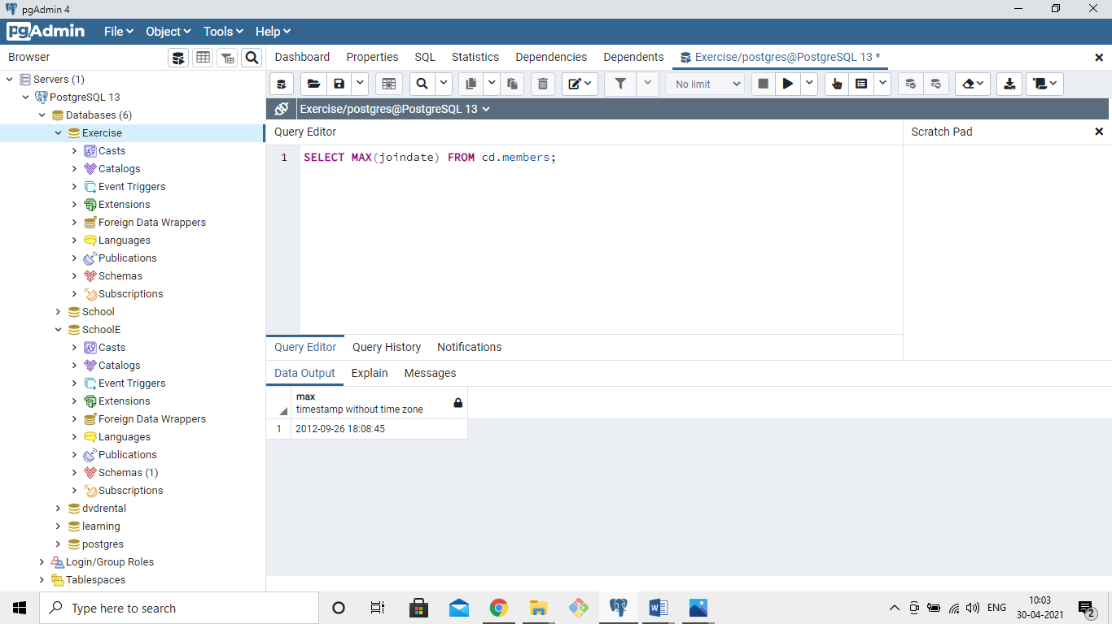

10)Produce a count of the number of facilities that have a cost to guests of 10 or more.

SELECT COUNT(*) FROM cd.facilities

WHERE guestcost>=10;

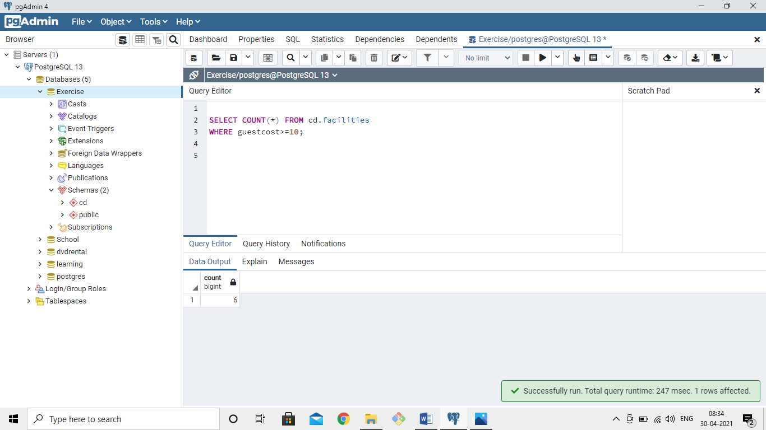

11)Produce a list of the total number of slots booked per facility in the month of September 2012. Produce an output table consisting of facility id and slots, sorted by the number of slots.

SELECT facid,SUM(slots) AS total_slots FROM cd.bookings

WHERE cd.bookings.starttime BETWEEN '2012-09-01' AND '2012-09-30'

GROUP BY facid

ORDER BY SUM(slots);

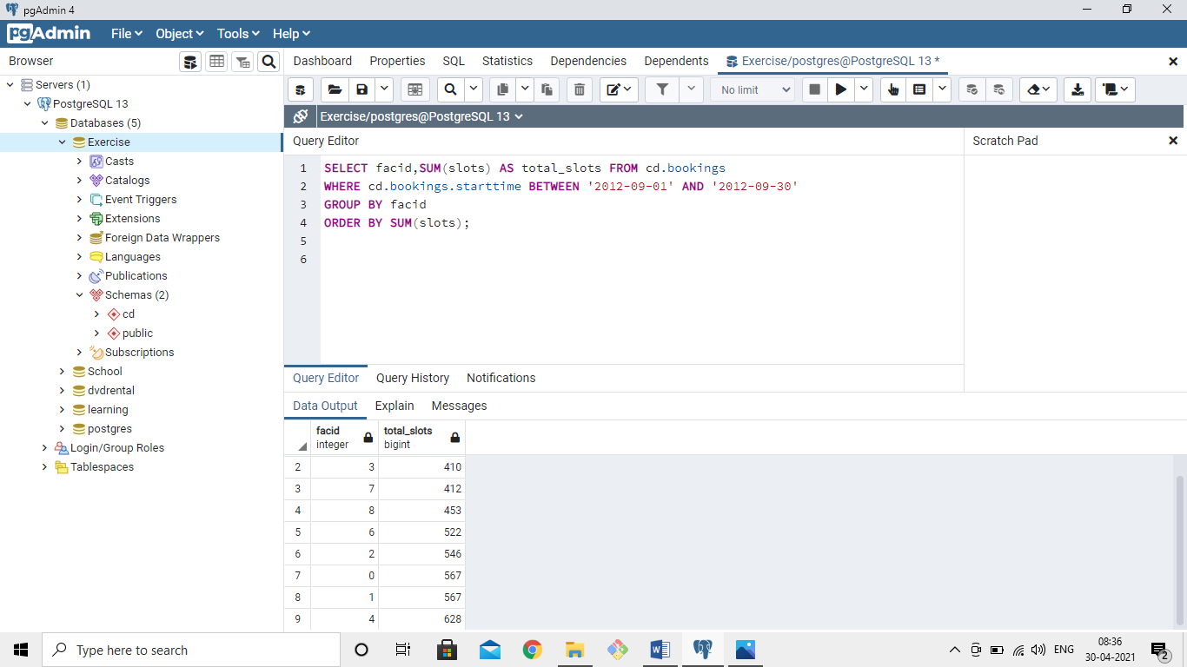

12)Produce a list of facilities with more than 1000 slots booked. Produce an output table consisting of facility id and total slots, sorted by facility id.

SELECT facid,SUM(slots) AS total_slots

FROM cd.bookings

GROUP BY facid

HAVING SUM(slots)>1000

ORDER BY facid;

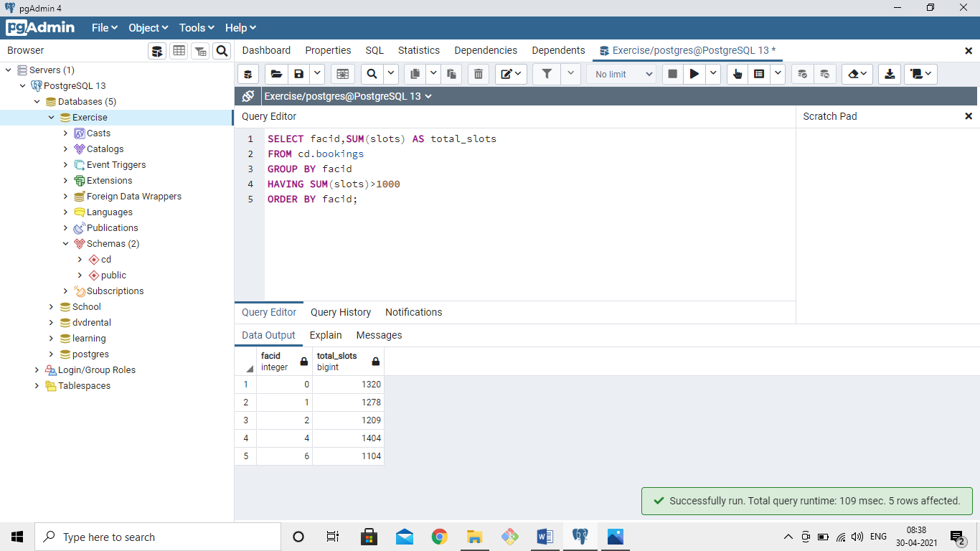

13)How can you produce a list of the start times for bookings for tennis courts, for the date '2012-09-21'? Return a list of start time and facility name pairings, ordered by the time.

SELECT starttime,name FROM cd.bookings

INNER JOIN cd.facilities

ON cd.facilities.facid=cd.bookings.facid

WHERE name LIKE '%Tennis Court%' AND starttime BETWEEN '2012-09-21 00:00:00' AND '2012-09-21 23:59:59'

ORDER BY starttime;

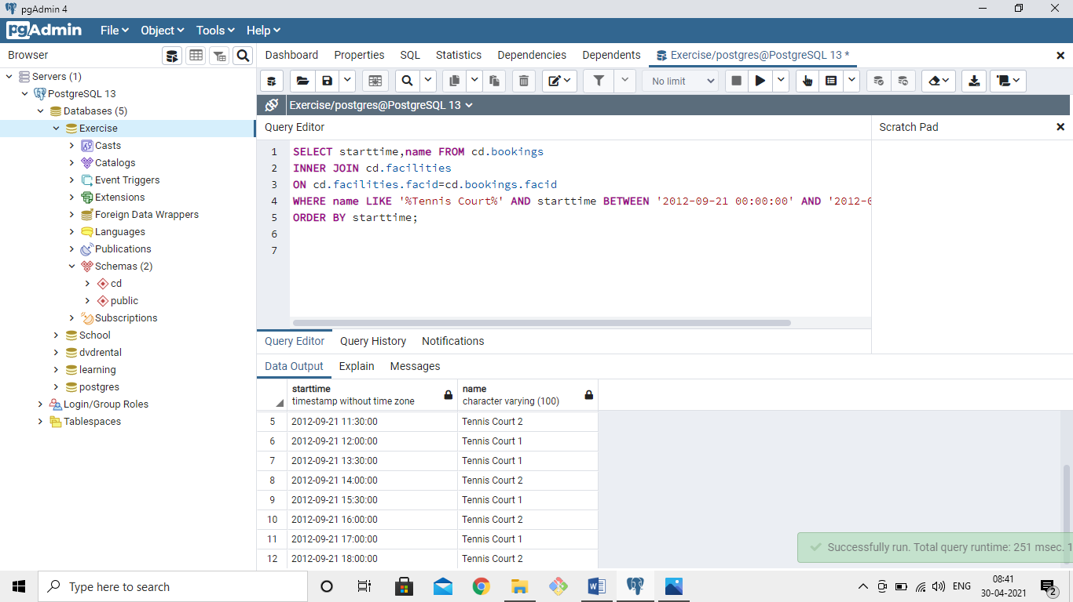

14)How can you produce a list of the start times for bookings by members named 'David Farrell'?

SELECT starttime FROM cd.bookings

INNER JOIN cd.members

ON cd.bookings.memid=cd.members.memid

WHERE surname LIKE '%Farrell%' AND firstname LIKE '%David%'

ORDER BY starttime;

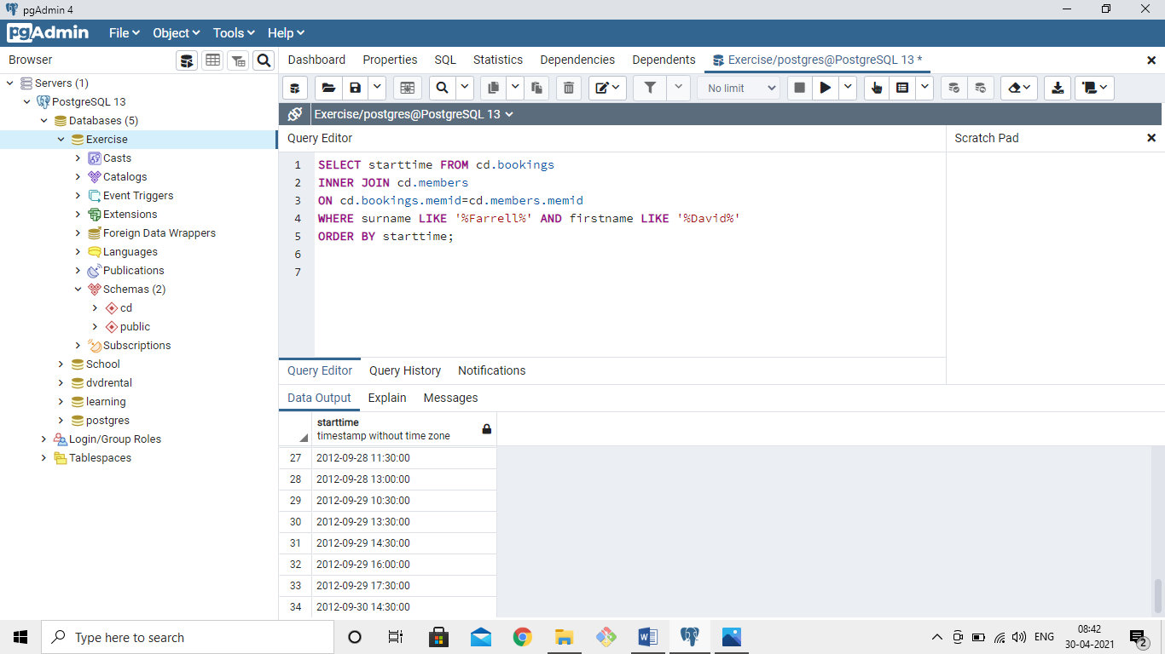

SQL DATABASE:

Create a new database called "School" this database should have two tables: teachers and students.

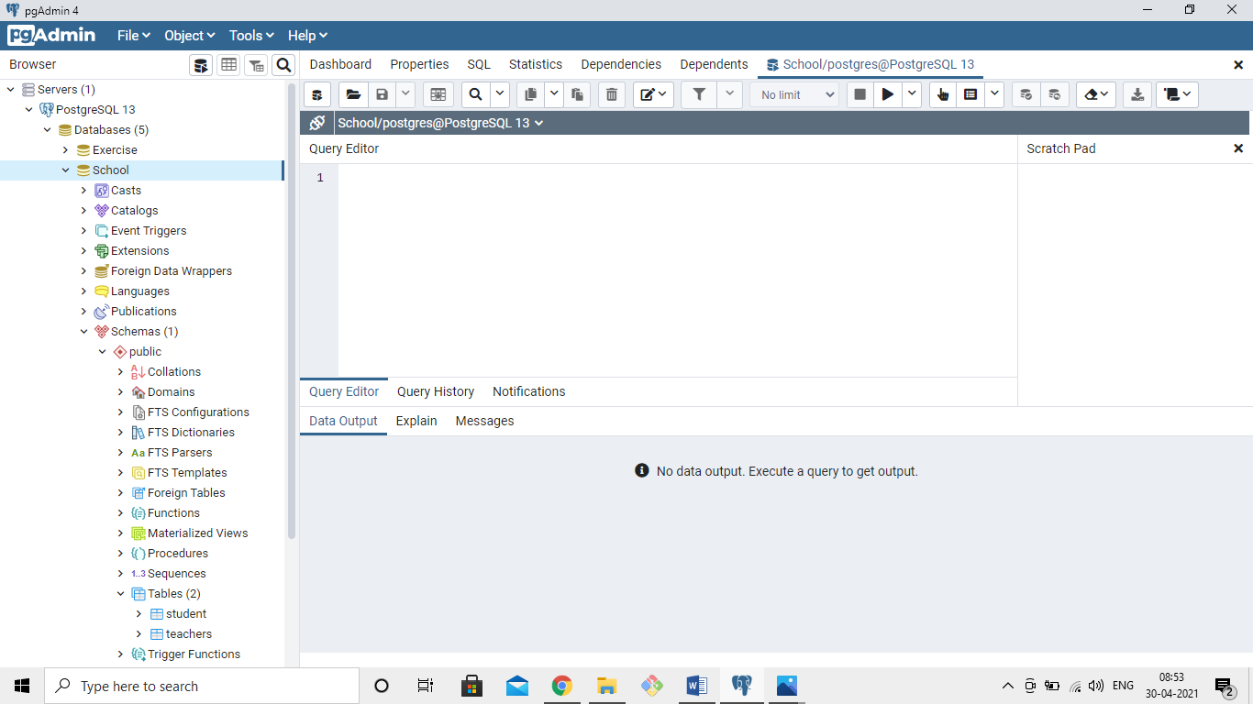

The teachers table should have columns for teacher_id, first_name, last_name, homeroom_number, department, email, and phone.

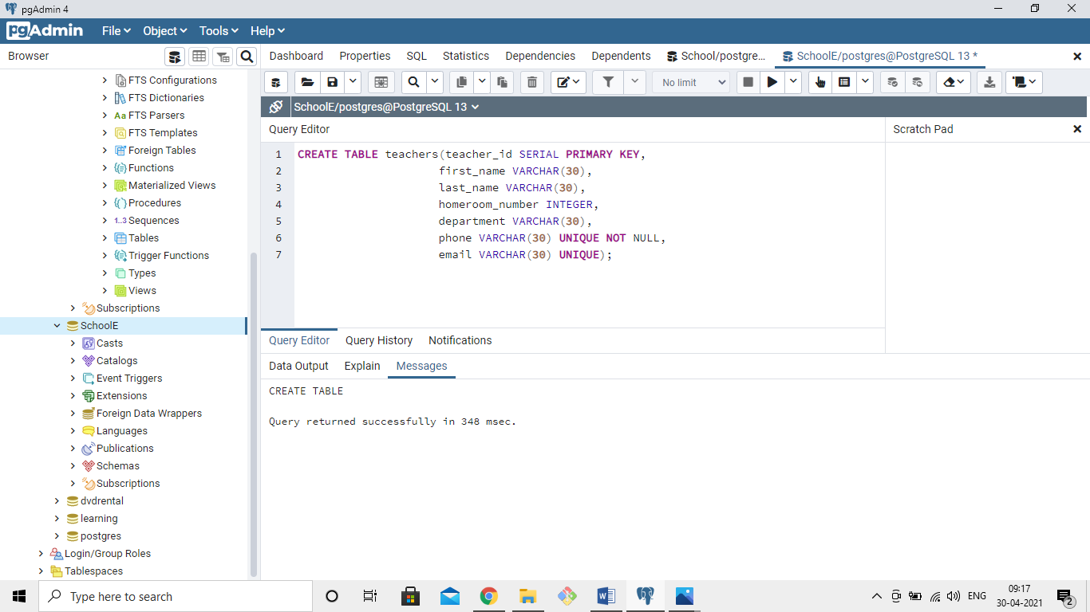

The students table should have columns for student_id, first_name,last_name, homeroom_number, phone,email, and graduation year.

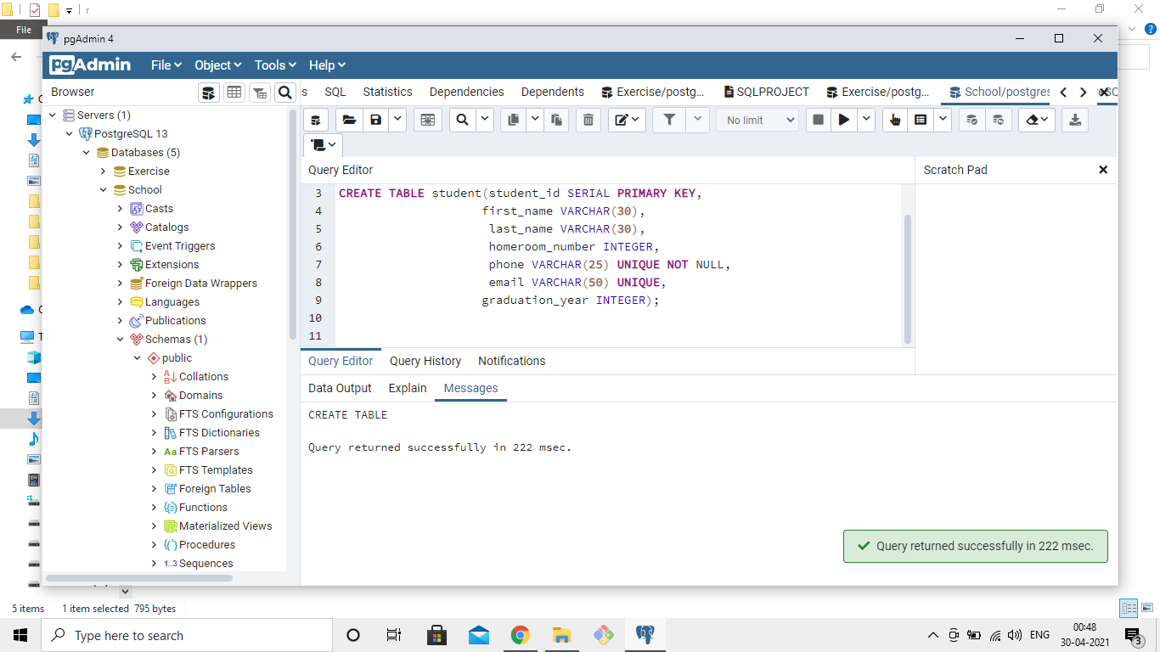

Once you've made the tables, insert a student named Mark Watney (student_id=1) who has a phone number of 777-555-1234 and doesn't have an email. He graduates in 2035 and has 5 as a homeroom number.

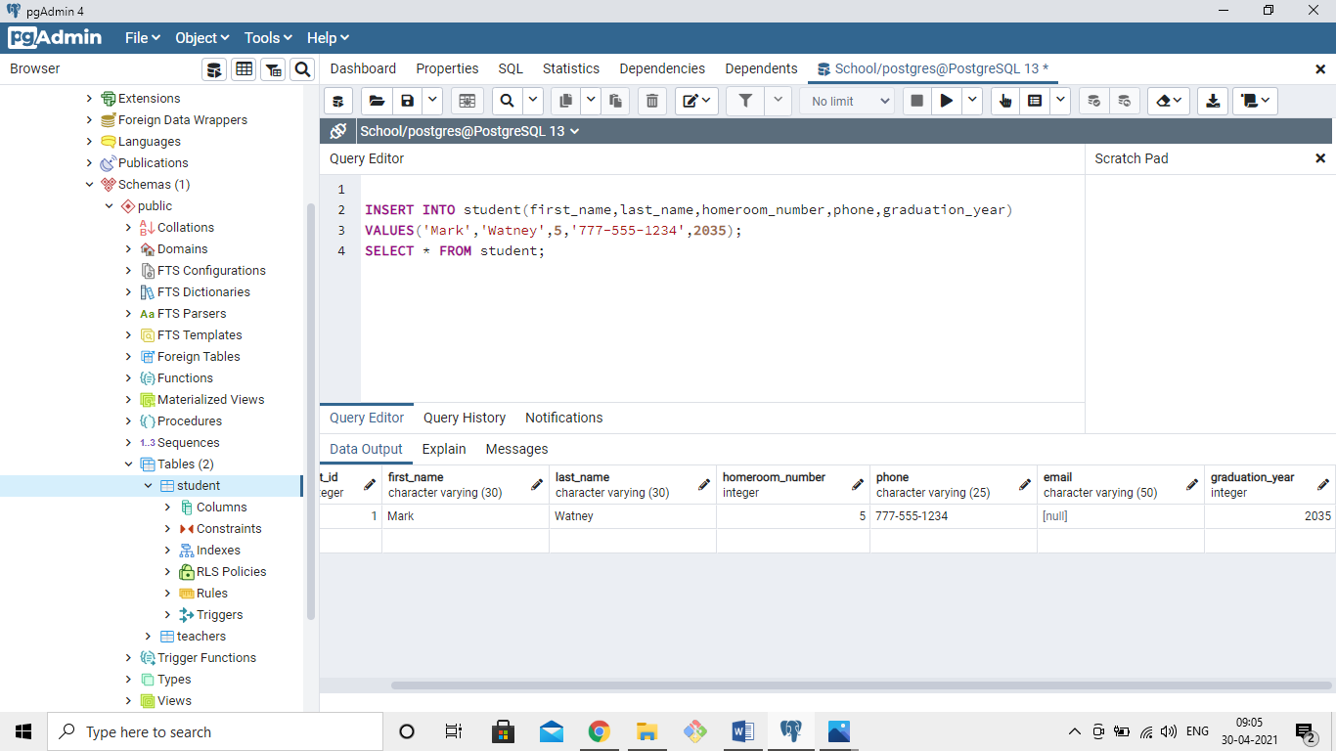

Then insert a teacher names Jonas Salk (teacher_id = 1) who as a homeroom number of 5 and is from the Biology department. His contact info is: jsalk@school.org and a phone number of 777-555-4321.

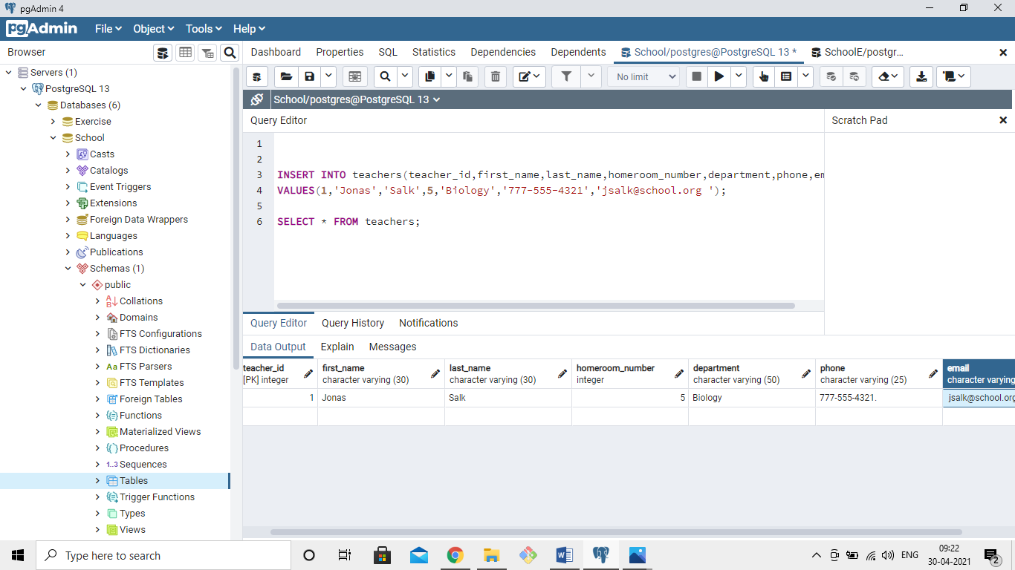

Keep in mind that these insert tasks may effect your constraints!

