1) My partner and I want to come by each of the stores in person and meet the managers. Please send over the managers’ names at each store, with the full address of each property (street address, district, city, and country please).

QUERY:

SELECT first_name AS manager_first_name,last_name AS manager_last_name,address,city,district,country FROM staff

INNER JOIN store

ON store.store_id=staff.store_id

INNER JOIN address

ON address.address_id=staff.address_id

INNER JOIN city

ON address.city_id=city.city_id

INNER JOIN country

ON city.country_id=country.country_id;

`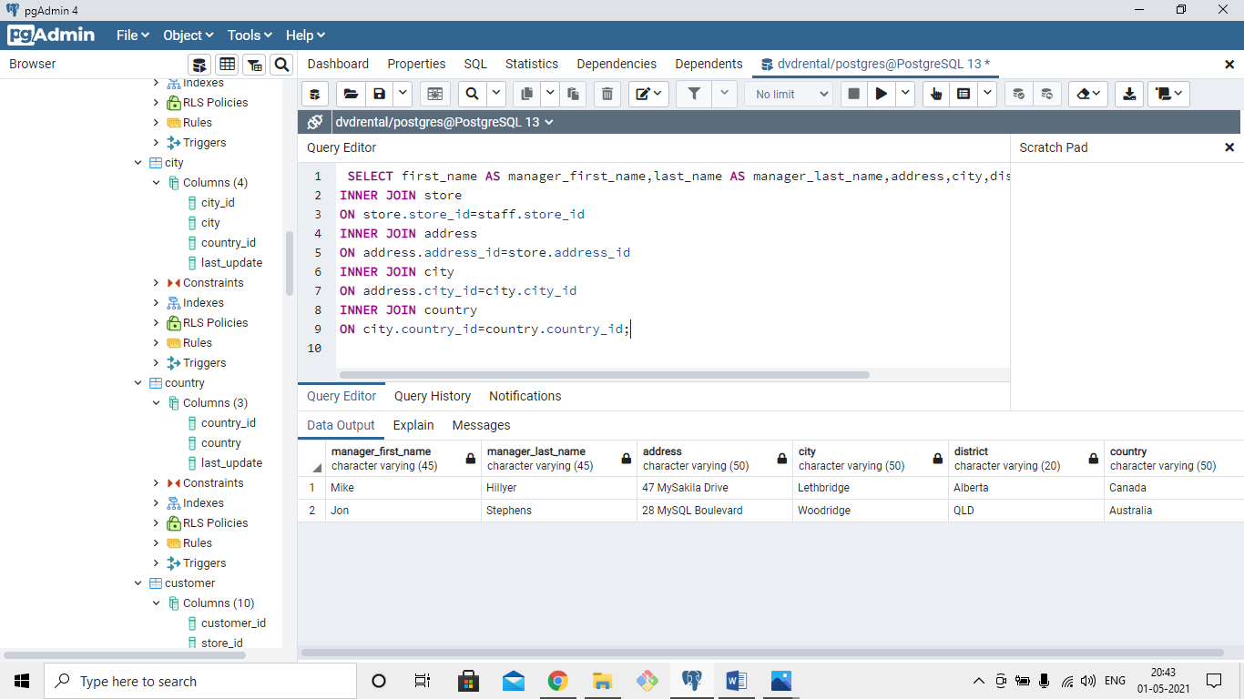

2) I would like to get a better understanding of all of the inventory that would come along with the business. Please pull together a list of each inventory item you have stocked, including the store_id number, the inventory_id , the name of the film, the film’s rating, its rental rate and replacement cost.

QUERY:

SELECT store_id,inventory_id,title,rating,rental_rate,replacement_cost FROM film

INNER JOIN inventory

ON inventory.film_id=film.film_id;

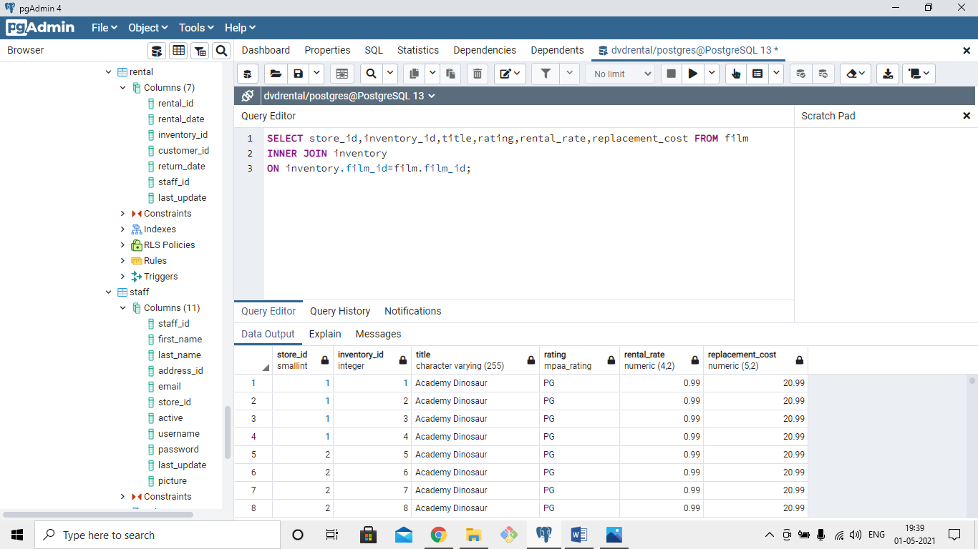

3) From the same list of films you just pulled, please roll that data up and provide a summary level overview of your inventory. We would like to know how many inventory items you have with each rating at each store.

QUERY:

SELECT store_id,rating, COUNT(inventory_id) FROM film

INNER JOIN inventory

ON inventory.film_id=film.film_id

GROUP BY film.rating,inventory.store_id

ORDER BY store_id;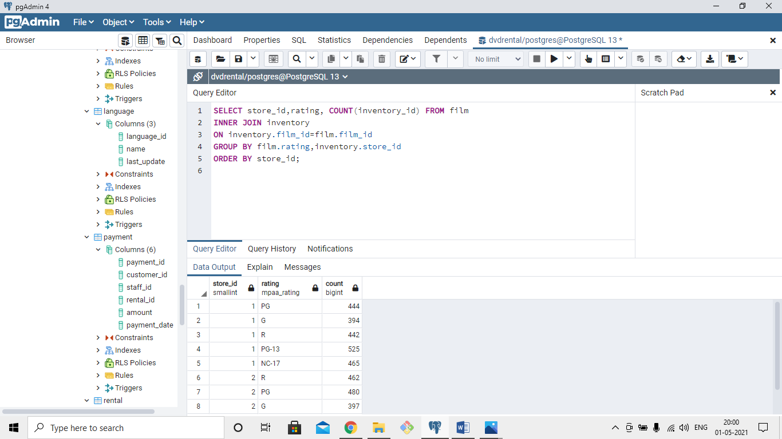

4) Similarly, we want to understand how diversified the inventory is in terms of replacement cost. We want to see how big of a hit it would be if a certain category of film became unpopular at a certain store. We would like to see the number of films, as well as the average replacement cost, and total replacement cost, sliced by store and film category.

QUERY:

SELECT * FROM category;

SELECT store_id,name AS category,COUNT(film) AS films ,AVG(replacement_cost),SUM(replacement_cost) FROM film

INNER JOIN film_category

ON film.film_id=film_category.film_id

INNER JOIN category

ON category.category_id=film_category.category_id

INNER JOIN inventory

ON inventory.film_id=film.film_id

GROUP BY store_id,category.name;

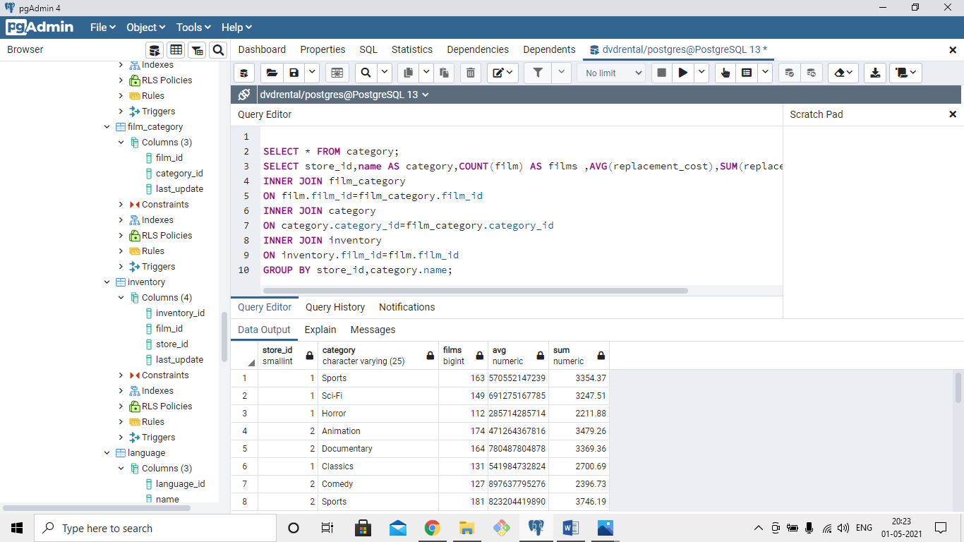

5) We want to make sure you folks have a good handle on who your customers are. Please provide a list of all customer names, which store they go to, whether or not they are currently active, and their full addresses street address, city, and country.

QUERY: SELECT first_name,last_name,store_id,active,address,city,country FROM customer

INNER JOIN address

ON address.address_id=customer.address_id

INNER JOIN city

ON address.city_id=city.city_id

INNER JOIN country

ON country.country_id=city.country_id;

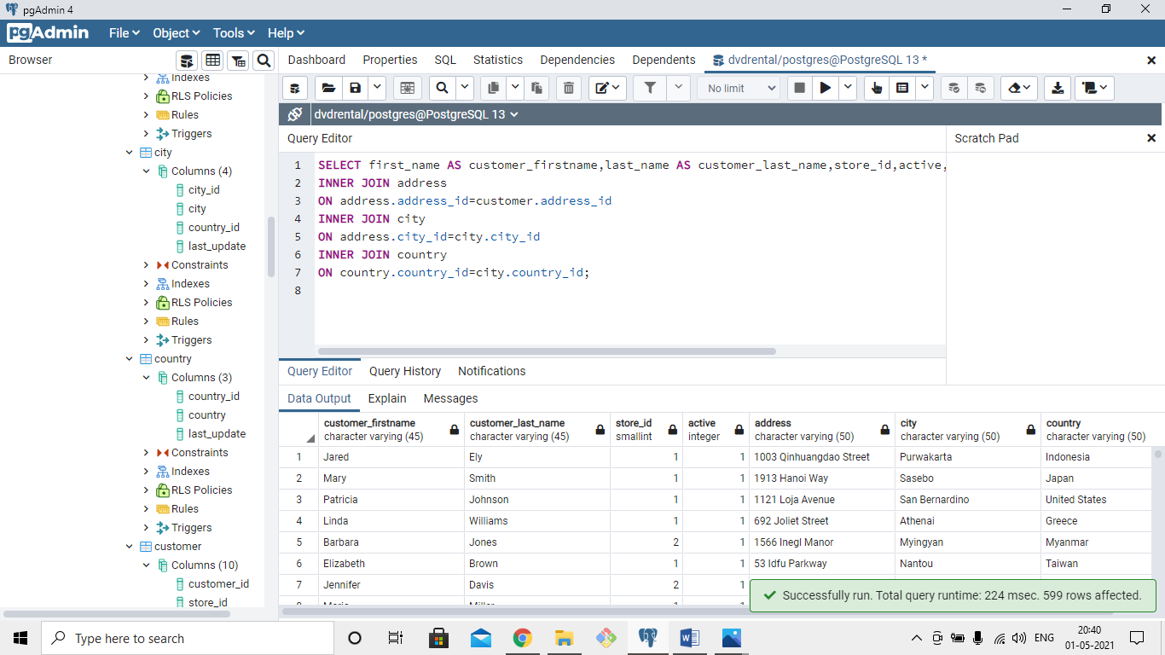

`

6) We would like to understand how much your customers are spending with you, and also to know who your most valuable customers are. Please pull together a list of customer names, their total lifetime rentals, and the sum of all payments you have collected from them. It would be great to see this ordered on total lifetime value, with the most valuable customers at the top of the list.

QUERY:

