**Computer Networks**

**UNIT I**

Data communications refers to the transmission of digital data between two or more computers. The physical connection between networked computing devices is established using either cable media or wireless media. For data communications to occur, the communicating devices must be part of a communication system made up of a combination of hardware (physical equipment) and software (programs). The effectiveness of a data communications system depends on four fundamental characteristics: **delivery, accuracy, timeliness, and jitter.**

**Delivery**: The system must deliver data to the correct destination. Data must be received by the intended device or user

**Accuracy:** The system must deliver the data accurately. Data that have been altered in transmission and left uncorrected or unusable.

**Timeliness:** The system must deliver data in a timely manner. Data that have been altered are useless

**Jitter:** Jitter refers to the variation in packet arrival time. It is the uneven delay in the delivery of audio or video packets.

**Components:**

1. A data communications system has five components.

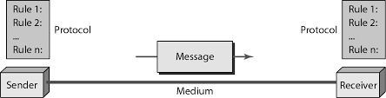

**Introduction to Data Communications**:

A data communications system has five components:

1. **Message:** The message is the information (data) to be communicated. Popular forms of information include text, numbers, pictures, audio, and video.
2. **Sender:** The sender is the device that sends the data message. It can be a computer, workstation, telephone handset, video camera, and so on.
3. **Receiver:** The receiver is the device that receives the message. It can be a computer, workstation, telephone handset, television, and so on.
4. **Transmission medium:** The transmission medium is the physical path by which a message travels from sender to receiver. Some examples of transmission media include twisted-pair wire, coaxial cable, fiber-optic cable, and radio waves
5. **Protocol:** A protocol is a set of rules that govern data communications. It represents an agreement between the communicating devices. Without a protocol, two devices may be connected but not communicating, just as a person speaking French cannot be understood by a person who speaks only Japanese.

**Direction of Data Flow**



***Simplex:*** In simplex mode, the communication is unidirectional, as on a one-way street. Only oneof the two devices on a link can transmit; the other can only receive. The simplex mode can use the entire capacity of the channel to send data in one direction.

***Half-Duplex:*** In half-duplex mode, each station can both transmit and receive, but not at the same time. When one device is sending, the other can only receive, and vice versa The half-duplex mode is like a one-lane road with traffic allowed in both directions.

**Full-Duplex:** In full-duplex both stations can transmit and receive simultaneously .Thefull-duplex mode is like a way street with traffic flowing in both directions at the same time. In full-duplex mode, signals going in one direction share the capacity of the link: with signals going in the other direction.

**NETWORKS**

A network is a set of devices (often referred to as *nodes)* connected by communication links. A node can be a computer, printer, or any other device capable of sending and/or receiving data generated by other nodes on the network.

**Distributed Processing**

Most networks use distributed processing, in which a task is divided among multiple computers. Instead of one single large machine being responsible for all aspects of a process, separate computers (usually a personal computer or workstation) handle a subset.

**Type of Connection** A network is two or more devices connected through links. A link is a communications pathway that transfers data from one device to another.

For communication to occur, two devices must be connected in some way to the same link at the same time. There are two possible types of connections: point-to-point and multipoint.

**Point-to-Point** A point-to-point connection provides a dedicated link between two devices. The entire capacity of the link is reserved for transmission between those two devices. Most point-to-point connections use an actual length of wire or cable to connect the two ends, but other options, such as microwave or satellite links, are also possible

**Multipoint** A multipoint (also called multidrop) connection is one in which more than two specific devices share a single link. In a multipoint environment, the capacity of the channel is shared, either spatiallyor temporally. If several devices can use the link simultaneously, it is a spatially shared connection. If users must take turns, it is a timeshared connection.

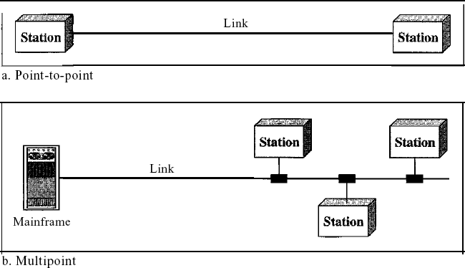

**Physical Topology** The term physical topology refers to the way in which a network is laid out physically. One or more devices connect to a link; two or more links form a topology. The topology of a network is the geometric representation of the relationship of all the links and linking devices (usually called nodes) to one another. There are four basic topologies possible: mesh, star, bus, and ring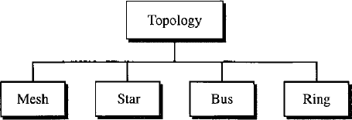

**Mesh**: In a mesh topology, every device has a dedicated point-to-point link to every other device. The term dedicated means that the link carries traffic only between the two devices it connects. To find the number of physical links in a fully connected mesh network with n nodes, we first consider that each node must be connected to every other node.

Node 1 must be connected to n - I nodes, node 2 must be connected to n – 1 nodes, and finally node n must be connected to n - 1 nodes. We need n(n - 1) physical links. However, if each physical link allows communication in both directions (duplex mode), we can divide the number of links by 2. In other words, we can say that in a mesh topology, we need n(n -1) /2 duplex-mode links.

2. A mesh topology is robust. If one link becomes unusable, it does not incapacitate the entire system. Third, there is the advantage of privacy or security. When every message travels along a dedicated line, only the intended recipient sees it. Physical boundaries prevent other users from gaining access to messages.

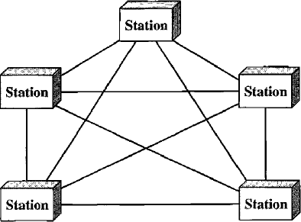

**Star Topology**: In a star topology, each device has a dedicated point-to-point link only to a central controller, usually called a hub. The devices are not directly linked to one another. Unlike a mesh topology, a star topology does not allow direct traffic between devices. The controller acts as an exchange: If one device wants to send data to another, it sends the data to the controller, which then relays the data to the other connected device .

One big disadvantage of a star topology is the dependency of the whole topology on one single point, the hub. If the hub goes down, the whole system is dead. 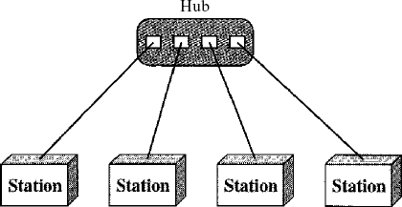

**Bus Topology**: The preceding examples all describe point-to-point connections. A bus topology, on the other hand, is multipoint. One long cable acts as a backbone to link all the devices in a network

Nodes are connected to the bus cable by drop lines and taps.

A drop line is a connection running between the device and the main cable. A tap is a connector that either splices into the main cable or punctures the sheathing of a cable to create a contact with the metallic core.

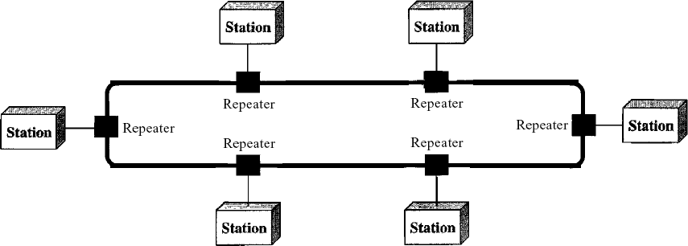**Ring Topology** In a ring topology, each device has a dedicated point-to-point connection with only the two devices on either side of it. A signal is passed along the ring in one direction, from device to device, until it reaches its destination. Each device in the ring incorporates a repeater. When a device receives a signal intended for another device, its repeater regenerates the bits and passes them along.

**Hybrid Topology** A network can be hybrid. For example, we can have a main star topology with each branch connecting several stations in a bus topology as shown in Figure

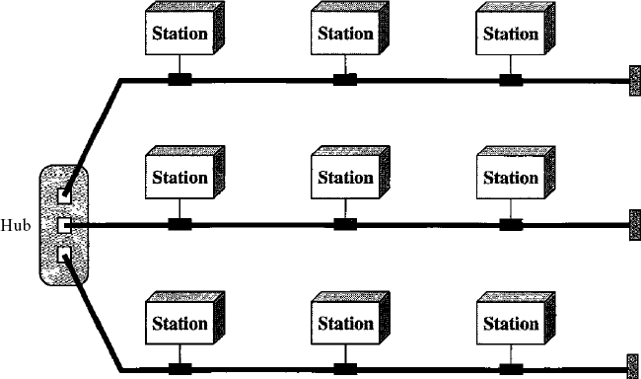

**Categories of Network**

Local area networks, generally called LANs, are privately-owned networks within a single building or campus of up to a few kilometres in size. They are widely used to connect personal computers and workstations in company offices and factories to share resources (e.g., printers) and exchange information. LANs are distinguished from other kinds of networks by three characteristics:

1. Their size,
2. Their transmission technology, and
3. Their topology.

LANs are restricted in size, which means that the worst-case transmission time is bounded and known in advance. Knowing this bound makes it possible to use certain kinds of designs that would not otherwise be possible. It also simplifies network management.

LANs may use a transmission technology consisting of a cable to which all the machines are attached, like the telephone company party lines once used in rural areas. Traditional LANs run at speeds of 10 Mbps to 100 Mbps, have low delay (microseconds or nanoseconds), and make very few errors. Newer LANs operate at up to 10 Gbps Various topologies are possible for broadcast LANs.

**Metropolitan Area Network:**

A metropolitan area network, or MAN, covers a city. The best-known example of a MAN is the cable television network available in many cities. This system grew from earlier community antenna systems used in areas with poor over-the-air television reception. In these early systems, a large antenna was placed on top of a nearby hill and signal was then piped to the subscribers' houses.

## Wide Area Network:

A wide area network, or WAN, spans a large geographical area, often a country or continent. It contains a collection of machines intended for running user (i.e., application) programs. These machines are called as hosts. The hosts are connected by a communication subnet, or just subnet for short.

**Protocols and Standards**

In computer networks, communication occurs between entities in different systems. An entity is anything capable of sending or receiving information. However, two entities cannot simply send bit streams to each other and expect to be understood. For communication to occur, the entities must agree on a protocol. **A protocol is a set of rules** that govern data communications. A protocol defines what is communicated, **how** it is communicated, and **when** it is communicated. The key elements of a protocol are syntax, semantics, and timing.

* + - Syntax. The term *syntax* refers to the structure or format of the data, meaning the order in which they are presented. For example, a simple protocol might expect the first 8 bits of data to be the address of the sender, the second 8 bits to be the address of the receiver, and the rest of the stream to be the message itself.
    - Semantics. The word *semantics* refers to the meaning of each section of bits. How is a particular pattern to be interpreted, and what action is to be taken based on that interpretation? For example, does an address identify the route to be taken or the final destination of the message?
    - Timing. The term *timing* refers to two characteristics: when data should be sent and how fast they can be sent. For example, if a sender produces data at 100 Mbps but the receiver can process data at only 1 Mbps, the transmission will overload the receiver and some data will be lost.

**Networking hardware**

**Networking hardware**, also known as **network equipment** or **computer networking devices**, are electronic devices which are required for communication and interaction between devices on a [computer network](https://en.wikipedia.org/wiki/Computer_network).

**Network software**

Network software encompasses a broad range of software used for design, implementation, and operation and monitoring of computer networks. Traditional networks were hardware based with software embedded. With the advent of Software Defined Networking (SDN), software is separated from the hardware thus making it more adaptable to the ever-changing nature of the computer network.

## Functions of Network Software

* Helps to set up and install computer networks
* Enables users to have access to network resources in a seamless manner
* Allows administrations to add or remove users from the network

Layering Scenario

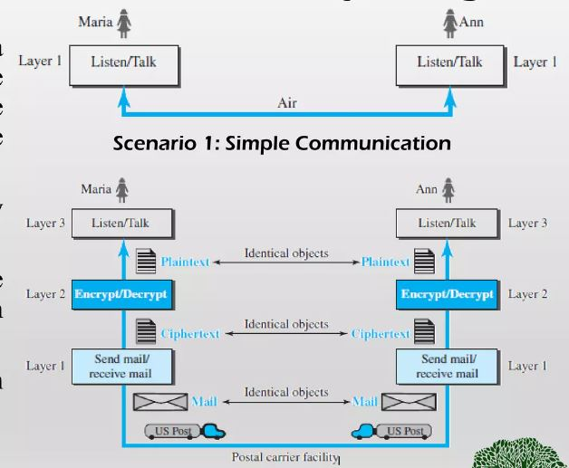

**THE OSI MODEL**

Open Systems Interconnection Basic Reference Model (OSI Reference Model or OSI Model) is an abstract description for layered communications and computer network protocol design. It was developed as part of the Open Systems Interconnection (OSI) initiative. In its most basic form, it divides network architecture into seven layers which, from top to bottom, are the Application, Presentation, Session, Transport, Network, Data-Link, and Physical Layers. It is therefore often referred to as the OSI

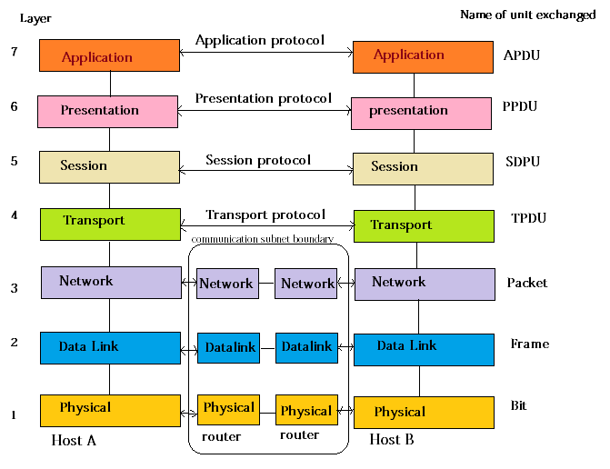

Seven Layer Model.

**1.Physical layer**

* One of the major function of the physical layer is to move data in the form of electromagnetic signals across a transmission medium.
* Its responsible for movements of individual bits from one hop (Node) to next.
* Both data and the signals can be either *analog* or *digital*.
* Transmission media work by conducting energy along a physical path which can be wired or wireless

Concerned:

* **Physical characteristics of interface and medium** :The physical layer defines the characteristics of the interface between the devices and the transmission medium.
* **Representation of bits**: The physical layer data consists of a stream of bits (sequence of Os or 1s) with no interpretation. To be transmitted, bits must be encoded into signals—electrical.
* **Data rate:** The transmission rate-the number of bits sent each second-is also defined by the physical layer
* **Synchronization of bits:** The sender and receiver not only must use the same bit rate but also must be synchronized at the bit level
* **Line configuration**: The physical layer is concerned with the connection of devices to the media. In a point-to-point configuration, two devices are connected through a dedicated link. In a multipoint configuration, a link is shared among several devices.
* **Physical topology**: The physical topology defines how devices are connected to make a network.
* **Transmission mode**: The physical layer also defines the direction of transmission between two devices: simplex, half-duplex, or full-duplex.

# 2.Data link layer

# This is responsible for moving frames from one hop (Node) to the next.

Concerned:

* **Framing**: The data link layer divides the stream of bits received from the network layer into manageable data units called frames.
* **Physical addressing**: If frames are to be distributed to different systems on the network, the data link layer adds a header to the frame to define the sender and/or receiver of the frame
* **Flow Control**: If the rate at which the data are absorbed by the receiver is less than the rate at which data are produced in the sender, the data link layer imposes a flow control mechanism.
* **Error Control**: The data link layer adds reliability to the physical layer by adding mechanisms to detect and retransmit damaged or lost frames.
* **Access Control**: When two or more devices are connected to the same link, data link layer protocols are necessary to determine which device has control over the link at any given time

3. Network layer

# This layer is responsible for the delivery of individual packets from the source host to the destination host.

Concerned:

* **Logical addressing**: The network layer adds a header to the packet coming from the upper layer that, among other things, includes the logical addresses of the sender and receiver
* **Routing** When independent networks or links are connected to create intemetworks (network of networks) or a large network, the connecting devices (called routers or switches) route or switch the packets to their final destination.

4. Transport layer

# The transport layer is responsible for the delivery of a message from one process to another

Concerned:

* **Service-point addressing** The transport layer header must include a type of address called a service-point address (or port address). The network layer gets each packet to the correct computer.
* **Segmentation and reassembly**: A message is divided into transmittable segments, with each segment containing a sequence number. These numbers enable the transport layer to reassemble the message correctly upon arriving at the destination and to identify and replace packets that were lost in transmission.
* **Connection** control The transport layer can be either connectionless or connectionoriented. A connectionless transport layer treats each segment as an independent packet and delivers it to the transport layer at the destination machine. A connectionoriented transport layer makes a connection with the transport layer at the destination
* **Flow control**: the transport layer is responsible for flow control. However, flow control at this layer is performed end to end rather than across a single link
* **Error Control**: Like the data link layer, the transport layer is responsible for error control. However, error control at this layer is performed process-toprocess rather than across a single link.

5. Session layer

# The session layer is responsible for dialog control and synchronization

Concerned:

* **Dialog Control**:The session layer allows two systems to enter into a dialog. It allows the communication between two processes to take place in either halfduplex (one way at a time) or full-duplex (two ways at a time) mode.
* **Synchronization**: The session layer allows a process to add checkpoints, or synChronization points, to a stream of data.

6. Presentation layer

# The presentation layer is responsible for translation, compression and encryption

Concerned:

* **Translation** The processes (running programs) in two systems are usually exchanging information in the form of character strings, numbers, and so on.
* **Encryption** To carry sensitive information, a system must be able to ensure privacy. Encryption means that the sender transforms the original information to another form and sends the resulting message out over the network.
* **Compression**: Data compression reduces the number of bits contained in the information

7.Application layer

# The application layer is responsible for providing services to the user.

Concerned:

* **Network virtual terminal.** A network virtual terminal is a software version of a physical terminal, and it allows a user to log on to a remote host.File transfer, access and management
* File transfer, access, and management. This application allows a user to access files in a remote host (to make changes or read data), to retrieve files from a remote computer for use in the local computer, and to manage or control files in a remote computer locally.
* **Mail services.** This application provides the basis for e-mail forwarding and storage.
* **Directory services.** This application provides distributed database sources and access for global information about various objects and services.

**TCP/IP PROTOCOL SUITE**

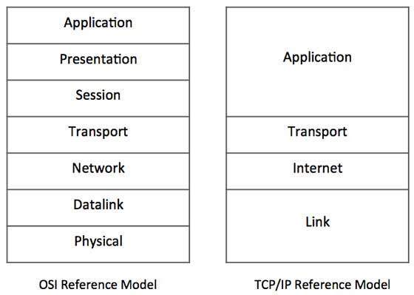

The Transmission Control Protocol/ Internet Protocol suite of protocol form the basis of the internet. It is TCP/IP that creates a virtual network when multiple computer networks are connected together. The TCP/IP networks was earlier known as ARPANET, but is now known as internet.

**TCP/IP Suite consists of Four layer**

**Network Interface**: - It include the function of physical layer and data link layer. TCP/IP protocol suite includes Host-to-network layer protocols such as Serial Line internet protocol and point to point protocol.

**Internet Layer**: - The internet layer is exactly same to the network layer of OSI model. IP is the primary protocol operating at this layer and it provides data encapsulation routing, addressing and fragmentation services to the protocols at the transport layer above it.

**Transport Layer**: - TCP/IP Suite includes two protocol at this layer, the transmission control protocol and the user datagram protocol These protocol provides connection or connectionless data transfer services.

**Application layer**: - The TCP/IP protocol at the application layer can take different forms of Protocols, such as the File Transfer Protocol, Hypertext Transfer Protocol.

**TCPI/IP and OSI model**

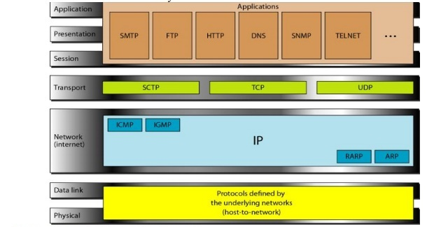

Application Layer The application layer in TCPIIP is equivalent to the combined session, presentation, and application layers in the OSI model

**SMTP**. Stands for "Simple Mail Transfer Protocol." This is the protocol used for sending e-mail over the Internet.

FTP File Transfer Protocol (FTP) is a standard Internet [protocol](https://searchnetworking.techtarget.com/definition/protocol) for transmitting files between computers on the Internet over [TCP/IP](https://searchnetworking.techtarget.com/definition/TCP-IP) connections

The Hypertext Transfer Protocol (**HTTP**) is an application-level protocol for distributed, collaborative, hypermedia information systems.

The Domain Name System (**DNS**) is a hierarchical and decentralized naming system for **computers**, services, or other resources connected to the Internet or a private **network**.

**Simple Network Management Protocol** (**SNMP**) is an [Internet Standard](https://en.wikipedia.org/wiki/Internet_Standard) protocol for collecting and organizing information about managed devices on [IP](https://en.wikipedia.org/wiki/Internet_Protocol) networks.

**Telnet** is an application protocol used on the Internet or local area **network** to provide a bidirectional interactive text-oriented communication facility using a virtual terminal connection

**Transport Layer**

Traditionally the transport layer was represented in TCP/IP by two protocols: TCP and UDP. IP is a host-to-host protocol, meaning that it can deliver a packet from one physical device to another.

**Stream Control Transmission Protocol** The Stream Control Transmission Protocol (SCTP) provides support for newer applications such as voice over the Internet. It is a transport layer protocol that combines the best features of UDP and TCP.

**The Transmission Control Protocol (TCP)** provides full transport-layer services to applications. TCP is a reliable stream transport protocol. The term stream, in this context, means connection-oriented.

**User Datagram Protocol** The User Datagram Protocol (UDP) is the simpler ofthe two standard TCPIIP transport protocols. It is a process-to-process protocol that adds only port addresses, checksum error control, and length information to the data from the upper layer.

**Network Layer**

At the network layer (or, more accurately, the internetwork layer), TCP/IP supports the Internetworking Protocol. IP, in turn, uses four supporting protocols: ARP, RARP, ICMP, and IGMP.

**Internet Control Message Protocol** The Internet Control Message Protocol (ICMP) is a mechanism used by hosts and gateways to send notification of datagram problems back to the sender. ICMP sends query and error reporting messages

**Internet Group Message Protocol** The Internet Group Message Protocol (IGMP) is used to facilitate the simultaneous transmission of a message to a group of recipients.

Internetworking Protocol (IP) The Internetworking Protocol (IP) is the transmission mechanism used by the TCP/IP protocols. It is an unreliable and connectionless protocol-a best-effort delivery service.

**Reverse Address Resolution Protocol** The Reverse Address Resolution Protocol (RARP) allows a host to discover its Internet address when it knows only its physical address. It is used when a computer is connected to a network for the first time or when a diskless computer is booted.

**Address Resolution Protocol** The Address Resolution Protocol (ARP) is used to associate a logical address with a physical address. On a typical physical network, such as a LAN, each device on a link is identified by a physical or station address, usually imprinted on the network interface card (NIC).

**Physical and Data Link Layers**

At the physical and data link layers, TCPIIP does not define any specific protocol. It supports all the standard and proprietary protocols. A network in a TCPIIP internetwork can be a local-area network or a wide-area network.

**ADDRESSING**

Four levels of addresses are used in an internet employing the *TCP/IP* protocols:

physical (link) addresses, logical (IP) addresses, port addresses, and specific

addresses.

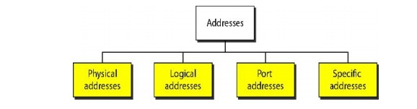

**Physical Address** /[**MAC Address**](https://www.geeksforgeeks.org/introduction-of-mac-address-in-computer-network/)**:**

A MAC address is a one-of-a-kind identification assigned to a NIC (Network Interface Controller/Card). The full form of MAC address is Media Access Control address. MAC addresses are 48 bits long and these addresses could not be routed between networks. MAC Address is a 12 digit hexadecimal numeral which is most typically expressed with a colon or hyphen separating every two digits (an octet), making reading easier. MAC Addresses are used at the Data Link Layer.

[**IP Address**](https://www.geeksforgeeks.org/difference-between-ip-address-and-port-number/)**/Logical Address**  
An Internet Protocol address is an IP address. It is a unique address that identifies the device on the network. The Internet Service Provider (ISP) assigns IP addresses to all devices on its network. IP addresses are not generated at random. The Internet Assigned Numbers Authority (IANA), a part of the Internet Corporation for Assigned Names and Numbers (ICANN), generates and assigns them mathematically . IP addresses are used at the network layer. IP Addresses are routable in nature.

**Port Address**

Port addressingrefers to using the port numbers assigned to every process to exchange data between them. Now, for processes that send and receive data over the internet, the following information must be assigned to every process:

* **The IP address**: We use this to uniquely identify the machines that run the processes over the internet.
* **The port address (port number)**: We use this to identify the processes uniquely on a machine. This number can range from 0–65535.

**Specific Addresses**

Some applications have user-friendly addresses that are designed for that specific address.

Examples include the e-mail address (for example, forouzan@fhda.edu) and the Universal

Resource Locator (URL) (for example, www.mhhe.com).

**INTERNET**

The Internet has revolutionized many aspects of our daily lives. It has affected the way we do business as well as the way we spend our leisure time. Count the ways you've used the Internet recently. Perhaps you've sent electronic mail (e-mail) to a business associate, paid a utility bill, read a newspaper from a distant city, or looked up a local movie schedule-all by using the Internet. Or maybe you researched a medical topic, booked a hotel reservation, chatted with a fellow Trekkie, or comparison-shopped for a car. The Internet is a communication system that has brought a wealth of information to our fingertips and organized it for our use.

**A Brief History**

A network is a group of connected communicating devices such as computers and printers. An internet is two or more networks that can communicate with each other. The most notable internet is called the Internet , a collaboration of more than hundreds of thousands of interconnected networks. Private individuals as well as various organizations such as government agencies, schools, research facilities, corporations, and libraries in more than 100 countries use the Internet.

In the mid-1960s, mainframe computers in research organizations were standalone devices. Computers from different manufacturers were unable to communicate with one another. The **Advanced Research Projects Agency (ARPA)** in the Department of Defense (DoD) was interested in finding a way to connect computers so that the researchers they funded could share their findings, thereby reducing costs and eliminating duplication of effort.

In 1967, at an Association for Computing Machinery (ACM) meeting, ARPA presented its ideas for ARPANET, a small network of connected computers. The idea was that each host computer (not necessarily from the same manufacturer) would be attached to a specialized computer, called an *inteiface message processor* (IMP). The IMPs, in tum, would be connected to one another.

In 1972, Vint Cerf and Bob Kahn, both of whom were part of the core ARPANET group, collaborated on what they called the *Internetting Projec1.* Cerf and Kahn's landmark 1973 paper outlined the protocols to achieve end-to-end delivery of packets.

This paper on Transmission Control Protocol (TCP) included concepts such as encapsulation, the datagram, and the functions of a gateway. Shortly thereafter, authorities made a decision to split TCP into two protocols: Transmission Control Protocol (TCP) and Internetworking Protocol (lP).

**The Internet Today**

The Internet has come a long way since the 1960s. The Internet today is not a simple hierarchical structure. It is made up of many wide- and local-area networks joined by connecting devices and switching stations.

Today most end users who want Internet connection use the services of Internet service providers (lSPs). There are international service providers, national service providers, regional service providersand local service providers. The Internet today is run by private companies, not the government.

**International Internet Service** Providers At the top of the hierarchy are the international service providers that connect nations together.

**National Internet Service Providers** The national Internet service providers are backbone networks created and maintained by specialized companies.

**Regional Internet Service Providers** Regional internet service providers or regional ISPs are smaller ISPs that are connected to one or more national ISPs.

**Local Internet Service Providers** Local Internet service providers provide direct service to the end users. The local ISPs can be connected to regional ISPs or directly to national ISPs.

**ARPANET**

This may be considered as the breakthrough for many of current ideas, algorithms and [Internet](https://ecomputernotes.com/computernetworkingnotes/services-and-applications/what-is-internet) technologies. It started Paul Baran in 1960s funded by **Advanced Research Projects Agency** (ARPA), an organization of the united States Defense Department and, therefore, named as **Advanced Research Projects Agency Network** (**ARPANET**) predecessor of the modern [Internet](https://ecomputernotes.com/computernetworkingnotes/services-and-applications/what-is-internet). It was **world’s first fully operational packet switching**[**computer**](https://ecomputernotes.com/fundamental/introduction-to-computer/what-is-computer)**network** and the world’s first successful [computer](https://ecomputernotes.com/fundamental/introduction-to-computer/what-is-computer) network to implement the TCP/IP reference model that was used earlier by ARPANET, before being used in the Internet. The ARPANET is the first network that planed the seed of interent.

ARPANET was built to accommodate research equipment on packet switching technology and to allow resource sharing for the Department of Defense’s contractors. The network interconnected research centers, some military bases and government locations. It soon became popular with researchers for collaboration through electronic mail and other services.

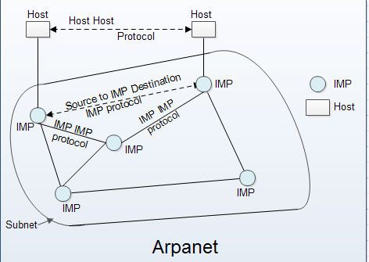

**Difference between TCP/IP and OSI Model**

Following are the differences between OSI and TCP/IP Reference Model −

| **OSI** | **TCP/IP** |
| --- | --- |
| OSI represents **Open System Interconnection**. | TCP/IP model represents the Transmission Control Protocol / Internet Protocol. |
| OSI is a generic, protocol independent standard. It is acting as an interaction gateway between the network and the final-user. | TCP/IP model depends on standard protocols about which the computer network has created. It is a connection protocol that assigns the network of hosts over the internet. |
| The OSI model was developed first, and then protocols were created to fit the network architecture’s needs. | The protocols were created first and then built the TCP/IP model. |
| It provides quality services. | It does not provide quality services. |
| The OSI model represents defines administration, interfaces and conventions. It describes clearly which layer provides services. | It does not mention the services, interfaces, and protocols. |
| The protocols of the OSI model are better unseen and can be returned with another appropriate protocol quickly. | The TCP/IP model protocols are not hidden, and we cannot fit a new protocol stack in it. |
| It is difficult as distinguished to TCP/IP. | It is simpler than OSI. |
| It provides both connection and connectionless oriented transmission in the network layer; however, only connection-oriented transmission in the transport layer. | It provides connectionless transmission in the network layer and supports connecting and connectionless-oriented transmission in the transport layer. |
| It uses a horizontal approach. | It uses a vertical approach. |
| The smallest size of the OSI header is 5 bytes. | The smallest size of the TCP/IP header is 20 bytes. |
| Protocols are unknown in the OSI model and are returned while the technology modifies. | In TCP/IP, returning protocol is not difficult. |

**Transmission Media**

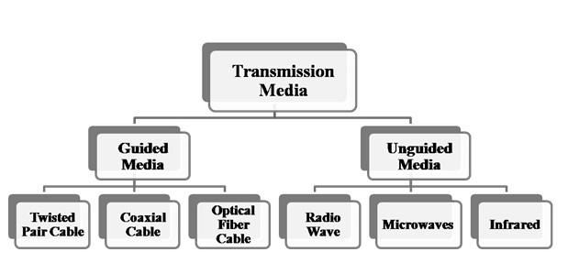

# Guided Media It is defined as the physical medium through which the signals are transmitted. It is also known as Bounded media.

**Guided** **Media**− In guided media, transmitted data travels through cabling system that has a fixed path. For example, copper wires, fibre optic wires, etc.

**Types Of Guided media:**

The degree of reduction in noise interference is determined by the number of turns per foot. Increasing the number of turns per foot decreases noise interference.

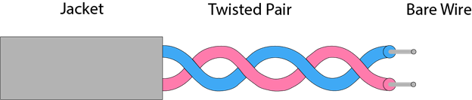

**Types of Twisted pair:**

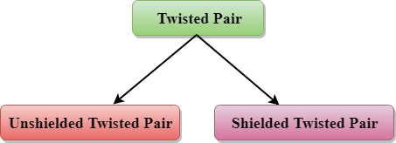

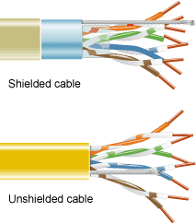

**Unshielded Twisted Pair:**

An unshielded twisted pair is widely used in telecommunication. Following are the categories of the unshielded twisted pair cable:

* **Category 1:** Category 1 is used for telephone lines that have low-speed data.
* **Category 2:** It can support upto 4Mbps.
* **Category 3:** It can support upto 16Mbps.
* **Category 4:** It can support upto 20Mbps. Therefore, it can be used for long-distance communication.
* **Category 5:** It can support upto 200Mbps.

**Advantages Of Unshielded Twisted Pair:**

* It is cheap.
* Installation of the unshielded twisted pair is easy.
* It can be used for high-speed LAN.

**Disadvantage:**

* This cable can only be used for shorter distances because of attenuation.

### Shielded Twisted Pair

A shielded twisted pair is a cable that contains the mesh surrounding the wire that allows the higher transmission rate.

**Characteristics Of Shielded Twisted Pair:**

* The cost of the shielded twisted pair cable is not very high and not very low.
* An installation of STP is easy.
* It has higher capacity as compared to unshielded twisted pair cable.
* It has a higher attenuation.
* It is shielded that provides the higher data transmission rate.

**Disadvantages**

* It is more expensive as compared to UTP and coaxial cable.
* It has a higher attenuation rate.

## Coaxial Cable

* Coaxial cable is very commonly used transmission media, for example, TV wire is usually a coaxial cable.
* The name of the cable is coaxial as it contains two conductors parallel to each other.
* It has a higher frequency as compared to Twisted pair cable.
* The inner conductor of the coaxial cable is made up of copper, and the outer conductor is made up of copper mesh. The middle core is made up of non-conductive cover that separates the inner conductor from the outer conductor.
* The middle core is responsible for the data transferring whereas the copper mesh prevents from the **EMI**(Electromagnetic interference).

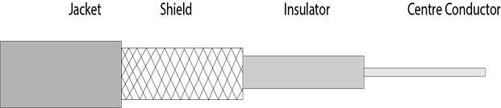

**Coaxial cable is of two types:**

1. **Baseband transmission:** It is defined as the process of transmitting a single signal at high speed.
2. **Broadband transmission:** It is defined as the process of transmitting multiple signals simultaneously.

**Advantages Of Coaxial cable:**

* The data can be transmitted at high speed.
* It has better shielding as compared to twisted pair cable.
* It provides higher bandwidth.

**Disadvantages Of Coaxial cable:**

* It is more expensive as compared to twisted pair cable.
* If any fault occurs in the cable causes the failure in the entire network.

## Fibre Optic

* Fibre optic cable is a cable that uses electrical signals for communication.
* Fibre optic is a cable that holds the optical fibres coated in plastic that are used to send the data by pulses of light.
* The plastic coating protects the optical fibres from heat, cold, electromagnetic interference from other types of wiring.
* Fibre optics provide faster data transmission than copper wires.

**Diagrammatic representation of fibre optic cable:**

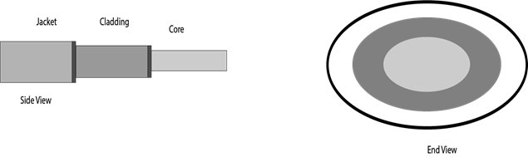

**Basic elements of Fibre optic cable:**

* **Core:** The optical fibre consists of a narrow strand of glass or plastic known as a core. A core is a light transmission area of the fibre. The more the area of the core, the more light will be transmitted into the fibre.
* **Cladding:** The concentric layer of glass is known as cladding. The main functionality of the cladding is to provide the lower refractive index at the core interface as to cause the reflection within the core so that the light waves are transmitted through the fibre.
* **Jacket:** The protective coating consisting of plastic is known as a jacket. The main purpose of a jacket is to preserve the fibre strength, absorb shock and extra fibre protection.

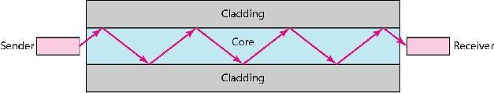

**Unguided** **Media** − In unguided media, transmitted data travels through free space in form of electromagnetic signal. For example, radio waves, lasers, etc

## Infrared

Low frequency infrared waves are used for very short distance communication like TV remote, wireless speakers, automatic doors, hand held devices etc. Infrared signals can propagate within a room but cannot penetrate walls. However, due to such short range, it is considered to be one of the most secure transmission modes.

**Microwaves –**   
It is a line of sight transmission i.e. the sending and receiving antennas need to be properly aligned with each other. The distance covered by the signal is directly proportional to the height of the antenna. Frequency Range:1GHz – 300GHz. These are majorly used for mobile phone communication and television distribution

## Radio Wave

Transmission of data using radio frequencies is called **radio-wave transmission**. We all are familiar with radio channels that broadcast entertainment programs. Radio stations transmit radio waves using **transmitters**, which are received by the receiver installed in our devices.

Both transmitters and receivers use antennas to radiate or capture radio signals. These radio frequencies can also be used for **direct voice communication** within the **allocated range**. This range is usually 10 miles.

# THE DATA LINK LAYER DESIGN ISSUES

**FUNCTIONS**

* + - Providing a well-defined service interface to the network layer.
    - Dealing with transmission errors.
    - Regulating the flow of data so that slow receivers are not swamped by fast senders –flow control.

The two main functions of the data link layer are:

1. **Data Link Control (DLC)**: It deals with the design and procedures for communication b/w nodes: node-to-node communication.
2. **Media Access Control (MAC)**: It explains how to share the link.

**DATA LINK CONTROL (DLC):** Data link control functions includes

* 1. **Framing.**
  2. **Error Control.**
  3. **Flow Control.**

1. **FRAMING**

The frame contains

* 1. Frame header
  2. Payload field for holding packet
  3. Frame trailer

# 

**Services provided to the network layer**

Transferring data from the network layer on the source machine to the network layer on the destination machine. The data link layer can be designed to offer various services. The actual services offered can vary from system to system. Three reasonable possibilities that are commonly provided are

# Unacknowledged connectionless service

* + Source machine sends independent frames to destination machine having destination machine acknowledge them
  + No logical connection

# Acknowledged connectionless service

* + No logical connection
  + Each frame sent is individually acknowledged
  + Useful over unreliable channels (i.e. wireless systems)

# Acknowledged connection-oriented service

* + Source and destination machines establish a connection before any data are transferred
  + Each frame is numbered

# FRAMING

Breaking the bit stream up into frames is more difficult than it at first appears. One way to achieve this framing is to insert time gaps between frames, much like the spaces between words in ordinary text. However, networks rarely make any guarantees about timing, so it is possible these gaps might be squeezed out or other gaps might be inserted during transmission.

There are four methods:

1. Character count.
2. Flag bytes with byte stuffing.
3. Starting and ending flags, with bit stuffing.
4. Physical layer coding violations.

# Character count:

The first framing method uses a field in the header to specify the number of characters in the frame. When the data link layer at the destination sees the character count, it knows how many characters follow and hence where the end of the frame is. This technique is shown in Fig. 3-4(a) for four frames of sizes 5, 5, 8, and 8 characters, respectively.

# A character stream. (a) Without errors. (b) With one error.

**Explanation ( A character stream Without errors.)**

* The first framing method uses a field in the header to specify the number of characters in the frame.
* When above the data link layer at the destination sees the character count, it knows how many characters follow and hence where the end of the frame is.
* This technique is shown in Fig. for four frames of sizes 5, 5, 8, and 8 characters, respectively.
* The trouble with this algorithm is that the count can be garbled by a transmission error.

# Explanation (b) A character stream with errors.

* For example, if the character count of 5 in the second frame of fig b becomes a 7, the destination will get out of synchronization and will be unable to locate the start of the next frame.
* Even if the checksum is incorrect so the destination knows that the frame is bad, it still has no way of telling where the next frame starts.
* Sending a frame back to the source asking for a retransmission does not help either, since the destination does not know how many characters to skip over to get to the start of the retransmission. For this reason, the character count method is rarely used anymore.

# Flag bytes with byte stuffing:

**Character-oriented framing approach**

* + In a character-oriented approach, data to be carried are 8-bit characters.
  + The header, which normally carries the source and destination addresses and other control information.
  + Trailer carries error detection or error correction redundant bits, are also multiples of 8 bits.
  + To separate one frame from the next, an 8-bit (1-byte) flag is added at the beginning and the end of a frame.

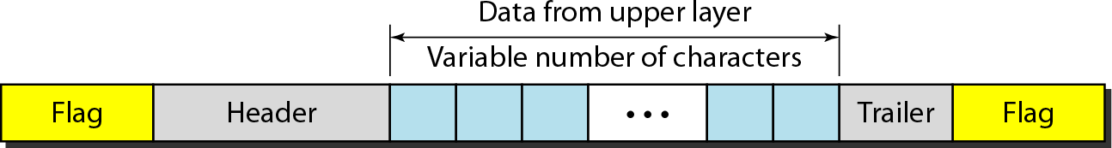Figure: shows the format of a frame in a character-oriented protocol

**Advantage:**

1. Simple framing method.
2. Character-oriented framing was popular when only text was exchanged by the data Link layers.
3. The flag could be selected to be any character not used for text communication.

# Disadvantage:

1. Even if with checksum, the receiver knows that the frame is bad there is no way to tell where the next frame starts.
2. Asking for retransmission doesn’t help either because the start of the retransmitted frame is not known.
3. Hence No longer used.

# Starting and ending character with byte stuffing

Byte stuffing is the process of adding 1 extra byte whenever there is a flag or escape character in the text.

Figure : Byte stuffing and unstuffing

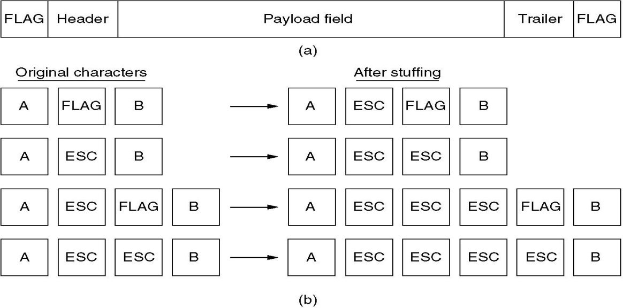

**Fig: Framing with byte stuffing**

# Bit-Oriented framing approach

* + Bit stuffing is the process of adding one extra 0 whenever five consecutive 1’s follow a 0 in the data, so that the receiver does not mistake the pattern 0111110 for a flag.
  + Most protocols use a special 8-bit pattern flag 01111110 as the delimiter to define the beginning and the end of the frame, as shown in Figure below
    - This flag can create the same type of problem. That is, if the flag pattern appears in the data, we need to somehow inform the receiver that this is not the end of the frame.

We do this by stuffing 1 single bit (instead of I byte) to prevent the pattern from looking like a flag. The strategy is called bit stuffing.

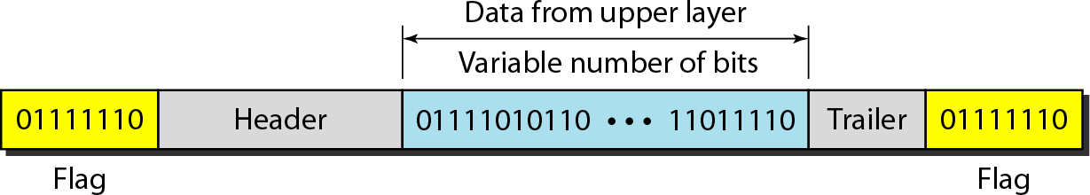

**Bit stuffing** is the process of adding one extra 0 whenever five consecutive 1s follow a 0 in the data, so that the receiver does not mistake the pattern 0111110 for a flag.

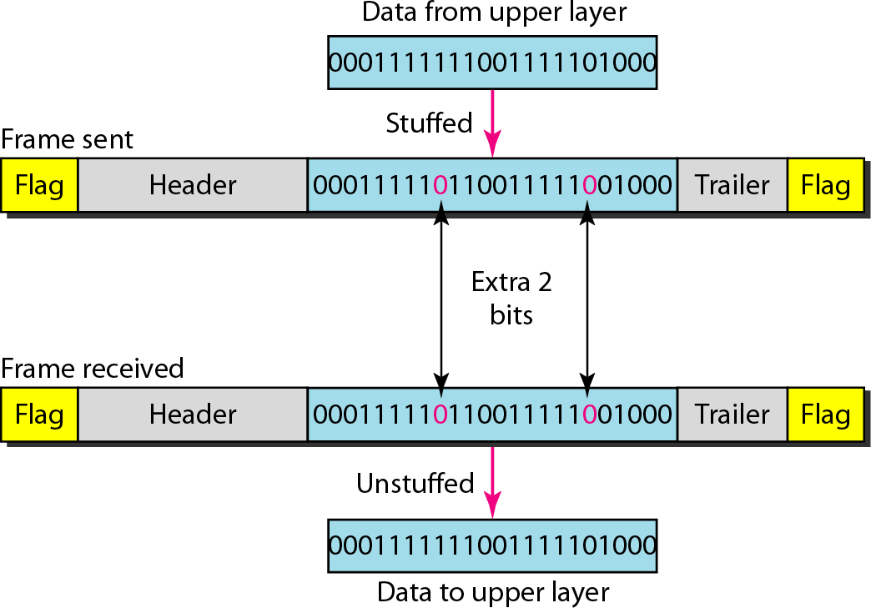

# Figure (b)

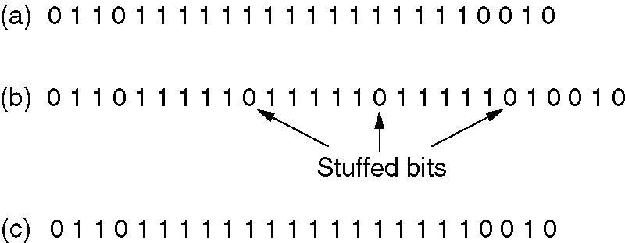

**Figure (c)**

1. The original data.
2. The data as they appear on the line.
3. The data as they are stored in receiver’s memory after destuffing.

# ERROR CONTROL

* How do we make sure that all frames are eventually delivered to the network layer at the destination and in the proper order?
* Provide sender with some acknowledgement about what is happening with the receiver
* Sender could wait for acknowledgement

# TYPES OF ERRORS

* **Single bit error**: Only one bit gets corrupted. Common in Parallel transmission.
* **Burst error:** More than one bit gets corrupted very common in serial transmission of data occurs when the duration of noise is longer than the duration of one bit.

# Single bit error:

* The term single-bit error means that only one bit of given data unit (such as a byte, character, or data unit) is changed from 1 to 0 or from 0 to 1 as shown in Fig. 3.2.1.
* Single bit errors are least likely type of errors in serial data transmission.
* For example, if 16 wires are used to send all 16 bits of a word at the same time and one of the wires is noisy, one bit is corrupted in each word.

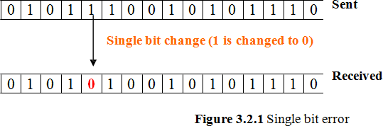

# Burst error:

* More than one bit gets corrupted very common in serial transmission of data occurs when the duration of noise is longer than the duration of one bit.
* The noise affects data; it affects a set of bits.
* The number of bits affected depends on the data rate and duration of noise.

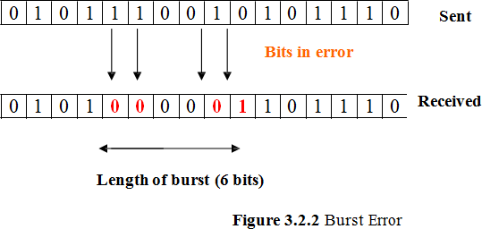

# ERROR DETECTION TECHNIQUES

Basic approach used for error detection is the use of redundancy, where additional bits are added to facilitate detection and correction of errors. Popular techniques are

* Cyclic redundancy check
* 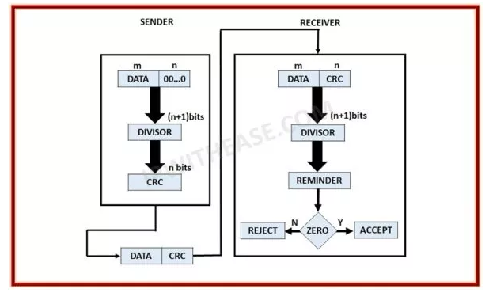

**Cyclic redundancy check (CRC)**

* Unlike checksum scheme, which is based on addition, CRC is based on binary division.
* In CRC, a sequence of redundant bits, called cyclic redundancy check bits, are appended to the end of data unit so that the resulting data unit becomes exactly divisible by a second, predetermined binary number.
* At the destination, the incoming data unit is divided by the same number. If at this step there is no remainder, the data unit is assumed to be correct and is therefore accepted.
* A remainder indicates that the data unit has been damaged in transit and therefore must be rejected.

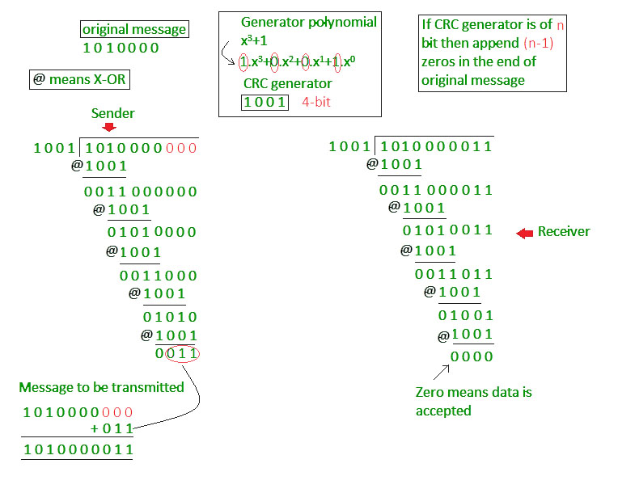

**ELEMENTARY DATA LINK LAYER PROTOCOLS**

**PROTOCOLS**

The protocols are normally implemented in software by using one of the common programming languages.

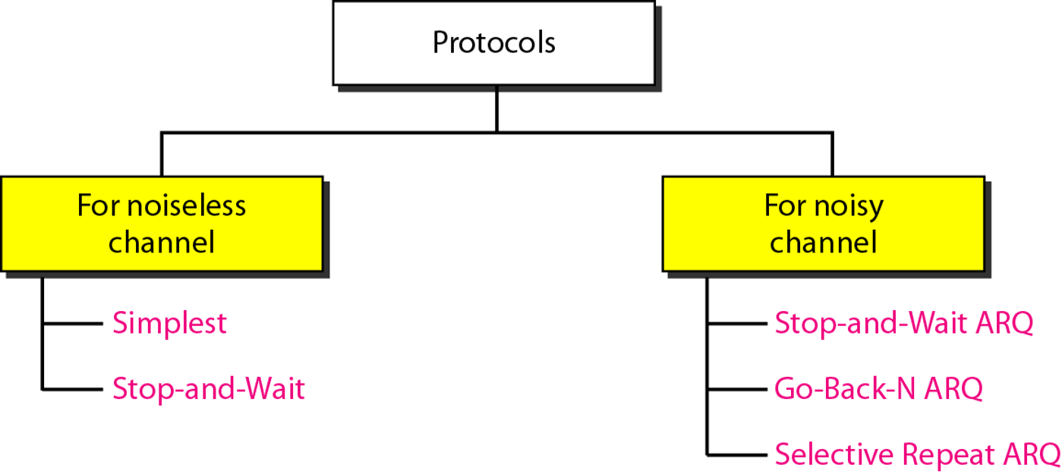

**NOISELESS CHANNELS**

Let us first assume we have an ideal channel in which no frames are lost, duplicated, or corrupted. It introduces two protocols for this type of channel. The first is a protocol that does not use flow control.

**Simplest Protocol**

 It has no flow or error control. It is a unidirectional protocol in which data frames are traveling in only one direction-from the sender to receiver. The data link layer of the receiver immediately removes the header from the frame and hands the data packet to its network layer, which can also accept the packet immediately.

 It is very simple. The sender sends a sequence of frames without even thinking about the receiver. To send three frames, three events occur at the sender site and three events at the receiver site. Note that the data frames are shown by tilted boxes; the height of the box defines the transmission time difference between the first bit and the last bit in the frame.

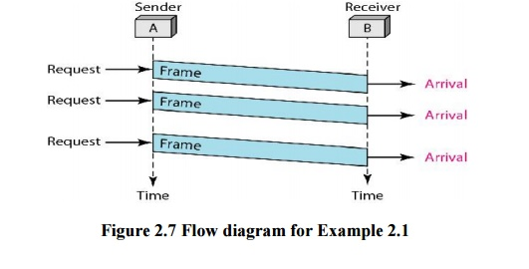

**Stop-and-Wait Protocol**

 If data frames arrive at the receiver site faster than they can be processed, the frames must be stored until their use.

 In Stop-and-Wait Protocol the sender sends one frame, stops until it receives confirmation from the receiver (okay to go ahead), and then sends the next frame.

**Example**

 Figure shows an example of communication using this protocol. It is still very simple. The sender sends one frame and waits for feedback from the receiver. When the ACK arrives, the sender sends the next frame. Note that sending two frames in the protocol involves the sender in four events and the receiver in two events.

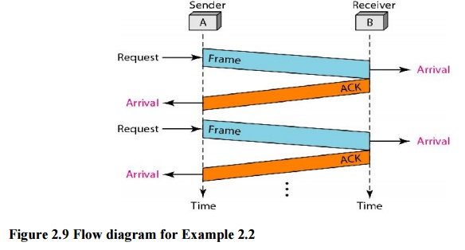

**Noisy Channels:**

**1. Stop-and-Wait Automatic Repeat Request**

 The Stop-and-Wait Automatic Repeat Request (Stop-and-Wait ARQ), adds a simple error control mechanism to the Stop-and-Wait Protocol. To detect and correct corrupted frames, we need to add redundancy bits to our data frame. When the frame arrives at the receiver site, it is checked and if it is corrupted, it is silently discarded. The detection of errors in this protocol is manifested by the silence of the receiver.

The receiver has a control variable, which we call *Rn* (receiver, next frame expected), that holds the number of the next frame expected. When a frame is sent, the value of *Sn* is incremented (modulo-2), which means if it is 0, it becomes 1 and vice versa. When a frame is received, the value of *Rn* is incremented (modulo-2), which means if it is 0, it becomes 1 and vice versa. Three events can happen at the sender site; one event can happen at the receiver site. Variable *Sn* points to the slot that matches the sequence number of the frame that has been sent, but not acknowledged; *Rn* points to the slot that matches the sequence number of the expected frame.

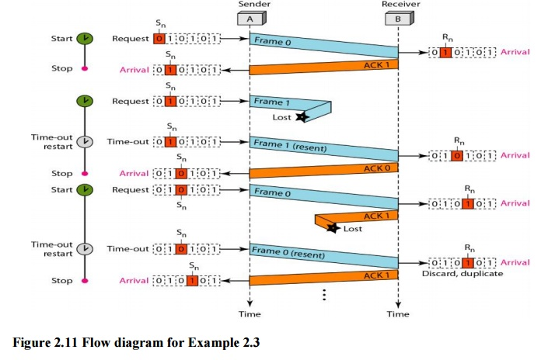

**Go-Back-N Automatic Repeat Request**

 In this protocol we can send several frames before receiving acknowledgments; we keep a copy of these frames until the acknowledgments arrive.

Note that we need only one variable Rn (receive window, next frame expected) to define this abstraction. The sequence numbers to the left of the window belong to the frames already received and acknowledged; the sequence numbers to the right of this window define the frames that cannot be received. Any received frame with a sequence number in these two regions is discarded. Only a frame with a sequence number matching the value of Rn is accepted and acknowledged. The receive window also slides, but only one slot at a time.

***Send Window Size***

 We can now show why the size of the send window must be less than *2m.* As an example, we choose *m* =2, which means the size of the window can be *2m*- 1, or 3. Figure 2.15 compares a window size of 3 against a window size of 4. If the size of the window is 3 (less than 22) and all three acknowledgments are lost, the frame 0 timer expires and all three frames are resent. The receiver is now expecting frame 3, not frame 0, so the duplicate frame is correctly discarded.

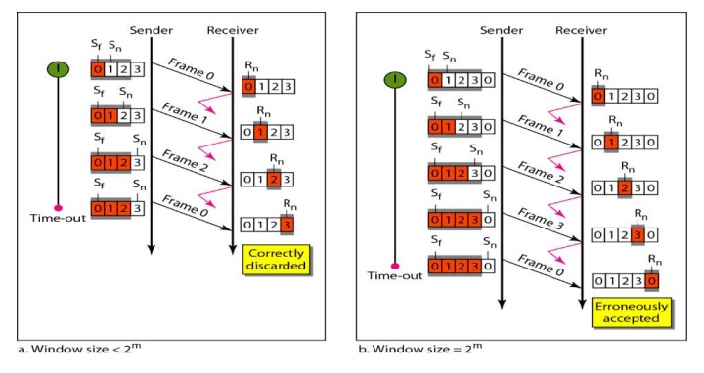

***Sliding Window***

 The sliding window is an abstract concept that defines the range of sequence numbers that is the concern of the sender and receiver. In other words, the sender and receiver need to deal with only part of the possible sequence numbers. The range which is the concern of the sender is called the send sliding window; the range that is the concern of the receiver is called the receive sliding window.

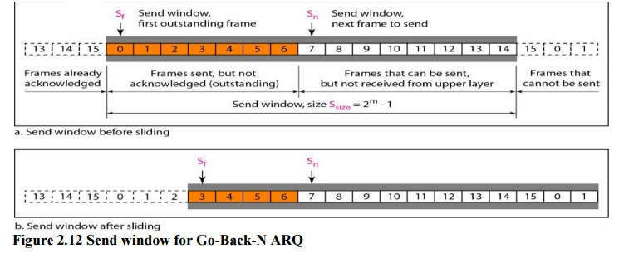

## Working Principle

In these protocols, the sender has a buffer called the sending window and the receiver has buffer called the receiving window.

The size of the sending window determines the sequence number of the outbound frames. If the sequence number of the frames is an n-bit field, then the range of sequence numbers that can be assigned is 0 to 2𝑛−1. Consequently, the size of the sending window is 2𝑛−1. Thus in order to accommodate a sending window size of 2𝑛−1, a n-bit sequence number is chosen.

The sequence numbers are numbered as modulo-n. For example, if the sending window size is 4, then the sequence numbers will be 0, 1, 2, 3, 0, 1, 2, 3, 0, 1, and so on. The number of bits in the sequence number is 2 to generate the binary sequence 00, 01, 10, 11.

The size of the receiving window is the maximum number of frames that the receiver can accept at a time. It determines the maximum number of frames that the sender can send before receiving acknowledgment.

## Example

Suppose that we have sender window and receiver window each of size 4. So the sequence numbering of both the windows will be 0,1,2,3,0,1,2 and so on. The following diagram shows the positions of the windows after sending the frames and receiving acknowledgments.

**Selective Repeat Automatic Repeat Request**

Go-Back-N ARQ simplifies the process at the receiver site. The receiver keeps track of only one variable, and there is no need to buffer out-of-order frames; they are simply discarded. However, this protocol is very inefficient for a noisy link. In a noisy link a frame has a higher probability of damage, which means the resending of multiple frames. This resending uses up the bandwidth and slows down the transmission.

***Windows***

 The Selective Repeat Protocol also uses two windows: a send window and a receive window. First, the size of the send window is much smaller; it is 2m- 1. Second, the receive window is the same size as the send window. The send window maximum size can be 2m- 1. For example, if m = 4, the sequence numbers go from 0 to 15, but the size of the window is just 8 (it is 15 in the Go-Back-N Protocol). The smaller window size means less efficiency in filling the pipe, but the fact that there are fewer duplicate frames can compensate for this.

**Design of Selective Repeat ARQ**

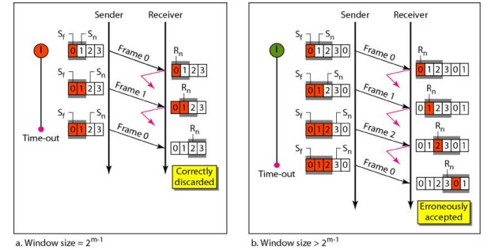

**Selective Repeat ARQ, Window size**