# Mini Project-1A

Report on

# “**Medical Management System**”

Submitted by **Karan Shah Varun Gurav**

#### Pratik Metkari

#### Karan Surve

Semester III Second Year Under the guidance of

#### Prof. Shashikant Renushe



Department of Electronics & Computer Science

**Mahatma Education Society’s**

### Pillai HOC College of Engineering and Technology

Pillai HOCL Educational Campus, HOCL Colony, Rasayani Tal: Khalapur, Dist: Raigad- 410207

University of Mumbai Academic Year: 2024 – 25

Mahatma Education Society’s

Pillai HOC College of Engineering and Technology, Pillai HOCL Educational Campus, HOCL Colony, Rasayani, Tal: Khalapur, Dist: Raigad-410207 Department of Electronics & Computer Science

Date:

## CERTIFICATE

This is to certify that**, Karan Shah, Varun Gurav, Pratik Metkari, Karan Surve** satisfactorily worked on project entitled “**Medical Management System**”, as a part of Mini Project 1A in semester III, second year of Bachelor of Engineering in Electronics and Computer Science.

#### **Mr. Shashikant Renushe** Guide

**Mr. Shashikant Renushe MP-1A Coordinator**

**Dr. Mansi Subhedar Head of Department**

**Dr. J. W. Bakal Principal**

**Seal of College**

## Mini Project Submission Approval

This Mini Project 1A report entitled “**Medical Management System**” by a **Karan Shah, Varun Gurav, Pratik Metkari and Karan Surve** is examined and approved for submission as part of term work.

#### External Examiner

Sign:

Name:

**Internal Examiner** Sign: Name:

Date:

Place: Rasayani

This mini project report would not have been come into reality without the able guidance, support and wishes of all those who stand by us in the development. We wish to give our special thanks to our **Guide Mr. Shashikant Renushe** for his timely advice and guidance.

We humbly thank our **Mini Project-1A Coordinator**, **Mr. Shashikant T. Renushe** and our **Head of Department**, **Dr. Mansi Subhedar**, for their valuable guidance and unending support. We would also like to thank our **Principal**, **Dr. J. W. Bakal** for his constant encouragement throughout the course. The cheerful spirit they radiated all the time fuelled our desire to excel in the work that we had undertaken.

We acknowledge all the faculty members and non-teaching staff of the Department of Electronics and Computer Science for their help and suggestions during various phases of this project work.

#### Karan Shah Varun Gurav Pratik Metkari

**Karan Surve**

This paper provides an overview of a conventional fire alarm system, emphasizing its simplicity and effectiveness in detecting fires and ensuring safety. Fire alarm systems are essential for early fire detection, consisting of key components such as smoke detectors, heat sensors, alarm bells, and control panels. The system operates through straightforward mechanisms: smoke or heat triggers the sensors, which activate the alarms to alert occupants. The design prioritizes ease of use and reliability, making it suitable for various settings, including residential, commercial, and industrial environments. This study also discusses the importance of regular maintenance and adherence to safety codes to ensure optimal performance. Ultimately, this paper highlights the crucial role of traditional fire alarm systems in safeguarding lives and property from fire hazards.

1.1 Circuit Diagram of fire alarm system 8

6.1 Output of fire alarm system 11

|  |  |  |  |
| --- | --- | --- | --- |
|  | | **Acknowledgment** | **1** |
| **Abstract** | **2** |
| **List of Figures** | **3** |
| **Contents** | **4** |
| **1** |  | **Introduction** | **5** |
|  | 1.1 | Brief overview of work | 5 |
|  | 1.2 | Objective | 5 |
| **2** |  | **Literature Review and Problem Definition** | **6** |
|  | 2.1 | Literature survey | 6 |
|  | 2.2 | Problem definition | 6 |
|  | 2.3 | Importance of fire alarm system | 6 |
|  | 2.4 | Scope | 7 |
| **3** |  | **Design Methodology** | **8** |
|  | 3.1 | Circuit Diagram | 8 |
| **4** |  | **Component List** | **9** |
|  | 4.1 | Hardware Details | 9 |
| **5** |  | **Implementation of System** | **10** |
|  | 5.1 | Hardware Implementation | 10 |
| **6** |  | **Results** | **11** |
| **7** |  | **Applications and Future Scope** | **12** |
|  | 7.1 | Application | 12 |
|  | 7.2 | Future Scope | 12 |
| **8** |  | **Conclusion** | **13** |
|  |  | **References** | **14** |

### Introduction

#### Brief Overview of Work

Fire alarm systems are essential components in safeguarding lives and property by providing early detection and warning of fire hazards. These systems are integrated into various building infrastructures, from residential apartments to complex commercial and industrial facilities, ensuring swift evacuation and prompt emergency response. This report emphasizes the hardware components of fire alarm systems, which play a critical role in their overall functionality and reliability. These components form the backbone of fire detection and alert mechanisms, directly impacting the system’s ability to respond to emergencies effectively. The goal of this report is to provide a comprehensive guide for selecting, installing, and maintaining the hardware used in fire alarm systems. Understanding the unique roles of these components will enable stakeholders to optimize system performance and ensure compliance with safety standards. Through proper installation, regular testing, and maintenance, fire alarm hardware can significantly reduce fire-related risks, ensuring occupant safety and minimizing property damage.

#### Objective

The objective of a fire alarm system is to ensure the safety of individuals and protect property by detecting and responding to fire hazards promptly. These systems are designed to provide early warnings to occupants through audible and visual alarms, facilitating a timely evacuation. Additionally, fire alarms aim to minimize damage by automatically triggering fire suppression mechanisms and notifying emergency responders. Beyond life safety and property protection, such systems help organizations comply with legal requirements and standards, ensuring preparedness in emergencies. Effective fire alarm systems can also integrate with other safety solutions to streamline responses, reducing downtime and operational disruptions

### Literature Review and Problem Definition

#### Literature survey

Research on fire alarm systems highlights advancements in detection technologies and their critical role in safety. Fire alarm systems have evolved from basic manual alarms to sophisticated automated solutions integrated with building management systems, improving response times and occupant safety.

#### Problem definition

Research on fire alarm systems highlights advancements in detection technologies and their critical role in safety. Fire alarm systems have evolved from basic manual alarms to sophisticated automated solutions integrated with building management systems, improving response times and occupant safety.

#### Importance of Fire Alarm System

Fire alarm systems are crucial for ensuring safety and protecting property from fire incidents. Their importance can be summarized as follows:

* + 1. Early Detection:

Detecting smoke and heat early reduces response times, allowing for safe evacuations and quicker emergency responses.

* + 1. Life Safety:

These systems are primarily designed to alert occupants, facilitating timely evacuations, and saving lives.

* + 1. Property Protection:

Early warnings minimize fire damage to buildings and possessions, reducing overall loss.

* + 1. Regulatory Compliance:

Fire alarm systems are often required by law in many jurisdictions, ensuring that buildings meet safety standards.

* + 1. System Integration:

Modern systems can integrate with sprinklers and emergency lighting, enhancing overall safety and response efforts.

* + 1. Continuous Monitoring:

Some systems provide real-time monitoring, alerting emergency services directly for quicker responses.

* + 1. Insurance Benefits:

Reliable fire alarm systems can lower insurance premiums for property owners.

* + 1. Peace of Mind:

Their presence reduces anxiety about fire risks, providing occupants with confidence in safety measures.

#### Scope

This report focuses on the hardware components of fire alarm systems, including sensors, control panels, alarms, and power supplies. The scope of a fire alarm system involves early detection of fire or smoke, alerting occupants for evacuation, and triggering fire suppression mechanisms. It also includes notifying emergency responders and integrating with other safety systems, ensuring compliance with legal standards, and minimizing damage and downtime. These systems are crucial across residential, commercial, and industrial spaces to enhance safety and response efficiency.

### 3.1 Circuit Diagram:

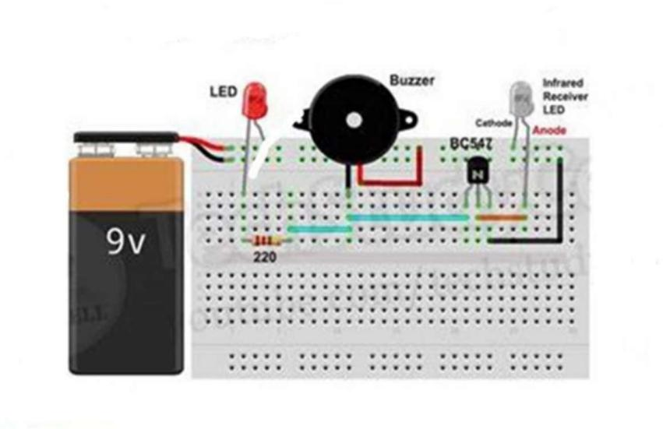

Fig. 1.1 Circuit Diagram of fire alarm system

#### Hardware details

Required Hardware Components for Fire Alarm System :

* + - IR Sensor
* Purpose: Detects infrared radiation from heat or flames.
* 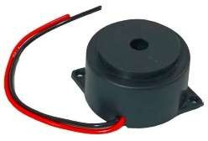Function: Triggers the alarm system upon detecting elevated temperatures.
  + - Buzzer
* Purpose: Provides an audible alarm signal.
* Function: Alerts occupants to a fire or emergency situation.
  + - Voltage Supply
* Purpose: Provides consistent voltage levels required for the circuit.
* Function: Maintains reliable operation of sensors and alarms.
  + - SK100 Transistor
* Purpose: Acts as a switch to control larger loads (e.g., the buzzer).
* 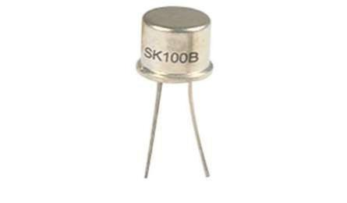Function: Amplifies the signal from the IR sensor to activate the alarm system.

#### Additional Components (Optional)

* Power Supply Unit (PSU): Converts AC to DC power if necessary.
* Control Panel: Central hub for processing signals from detectors and managing alarms.
* Smoke Detectors: For additional fire detection capabilities

.

* Heat Detectors: To complement the IR sensor for effective fire monitoring.

#### 5.1 Hardware Implementation:

The IR sensor (combination of IR transmitter and receiver) is used to detect smoke in the environment. The IR transmitter (an IR LED) continuously emits infrared light. Under normal conditions, the light passes through the air without much reflection. When smoke particles are present, they scatter and reflect the infrared light back toward the IR receiver (usually a photodiode or phototransistor). The IR receiver detects the reflected light intensity. As smoke increases, the amount of reflected IR light increases. If the reflected IR light exceeds a threshold (indicating smoke presence), it triggers the alarm system (activating the buzzer). The buzzer is typically connected to a transistor (like the SK100) to drive the buzzer when the current from the IR sensor is insufficient to power the buzzer directly. When the fire/smoke condition is triggered, the IR sensor sets the transistor (SK100) to ON by providing a base current. This allows current to flow from the collector to the emitter of the transistor, powering the buzzer and making it sound. A small current flows into the base, allowing a larger current to flow from the collector to the emitter, thus powering the buzzer or any other connected load. When the base current is stopped (by setting the pin to LOW), the transistor turns off, cutting off the power to the buzzer.

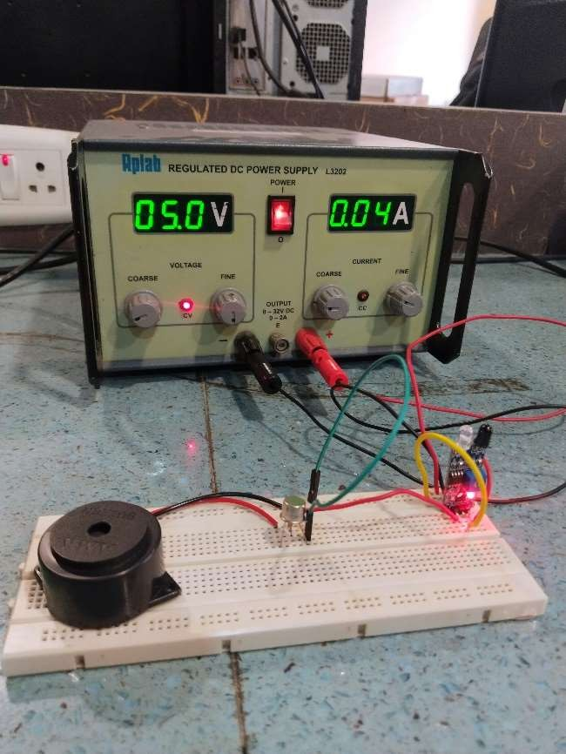

Fig 6.1 Output of fire alarm system

### Applications and Future Scope

#### Application:

* + 1. Commercial Buildings: Fire alarm systems in offices, shopping malls, and hotels ensure safety and compliance with regulations.
    2. Industrial Settings: Factories and warehouses use fire alarms to detect smoke and heat, protecting assets and personnel.
    3. Residential Use: Home fire alarm systems provide early warnings, enhancing safety for families.
    4. Public Infrastructure: Schools, hospitals, and airports utilize fire alarms to safeguard large populations and sensitive environments.
    5. Smart Buildings: Integration with IoT devices allows for advanced monitoring and remote control of fire safety systems.

#### Future Scope:

* + 1. IoT Integration: Future systems will increasingly use IoT for real-time data sharing and analytics, allowing for proactive fire safety measures.
    2. Enhanced Detection Technologies: Advancements in sensors, such as photoelectric and multi-sensor technologies, will improve detection accuracy and reduce false alarms.
    3. AI and Machine Learning: AI can analyze patterns in alarm data to predict fire risks and optimize response times.
    4. Wireless Communication: Improved wireless systems will allow for easier installation and maintenance, as well as enhanced connectivity with emergency services.
    5. Smart Home Integration: Fire alarm systems will integrate with smart home ecosystems, enabling automated responses, such as unlocking doors for emergency personnel.
    6. Sustainability: Future systems may focus on energy efficiency and the use of sustainable materials, aligning with broader environmental goals.

### Conclusion

This project has been prepared mainly to reduce fire accidents and reduce the severity of the fire. If there is any warning in the information received then we can send the fire control unit from the control room. Alarms can also be sounded and people can be evacuated from dangerous places to safe places. Also, after receiving this alert, we know whether there is enough water for firefighting, so, if necessary, we can start early firefighting with our trained personnel for rescue operations and using stored water. As a result, we can save lives and reduce property losses, we can act as needed by sitting in the control room and seeing the relevant information. It can also be said that accident prevention does not always require the monitoring of computers or other devices. By using this method, we can prevent fire or other fire-related accidents in places like multi-storage buildings hospitals, shopping malls, or metro stations.

1. . https://youtu.be/Bx5-MhBSZ1c?feature=shared
2. . https://[www.mifratech.com/public/blog](http://www.mifratech.com/public/blog)