This is Summary and Notes of Chapter 1

- The rapid evolution of autonomous agents is primarily driven by breakthroughs in foundation models and reinforcement learning.

- Traditional ML is an incredibly powerful technique, it is usually limited by the quantity and quality of the dataset.

- ML practitioners will typically tell you that they spend the majority of their time not training models, but on collecting and cleaning datasets that they can use for training.

-Recent advancements in large language models (LLMs) such as GPT-5, Anthropic’s Claude, Meta’s Llama, Google’s Gemini Ultra, and DeepSeek’s V3 have increased the performance on a range of difficult tasks even further, widening the scope of problems solvable with pretrained models.

- These models are capable of:
1- Contextual interpretation and decision making
2 - Tool use 3 - Adaptive planning (Planning and executing complex, multistep actions autonomously)
4- Management of unstructured data 5 - Code generation
6 -Multimodal information synthesis

Agents Types

The Information categorizes agents into seven practical types :
1 - Business-task agents :
These agents automate predefined business workflows such as UiPath , Microsoft Power Automate , or Zapier (They execute sequences of deterministic actions )
Example : نفس المدخلات → نفس الخطوات → نفس النتيجة.
اقرأ الإيميل
↓
افهم محتواه
↓
حدد إذا كان فاتورة أم شكوى أم طلب دعم
↓
قرر ما الإجراء الأنسب
↓
نفذ الإجراء
↓
راجع النتيجة وعدل الخطة إذا لزم الأمر

2- Conversational agents :
Similar like Chatbot , read context and try to build conversation , They are optimized for dialogue management, intent recognition, and conversational turn-taking, such as virtual assistants embedded in customer support platforms.

3 - Research agents :
Help to read documents , gathering information and summary it
4 - Analytics agents
Used to help the user in Analyzing the data similar like Power BI Copilot or Glean .
5- Developer agents :
help users to code similar like Cursor
6 - Domain-specific agents
They are agents that build for specific domain like medical or something like that
7 - Browser-using agents :
These agents navigate, interact with, extract information from, and take actions on websites without human interaction. As opposed to traditional robotic process automation,

8 - Voice agents
9- Video agents

Model Selection :
New techniques for distillation, quantization, and synthetic data generation are enabling compact models to inherit surprising levels of capability from their larger counterparts.

how do you choose the right model for your agentic system? The truth is, there isn’t a one-size-fits-all answer. In fact, one of the most reasonable starting points is simply to use the latest general-purpose model from a leading provider like OpenAI or Anthropic

That said, they aren’t always the most efficient choice. For many tasks—especially those that are well-defined, low-latency, or cost-sensitive—much smaller models can provide near-equivalent performance at a fraction of the cost. This has led to a growing trend: automated model selection. Some platforms now route simpler queries to fast, inexpensive small models, reserving the large, expensive models for more complex reasoning. This dynamic test-time optimization is proving effective, and it hints at a future where multimodel systems become the norm.

From Synchronous to Asynchronous Operations
In contrast, autonomous agents are designed for asynchronous operation unlike software systems . They can manage multiple tasks in parallel, swiftly adapt to new information, and prioritize actions dynamically based on changing conditions. This asynchronous processing dramatically enhances efficiency, reducing idle time and optimizing the use of computational resources.
Rather than spending time on repetitive or mechanical steps, individuals can focus on strategic oversight, review, and high-value decision making—amplifying human creativity and judgment while letting agents handle the operational details. These agents make it much easier for human roles to be proactive rather than reactive.

Workflows and Agents
In many real‐world projects, choosing between a simple script, a deterministic workflow, a traditional chatbot, a retrieval‐augmented generation (RAG) system, or a full‐blown autonomous agent can be the difference between an elegant solution and an overengineered

To make this choice clearer, consider four key factors:
1- The variability of your inputs
2- The complexity of the reasoning required
3 - Any performance or compliance constraints
4- The ongoing maintenance burden.

If your inputs are fully predictable and every possible output can be described in advance, a handful of lines of procedural code are often faster and cheaper

Deterministic or semiautomated workflows. Here, the logic can be expressed as a finite set of steps or branches, and you know ahead of time where you might need human intervention or extra error handling

Traditional chatbots or RAG systems occupy the next tier of complexity: they add natural language understanding and document retrieval but stop short of autonomous, multistep planning. If your primary need is to let users ask questions about a knowledge base—say, searching a product manual, a legal archive, or corporate wikis—a RAG system can embed documents into a vector store, retrieve relevant passages in response to a query, and generate coherent, context‐aware answers.

we reach autonomous agents—situations where neither simple code, nor rigid workflows, nor RAG suffice because inputs are unstructured, novel, or highly variable, and because you require dynamic, multistep planning or continuous learning from feedback

Agents also excel when many subtasks must run in parallel—such as a security operations agent that simultaneously queries threat intelligence APIs, scans network telemetry, and performs sandbox analysis on suspicious binaries. Because agents operate asynchronously and reprioritize based on real‐time data, they avoid the brittle “one‐step‐at‐a‐time” nature of workflows or RAG systems.

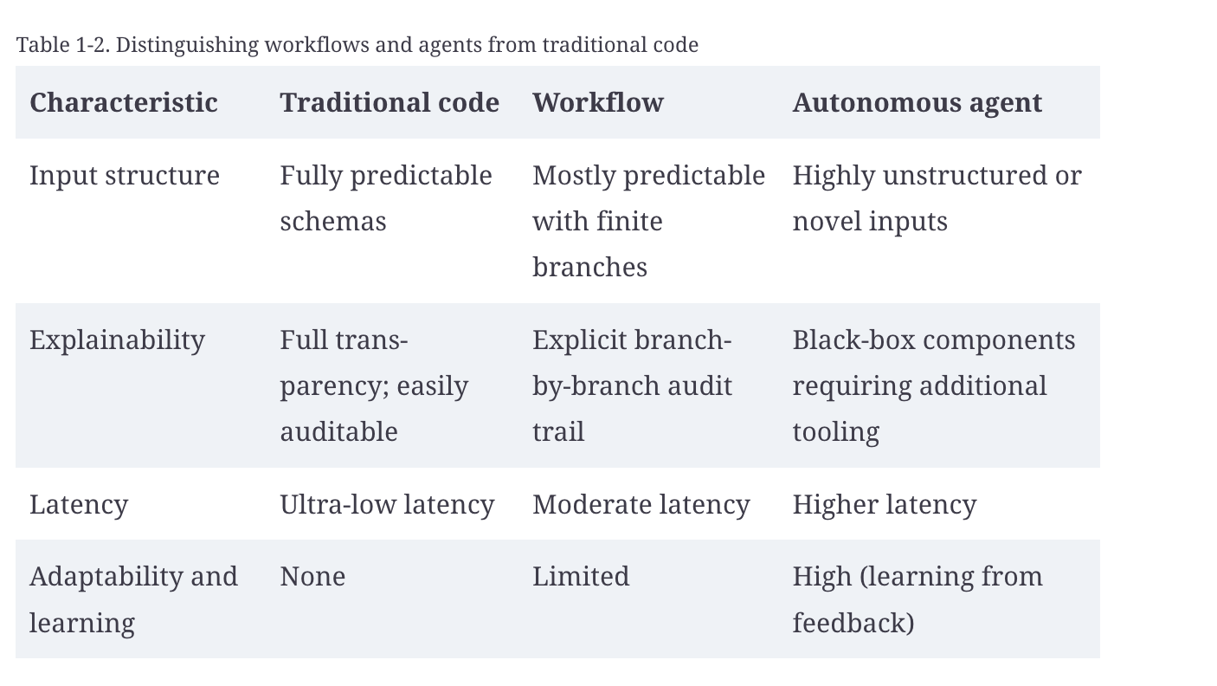

Every path carries trade‐offs. Pure code is cheap and fast but inflexible; workflows offer control but break down when inputs grow wildly variable; traditional chatbots or RAG are great for question‐answering over documents but cannot orchestrate multistep actions; and agents are powerful but demanding

Before choosing, ask: are my inputs unstructured or unpredictable? Do I need multistep planning that adapts to intermediate results? Can a document retrieval system suffice for my users’ information needs, or must the system decide and act autonomously Will I want this system to improve itself over time with minimal human intervention? And can I tolerate the latency and maintenance burden of a foundation model?

Principles for Building Effective Agentic Systems
Scalability
Ensure that agents can handle growing workloads and diverse tasks by utilizing distributed architectures, cloud-based infrastructure, and efficient algorithms that support parallel processing and resource optimization.
Modularity
Design agents with independent, interchangeable components connected through clear interfaces. This modular approach simplifies maintenance, promotes flexibility, and facilitates rapid adaptation to new requirements or technologies.
Continuous learning
Equip agents with mechanisms to learn from experience, such as in-context learning. Integrate user feedback to refine agent behaviors and maintain performance relevance as tasks evolve.
Resilience
Develop robust resilience architectures capable of gracefully handling errors, security threats, timeouts, and unexpected conditions.
Future-proofing
Build agent systems around open standards and scalable infrastructure, fostering a culture of innovation to adapt quickly to emerging technologies and evolving user expectations
Agentic Frameworks
Numerous frameworks currently exist for developing autonomous agents, each addressing critical functionalities such as skills integration, memory management, planning, orchestration, experiential learning, and multiagent coordination. This list is certainly not exhaustive, but leading frameworks include the following.
1- LangGraph. : it is good in Lon memory and multi agent similar like autogen , easy to use and good in , Async and support Retries
Suitable for : Single Agent - Small Multi-Agent - Production Systems
2 - AutoGen : heavy and complex for simple tasks , good in self re4flection and multi agent
Suitable for : Research - Complex Multi-Agent Systems
3- CrewAI : good for beginner , fast and good for prototyping but has less control and not mature like langgraph
Suitable for. : Beginners - Quick Prototypes - Personal Assistants

4 - OpenAI Agents Software Development Kit (SDK) : tool calling ready and memory ready and its security .. but it is hard to connect with something different than open
Suitable for : OpenAI Users - Fast Development

