

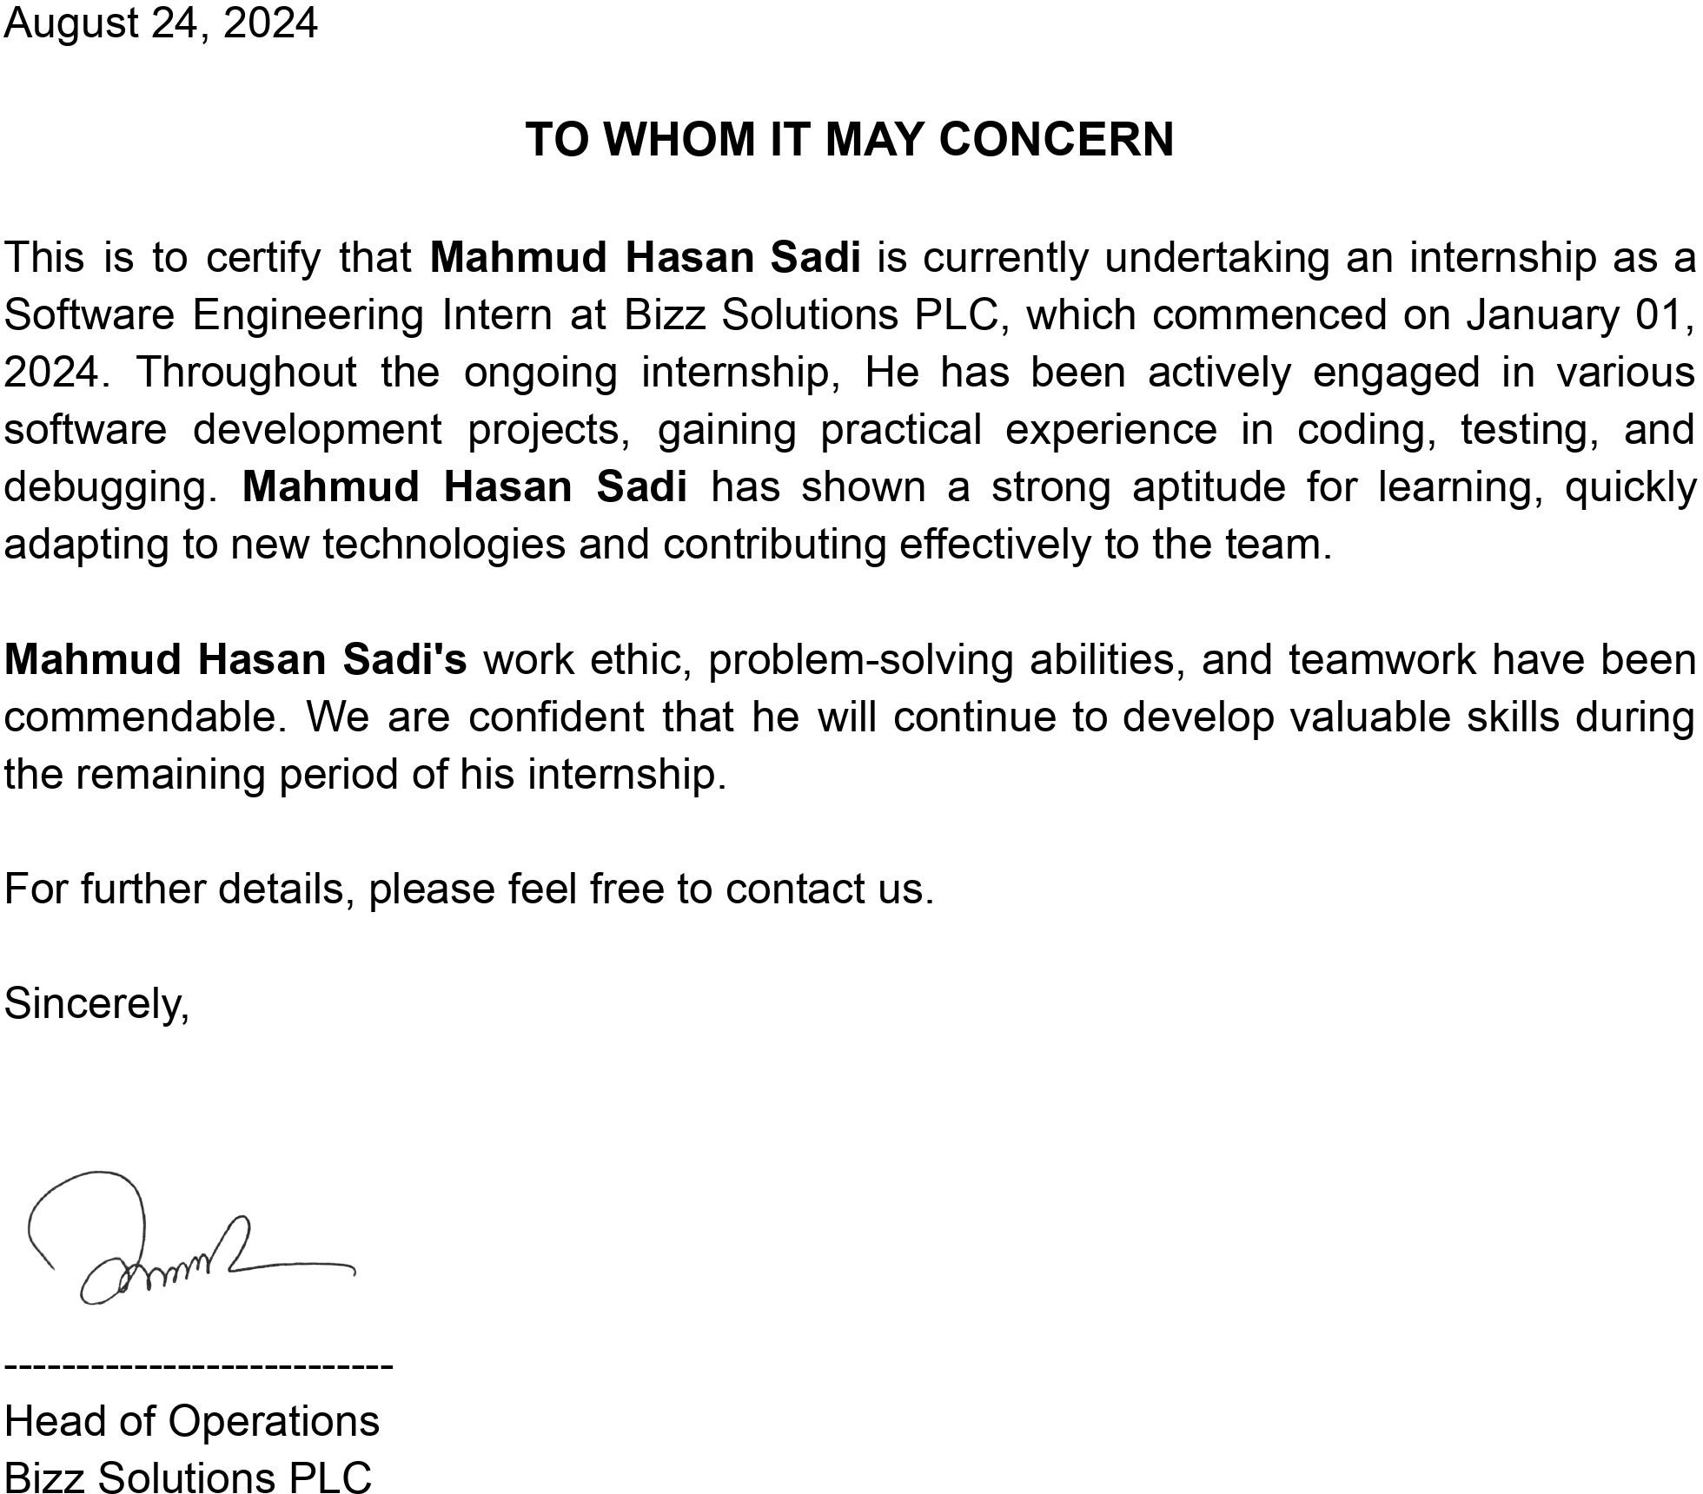

Bizz Solutions PLC

City Center 90/1, Level-25 (Lift-26), Type-D2, Motijheel C/A, Dhaka-1000

P: **+8801313-476488** | E: [info@bizzsol.com.bd](mailto:info@bizzsol.com.bd) | W: [www.bizzsol.com.bd](http://www.bizzsol.com.bd/)