ModelTrace Tool
AI validation evidence assistant

No | Full name | Student ID | GitHub ID
1 | Priya M | 2025MB26030 | Priya-bits237

Executive Summary

Problem Statement
Independent model validators assemble evidence from development reports, backtesting appendices, monitoring records and issue logs. Repeated searches, conflicting versions and missing documentation can increase preparation effort and obscure evidence gaps. ModelTrace tests whether this work can be made faster while preserving the quality and traceability of the final evidence note. Workflow pain and expected savings remain hypotheses requiring user research and timed evaluation.

Target User / Customer
The primary user is an independent model validation analyst in a financial institution. Validation leads review the evidence trail, while model owners resolve missing or conflicting documentation. The initial internal sponsor is the head of model risk or validation operations. Model validation consultancies are a potential later commercial customer, subject to demonstrated demand and approved data handling.

Product Concept
ModelTrace is an AI-assisted validation evidence workspace. A validator selects a requirement, reviews ranked source passages and citations, identifies missing or conflicting evidence, and records an acceptance, amendment, rejection or escalation with a reason. The smallest MVP covers one synthetic document pack for a deposit balance forecasting model and six requirements: scope, data lineage, backtesting, stress scenarios, monitoring and limitations. Human reviewers retain responsibility for evidence sufficiency and model approval.

Proposed ModelTrace Workflow
AI performs the initial check against validator-created guidance. Validators assess each potential gap, while model owners address confirmed issues.
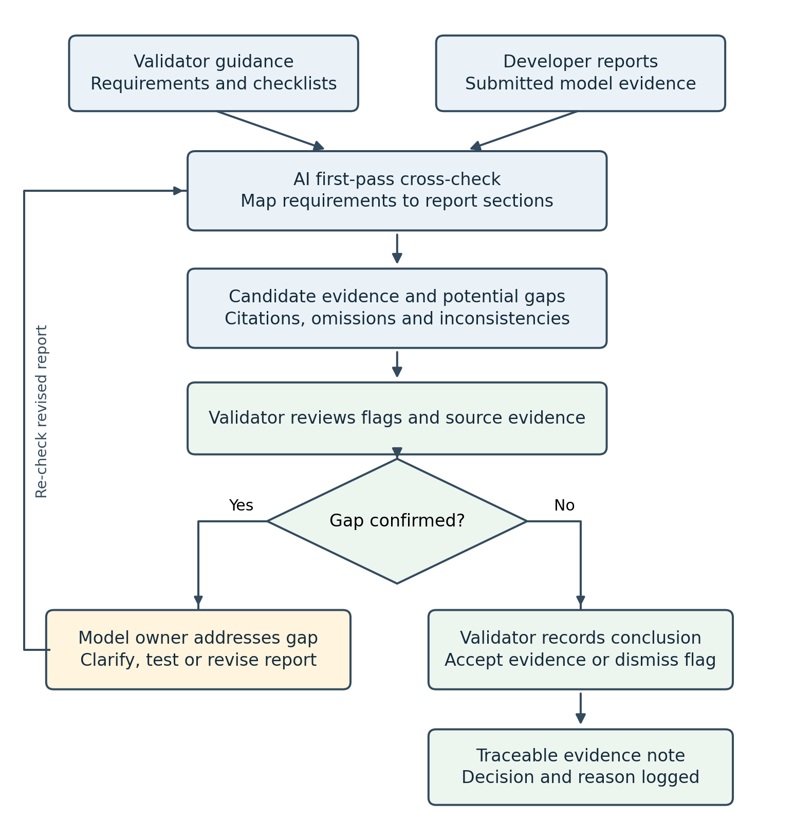
Missing or ambiguous evidence remains open for clarification. Model approval follows the existing validation governance process.

Why AI?
AI can use guidance, review criteria and checklists created by validators to perform a first-pass cross-check of reports submitted by model developers. By matching the expected evidence to relevant report sections, it can help flag missing analyses, incomplete explanations and inconsistencies for validator review. Language-based matching can help locate evidence even when developers use different terminology from the guidance. Each potential gap should link to the applicable criterion and available source evidence, with validators confirming whether it is a documentation gap or requires further model testing. This capability must be evaluated against governed keyword search; the current lexical prototype does not yet establish reliable gap identification.

Recommendation
Proceed with developing and evaluating a focused ModelTrace prototype that cross-checks model development reports against validator-created guidance. The prototype should flag potential gaps, link each flag to the relevant requirement and supporting report sections, and allow validators to confirm or dismiss the findings.
Evaluate it using synthetic reports containing known gaps, measuring gap detection, false flags and review time against manual review. Consider a supervised pilot only after the prototype demonstrates useful, reliable results. Final validation judgments and model approval should remain with the validators.

Product Strategy and Opportunity Framing

Product Vision
Enable model validators to identify potential evidence gaps efficiently through a secure internal tool that checks developer-submitted reports against validator-created guidance. Provide traceable references and consistent review support while preserving independent human judgment.

JTBD
When I am reviewing a model development report, I want to cross-check it against our validation guidance and identify potential gaps with supporting references, so that I can focus on material issues and raise clear, evidence-based questions to the developer.

Opportunity Framing
Why this problem matters: Validators repeatedly interpret requirements, search report sections and assess whether evidence is sufficient. Missing analyses, incomplete explanations or inconsistent versions can increase review effort and obscure important gaps. Better first-pass coverage could free time for deeper model challenge; the benefit must be measured.
Why current alternatives are weak: Manual checklists depend on reviewers locating and interpreting evidence consistently. Keyword search can locate terms but may miss relevant passages expressed differently, and a matching phrase does not establish that a requirement is satisfied. Generic external AI tools do not meet the proposed internal-only handling approach for confidential reports and governance material.
Why AI may help: AI can match validator-created guidance to relevant report sections despite differences in terminology, organize candidate evidence and flag possible omissions or inconsistencies. Each flag should include the relevant requirement and available source references. Validators confirm whether the issue is a documentation gap or requires further model testing. The opportunity is worth testing now through a narrow synthetic prototype; reliable gap detection and time savings remain unproven.

Opportunity Matrix
Idea | Business Value | Feasibility | Priority
Map guidance to cited report sections | High: reduce repeated evidence searches | High for a narrow text-based prototype | High - MVP
Flag potential evidence gaps | High: improve first-pass review coverage | Medium: requires independent labels and careful testing | High - MVP with human review
Flag explicit version or date conflicts | High: expose inconsistent evidence | Medium for clearly stated metadata and claims | Medium - after core mapping
Draft developer clarification questions | Medium: make confirmed gaps easier to communicate | Medium once evidence quality is established | Medium - later
Approve models or close findings autonomously | Unproven: high cost of incorrect decisions | Low for accountable independent judgment | Exclude

Build vs Buy vs Partner/API
Recommended path: Build and test ModelTrace internally within the financial institution's approved environment. Reuse approved libraries and internally hosted language or embedding models where available. Keep confidential reports, validation guidance, governance questions, indexes, prompts, outputs and logs within that boundary. Exclude external hosted model APIs from the initial MVP.
Why: The institution needs control over confidential modeling information and internal policies, along with access permissions, document versions, review records and changes to the tool. An internal build also allows the workflow and evaluation to reflect its own validation requirements. A purchased product or external partner would require separate assessment of deployment, data handling, integration and supplier terms; neither is selected for the MVP.
Main trade-offs: Internal development requires engineering capacity, infrastructure, security reviews, model maintenance and ongoing evaluation, and may take longer than buying an application. The institution gains control and customization but assumes the operating burden. Building internally does not require training a foundation model from scratch, and internal hosting still requires access controls, retention rules and testing.

First Wedge
Start with a first-pass evidence review for one deposit balance forecasting model. Use one synthetic developer report pack and a validator-created checklist covering scope, data lineage, backtesting, stress scenarios, monitoring and limitations.
For each requirement, show relevant report excerpts and citations, flag potential gaps and let the validator confirm, amend or dismiss the flag with a reason. Confirmed gaps become clarification requests to the developer. Model approval and final validation conclusions remain outside the tool's authority.
Test against manual review supported by the existing search process, using held-out reports with known gaps and independently reviewed labels. Measure gap detection, false flags, citation support and total review time. Consider a supervised internal pilot only after useful performance is demonstrated and the handling environment is approved.

UX and Workflow Design

Main Workflow
ModelTrace operates as a background capability within the existing model inventory portal. Validators use the portal to inspect results; they do not need a separate application or a manual start action for each submission. This is a proposed integration, not a claim that the portal connection already exists.
Report submitted: A developer submits a new report or report version for a specific model. The portal records its model ID, report ID, version and submission time and emits a submission event.
Background check triggered: The event queues a check using the applicable approved guidance version. Repeated delivery of the same event must not create duplicate reviews. The portal shows Queued, then Processing. If guidance is unavailable or applicability is unclear, the check routes to Needs attention.
Evidence mapped: The tool maps requirements to report passages, proposes candidate evidence and flags possible omissions, conflicts or uncertain mappings. Partial processing is visible; an unfinished check is never presented as complete.
Results available: The portal displays Ready for review or Needs attention against that exact report version. An in-portal indicator alerts the assigned validator. This means the AI check has finished or needs intervention, not that validation is approved.
Validator reviews: The validator opens the evidence-review panel, checks citations and addresses High review-priority items first. The validator confirms a gap, dismisses a flag, requests clarification or keeps it unresolved, with a reason.
Revisions and record: A revised report triggers a new version-specific check. Preserve prior decisions and mark earlier results as superseded. A validator may inspect earlier evidence, but it must not be presented as current or have its decisions carried forward automatically. The portal retains the evidence note and review trail; model approval uses existing governance.
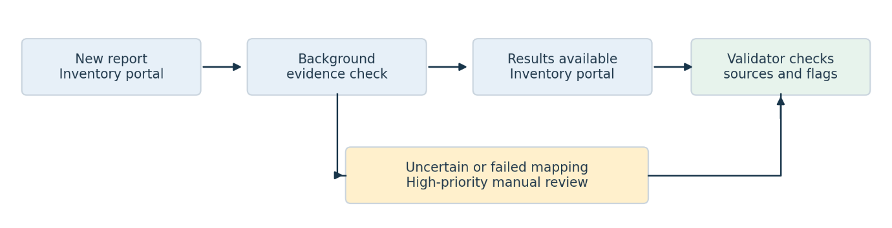

- Wireframes / Screens
Illustrative model inventory portal wireframes showing the proposed experience.
Screen 1 Model report list
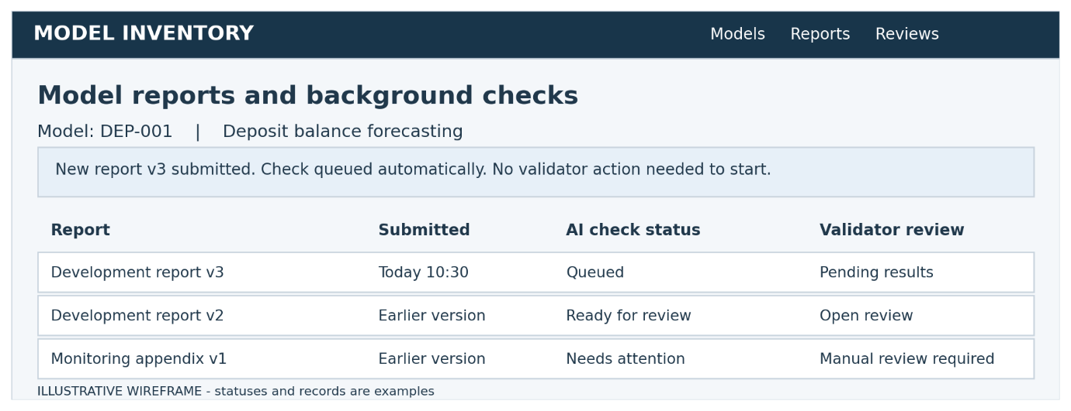
Screen 2 Validation evidence review
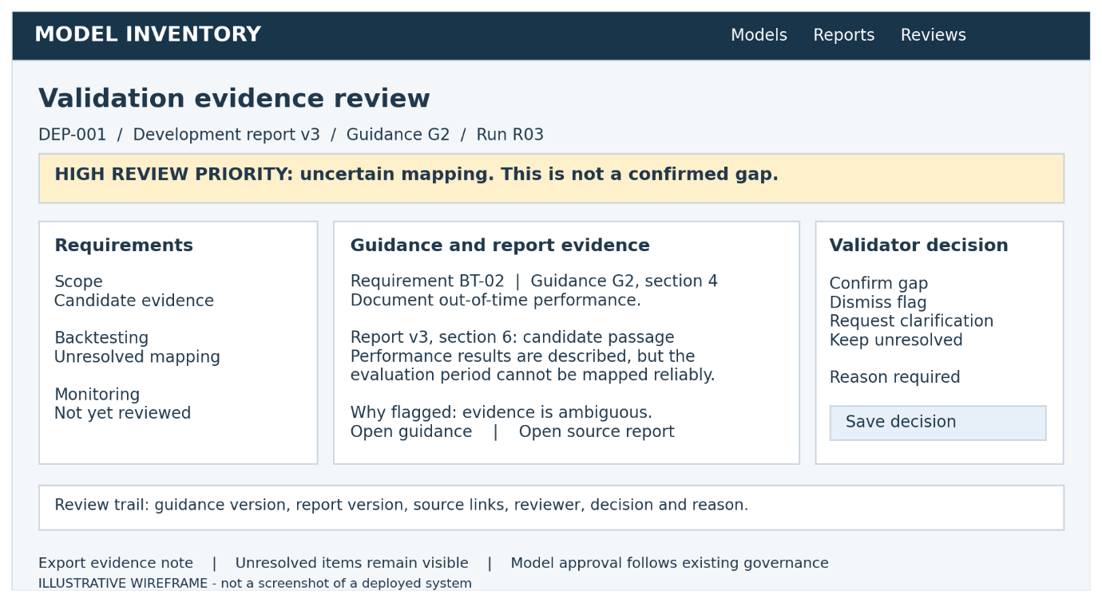
Display AI-processing and human-review statuses separately. Use text labels alongside color and provide keyboard-accessible controls. A finished background check is not a validation approval.

Trust and Explainability
What does the user need to know? The tool proposes evidence mappings and potential gaps. It can miss a real issue or flag a complete report incorrectly. A missing passage is not proof that analysis was never performed. The validator decides whether evidence is sufficient and whether an official gap exists.
What must be visible? Applicable requirement and guidance reference; report and guidance versions; submission and check times; processing status and incomplete sections; cited excerpts with source locators; why an item was flagged; evidence status; review priority; validator decision and reason; unresolved items and prior review history. When a revision is submitted, identify the older results as superseded. Source access must follow portal permissions, including excerpts and exports.
What should be hidden? Unnecessary technical detail such as embeddings, token counts and raw prompts belongs outside the normal validator workflow. Restricted sources must not appear in results. Do not expose internal chain-of-thought or unsupported confidence percentages. Provide concise evidence-based explanations, not claims that the AI has proved a conclusion. Authorized support staff may access relevant operational diagnostics under institutional controls.

Uncertainty Handling
High confidence behavior: Where evidence maps clearly to a requirement, show Candidate evidence with citations and Standard review priority. Require validator verification before acceptance. Do not auto-close the requirement or assign model approval. Use confidence categories only after evaluation supports their meaning; avoid uncalibrated numerical scores.
Low confidence behavior: If the tool cannot reliably recognize a gap or map the report to guidance, assign High validator-review priority and Unresolved - mapping or evidence uncertainty. Show the relevant requirement, attempted mapping, available sources and a concise reason. The validator checks the report before confirming or dismissing a gap. Keep review priority separate from gap severity and confidence: a higher review rating indicates a need for human attention.
Failure or fallback behavior: Missing guidance, unreadable sections, inaccessible sources, conflicting versions or a processing failure must produce a visible Needs attention status. Identify the affected requirements and leave them unresolved. The validator continues using manual review and approved search. A retry may be offered after the cause is addressed, with a new run record; it must preserve prior decisions. Repeated mapping failures, material quality failures or unauthorized disclosure pause the affected AI capability and trigger escalation. Resume only after correction, testing and the relevant owner's approval.
When some requirements finish and others fail, show partial coverage explicitly and route failed items to High review priority. Check a sample of apparently supported items for silent misses; an incorrectly confident mapping may not trigger the uncertainty route.

Human-in-the-Loop
Validators confirm the applicability of the selected guidance and checklist before relying on the results. Background processing may prepare candidate mappings in advance, but they remain provisional until this confirmation. Validators inspect evidence, confirm or override each reviewed item and record a reason. They may correct a mapping without declaring a gap, request developer clarification or escalate material ambiguity to the validation lead. Official gap severity is assigned only after human confirmation.
Developers respond through the portal's existing clarification process and submit revisions through the inventory. The validation lead adjudicates material disagreement; engineering investigates technical failures; security handles access or disclosure incidents. All handoffs retain the model, report, guidance and run identifiers. Prior records remain traceable, and unresolved issues cannot be hidden by exporting a clean summary. Final model approval remains with the institution's established validation authority.

Data, Model, and Evaluation Strategy

Problem as AI Task
ModelTrace combines retrieval and ranking with evidence-status classification. It runs in the background when a new model report or version is submitted to the model inventory portal. For each applicable validator-created requirement, it retrieves relevant passages and proposes one of four states: Candidate evidence, Potential gap, Unresolved mapping or evidence uncertainty, or Explicit inconsistency. These are assistance states, not final validation judgments.
Language-based matching connects differently worded requirements and report passages. Evidence assessment then considers whether the cited passages address the requirement. Retrieval alone cannot establish that a requirement is satisfied. A potential gap may reflect incomplete documentation rather than an underlying model defect; the validator makes that distinction. Generating clarification questions is a later option, conditional on reliable evidence mapping.

Data Sources
Internal: Approved model development reports and appendices; model inventory metadata; validator-created guidance, policies, checklists and review criteria; historical validation reports, clarification logs and issue records where authorized. Record model ID, document ID, report version, guidance version, effective dates, access scope and source locators. The initial use case is one deposit balance forecasting model family. The MVP checks report evidence rather than ingesting raw customer-level modeling datasets.
External: No external data is required for the initial use case. The tool relies on institution-approved internal sources, with no public-web retrieval or external hosted model API. Any later external source requires a separate decision on relevance, handling and approval.
User-generated: Validator-confirmed checklists, corrected evidence mappings, decisions, reasons and developer clarification responses entered within the portal. These remain internal confidential records. They are candidates for adjudication, not automatic training truth; reviewer acceptance alone does not prove correctness.
For the assignment, use synthetic versions of these internal document types. A real-data pilot requires institutional permission and an approved internal environment. Check parsing quality, tables, page references, missing sections, scanned documents and inconsistent versions before evaluating model behavior. Preserve access restrictions in passages, indexes, outputs and exports. Treat source content as evidence, not instructions to the AI.

Labeling / Ground Truth
Use the model-report-version and applicable requirement as the evaluation unit. Create a written labeling guide defining what evidence is needed for each requirement and what counts as a documentation gap, insufficient evidence, explicit conflict or unclear applicability. Distinguish a documented limitation from a missing required analysis.
Two qualified validators should independently label each held-out requirement and identify supporting report passages. A validation lead adjudicates disagreements. Record the requirement ID, applicability, reference evidence, gap type, materiality and rationale. Preserve unresolved label disputes for separate reporting rather than forcing false certainty. Assess agreement before adjudication to identify ambiguous guidance.
Use historical findings only as starting points: past reports may omit issues, reflect different guidance or contain superseded judgments. Independently inspect both flagged and apparently complete requirements to identify genuine negatives and missed gaps. Combine duplicate flags before scoring; distinguish genuinely uncertain cases from definite gaps and definite non-gaps.
Keep model families and related document versions together when splitting development and evaluation data. For a single-family prototype, keep related report packs together and report the limited generalization. Keep the held-out labels outside the runtime retriever. The applicable guidance is legitimate runtime input; future reports, future clarifications and finalized findings must not leak into a run on an earlier report version. Do not use later evidence unless it was available at that review snapshot.

Baseline
Compare ModelTrace with the existing manual validation workflow: a validator uses the same approved checklist, report pack and keyword search to identify evidence and potential gaps. Give both conditions the same source access and review scope. A secondary technical baseline can rank passages using keyword matching or TF-IDF without semantic matching or AI gap assessment.
Measure total task time, including evidence search, source verification, investigation of false flags, correction and clarification effort. Use distinct but matched report tasks and balance reviewer experience and report complexity. Randomize condition and order where practical. Compare final evidence quality as well as time: faster completion with more material misses is not success.

Model / API Choice
Build the application and workflow internally. Use deterministic controls for submission triggers, report-guidance version matching, source eligibility, permissions, review status and decision logging. Start with a frozen lexical baseline; compare it with an institution-approved, internally hosted embedding model and reranker for semantic retrieval.
If the institution has an approved internally hosted language model, evaluate it for evidence-status assessment using the applicable requirement and retrieved passages. Require structured outputs containing requirement ID, proposed status, citations and a concise evidence-based rationale. Use explicit uncertainty routes rather than forcing a gap or no-gap decision. If adequate evidence cannot be retrieved, leave the requirement unresolved for High validator-review priority; absence of retrieved text does not prove a gap.
No external hosted model API is proposed. Model size and deployment configuration depend on internal infrastructure, licensing, quality and support capacity; no specific model is assumed to be approved. Internal model-service calls may be used within the approved boundary. Do not train a foundation model from scratch for the MVP. Consider fine-tuning only after enough adjudicated examples exist and evaluation demonstrates a need.
Record parser, retrieval, model, prompt and policy versions for each run, together with the model ID, report version and guidance snapshot. A new report submission triggers a new check; duplicate event delivery must not create duplicate reviews. Results remain tied to their own report versions. Validate each component and the full workflow separately, since a correct citation can still support an incorrect conclusion.

Evaluation Framework
All numerical targets below are proposed decision gates, not observed results. Report counts, denominators and uncertainty, alongside results by review area, materiality, document quality and supported model family. Account for clustering within report packs when assessing uncertainty.
Metric Type | Metric | Why It Matters
Technical | Retrieval recall at a fixed k: reference passages retrieved / reference passages labeled relevant; fix k before the held-out test | Tests whether the assessment stage receives the evidence it needs. Retrieval success alone does not prove correct gap detection.
Technical | Gap recall = TP / (TP + FN); gap precision = TP / (TP + FP), with duplicate flags combined | Measures genuine gaps caught and unnecessary investigations. Unresolved real gaps are not counted as correctly detected gaps until the validator confirms them; report AI-only and assisted-workflow results separately.
Technical | Evidence-status agreement and unresolved-case rate | Tests the proposed routing states and reveals whether apparent safety is achieved by referring almost everything to humans. Report confusion between gap, supported, conflict and uncertainty states.
Business | Median end-to-end task-time reduction versus matched manual reviews, with final quality checked independently | Measures whether the tool saves effort after source checking, false flags and corrections.
Business | Productive validator utilization: substantive review, testing and model-challenge hours / available validation work hours | Tests whether released capacity is actually used for higher-value validation work. Use consistent time categories, exclude leave and agreed non-validation commitments, and track working hours.
Trust / Guardrail | Citation support and critical unsupported conclusions | Tests whether statements are supported by cited text and whether any output could materially mislead the reviewer.
Trust / Guardrail | Uncertain-mapping referral coverage, silent material misses and High-priority referral volume | Checks whether mapping failures reach validators before a gap conclusion, while exposing missed failures and excessive manual-review burden.
Trust / Guardrail | Source-permission and version-isolation failures; decision-and-reason completeness | Tests confidentiality, current-version handling and human accountability, including excerpts, exports and background processing.

TP is a unique genuine gap correctly flagged against the adjudicated reference; FN is a reference gap missed; FP is an incorrect gap flag. For AI-only recall, a generic unresolved referral is not a TP. Evaluate whether assisted human review ultimately detects the gap, and include its effort. For definite reference gaps, unresolved AI results remain undetected in AI-only recall; label-ambiguous cases are reported separately. Test with complete reports, genuine omissions, paraphrases, contradictions, unreadable sections, wrong versions and adversarial source instructions.

Launch Thresholds
Proceed first to a supervised internal pilot, not unrestricted deployment, only when the following proposed gates pass on held-out material and institutional owners accept the permitted scope:
Genuine-gap detection: At least 90% AI-only gap recall and 85% gap precision, with TP, FP and FN counts and separate materiality results. No observed material gap miss in the agreed challenge set. These thresholds require an adequate independently labeled test set; zero observed misses is not proof of zero future risk.
Evidence and uncertainty: At least 95% of assessed output statements supported by their citations, with no critical unsupported conclusion. All detected mapping failures route to High validator-review priority and an unresolved status before any gap declaration. Evaluate silent misses independently; do not infer referral reliability only from failures the system already recognizes.
Human control: Every reviewed requirement retains a validator decision and reason. Unresolved items remain visible and prevent the review being presented as complete. High review priority does not assign gap severity or establish that a gap exists.
Efficiency and utilization: At least 20% lower median total review time on comparable tasks without worse independently assessed quality. Target at least a 10-percentage-point rise in productive utilization without increased working hours; confirm over a sufficient observation period before expansion. Define an acceptable quality margin and sample size before the pilot rather than treating a nonsignificant difference as proof of equal quality.
Handling and operations: Institution-approved data handling and source access; no unauthorized disclosure or cross-version leakage in the agreed tests; validated duplicate-event handling; visible processing failures; and named validation, engineering, support and security owners. Keep the check's completion status distinct from validation approval.
If a requirement cannot be mapped reliably, route it to High-priority validator checking and leave it unresolved until reviewed. Repeated mapping failures, material quality failures or handling incidents pause the affected AI capability and return the workflow to manual review with approved search. Preserve prior outputs and decisions, investigate the cause and require regression evidence and owner approval before resuming.

Ethics, Governance, and Risk Note

Main Risks
Risk 1 - Bias and uneven review quality: The tool may perform better on familiar model families, standard report formats and well-documented requirements than on unusual models, scanned tables or ambiguous guidance. Historical findings and reviewer feedback may encode inconsistent judgments. Treating these records as unquestioned truth could reproduce those differences and miss material issues in less familiar reports.
Risk 2 - Privacy and confidentiality: Developer reports, internal guidance, governance questions and review records may contain confidential modeling information or personal data. Unauthorized retrieval, excessive permissions, exports, caches or logs could expose information across models or teams. Internal hosting alone does not establish confidentiality, and access to the inventory portal does not imply access to every model document.
Risk 3 - Hallucination, unsafe conclusions and misuse: The AI may invent a gap, cite a passage that does not support its conclusion, miss a genuine omission or present an uncertain mapping as complete. Reviewers may over-rely on a confident output. Source instructions may attempt to manipulate the check, and users may misuse flags as automatic findings, employee rankings or grounds for model approval without independent assessment.

Harm Scenarios
Who could be harmed | Scenario and consequence
Validators and validation leads | A convincing but unsupported evidence mapping hides a material gap. The reviewer reduces independent checking, and the final validation conclusion becomes less reliable.
Model developers and model owners | An uncertain mapping is labeled as a confirmed gap or assigned unwarranted severity. Unnecessary remediation, unfair escalation and delays follow.
The financial institution and potentially its customers | A missed material issue contributes to an inadequately challenged model being used. Any downstream effect depends on the model and its use; ModelTrace must not claim that its review prevents losses or establishes model soundness.
Document owners, employees or customers whose information appears in reports | A cross-model permission failure or unrestricted export reveals confidential information or personal data.
Teams using uncommon models or nonstandard documentation | Lower detection quality produces uneven scrutiny, repeated false flags or excessive manual referrals. Report style is mistaken for model quality.
Reviewers and developers | Management treats AI acceptance rates, flag counts or utilization measures as individual performance scores, creating pressure to accept outputs or avoid raising issues.

Controls
Guardrails: Build and operate within the institution-approved environment using approved internal sources and internally hosted models where available. Apply source-level permissions during ingestion, retrieval, background processing, display and export. Minimize unnecessary personal data; keep sensitive content out of general operational logs. Control encryption, retention, deletion and cache scope under institutional policy. Version reports, guidance and run configurations; keep old results attached to their own report versions. Treat source text as untrusted evidence and test instruction-injection attempts. Use structured outputs with requirement IDs and source locators, and check citation support. Do not issue autonomous model approval, finding closure or official gap severity. Compare quality by model family, requirement type, document format and parsing quality; restrict supported use where performance is insufficient.
Review process: Every reviewed requirement needs a validator decision and reason. If the tool cannot recognize a gap reliably or map the report to guidance, assign High validator-review priority and Unresolved - mapping or evidence uncertainty. The validator checks the guidance and report before confirming a gap, dismissing the flag, correcting the mapping or requesting clarification. Review priority is separate from gap severity and confidence. Unresolved requirements remain visible and prevent a review being presented as complete. Inspect samples of apparently supported requirements for silent misses; the uncertainty route cannot catch every confidently incorrect result. Two qualified validators independently label held-out evidence, with a validation lead adjudicating disagreements. User feedback is reviewed before it becomes evaluation or training material.
Escalation path: The assigned validator handles individual uncertain mappings. The validation lead adjudicates material ambiguity or disagreement; developers provide clarification through the portal's existing process. Engineering investigates parsing, retrieval, model and submission-trigger failures. Security and data owners handle access or disclosure incidents. Repeated mapping failures, material quality failures or unauthorized disclosure pause the affected AI capability and return users to manual review and approved search. Preserve prior records and reassess affected unreviewed outputs. Resume only after correction, regression evidence and authorization by the relevant institutional owner.
Logging / auditability: Record model ID, report and guidance versions, submission time, run ID, parser and model configuration versions, proposed status, review priority, source references, reviewer decision, reason and escalation history. Record processing failures, permission checks and exports. Store the evidence trail under controlled access and retention, with mechanisms to detect unauthorized alteration. Log only what is needed for traceability; avoid unrestricted raw document or prompt capture. A new report triggers a new check without overwriting earlier decisions. Prevent duplicate submission events from creating duplicate reviews. Distinguish AI-check completion from human-review completion and model approval.
The product owner is responsible for permitted use and scope; the validation lead owns evidence quality and human adjudication; engineering owns reliable operation; security and data owners approve handling controls. The institution's existing governance authority retains model approval. These are proposed responsibilities to assign before a pilot, not claims of regulatory compliance or institutional endorsement.

Launch Blockers
Pause or reject a pilot or rollout if any of the following applies:
Confidentiality or handling failure: Real documents are used without the institution's approval; source permissions cannot be enforced; an unauthorized disclosure occurs; or retention, export and incident ownership are unresolved. Investigate and verify remediation before any resumption.
Material quality failure: A material reference gap is missed in the agreed challenge set, a critical unsupported conclusion appears, or the proposed evidence-quality gates are not met. Proposed gates include at least 90% AI-only gap recall, 85% precision and 95% citation support on adequately sized held-out material. Report test coverage and uncertainty; passing a small test does not establish safety.
Unsafe uncertainty handling: Detected mapping failures are presented as resolved or confirmed gaps without validator review; High review-priority items have no clear owner; unresolved items disappear from the export; or the interface confuses a completed background check with validation approval. A high-priority referral alone does not count as a true-positive gap detection.
Unacceptable uneven performance: Performance for an intended model family, report format or requirement type is too weak for the agreed scope, or material differences remain unexplained. Narrow the supported scope or improve the system before including those cases. Do not hide weak segments behind an aggregate score.
Missing human or operational control: The tool permits approval or finding closure without the required authority; decisions lack reasons or traceability; report versions are mixed; duplicate triggers corrupt the review; or rollback and escalation cannot be demonstrated. Do not launch without named operational owners.
No defensible user benefit or evidence of misuse: Correction and false-flag investigation erase the efficiency benefit, review quality deteriorates, or utilization gains rely on longer working hours. Stop misuse of individual scores or AI flags as automatic judgments about staff or models. Refine or reject the product if benefits do not justify ongoing risk and cost.
An isolated uncertain requirement normally triggers manual checking of that requirement. A systemic or material failure triggers capability-level rollback. Final approval to proceed must document the supported use, residual risks, evaluation evidence and accountable owners; neither a high retrieval score nor a polished portal demonstration authorizes launch.

