MBA ZG583 · MANAGEMENT OF AI PRODUCTS
Appendix — Prototype Evidence (Complete)
UniConnect Operations OS — complete set of 66 screens captured from the live production system
Manoj Kumar Panchothi · 12 September 2026
Companion to 02_Final_Report — referenced from Section 8.6

How to read this appendix
Every screen in this appendix was captured on 12 September 2026 from the running UniConnect production system, not from a mock-up or a design file. Each figure carries the caption written for it and a line stating which section of the final report it supports, so a reader can move between the argument and its evidence in either direction.
Screens are grouped by what they prove rather than by menu order. Two groups deserve a note before you begin. Group C includes the live AI narrative layer with a visible error in it: the generated summary claims no operational activity for a day on which the same screen reports 355 of 369 sessions completed. That is the grounding failure listed as risk R1 in the report, shown from the system itself rather than asserted. Group E shows the budget approval path, which contains no AI at all by deliberate design, because approvals, spend thresholds and audit records have to be exactly correct.

A. The platform and its scoping model
What the platform is, and how the multi-tenant boundary is enforced. Everything later sits on top of this.
Figure 1 — Dashboard
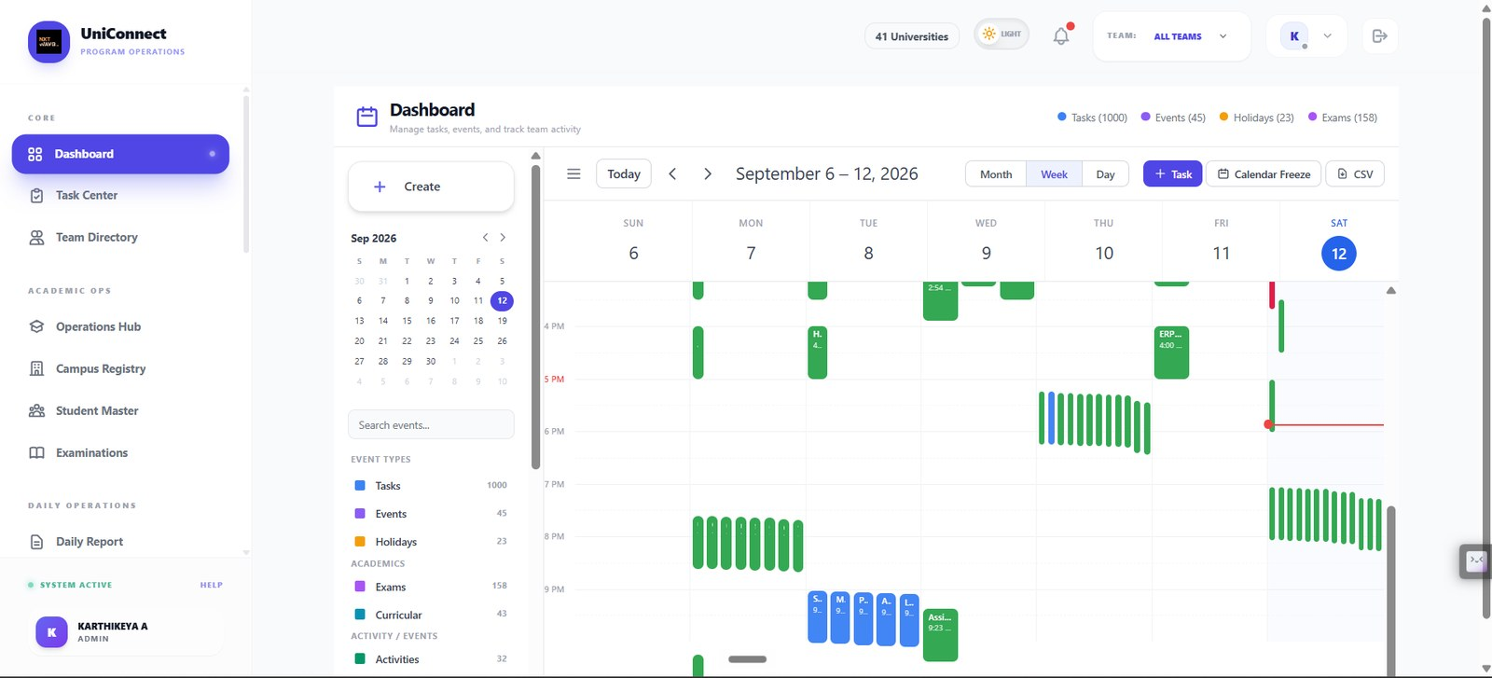
Unified operational calendar across 41 universities — tasks, events, holidays, exams and curricular items in one week view, with month/week/day switching and CSV export.
Supports: 8.2 Modules — Schedule Events; 4.2 reviewer journey
Figure 2 — Dashboard — New Task
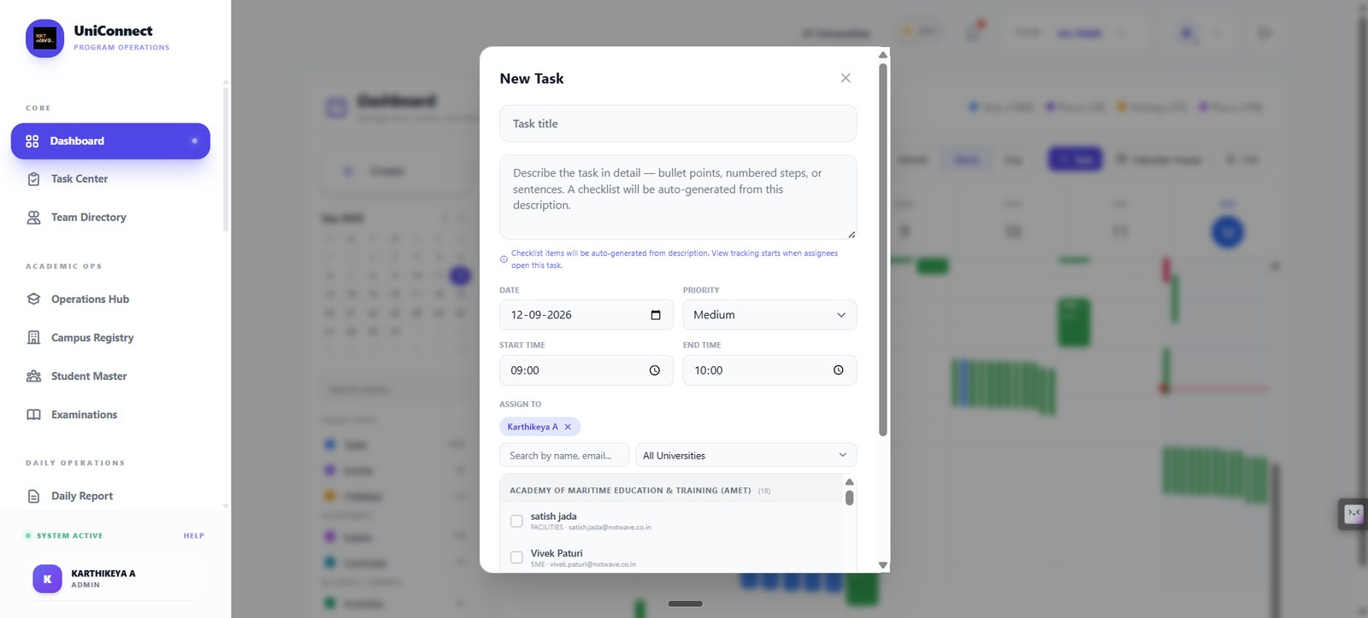
Task creation from the calendar. A checklist is auto-generated from the free-text description, and assignees are scoped by university.
Supports: 8.2 Modules — Task Centre
Figure 3 — Dashboard — Calendar Freeze
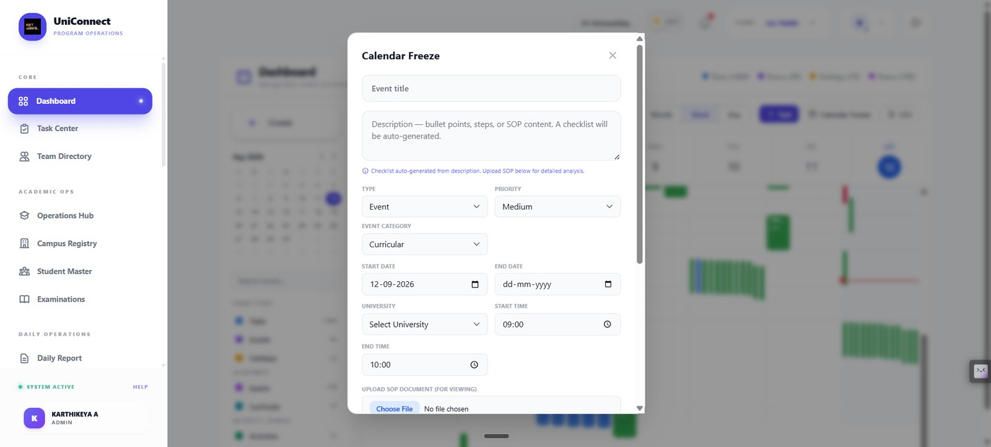
Calendar freeze entry with type, category, university scope and SOP document upload — how exam and activity blocks are declared.
Supports: 9.6 Disruption and change
Figure 4 — Calendar export
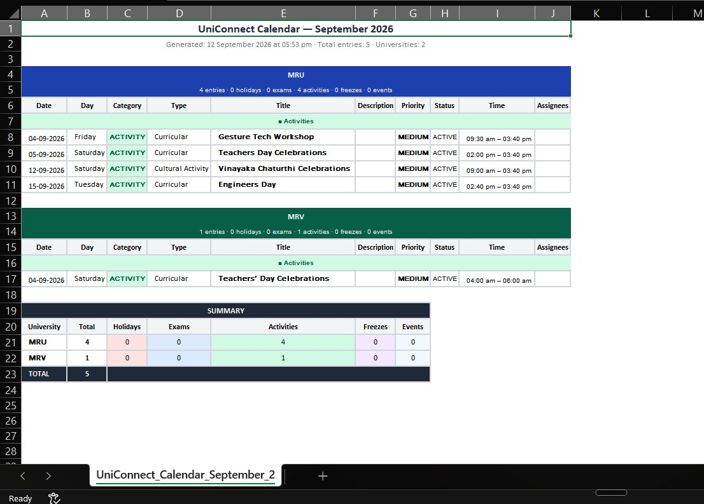
Generated September 2026 calendar export, grouped by university with a per-university summary of holidays, exams, activities, freezes and events.
Supports: 9.6; 6.2 auditability
Figure 5 — Task Centre
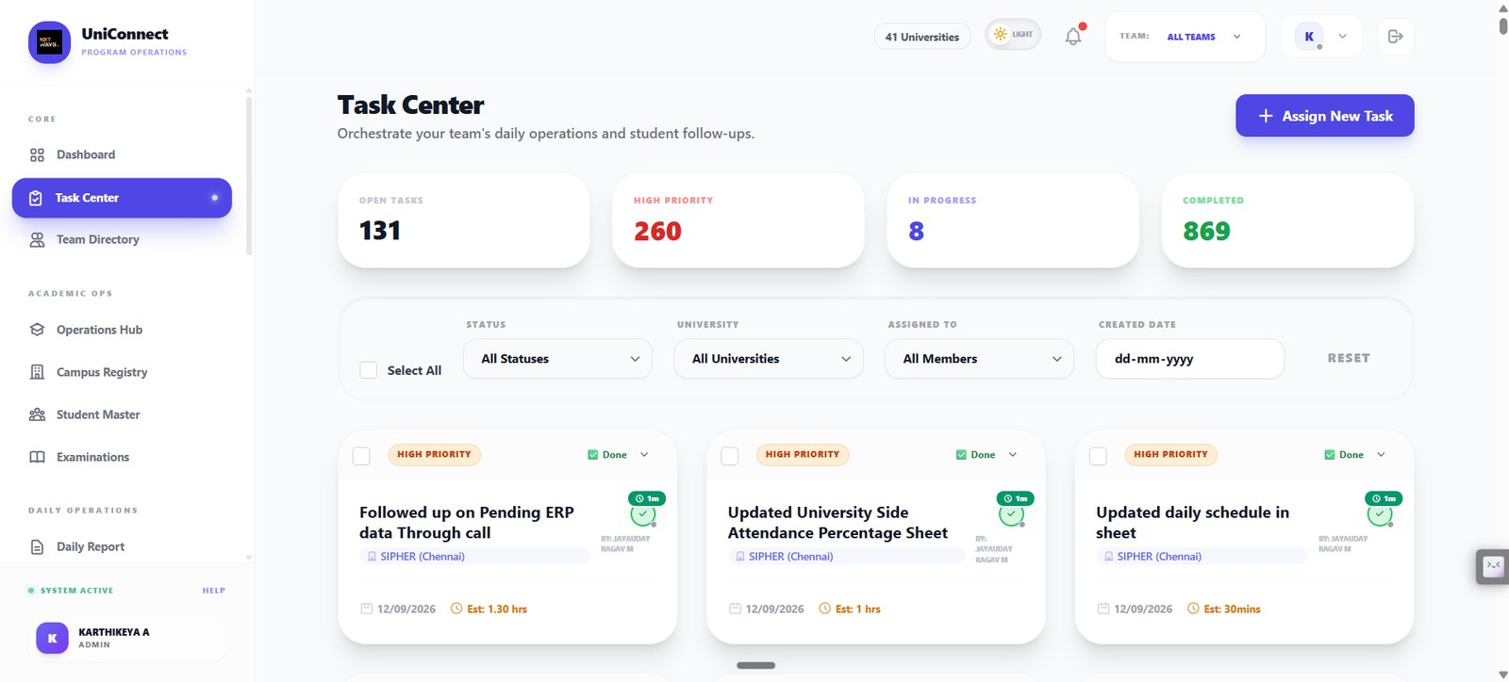
Task workload across the network — open, high priority, in progress and completed counts, with filters by status, university, assignee and date.
Supports: 8.2 Modules — Task Centre; 3.1 problem statement
Figure 6 — Task Centre — Design New Task
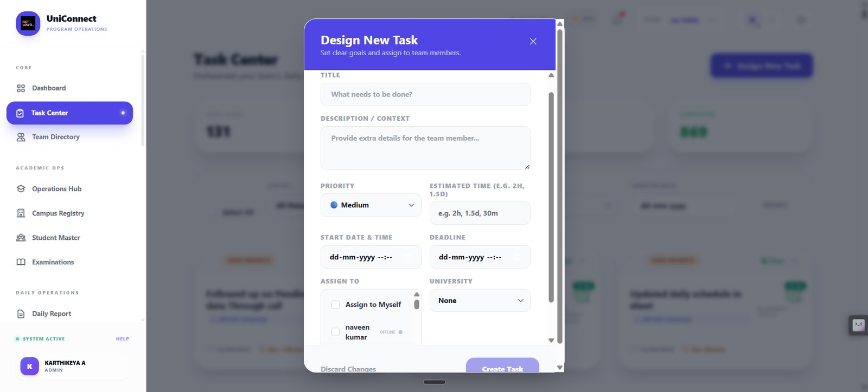
Task assignment with priority, estimated time, start and deadline, and university scoping.
Supports: 8.2 Modules — Task Centre
Figure 7 — Team Directory
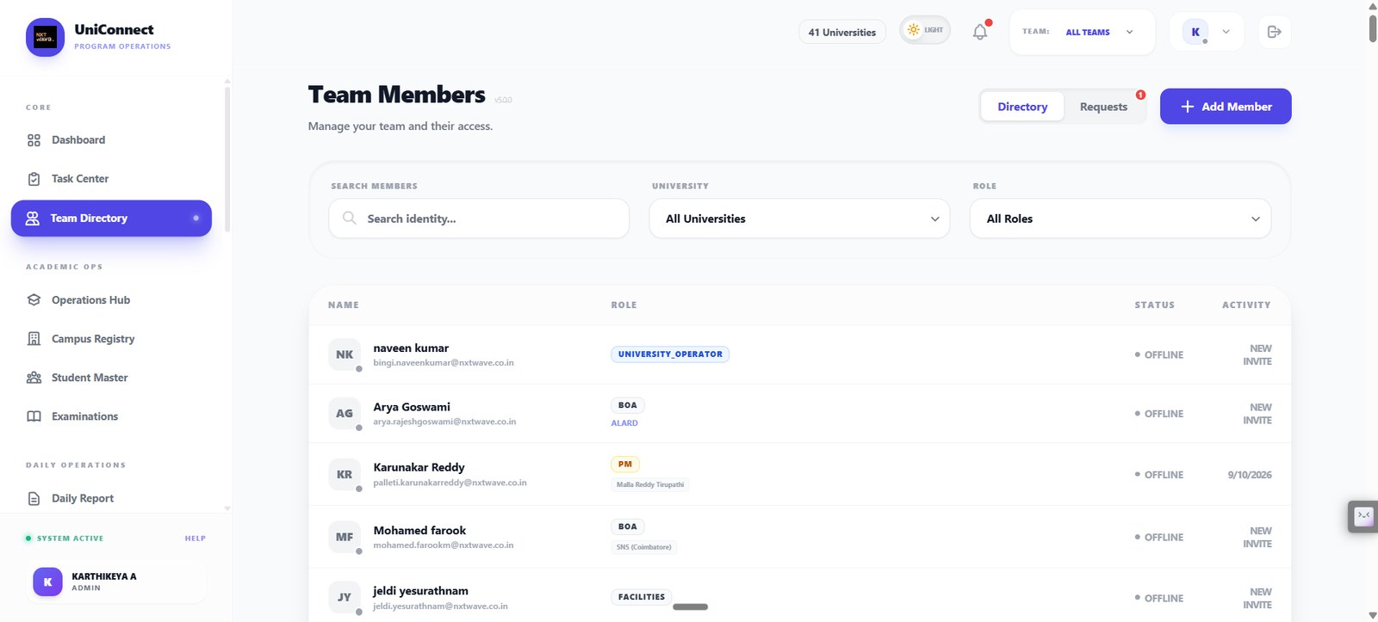
Role-scoped team directory showing the live role model in production — BOA, PM, University Operator, Facilities — each bound to a university.
Supports: 8.3 Core model — role-to-permission matrix; 7.3 control R4
Figure 8 — Campus Registry
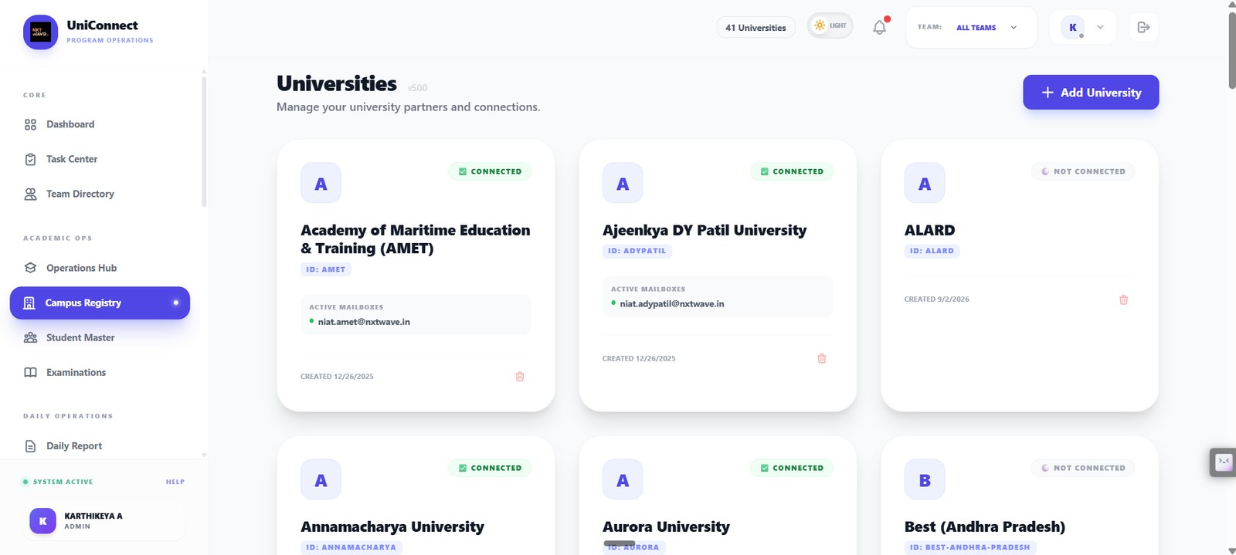
University partners with connection status and active mailboxes per institution — the multi-tenant spine where the university is the scoping key.
Supports: 8.3 Core model; 6.1 multi-tenancy
Figure 9 — Academic Operations Hub
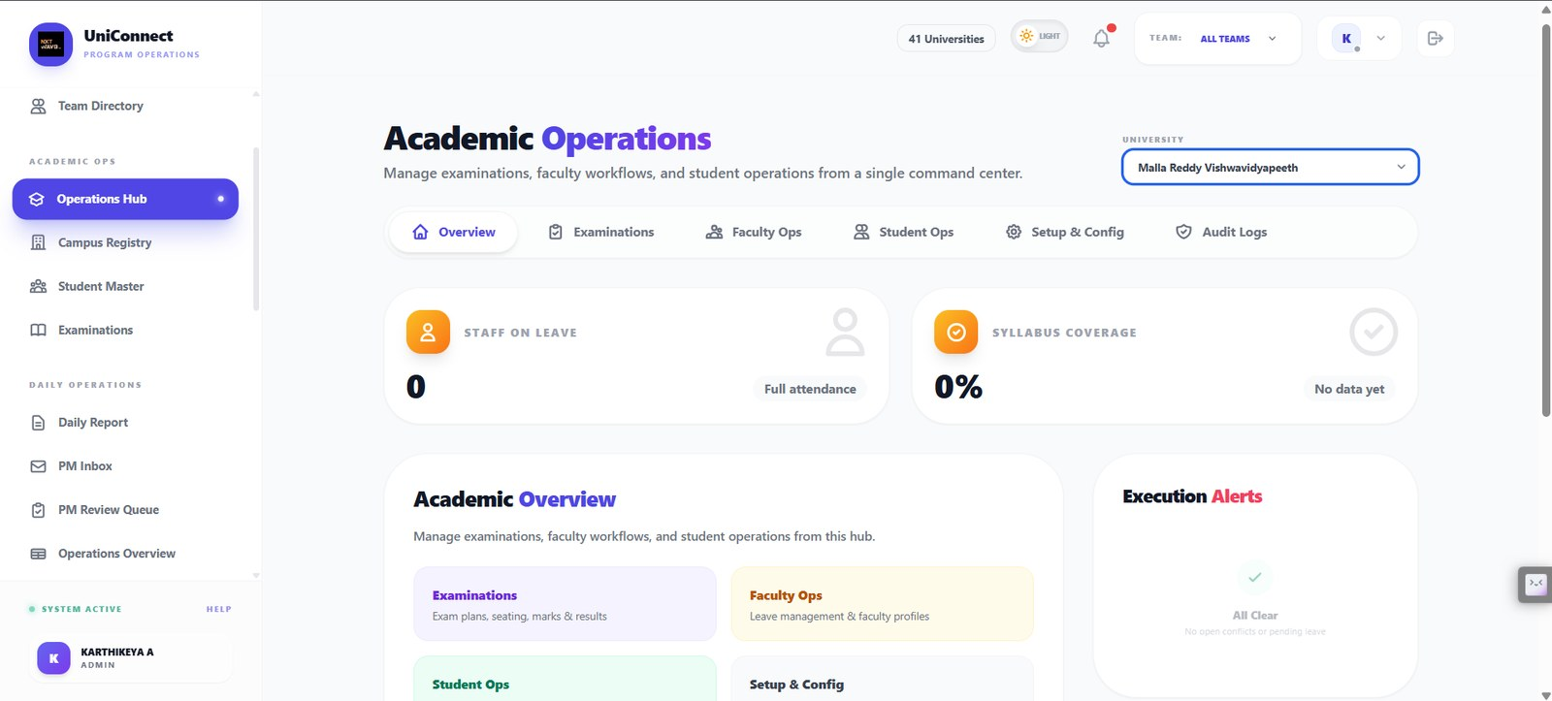
The per-university command centre: examinations, faculty ops, student ops, setup and audit logs, with staff-on-leave, syllabus coverage and execution alerts.
Supports: 8.2 Modules — Academic Operations Hub

B. Access control and privacy
Section 7.3 lists campus scoping and audit as controls and Section 7.4 commits to data minimisation. These are those controls in the product.
Figure 10 — Access Rights — Feature Management, Admin role
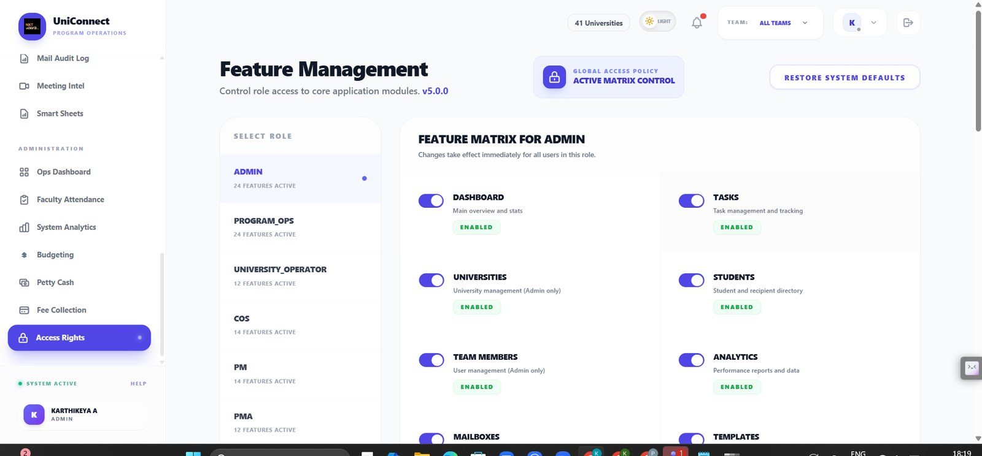
The live role-to-permission matrix. Each role holds its own set of module toggles, changes apply immediately to every user in that role, and system defaults can be restored. Admin holds 24 active features.
Supports: 8.3 Core model — role-to-permission matrix; 7.3 control for R4
Figure 11 — Access Rights — Feature Management, BOA role
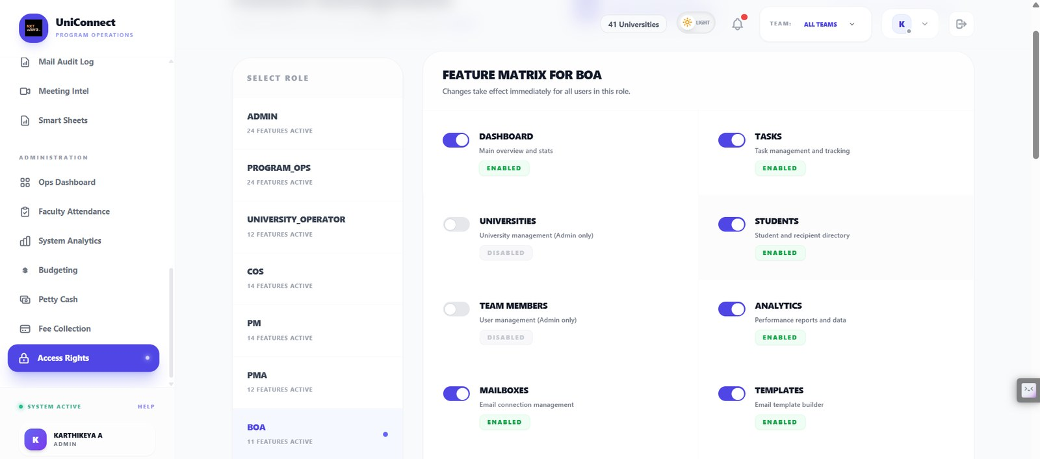
The same matrix for the Business Operations Associate, who holds 11 features rather than 24: university management and team-member management are switched off, while the modules the daily job needs remain on. The role list shows seven roles with genuinely different footprints — this is scoping enforced in production, not an access model described on paper.
Supports: 8.3 Core model; 7.1 risk R4; 7.3 controls
Figure 12 — Student record — Security PIN gate
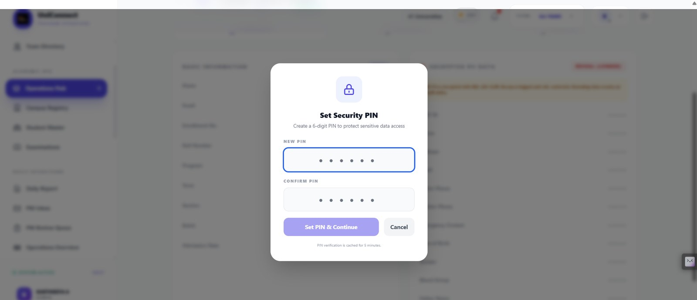
Sensitive fields sit behind a second factor. A six-digit PIN is set per user, verification is cached for five minutes only, and the record behind the dialog stays blurred until it is entered. Access to personal data is a deliberate act rather than a side effect of opening a page.
Supports: 7.3 controls; 7.4 privacy position
Figure 13 — Student record — Encrypted PII with logged reveal
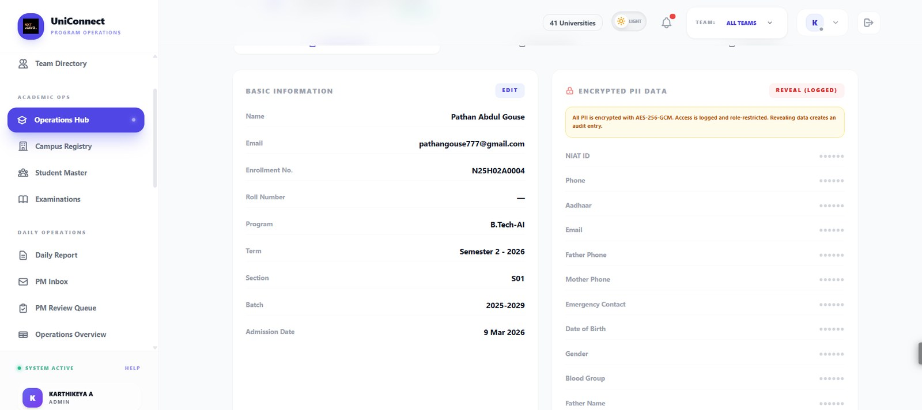
Ordinary academic fields on the left are freely visible; identifiers on the right — phone, Aadhaar, parent contacts, date of birth and the rest — are encrypted with AES-256-GCM, masked by default, and can only be revealed through an action that is role-restricted and writes an audit entry. The banner states this on the screen, so the person about to reveal the data knows it is recorded.
Supports: 7.4 privacy position; 7.3 immutable audit log; 7.1 risk R5
Figure 14 — Operations Hub — Student directory
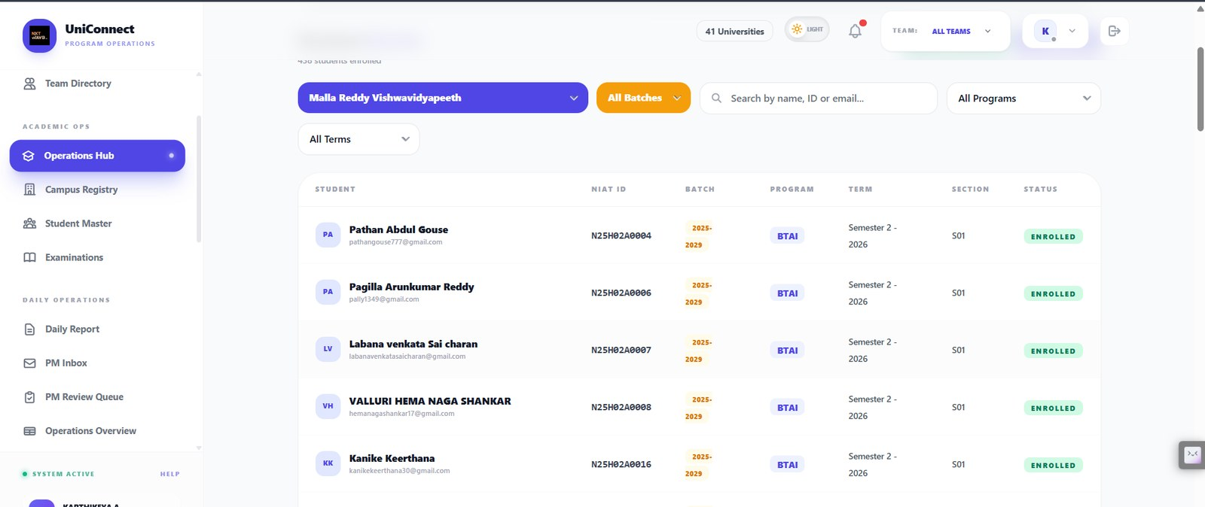
Enrolled students for one university with NIAT ID, batch, programme, term, section and status. The university filter is the scoping key, so an operator bound to one campus cannot widen the view from here.
Supports: 8.3 Core model; 6.1 multi-tenancy

C. The daily operations spine
Section 3 defines the problem as a reviewer deciding which campus reports need attention in a short evening window. This is the workflow that happens on.
Figure 15 — Daily Report — submission form
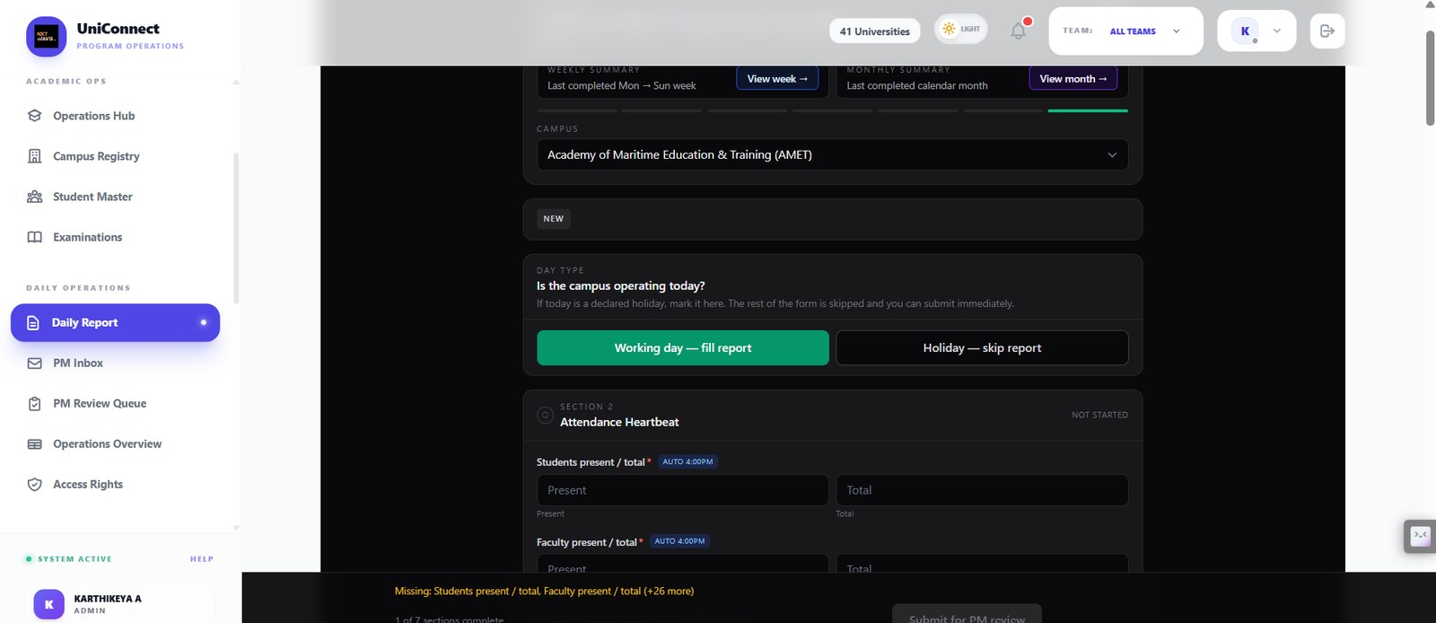
The BOA's daily submission. A holiday can be declared to skip the form; otherwise seven sections must be completed, with an auto-populated 4:00 PM attendance heartbeat and a live list of what is still missing before it can be submitted for PM review.
Supports: 3.3 core workflow step 1; 8.2 submission spine
Figure 16 — PM Review Queue
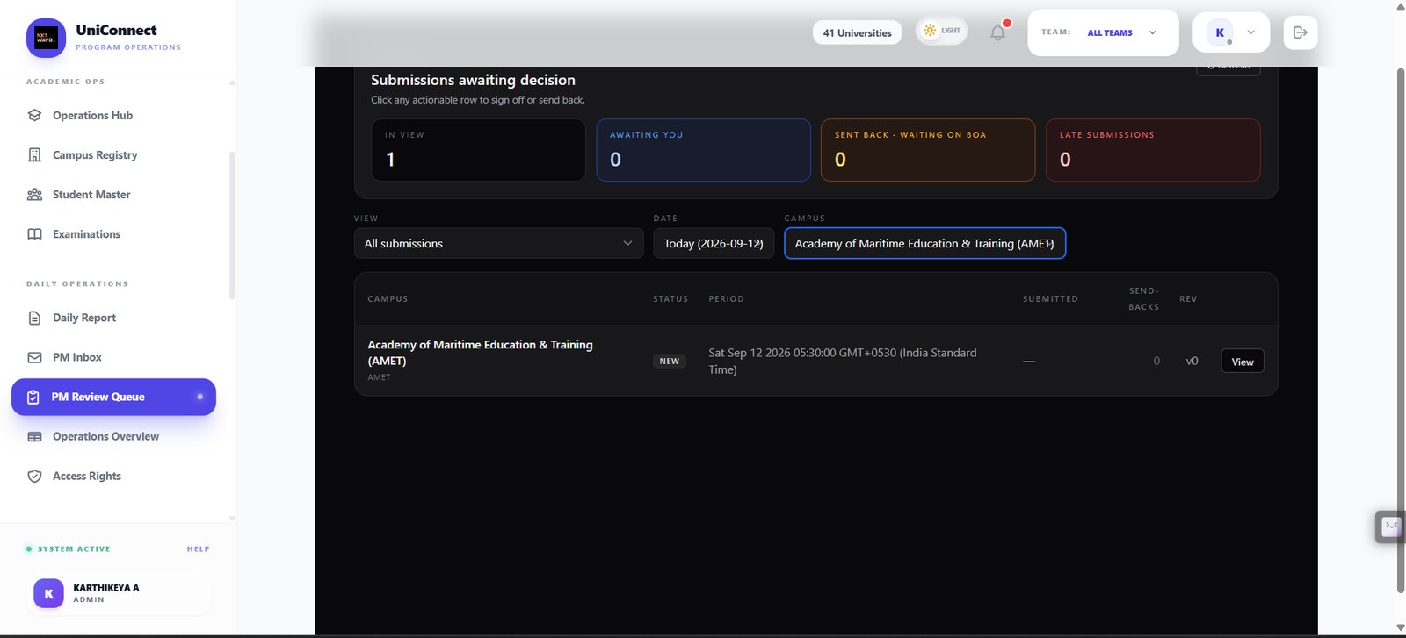
Submissions awaiting decision, split into in view, awaiting you, sent back and late, filtered by date and campus, with send-back count and revision number per row. This is the review surface the triage layer in Section 3 is designed to rank.
Supports: 3.1 problem statement; 4.2 reviewer journey
Figure 17 — Operations Dashboard — Overview
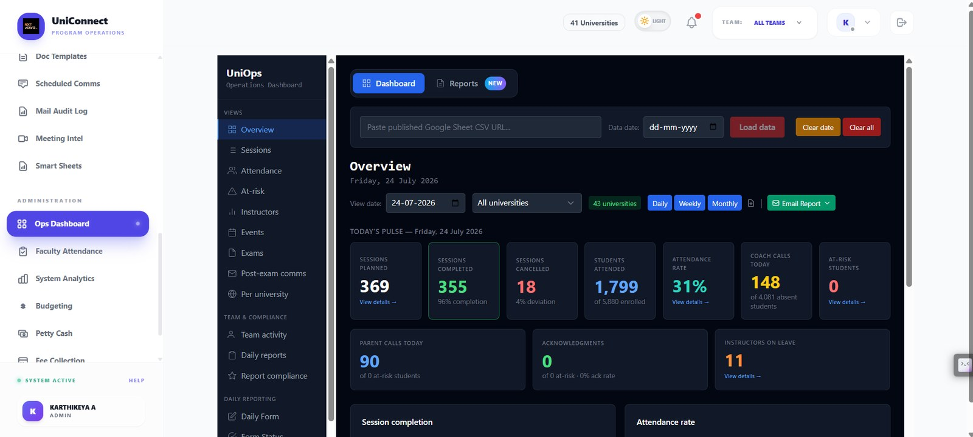
Today's operational pulse across 43 universities: sessions planned and completed, cancellations and deviation, attendance rate, coach calls, at-risk students, parent calls and instructors on leave — with daily, weekly and monthly views.
Supports: 5.1 numeric anomaly detection is deterministic; 4.4 facts versus generated text
Figure 18 — Operations Dashboard — Sessions
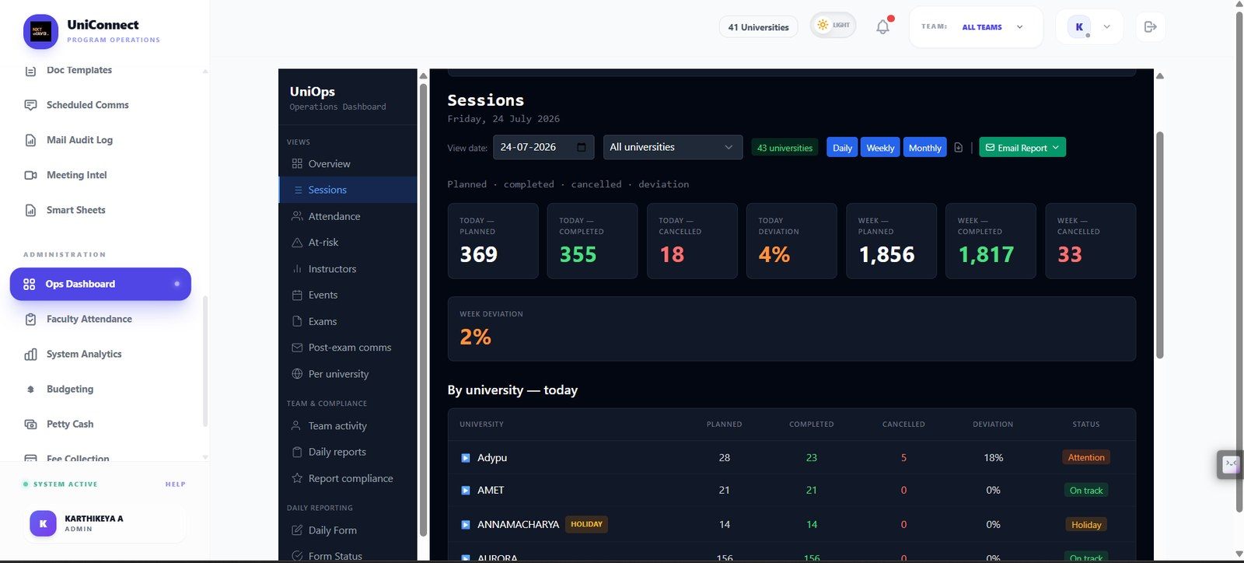
Session delivery by university with planned, completed, cancelled and deviation columns and an on-track / attention / holiday status per institution — the rules-based numeric layer that runs alongside any AI assistance.
Supports: 5.4 rules-only baseline; 5.1
Figure 19 — Operations Dashboard — Attendance
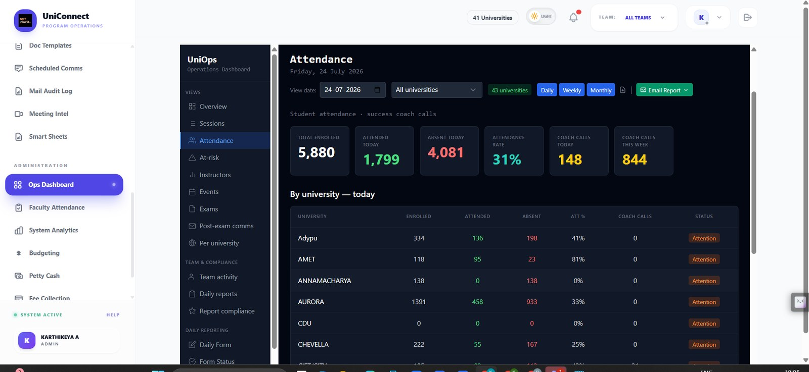
Student attendance and success-coach calls per university for the day, with enrolled, attended, absent, attendance percentage and an attention flag per institution.
Supports: 5.1 deterministic numeric layer; 5.4 rules-only baseline
Figure 20 — Operations Dashboard — Instructors
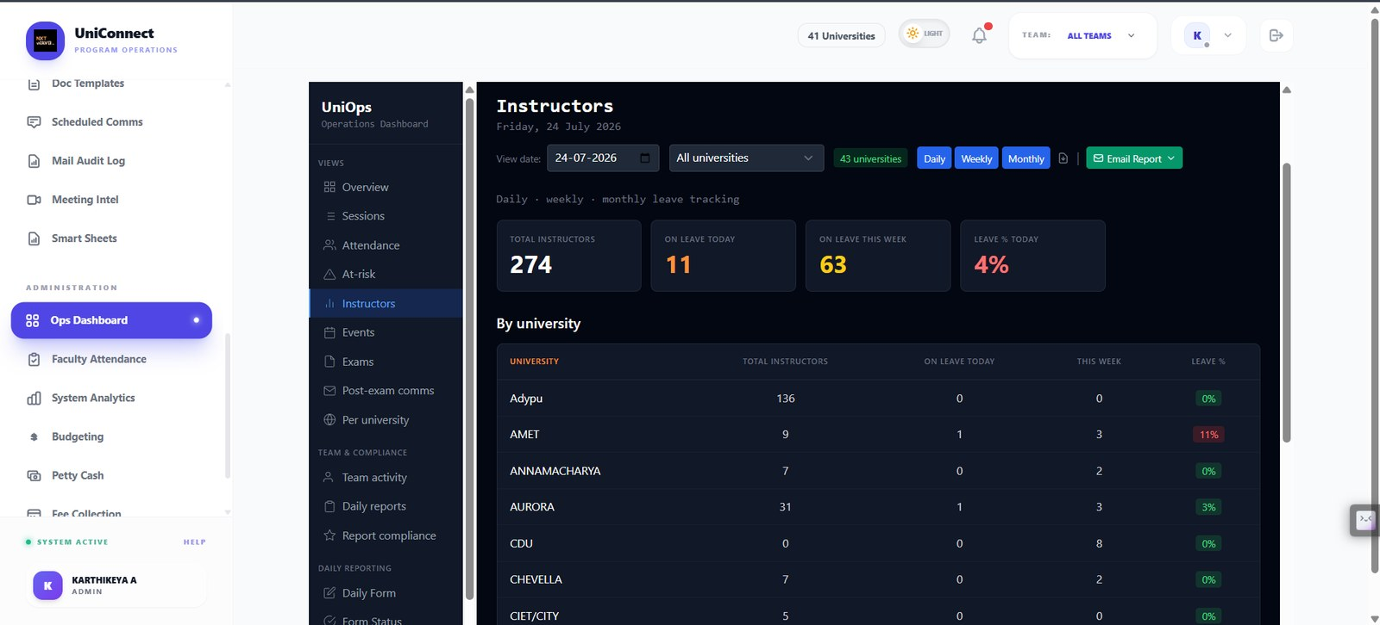
Instructor leave tracking across the network — total instructors, on leave today and this week, and leave percentage per university.
Supports: 5.2 data sources; 9.5 invigilation load
Figure 21 — Operations Reports — daily detail
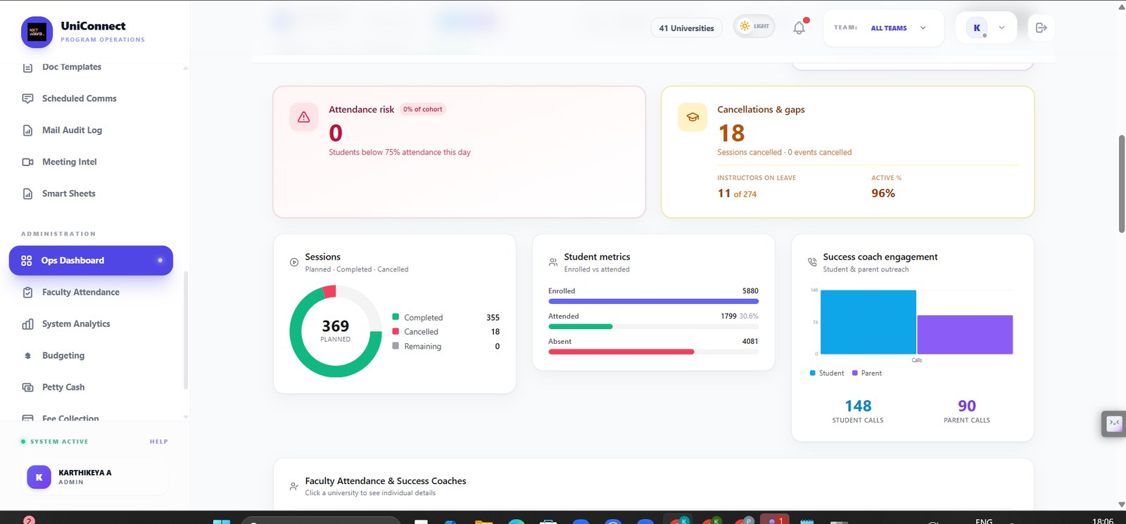
Attendance risk, cancellations and gaps, session completion, student metrics and success-coach engagement for the day, computed from records rather than generated.
Supports: 4.4 facts versus generated text; 5.1

D. The AI layer as it runs today
The narrative reporting layer is live. It is shown with its failure visible rather than in its best light, because that failure is the risk the report is built around.
Figure 22 — Operations Reports — Ops Copilot
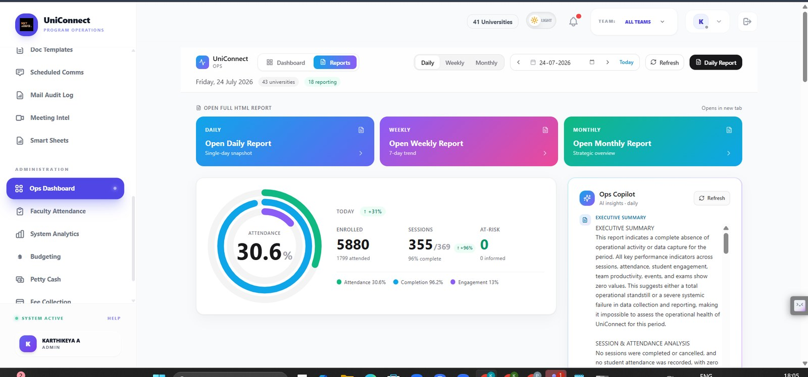
The shipped AI narrative layer: daily, weekly and monthly reports with a generated executive summary beside the deterministic figures. Note the summary states a complete absence of activity while the same screen reports 355 of 369 sessions completed — a live example of the grounding failure Section 7.1 lists as risk R1.
Supports: 1.3 shipped AI; 7.1 risk R1; 11.4 where AI was wrong

E. Team analytics
These screens report task completion, speed and on-time rate per team member. Every figure on them is a deterministic count drawn from the task system rather than a generated judgement, which is the distinction Section 2.4 draws when it rejects AI-scored staff performance and risk R7 when it rules out using model output in staff assessment.
Figure 23 — System Analytics — Team Overview
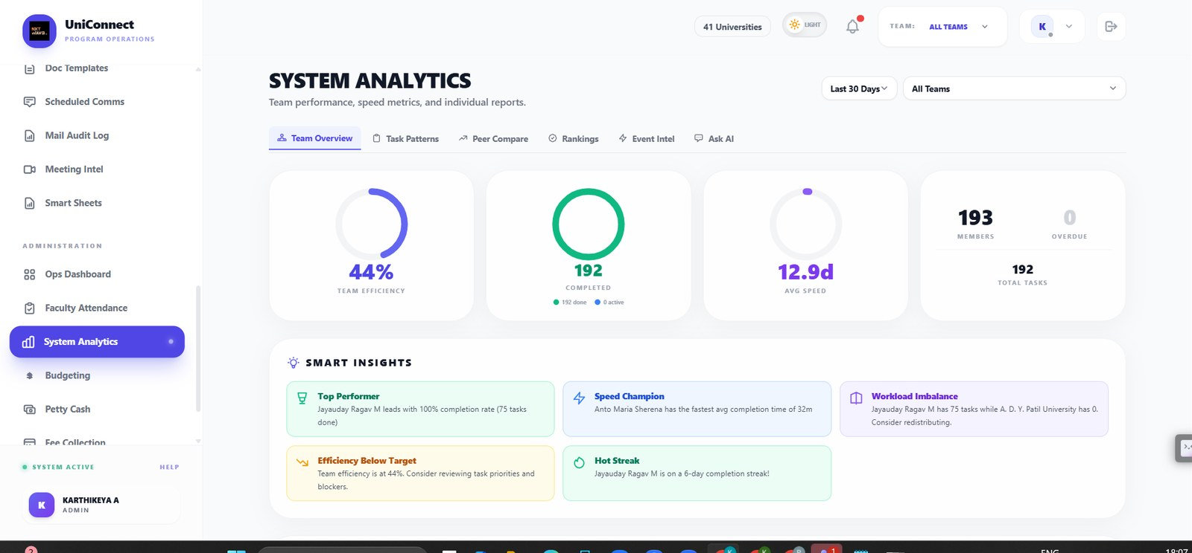
Team efficiency, completion, average speed and total tasks over 30 days, with generated Smart Insights beside them.
Supports: See note on R7 in Section 7
Figure 24 — System Analytics — Team Leaderboard
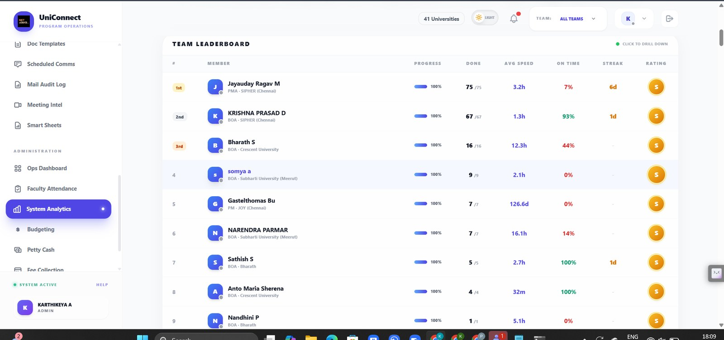
Per-member ranking by tasks done, average speed, on-time percentage, streak and rating.
Supports: Conflicts with Section 7.1 risk R7 and the 2.4 rejection of staff scoring
Figure 25 — System Analytics — Task Pattern Analysis
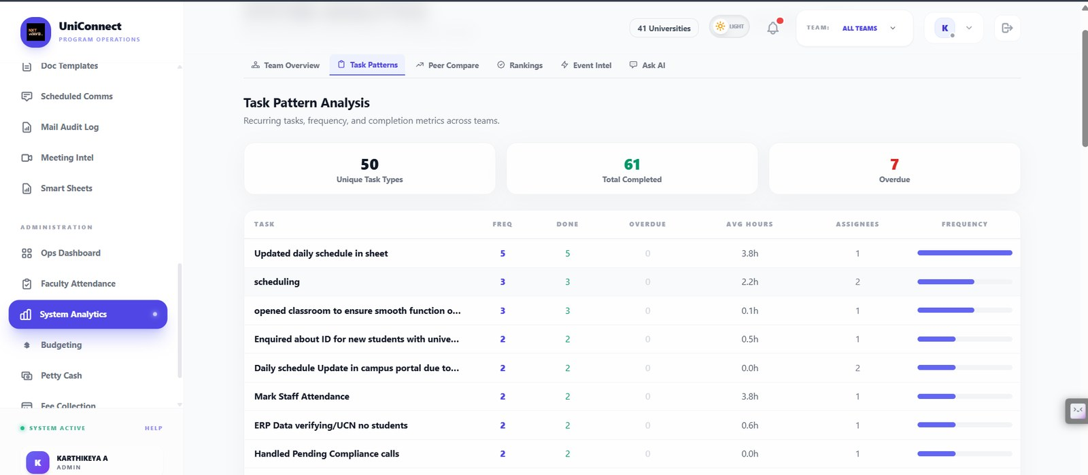
Recurring task types with frequency, completion, overdue count and average hours — the repeated-decision evidence that Section 2.3 argues makes this workflow suitable for AI.
Supports: 2.3 repeated friction; 3.1 problem statement
Figure 26 — System Analytics — same-task comparison
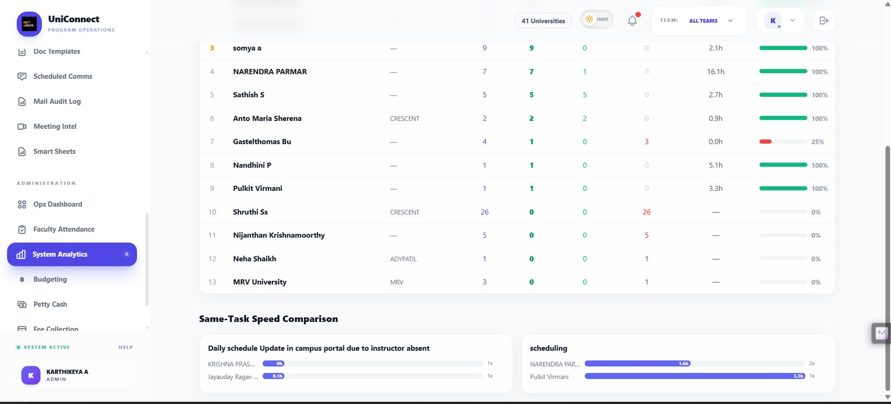
The same task compared across members by time taken, showing wide variance on identical work.
Supports: 2.3 inconsistency argument

F. Communication and document generation
Mailbox access is granted rather than assumed, templates are previewed, and campaigns are held in draft with a mandatory live test before any send.
Figure 27 — Student Master — Contact List
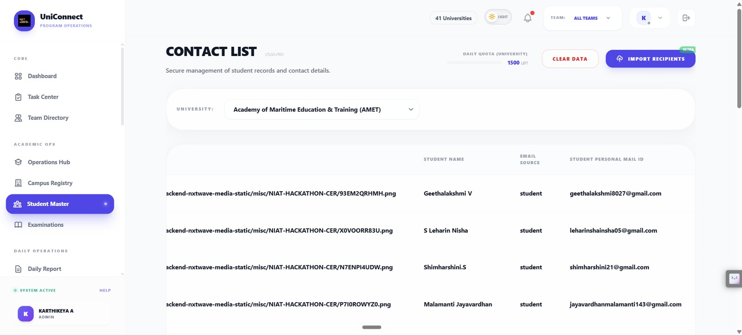
Student records and contact details, scoped to one university, with a daily send quota shown against the mailbox.
Supports: 8.2 Modules — Student Master
Figure 28 — Central Mailbox
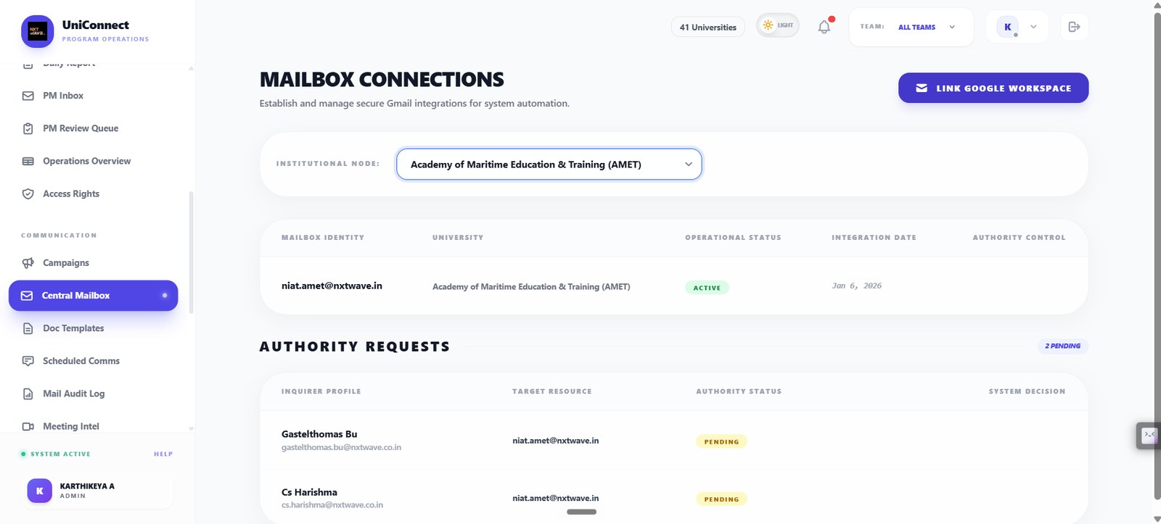
Per-university Gmail integrations with operational status, plus pending authority requests awaiting a system decision — mailbox access is granted, not assumed.
Supports: 7.3 controls; 8.2 Modules — Email Campaigns
Figure 29 — Doc Templates
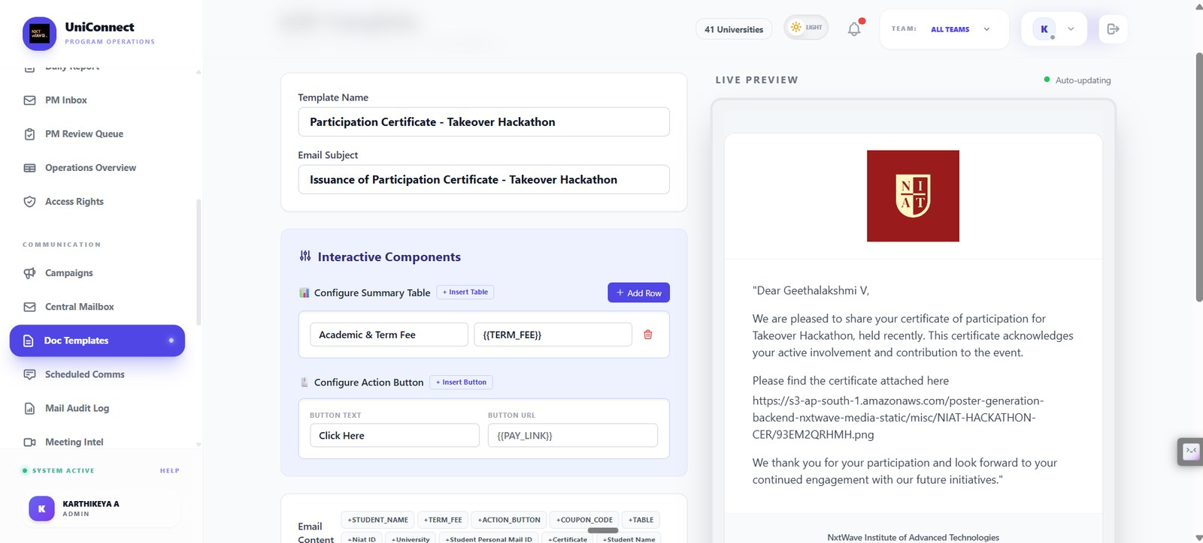
Template builder with interactive components, merge placeholders and a live preview of the rendered email.
Supports: 8.2 Modules — Email Campaigns
Figure 30 — Campaign — production readiness
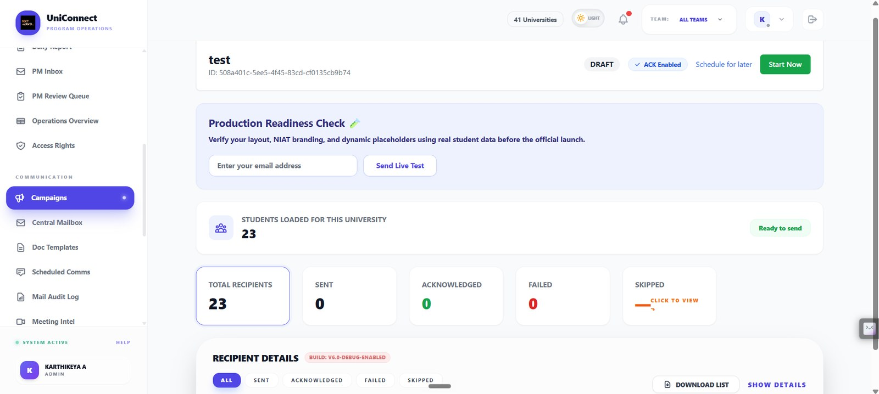
A campaign held in DRAFT with a mandatory live test send before launch, recipient counts, and per-recipient sent/acknowledged/failed/skipped tracking.
Supports: 4.6 human in the loop — nothing sends without a human; 5.6 delivery metrics

G. Faculty and success coaches
Faculty attendance and coach targets, which feed scheduling eligibility and the invigilation ladder in Section 9.5.
Figure 31 — Faculty Attendance — Mark Attendance
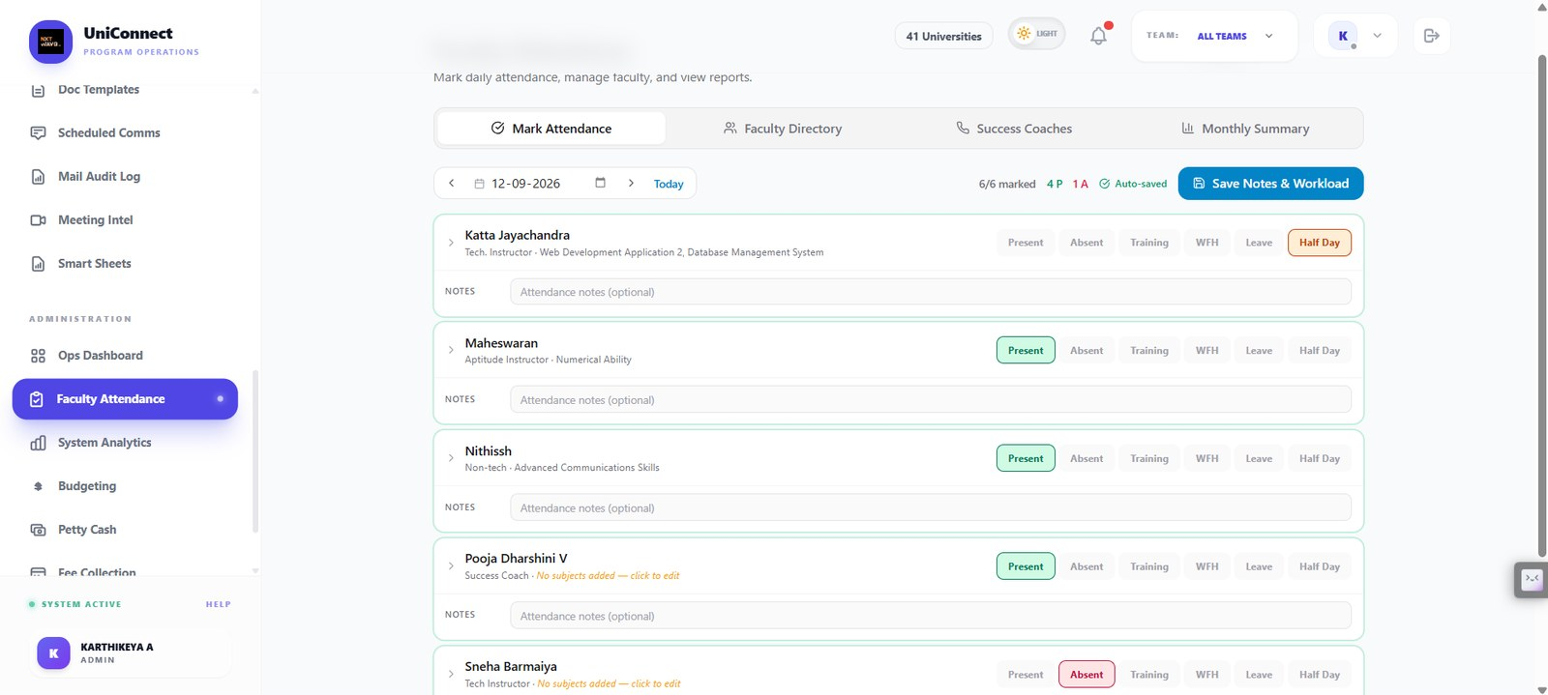
Daily faculty attendance marking with present, absent, training, WFH, leave and half-day states, optional notes and autosave.
Supports: 8.2 Modules — Faculty tracking
Figure 32 — Faculty Attendance — Faculty Directory
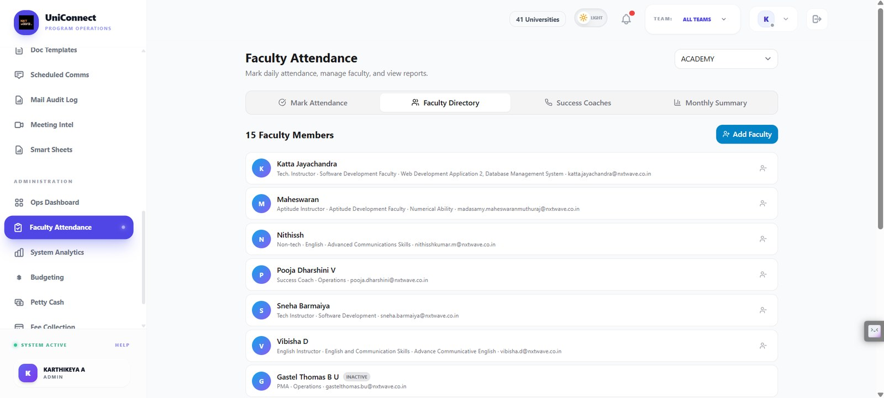
Faculty profiles with subject mappings that drive scheduling and invigilation eligibility.
Supports: 9.5 invigilation ladder
Figure 33 — Faculty Attendance — Success Coaches
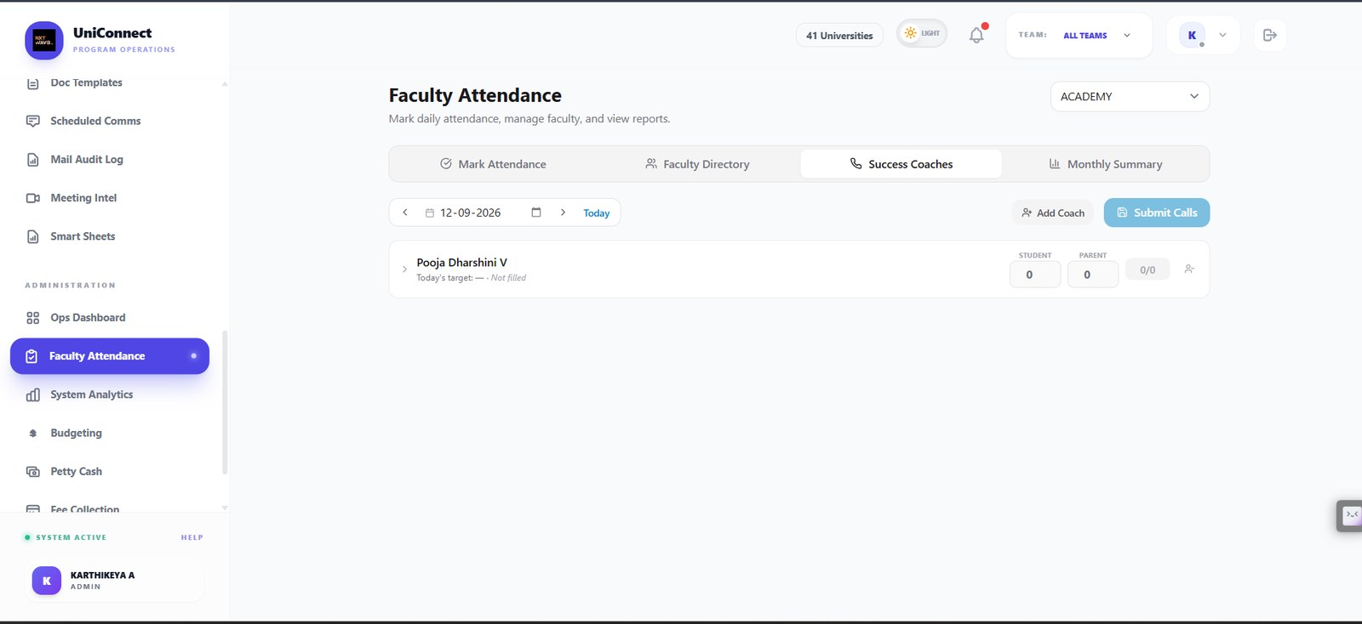
Success-coach call targets for the day with student and parent call counts submitted per coach.
Supports: 8.2 Modules — Success-coach tracking

H. Examinations — syllabus and question bank
The academic structure and the question bank the paper generator draws from.
Figure 34 — Examinations — Syllabus & Subjects
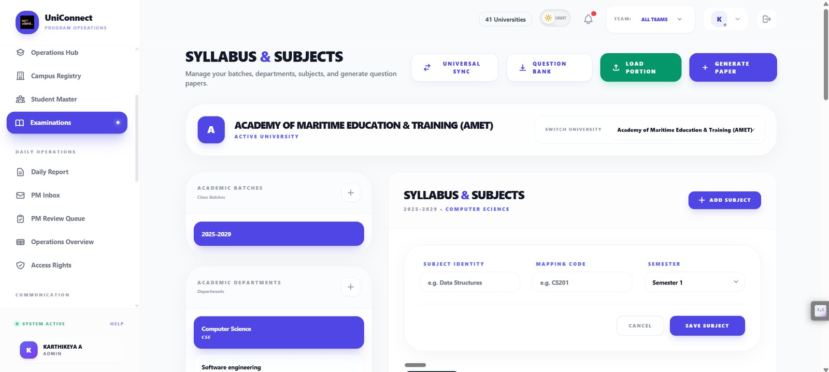
Per-university batch, department and subject structure, with load portion and generate paper actions.
Supports: 9.8 exam module status; 8.2 Modules — Assessments
Figure 35 — Examinations — Semester subjects
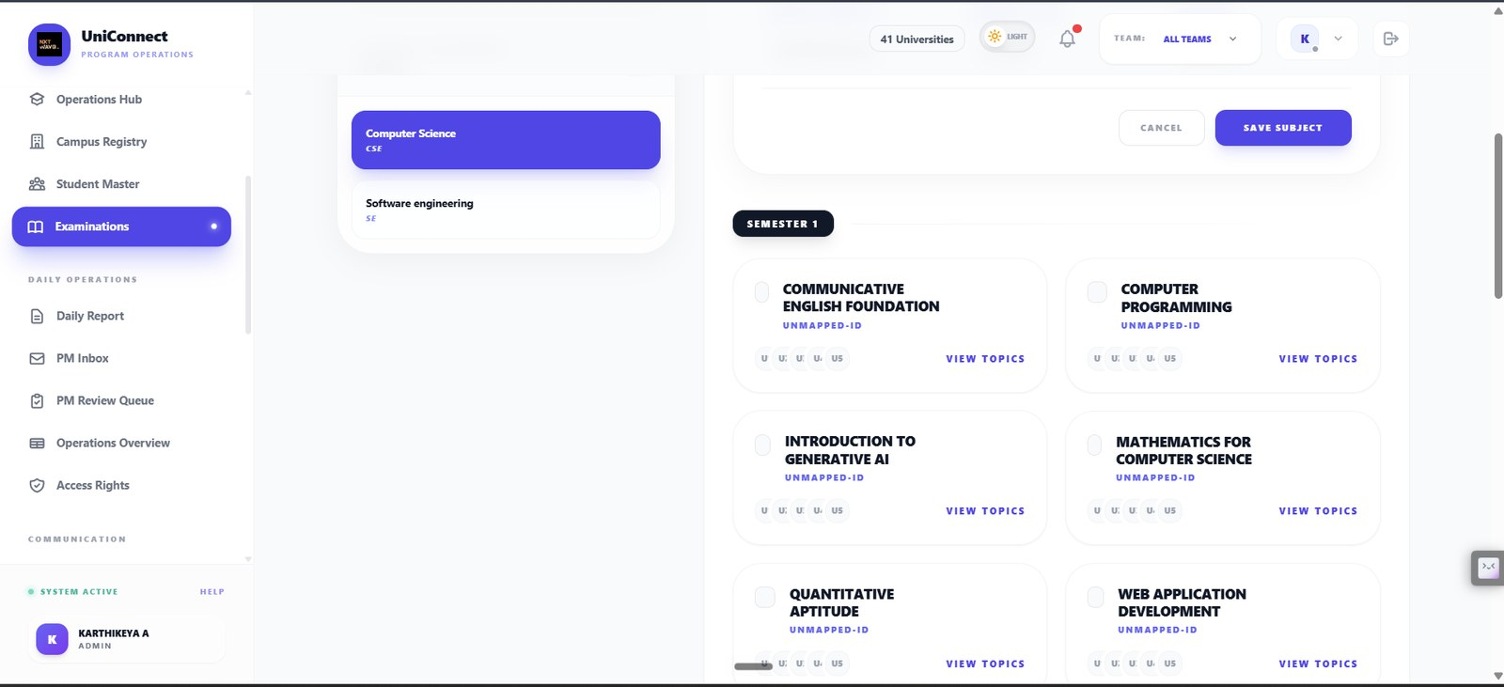
Semester subject cards with unit mapping state and topic drill-down.
Supports: 8.2 Modules — Assessments
Figure 36 — Examinations — Syllabus mapping
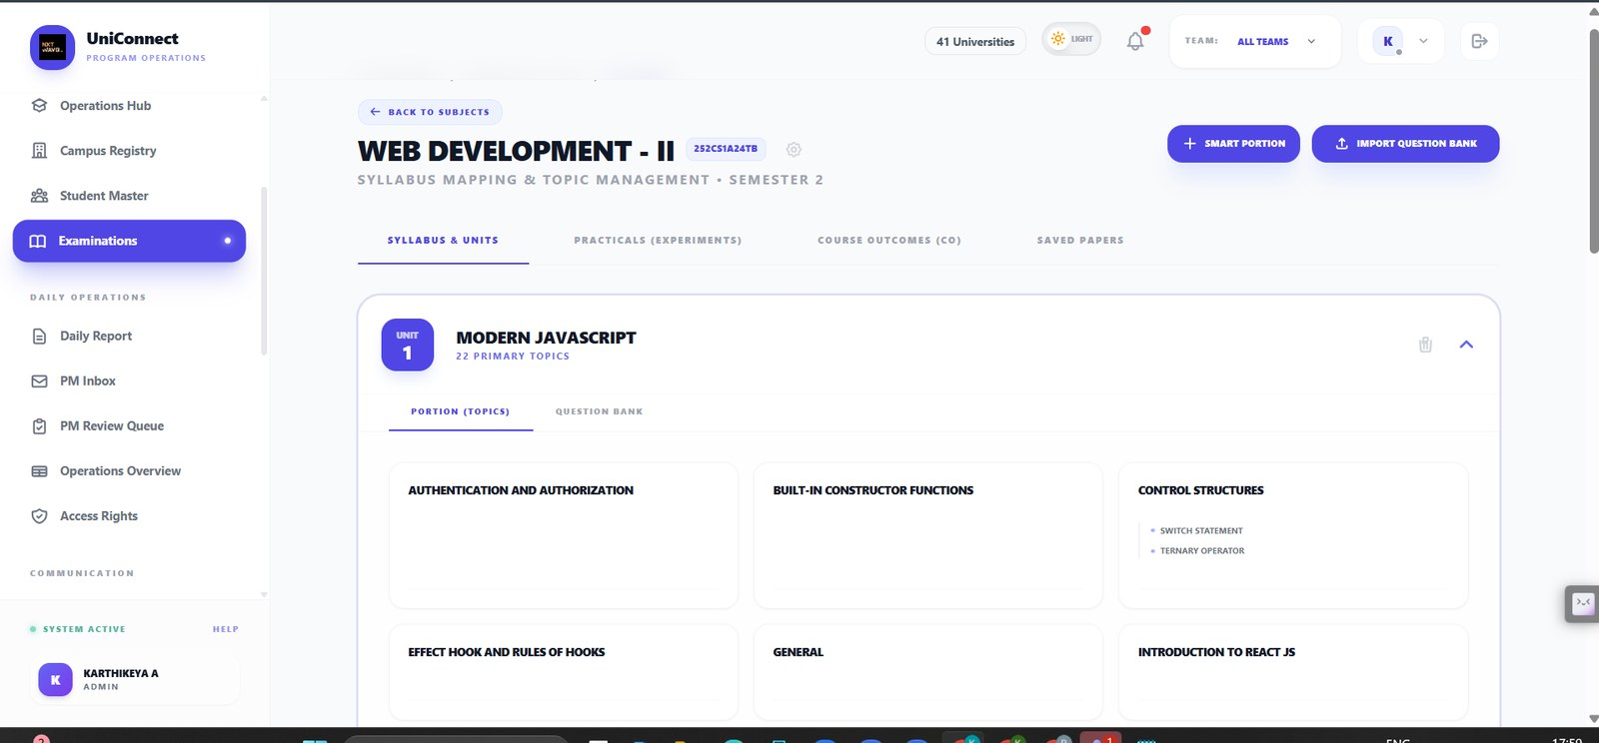
Unit-level topic management for a subject, with practicals, course outcomes and saved papers as separate tabs.
Supports: 8.2 Modules — Assessments
Figure 37 — Examinations — Question Bank
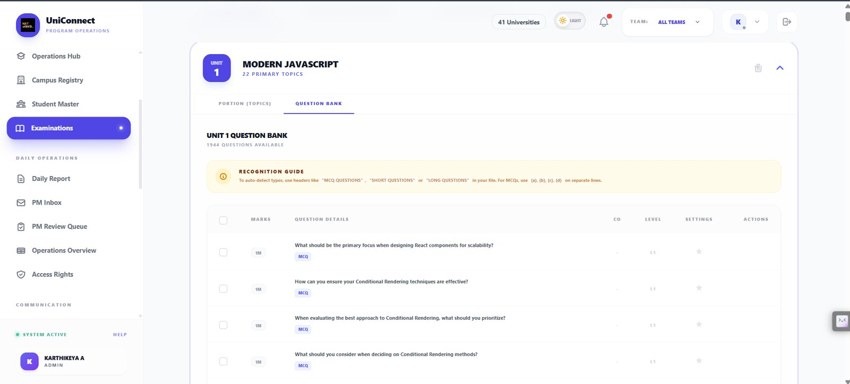
Unit question bank with 1,944 questions available, marks, type, CO mapping and difficulty level — the source the paper generator draws from.
Supports: 9.3 paper sets; 8.2 Modules — Assessments

I. Examinations — the question paper engine, end to end
All six steps of the generator, the generated output, the override path and the answer key. Figure 21 is worth particular attention: the system announces that a template is missing and that a different layout is being substituted, rather than substituting silently.
Figure 38 — Paper Engine step 1 — Institutional Context
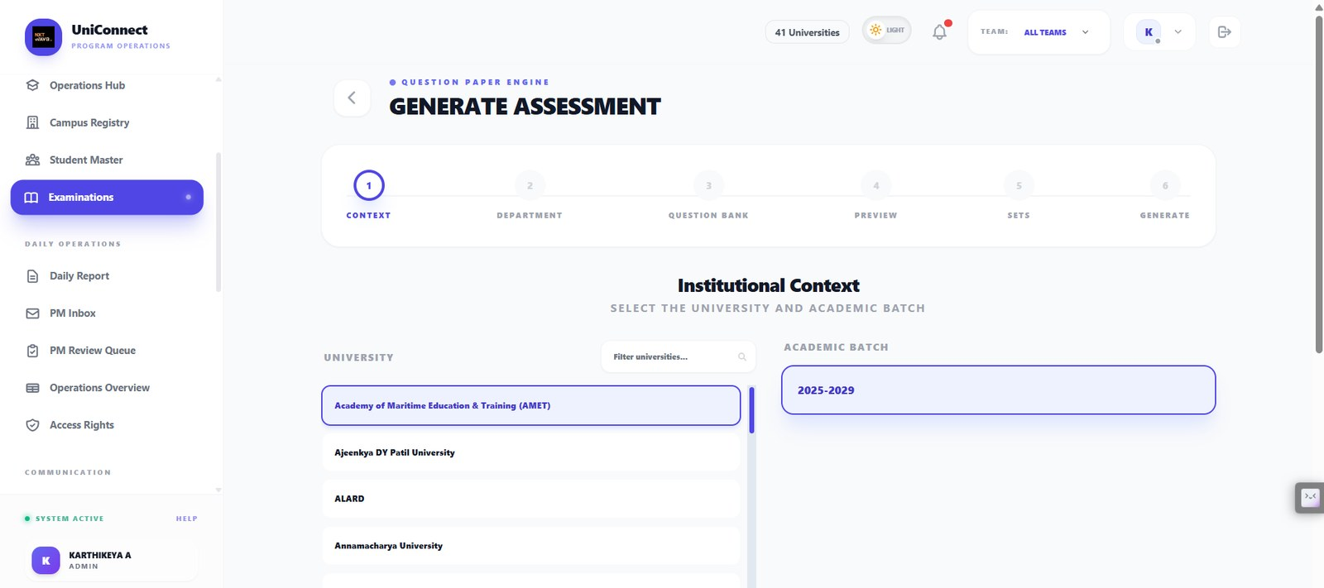
The six-step question paper engine begins by scoping to one university and academic batch — the multi-tenant boundary is enforced before any content is selected.
Supports: 9.3 paper sets; 8.3 core model
Figure 39 — Paper Engine step 2 — Department & Semester
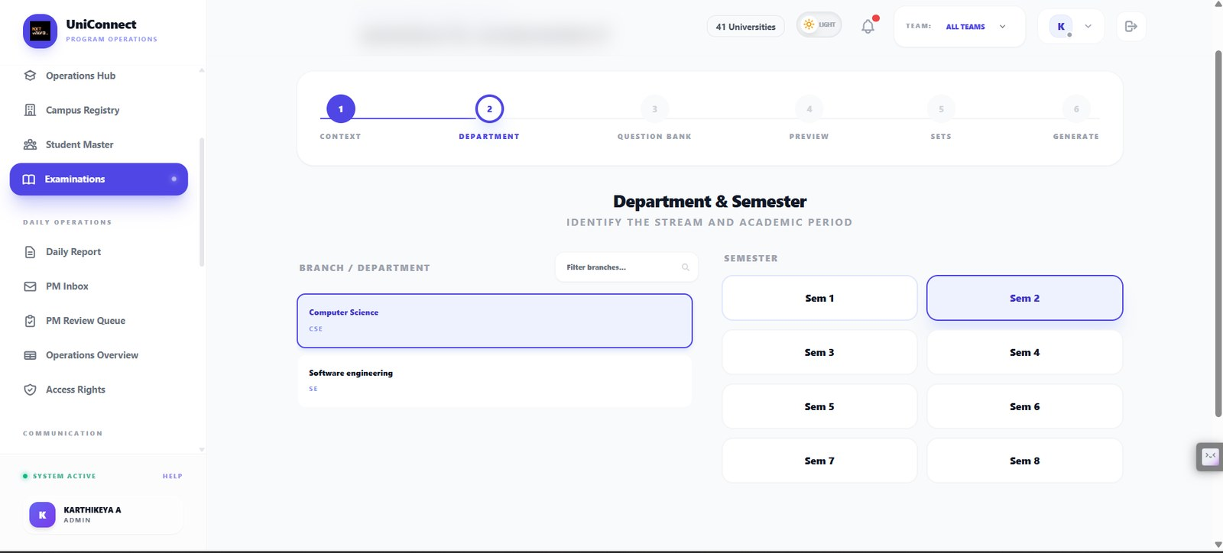
Branch and semester selection narrows the syllabus scope for the paper being generated.
Supports: 9.3 paper sets
Figure 40 — Paper Engine step 3 — Syllabus coverage
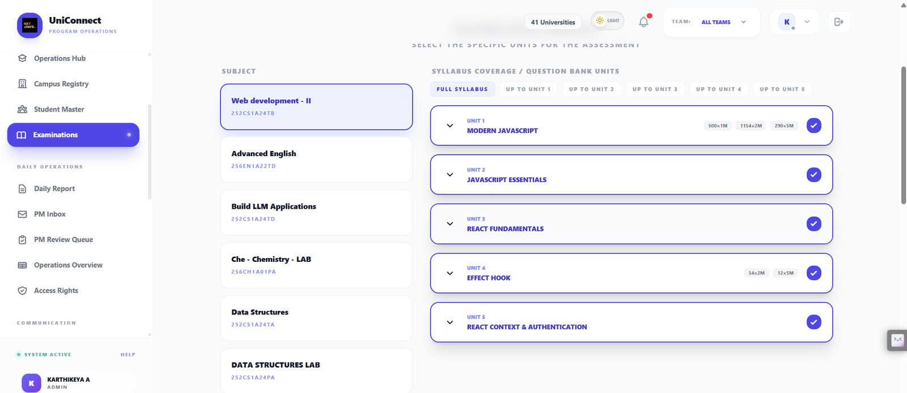
Unit selection with per-unit question availability by mark weight, and a full-syllabus or up-to-unit coverage choice — the operator states the portion rather than the system guessing it.
Supports: 9.4 the operator's value is the value used
Figure 41 — Paper Engine — Generation Strategy
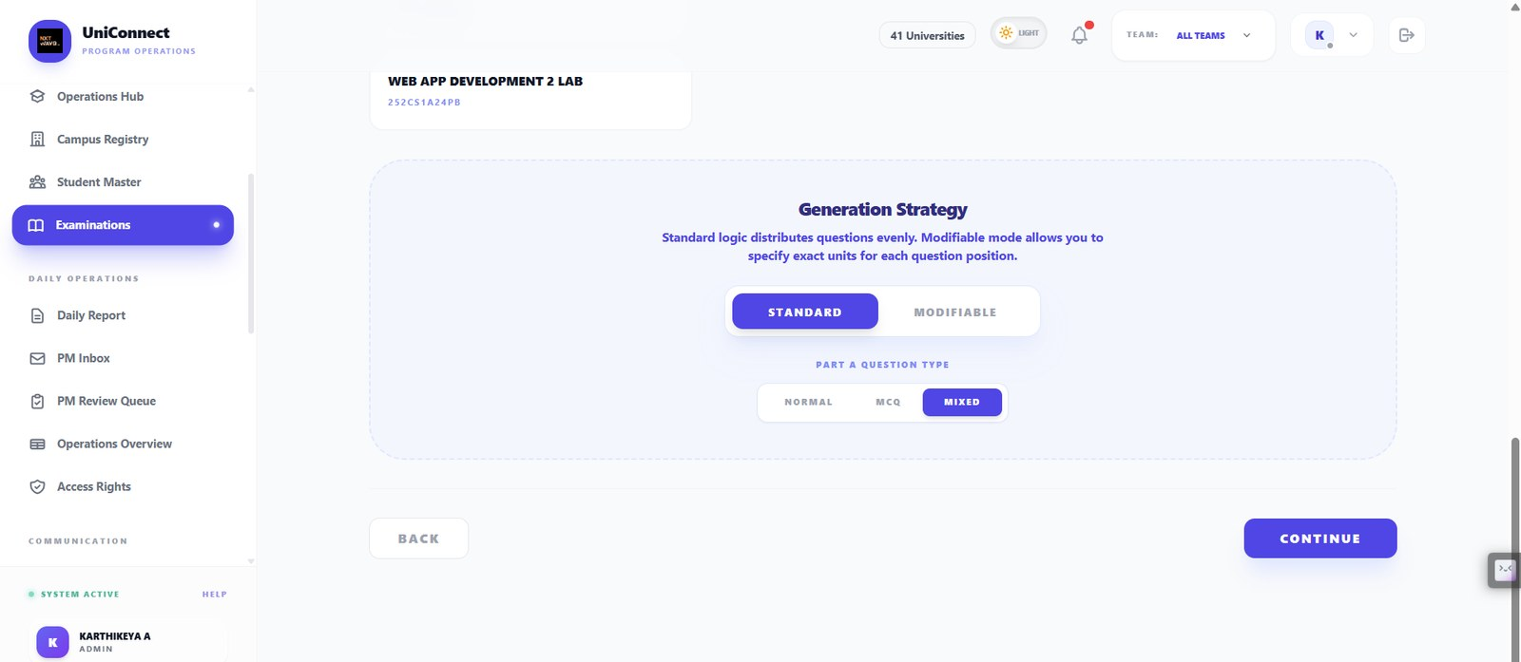
Standard distributes questions evenly; Modifiable lets the operator specify exact units per question position. Question type for Part A is chosen explicitly.
Supports: 4.6 human in the loop; 9.4
Figure 42 — Paper Engine step 4 — Metadata & Template
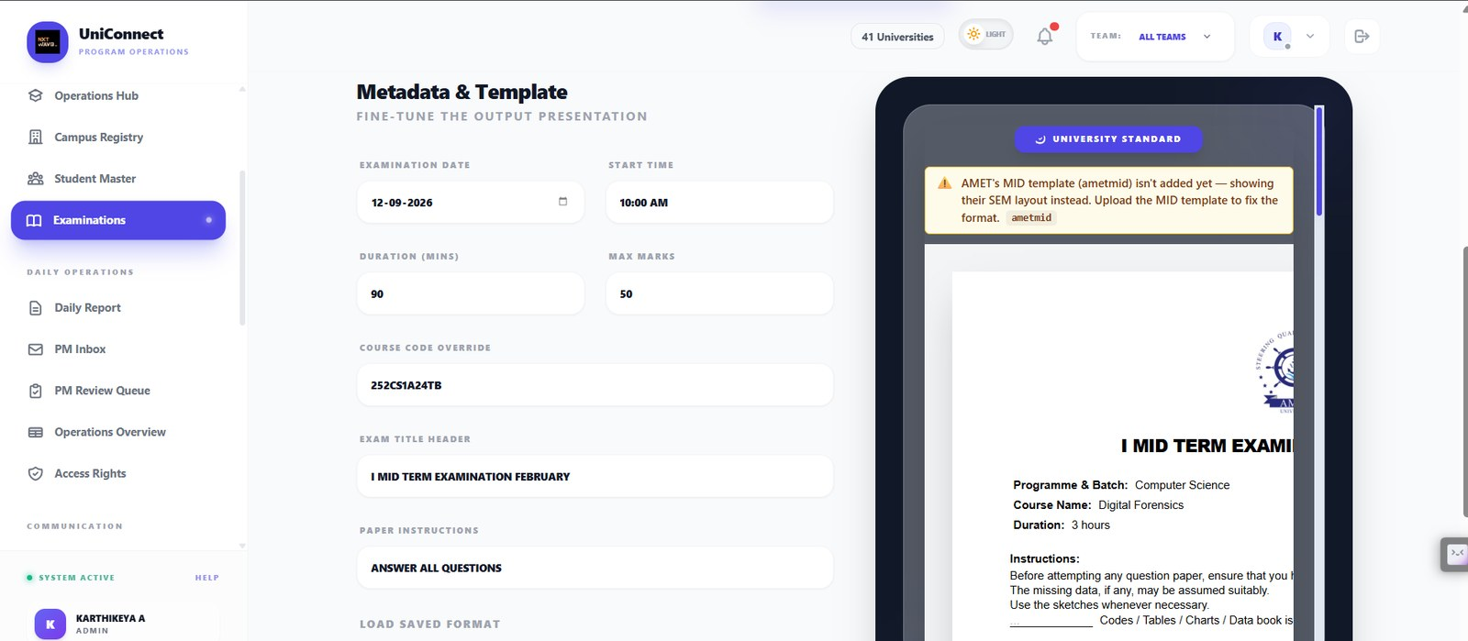
Exam date, duration, max marks, course code and instructions, with a live preview. The amber banner warns that the university's MID template is missing and that a SEM layout is being substituted — the system says what it is doing instead of silently substituting.
Supports: 9.4 governing rule — never substitute silently; 4.4 explainability
Figure 43 — Paper Engine step 5 — Set Configuration
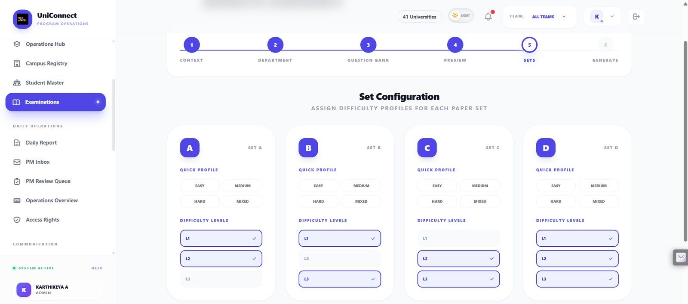
Difficulty profile assigned per paper set A to D, so the four sets are equivalent in coverage but distinct in composition.
Supports: 9.3 allocation modes; 9.4
Figure 44 — Paper Engine step 6 — Generate
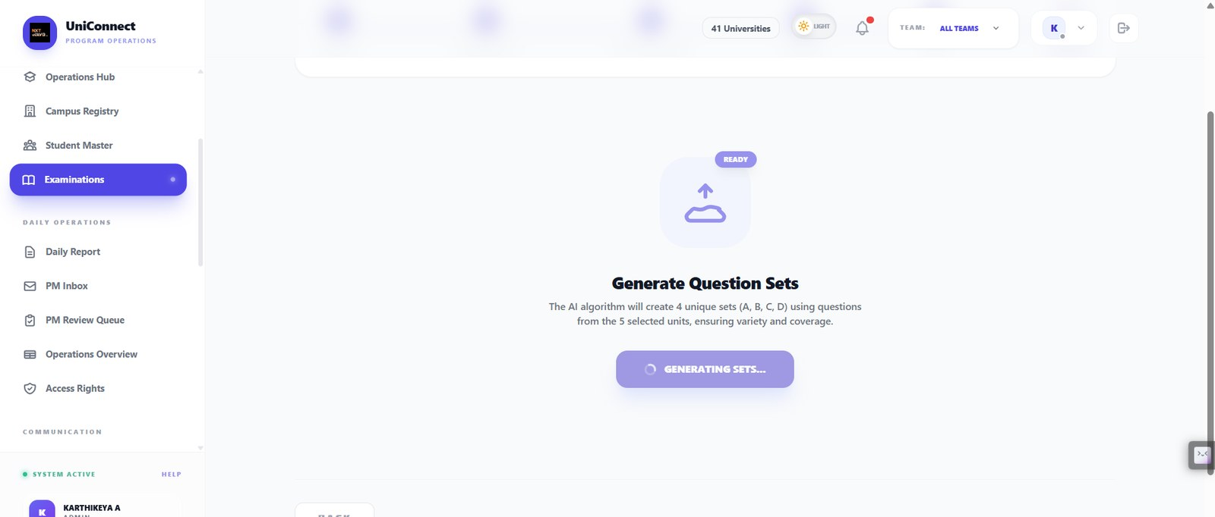
Generation of four unique sets from the selected units, stated as an algorithm producing variety and coverage rather than as a black box.
Supports: 9.1 optimisation AI; 1.4 why AI
Figure 45 — Generated paper — Set A
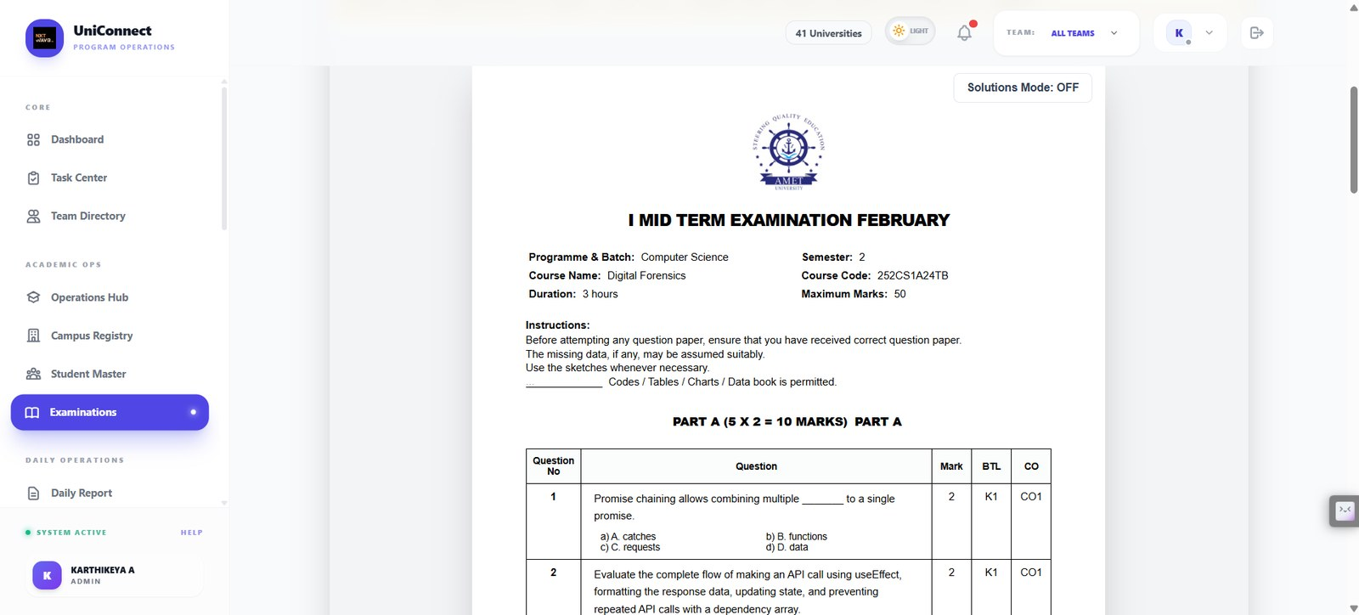
The rendered paper in the university's own format, with per-question marks, Bloom's level and course-outcome mapping.
Supports: 9.3 downstream output
Figure 46 — Generated paper — Swap Question
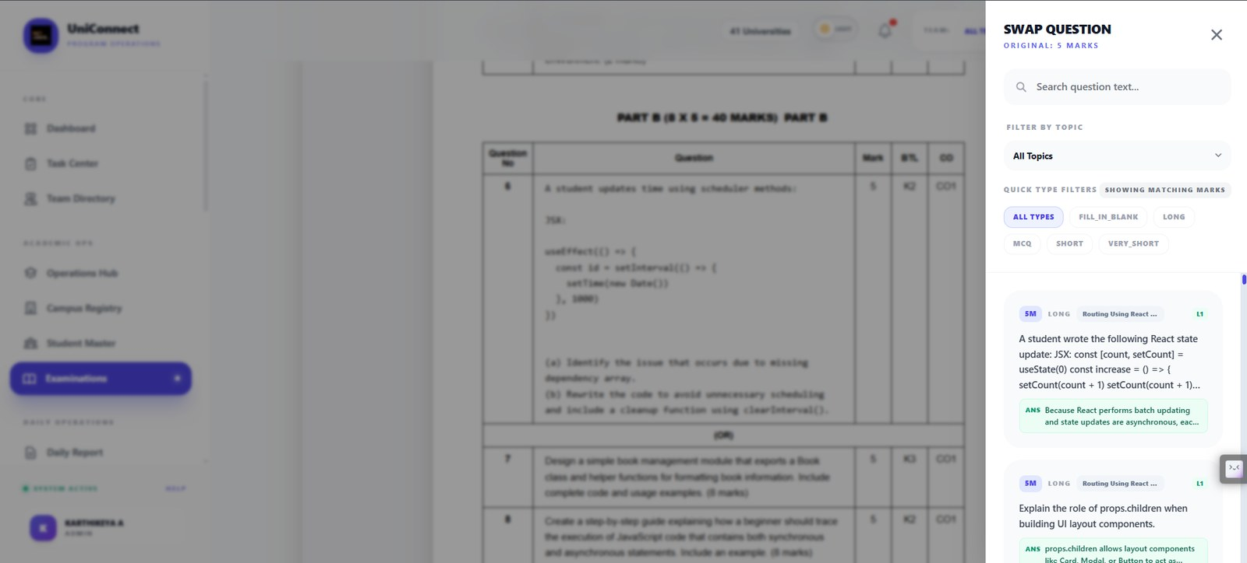
Any generated question can be swapped for an alternative of matching marks, filtered by topic and type. This is the override path: the operator can overrule the generator question by question.
Supports: 4.6 human in the loop; 7.3 control — no autonomy
Figure 47 — Generated paper — solution detail
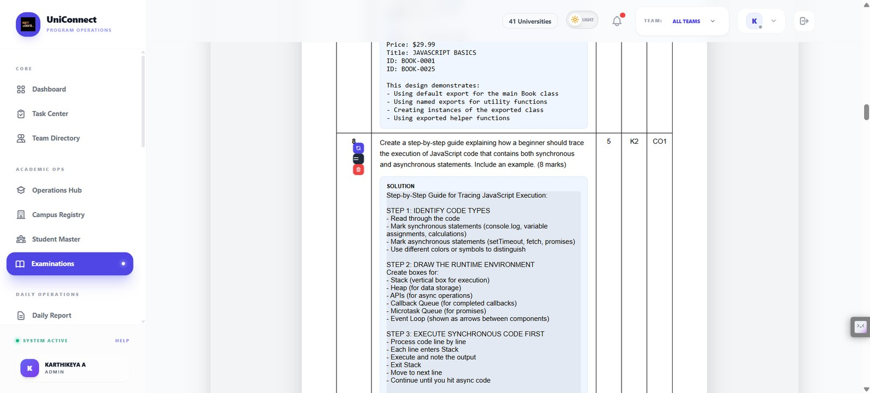
Model solutions attached to generated questions, visible to faculty for review before the paper is approved.
Supports: 9.7 human in the loop
Figure 48 — Paper editor — approval actions
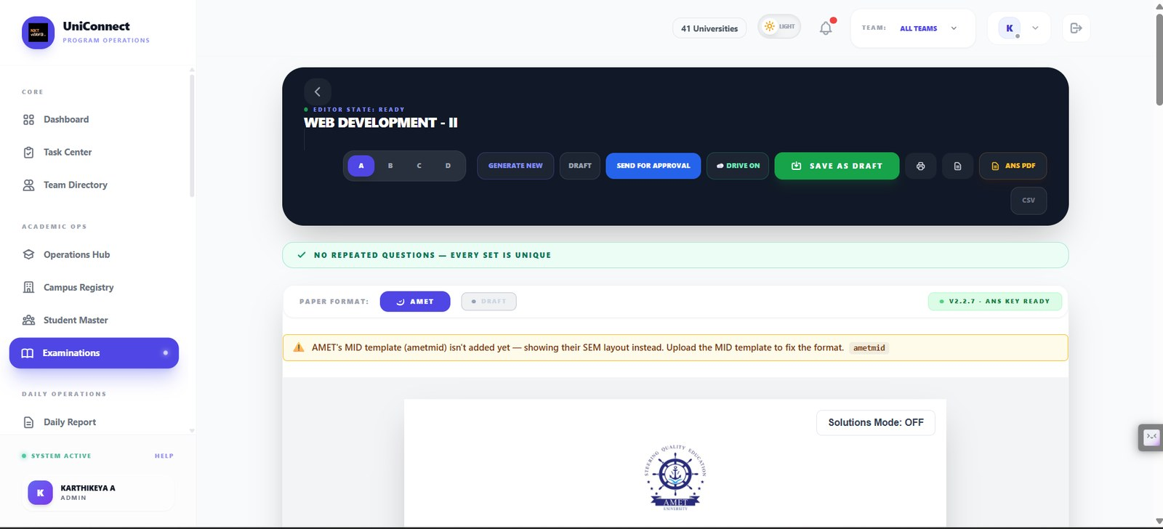
Set switching A to D, Send for Approval, Save as Draft and answer-key export, with an explicit check that no question repeats across sets. A paper leaves the system only through an approval action.
Supports: 4.6 human in the loop; 9.4 fail visibly
Figure 49 — Answer key — faculty only
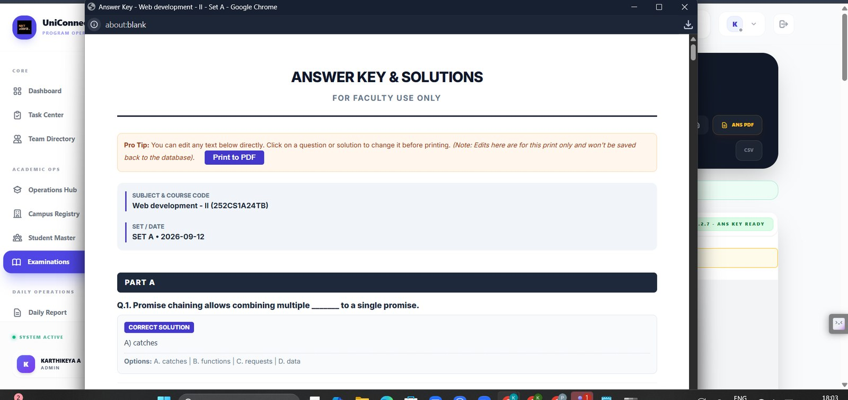
The answer key and solutions export, marked for faculty use, with print-time edits explicitly not written back to the database.
Supports: 7.3 controls; 9.7 audit

J. Examinations — plan, seating allocation and invigilation
The optimisation AI of Section 9: an exam plan, the generated seat map with its interleaving constraint and violation count, invigilation assignment, and marks entry.
Figure 50 — Examinations — Exam Plan
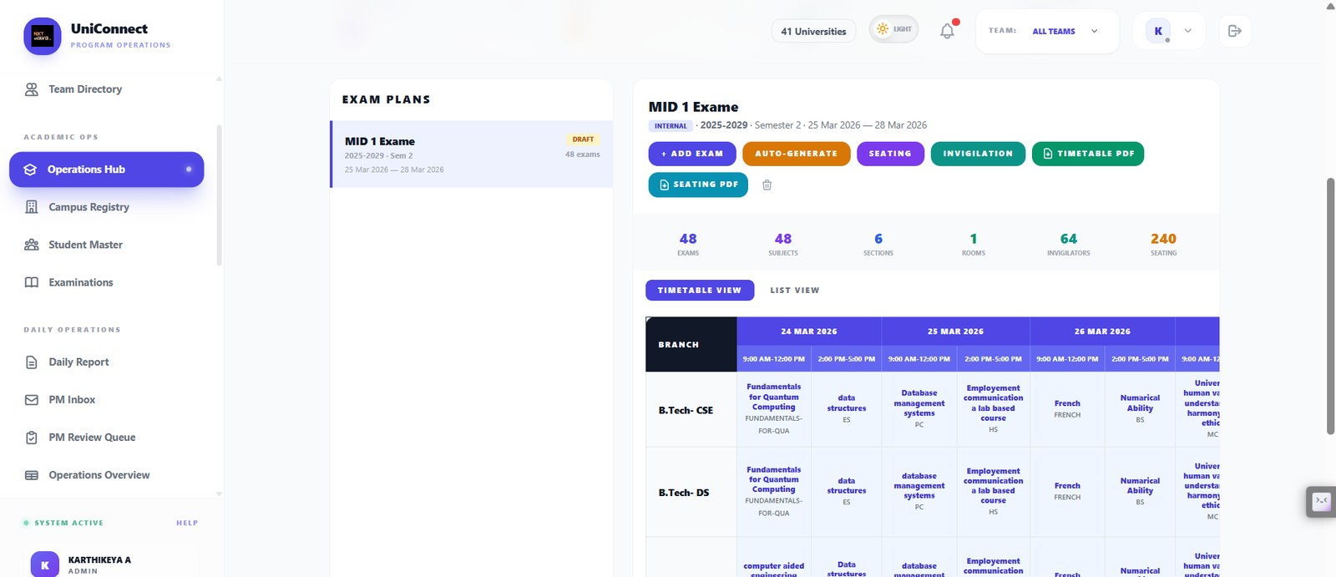
An exam plan in DRAFT covering 48 exams, 48 subjects, 6 sections, 1 room, 64 invigilators and 240 seats, with auto-generate, seating, invigilation and PDF exports, shown as a branch-by-date timetable.
Supports: 9.2 workflow replaced; 9.6 disruption
Figure 51 — Examinations — Seating allocation
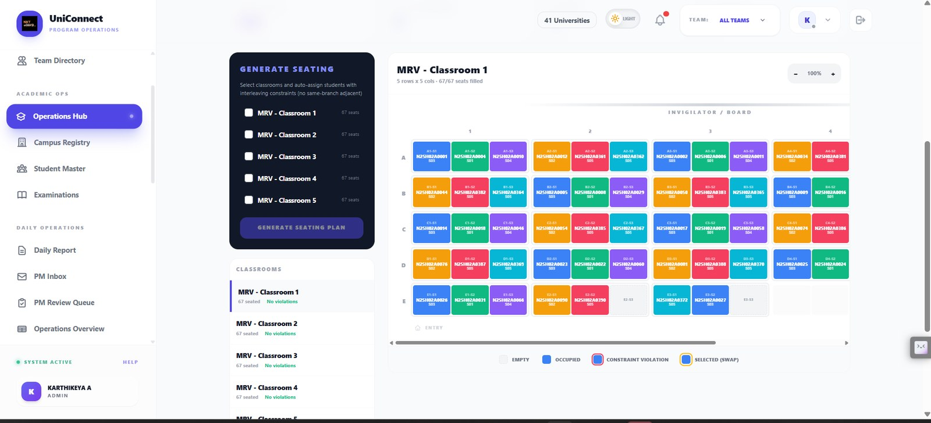
Generated seating for a 5x5 classroom, 67 of 67 seats filled, each seat carrying the student ID and section code. The generator auto-assigns with interleaving constraints so no two adjacent students are from the same branch, and the legend includes an explicit constraint-violation state. Every classroom reports no violations.
Supports: 9.3 hard constraint; 9.4 fail visibly; 9.7 override
Figure 52 — Examinations — Invigilation Duty
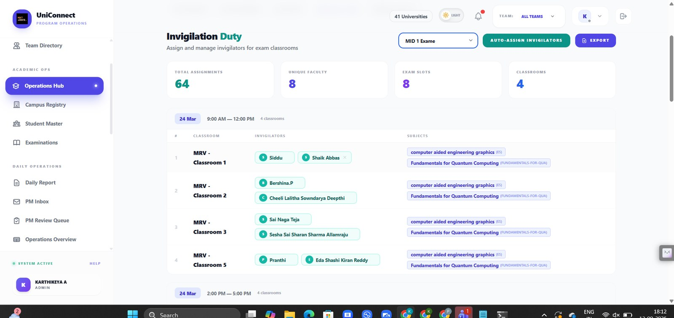
Invigilator assignment per classroom and exam slot with auto-assign and export: 64 assignments across 8 faculty, 8 slots and 4 classrooms.
Supports: 9.5 invigilation assignment
Figure 53 — Examinations — Marks entry
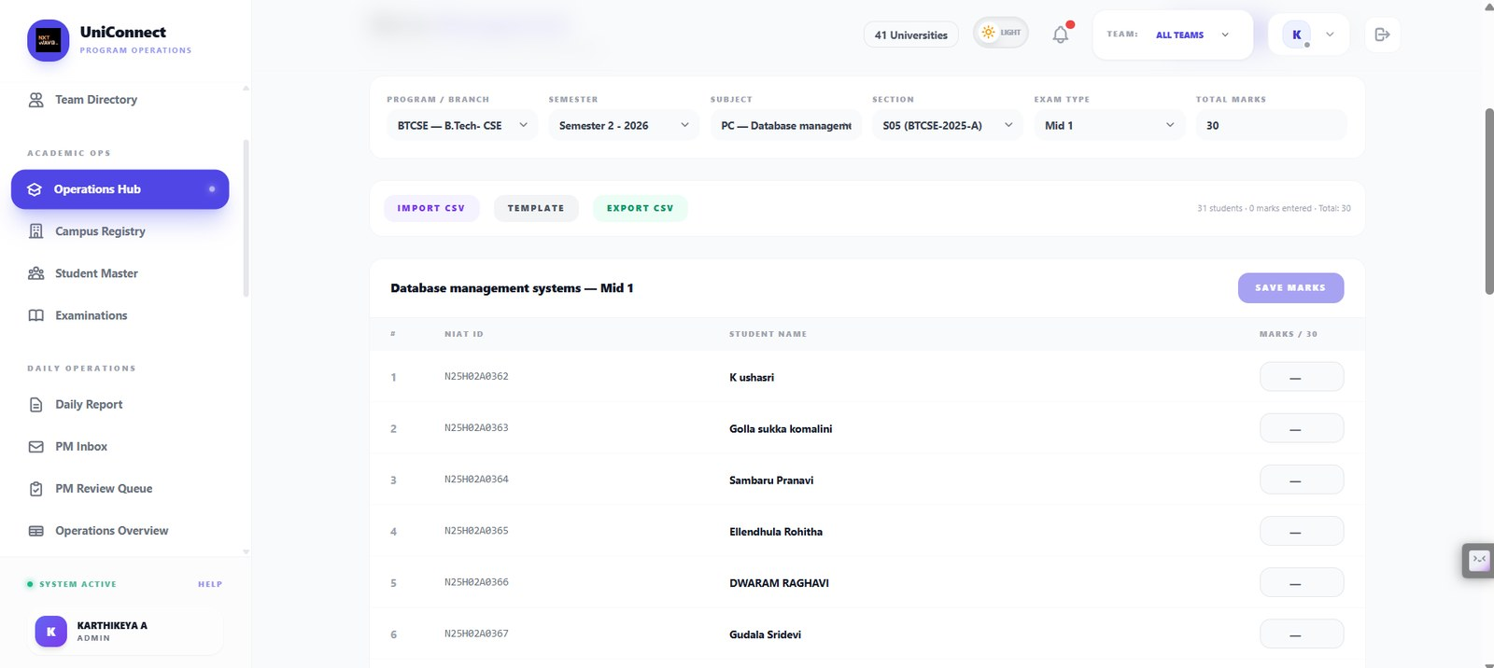
Marks entry per section and exam type with CSV import, template download and export, scoped to one subject and section.
Supports: 8.2 Modules — Assessments

K. The money path — where AI is deliberately absent
Section 8.2.1 argues that approvals, thresholds and audit records must stay deterministic. Figure 57 shows the threshold rule printed on the screen rather than hidden in code.
Figure 54 — Budget Proposals — Proposal list

Campus spend proposals with university, proposer, estimated budget and approval state, separated into all proposals, pending approval, my proposals and pending reports. This is the module Section 8.2.1 uses as the worked example of where a model is deliberately kept out.
Supports: 8.2.1 where AI is deliberately absent; 8.2 Modules — Budget Proposals
Figure 55 — Budget Proposals — Proposal detail
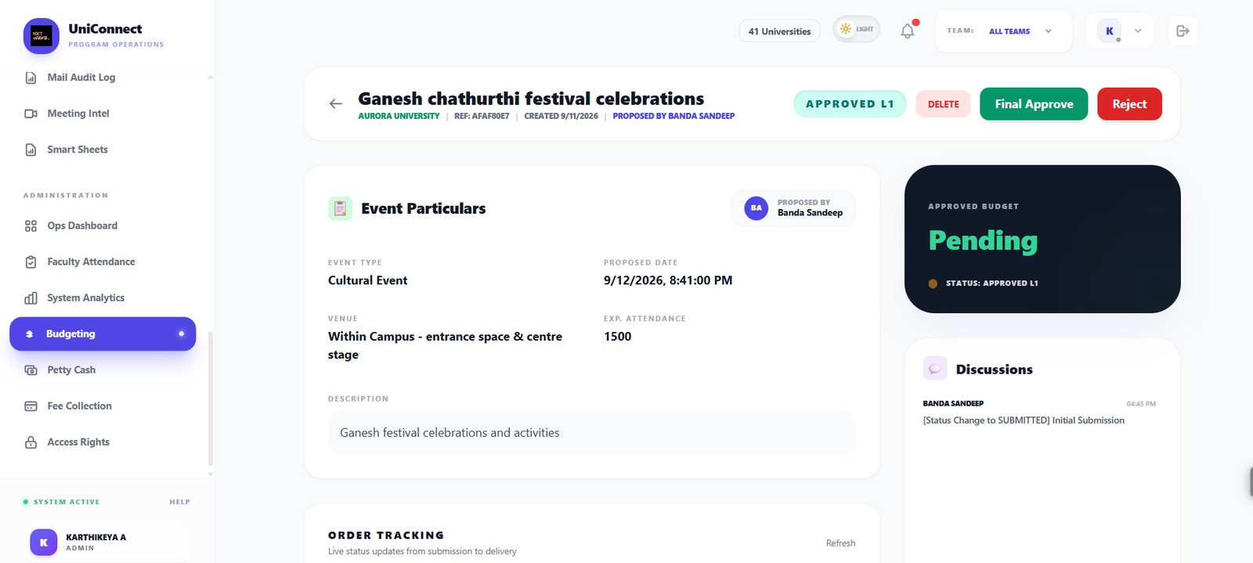
A single proposal with its reference, originating university, proposer, event particulars and current state of Approved L1, awaiting a final approve or reject decision. The approved budget reads Pending until a human acts. A discussion thread sits beside the record so the reasoning stays attached to the decision.
Supports: 8.2.1; 4.6 human in the loop
Figure 56 — Budget Proposals — Order tracking and evolution trail
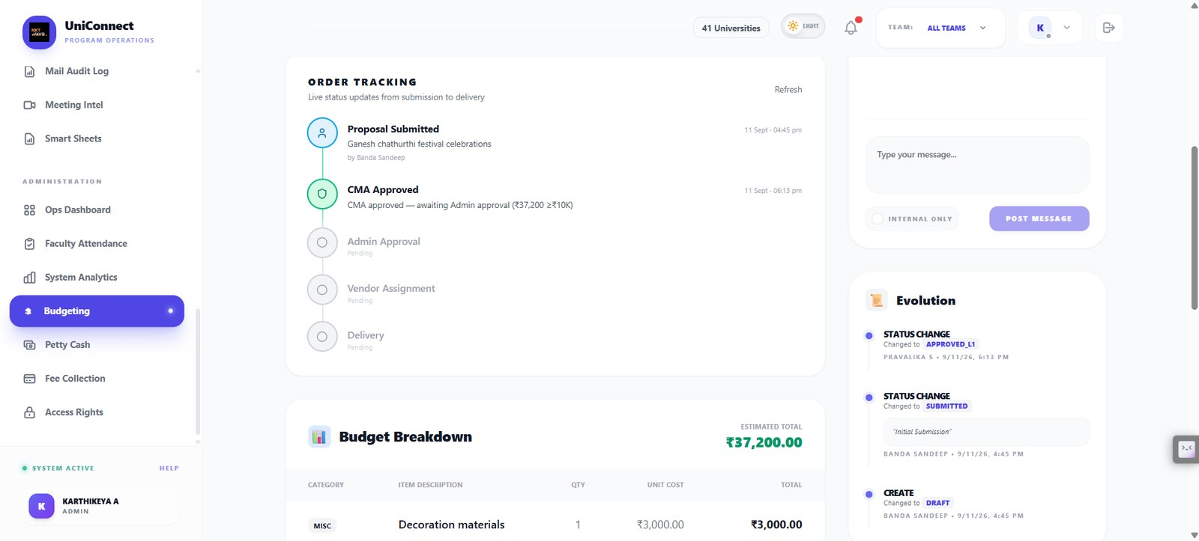
The money path end to end: submitted, approved at the first level, then held at admin approval because the amount crosses the ₹10,000 threshold — the rule is printed on the screen rather than hidden in code — followed by vendor assignment and delivery. The evolution panel records every state change with the person who made it and the time it happened. There is no model anywhere in this sequence, and the audit trail is the reason there will not be one.
Supports: 8.2.1 the line that does not move; 7.3 immutable audit log; 2.4 AI opportunity matrix
Figure 57 — Budget Proposals — Line items and supporting documents
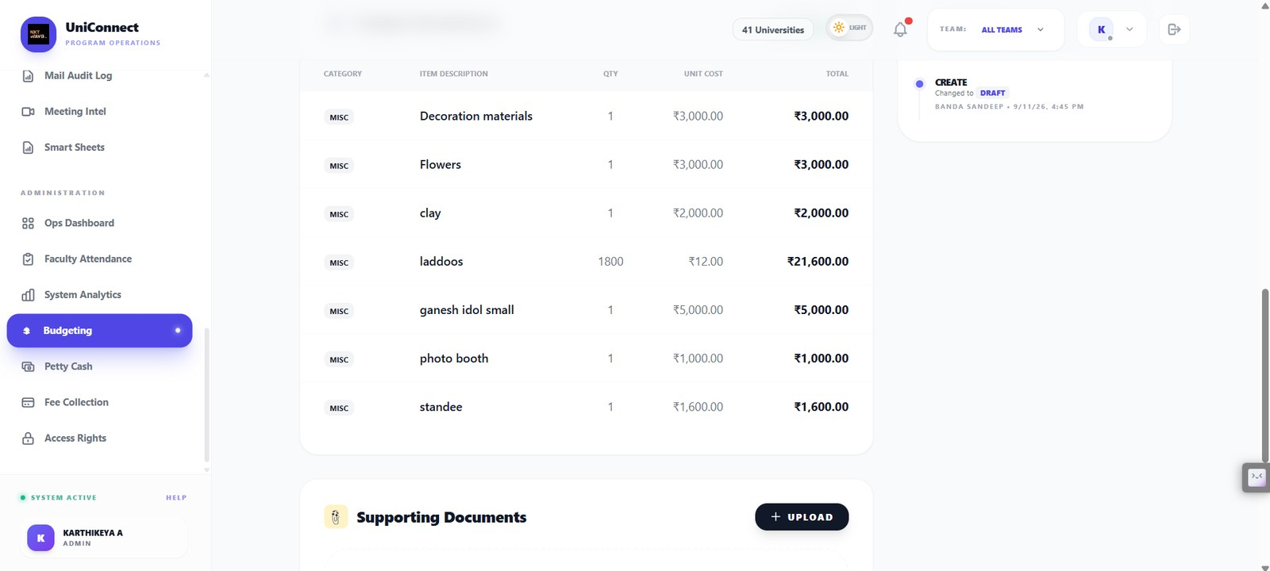
The itemised breakdown behind the estimated total, each line carrying category, quantity and unit cost, with an upload area for supporting documents such as quotes. This is the surface the P2 completeness check would read before submission: a missing quote or a cost line that does not match the narrative is exactly what a reviewer currently discovers only after opening the proposal, which sends it back and adds days.
Supports: 8.2.1 the P2 completeness check; 3.4 feature prioritisation; 2.4 AI opportunity matrix
Figure 58 — Petty Cash — Console
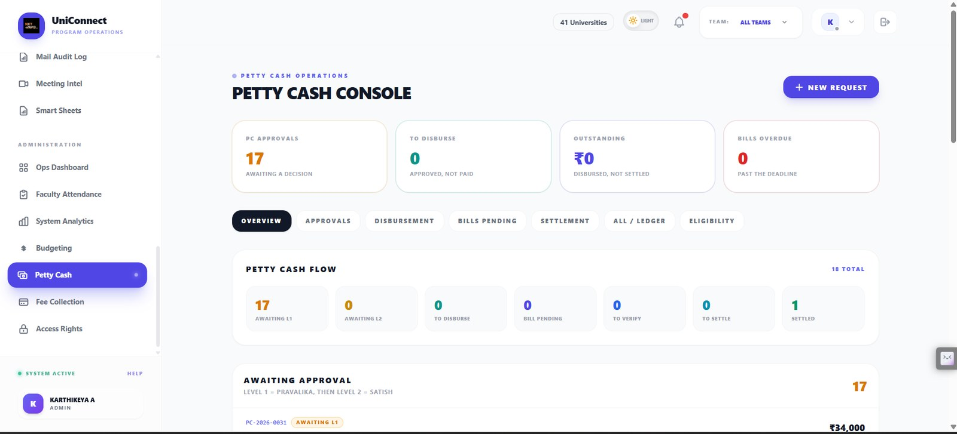
Petty cash running on the same approval spine as budget proposals: requests awaiting a decision, approved but not yet paid, disbursed but not settled, and bills past their deadline, with the two-level approval path named on the screen and every request carrying its own reference number through the flow.
Supports: 8.2.1 petty cash on the same spine; 8.2 Modules — Budget Proposals and Petty Cash

L. Fee collection and the honest state of the data
The numeric layer is deterministic and reports its own failures and gaps. This is the evidence behind the data-quality assumptions in Section 13.
Figure 59 — Fee Collection — Overview
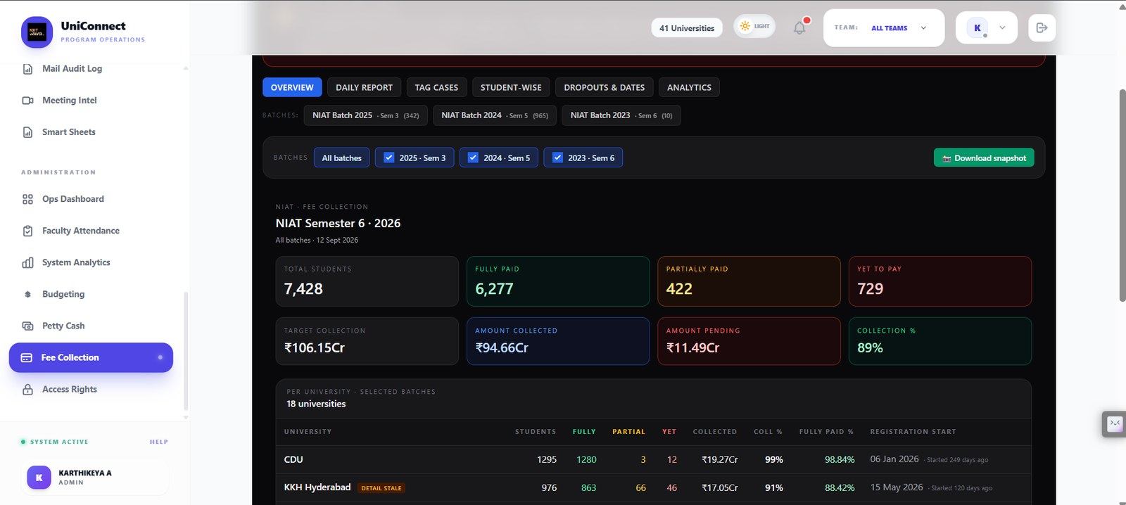
The module headline for the semester window: 7,428 students, ₹106.15Cr payable against ₹94.66Cr collected at 89 per cent, broken into fully paid, partially paid and yet to pay, with a per-university table of 18 institutions and the date each registration window opened. One university carries an explicit detail-stale badge rather than presenting figures that may have moved since the last sync.
Supports: 8.2 Modules — Fee Collection; 4.4 facts versus generated text; 5.1 deterministic numeric layer
Figure 60 — Fee Collection — Daily Report
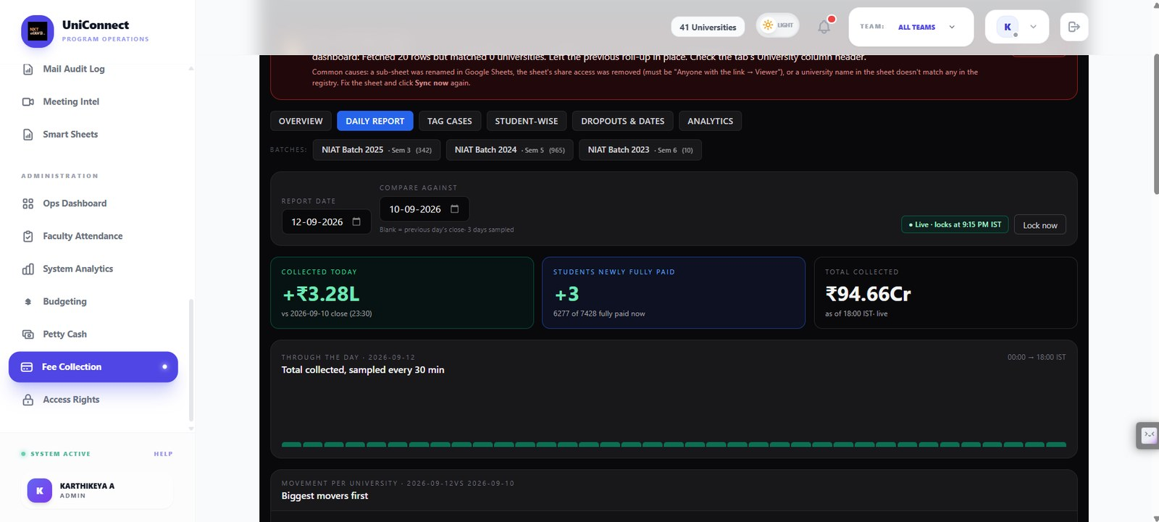
The day measured against the previous close: collected today, students newly fully paid, and a running total stamped as live at a named time. The report locks automatically at 9:15 PM or on demand, and collection is sampled every thirty minutes through the day, so the shape of the day exists without anyone asking for a figure.
Supports: 8.2 Modules — Fee Collection; 3.3 core workflow; 5.1
Figure 61 — Fee Collection — Movement per university
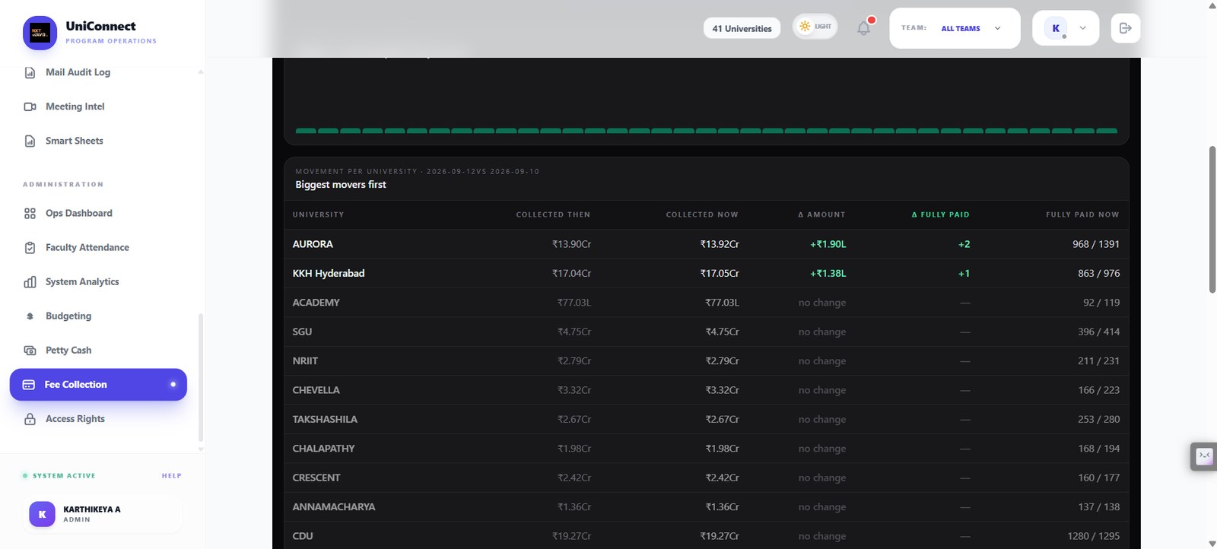
Day-on-day movement across the network, biggest movers first: collected then, collected now, change in amount, change in fully paid students. Two universities moved; the rest are explicitly marked no change. The comparison is arithmetic on two snapshots, not an inferred trend.
Supports: 5.1 the numeric layer is deterministic; 5.4 rules-only baseline; 8.2 Modules — Fee Collection
Figure 62 — Fee Collection — Student-wise, with a visible sync failure
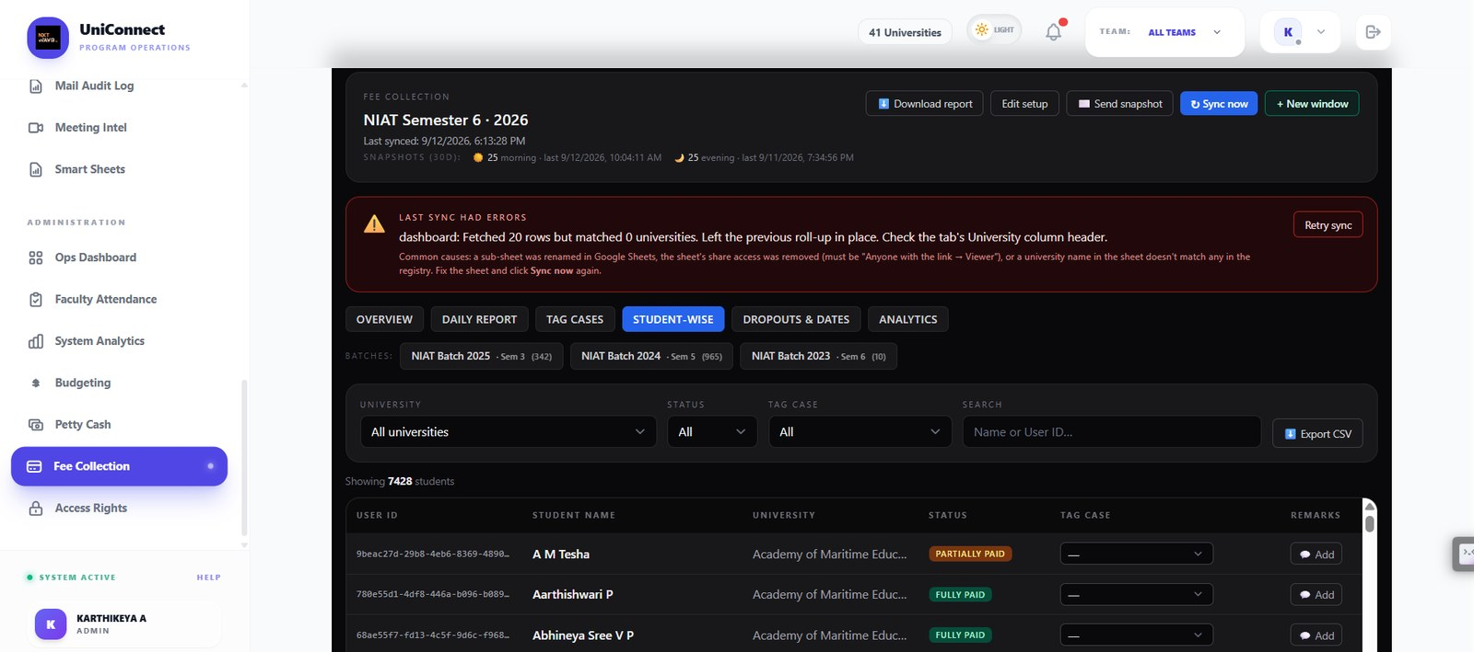
A failed synchronisation reported in full: the sheet returned 20 rows but matched no university, so the system left the previous roll-up in place instead of overwriting good numbers with bad ones. It names the likely causes and offers a retry. Below it, 7,428 student records with payment status, tag case and remarks.
Supports: 4.4 facts versus generated text; 4.5 uncertainty handling; 9.4 fail visibly; 8.2 Modules — Fee Collection
Figure 63 — Fee Collection — Dropouts and fee dates
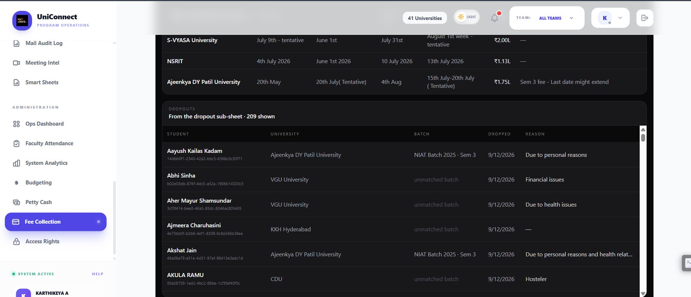
Per-university fee window dates above, and the dropout register below — 209 students drawn from the dropout sub-sheet with university, batch, date and stated reason. Several rows show an unmatched batch, which is left visible rather than silently assigned.
Supports: 13. Assumptions and evidence quality; 8.2 Modules — Fee Collection
Figure 64 — Fee Collection — Analytics overview
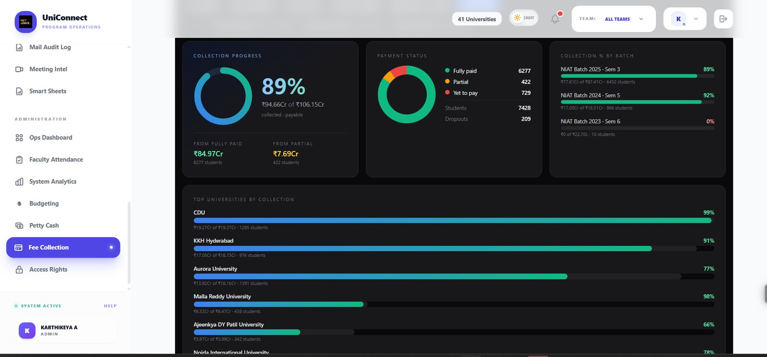
Collection progress at 89 per cent, split by payment status and by batch, with the top universities ranked by collection percentage. Every figure on this screen is computed from records; none of it is generated text.
Supports: 5.1 deterministic numeric layer; 4.4 facts versus generated text; 6.2 value logic
Figure 65 — Fee Collection — Dropout reasons and collection trend
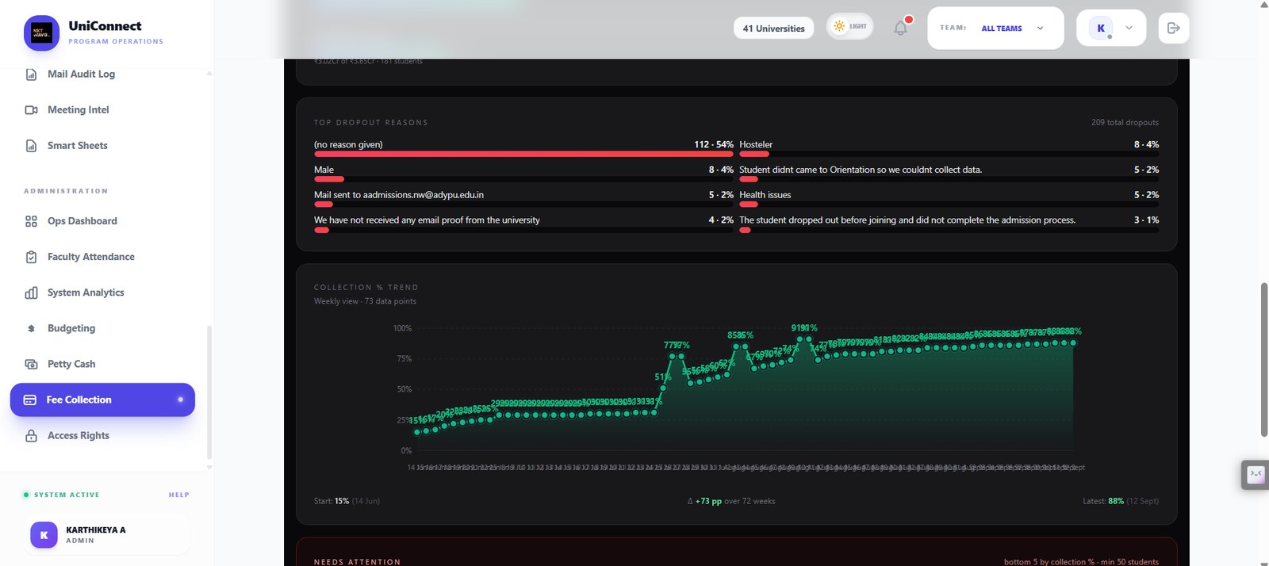
Top dropout reasons and a 72-week collection trend from 15 per cent in June to 88 per cent in September. The reason list is honest about its own quality: 54 per cent of dropouts carry no reason at all, and entries such as a gender value or a mail address have been typed into the reason field. This is the free-text mess the operational data actually contains.
Supports: 13. Assumptions and evidence quality; 5.2 data sources; 5.3 labelling and ground truth
Figure 66 — Fee Collection — Needs attention
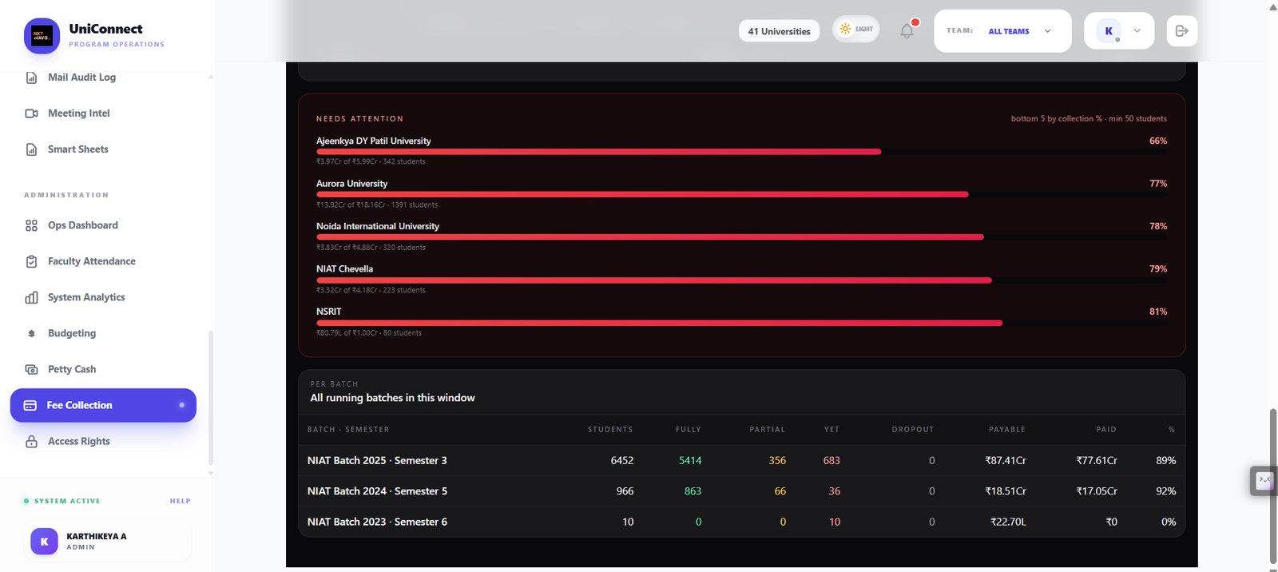
The bottom five universities by collection percentage, with the selection rule stated on the screen — bottom five, minimum 50 students — followed by the per-batch roll-up. Ranking by a published threshold is what the rules-only baseline in Section 5.4 looks like in production.
Supports: 5.4 rules-only baseline; 5.1; 3.1 problem statement

