TASK - 1
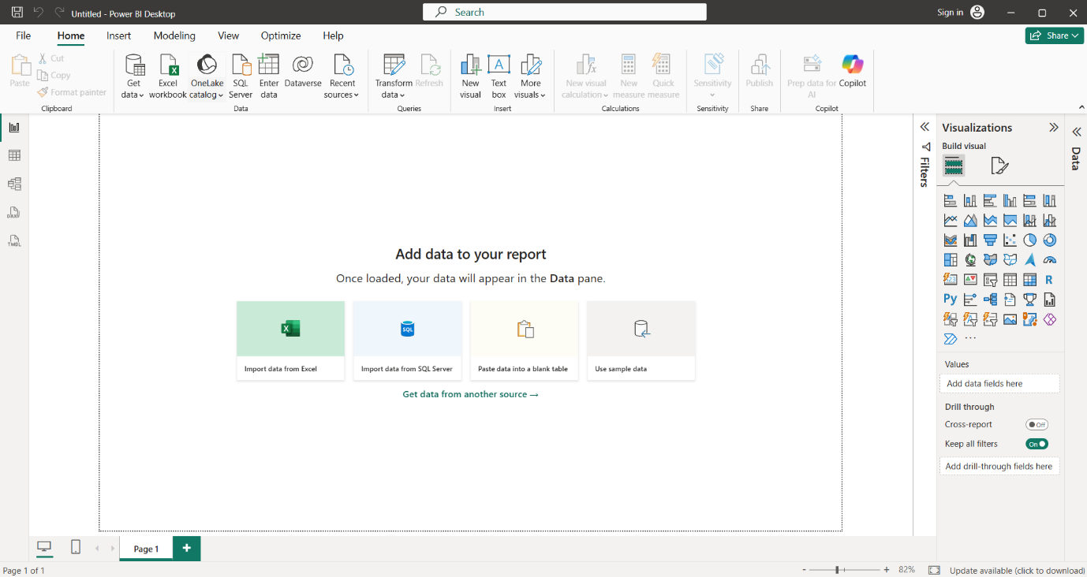

TASK - 2
- Report View : The main workspace where you create dashboards and reports using charts , tables , cards , slicers and other visuals.

- Data View : Displays the data in a table format so you can inspect columns and rows and understand the imported data.

- Model View : Shows the relationship between different table and allows you to create or manage relationships between them.

- Fields pane : Contains the tables , columns and measures from you dataset. You drag these fields into visuals to analyze the data.

- Visualizations Pane : Contains different visual type such as bar charts , line charts etc and cards , tables that you can add to your report.

- Filters Pane : Allows you to filter data at the visual, page or entire report level.

TASK – 3
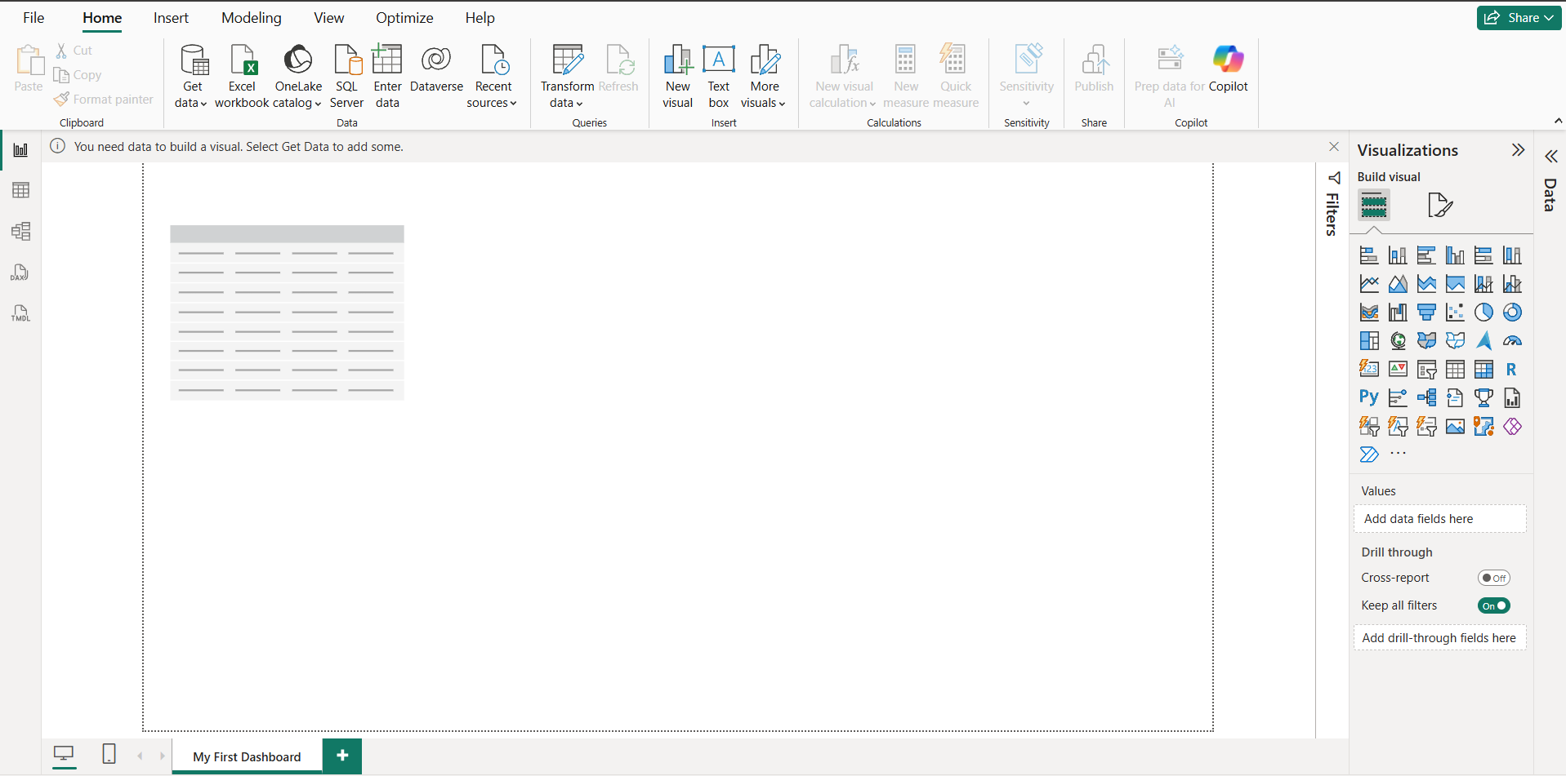

TASK – 4:
Feature | Excel Dashboard | Power BI Dashboard
Data Handling | Usually relies on excel tables, formulas, PivotTables, and PivotCharts. | Designed for importing, transforming, and modeling data from multiple sources.
Interactivity | Can use slicers, filters, and PivotTables, but interaction is generally more limited. | Provides highly interactive visuals, slicers, cross-filtering, drill-down, and interactive report pages.
Data Transformation & Modeling | Uses formulas, PivotTables, Power Query, and other Excel features. | Uses Power Query for data cleaning and data modeling/DAX for calculations and relationships.

