Acme Security Incident Investigation and Architecture Hardening Report
Prepared by:
Ahmet Temirtekin
Position:
Penetration Tester
Date:
09/11/2025

Section 1: Incident Analysis
All timestamps have been normalized to UTC
Time (UTC) | Event Description | Evidence Source | Impact Assessment
01:30-01:45 | Internal security scans from 192.168.1.100; sec_team accessed test accounts 5001–5005 | API logs | Benign activity, aligned with scheduled scans
06:45 – 06:48 | Account 1523 login from 203.0.113.45; stolen JWT reused to access portfolios 1524–1538 | API logs, WAF logs | Unauthorized portfolio access (multi-account)
09:00 – 09:01 | Phishing emails sent from spoofed domain; users 1, 3, 5 clicked malicious links | Email logs, WAF logs | Likely credential/token compromise
09:18 – 09:24 | SQL injection attempts against /dashboard/search; obfuscated payload bypassed WAF; large response and CSV export | WAF logs, Web logs | Potential data exfiltration via export
10:15 – 11:25 | Normal web activity by accounts 4567 and 7891 | Routine usage, unrelated to attack

• 01:30–01:45 – Internal security scans from IP 192.168.1.100 generated failed login attempts; sec_team accessed test accounts 5001–5005.

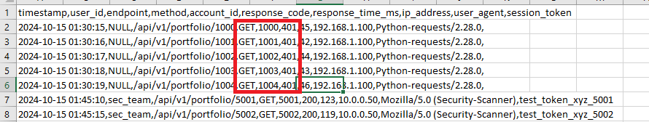
• 06:45–06:48 – Account 1523 logged in from 203.0.113.45; stolen JWT reused to access portfolios

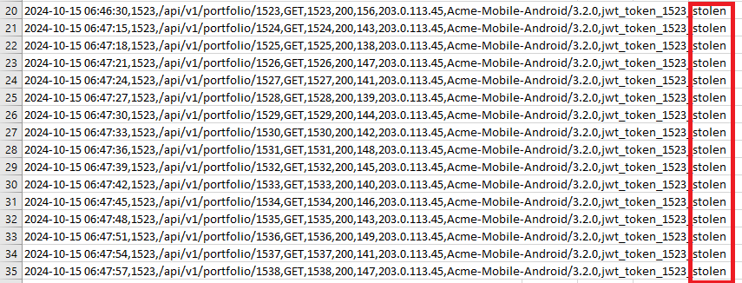.

• 09:00–09:01 – Phishing emails sent from spoofed domain; users 1, 3, 5 clicked malicious links.

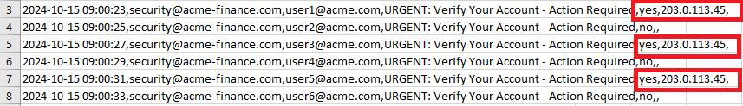
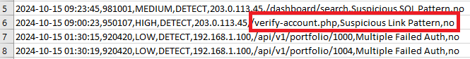
• 09:18–09:24 – SQL injection attempts against /dashboard/search; obfuscated payload bypassed WAF, large response and CSV export followed.

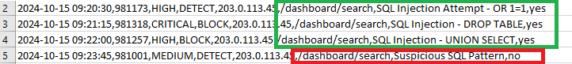
&
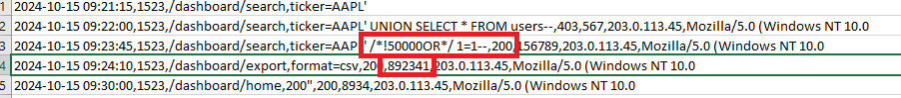

Attack Vector Identification
Attack Vector | Description | Evidence Source | Impact
Phishing Campaign | Spoofed emails tricked users into clicking links | Email logs, WAF logs | Credential/token compromise
SQL Injection | Obfuscated payload bypassed WAF | WAF logs, Web logs | Large response, data export
API Broken Access Control | Stolen JWT reused across accounts | API logs, WAF logs | Unauthorized portfolio access

The incident combined phishing, SQL injection, and API broken access control. Evidence correlates across email, WAF, web, and API logs.
Attack Classification
Owasp Table For Vulnerabilities
Owasp category | Description | Evidence in Incident
A01: Broken Access Control | API did not enforce account ownership | Stolen JWT used to access 1524–1538
A03: Injection | SQL injection payload bypassed WAF | Web logs show 156,789 bytes response
A05: Security Misconfiguration | Email gateway lacked DMARC/SPF/DKIM enforcement | Phishing emails from spoofed domain
OWASP Top 10 categories mapped to Acme incident evidence.
MITRE ATT&CK Mapping (Table)
Technique Name | Evidence in Incident
Phishing | Users clicked malicious email links
Exploit Public-Facing Application | SQL injection on /dashboard/search
Valid Accounts | Stolen JWT reused for multiple accounts
MITRE ATT&CK techniques relevant to Acme incident.”

Root Cause Analysis
The coordinated attack exploited systemic weaknesses. The Trading API validated tokens but failed to enforce ownership, enabling cross-account access. The web application lacked robust input validation, allowing obfuscated SQL payloads to bypass WAF detection. The email gateway had no strict DMARC/SPF/DKIM enforcement, increasing susceptibility to spoofed phishing emails. Together, these gaps created a chain of compromise.
Impact Assessment
Unauthorized portfolio access across accounts 1524–1538, potential data exfiltration via CSV export, and erosion of trust in Acme’s trading platform.
Impact Area | Description | Severity
Data Confidentiality | Unauthorized portfolio access (1524–1538) | Critical
Data Integrity | Potential manipulation via SQL injection | High
Availability | No direct outage observed | Low
Trust/Reputation | Customer confidence erosion | High

Section 2: Architecture Review
Current Architecture Weaknesses
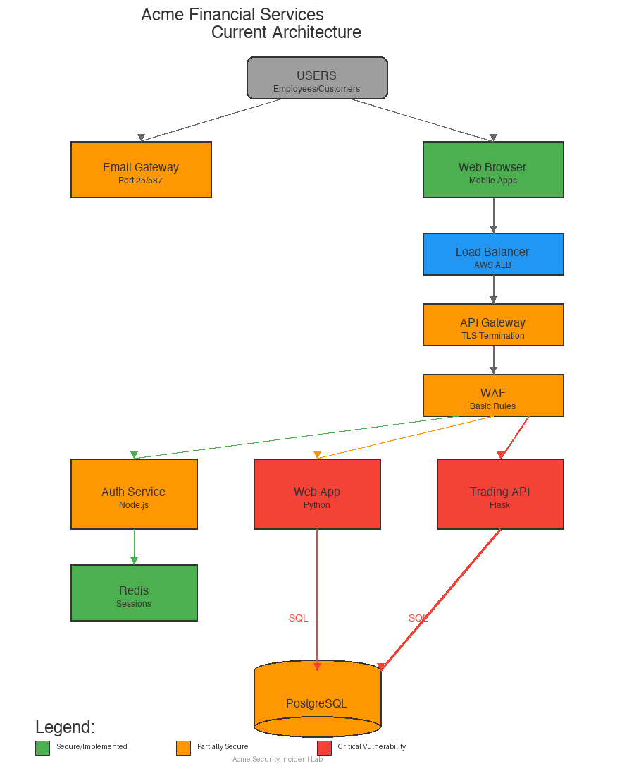
Current architecture highlighting vulnerabilities in API, Web App, and Email Gateway.

Weaknesses include missing ownership validation in API, insufficient input validation in web app, and lack of DMARC/SPF/DKIM in email gateway.

Improved Security Architecture Diagram
Defense-in-depth ensures resilience: if WAF fails, API ownership validation, SIEM monitoring, MFA, and least-privilege DB roles continue to protect the system.

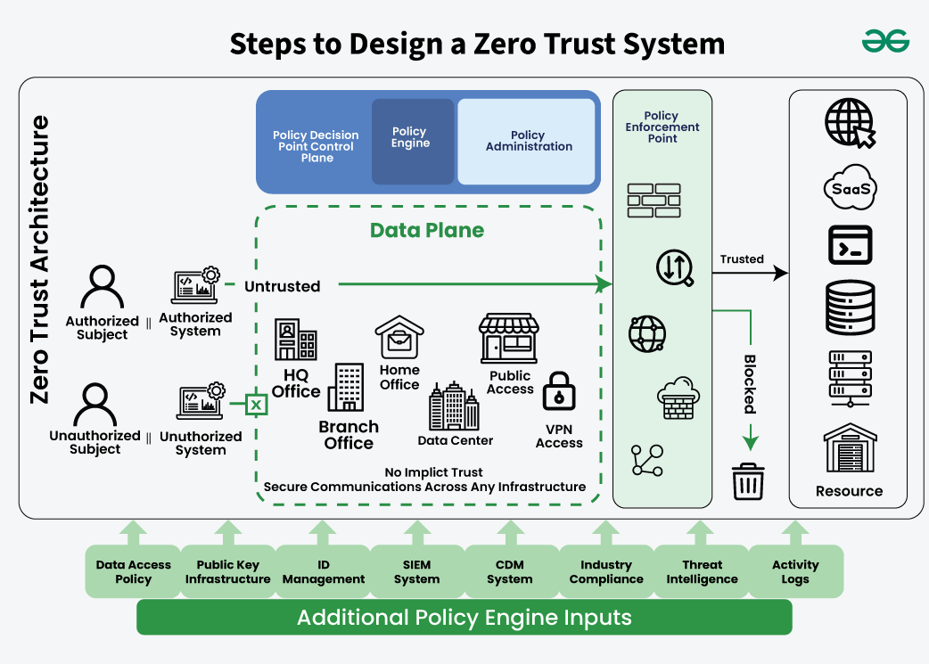
Proposed Zero Trust architecture for Acme Financial Services.
This diagram illustrates the proposed Zero Trust architecture for Acme Financial Services. It emphasizes that no implicit trust is granted to any access point (HQ, branch, home, public, VPN, or data center). All requests are evaluated through a policy engine and administrator, with enforcement points protecting SaaS, PaaS, IaaS, and internal resources. Inputs such as identity management, SIEM telemetry, compliance requirements, and threat intelligence feed into the policy engine, ensuring continuous verification and defense-in-depth.

Section 3: Response & Remediation

Immediate Actions (0–24 hours)
Block malicious IP range 203.0.113.0/24, revoke compromised JWTs, rotate signing keys, disable /dashboard/export temporarily, enforce WAF rules against obfuscated payloads, and require MFA re-verification for affected users.
Short-Term Fixes (1–2 weeks)
Implement strict ownership validation, parameterized queries, rate limits, DMARC/SPF/DKIM reject policies, and phishing awareness training.
Long-Term Improvements (1–3 months)
Introduce Zero Trust API Gateway, least-privilege DB roles, JWT binding, centralized SIEM correlation, and align with OWASP ASVS, NIST 800-53, SOC 2.

Compliance Considerations
All recommendations align with OWASP ASVS, NIST 800-53, and SOC 2 Type II requirements, ensuring regulatory compliance and customer trust.

This report provides a clear roadmap for incident containment, remediation, and long-term resilience. By addressing broken access control, strengthening input validation, and improving phishing defenses, Acme Financial Services can significantly reduce exposure to future threats. The recommended Zero Trust architecture and compliance-aligned controls ensure that the organization not only mitigates current risks but also builds sustainable trust with customers and regulators.

