Project 1 — Wireframe Diagram
Low-Fidelity Wireframe · Personal Developer Portfolio
Muhammad Abdul Kareem · DecodeLabs Internship Program · Batch 2026

Purpose
Per the brief's Pillar 1 (Strategy & Blueprint): “If it doesn’t work in grayscale, color won’t fix it.” This wireframe was produced before any HTML, CSS, or color decisions were made, focusing purely on content hierarchy and page flow, mobile-first.
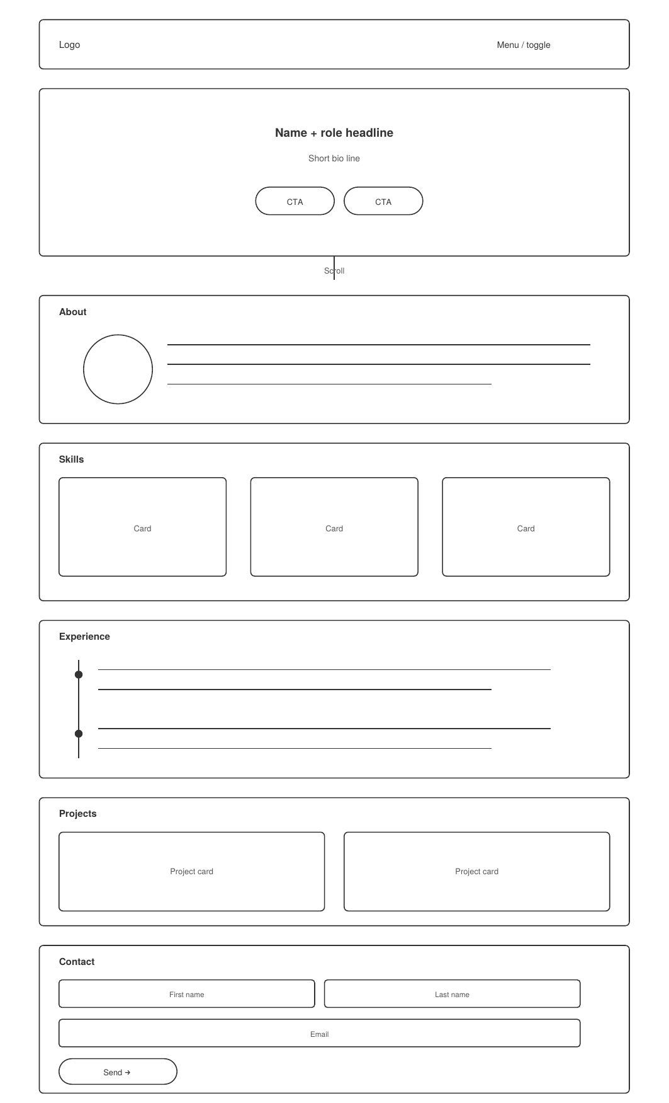
Fig. 1 — Mobile-first low-fidelity wireframe (grayscale, no styling)

Layout & Flow Notes
- Single-column, top-to-bottom flow: Nav → Hero → About → Skills → Experience → Projects → Contact.
- Hero limited to one headline, one bio line, and two CTAs — respecting the brief's 10-second attention window.
- Skills and Projects use repeatable card blocks, designed to scale from 1 column (mobile) to 2-3 columns (tablet/desktop) via CSS Grid.
- Experience uses a vertical timeline structure to show chronological progression clearly.
- Contact form placed last by design — appearing only once credibility has been established earlier in the flow.
- No colors, icons, or final copy were used at this stage — only boxes, lines, and labels to validate structure.
DecodeLabs · Project 1: The Responsive Architecture · decodelabs.tech@gmail.com

