Orbit
A CRM & Distribution Platform built for IRBAS

High-Level Solution Proposal
From import to sale to settlement — one connected system
Prepared by | M. Muhtashim Ali — Technical Lead, ESoftSols
Presented to | IRBAS Management
Scope | High-level — non-technical
Version | 2.0
Date | 15 June 2026

1. Orbit at a Glance
IRBAS imports Keune products from Europe, holds them at a central warehouse in Lahore, and distributes them through 10–15 Regional Offices (ROs) that sell to pharmacies, retail chains, and stores across Pakistan. Today this runs on a legacy ERP covering only invoices, ledgers, and salaries — with everything else handled through WhatsApp, phone calls, and manual entry.
Orbit replaces that with one connected platform that manages the entire operation — from the moment stock is ordered from Keune, through warehousing and distribution, to the final sale and payment. It is designed specifically around how IRBAS works: not a generic product bent to fit, and not bloated with features IRBAS will never use.

The principle behind Orbit:
Track the product and the money together, at every stage, in one place — so that IRBAS always knows what stock exists, where it is, who owes what, and why. Everything that happens between an RO and Head Office becomes a structured, approved, recorded action instead of a WhatsApp message.

1.1 The system, holistically
Orbit is organized into clear domains across four layers — operations, finance and workflow, people and master data, and visibility. Each domain has a distinct purpose; together they cover the whole business.

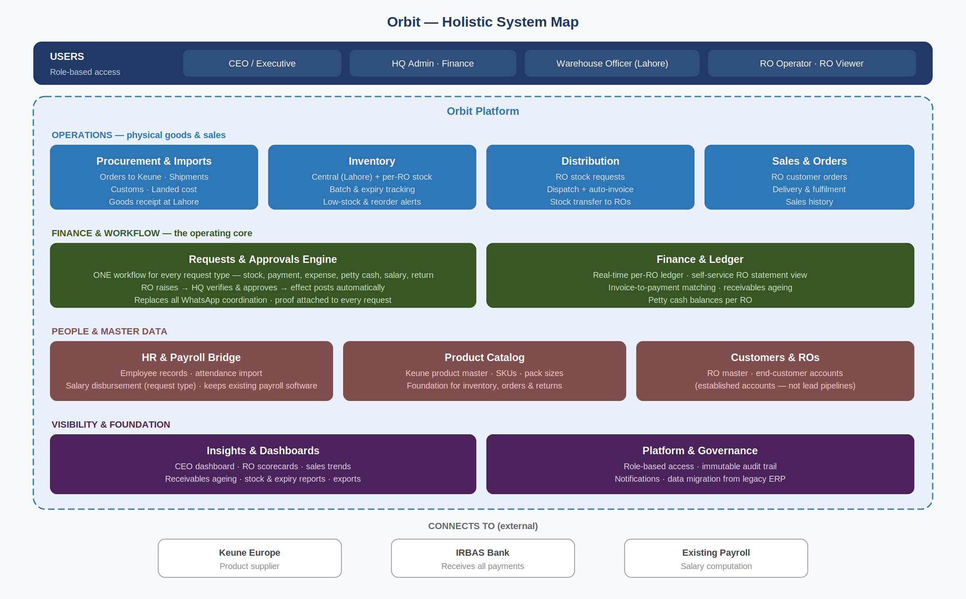
Figure 1: Orbit holistic system map — every domain, grouped by layer

2. What Orbit Adds Beyond the Obvious
A distribution business cannot be managed by tracking money alone. The earlier thinking captured invoices and ledgers but stopped at the financial value of a dispatch — it never tracked the physical product. Orbit closes that gap. The additions below are not extras; they are what makes Orbit a true distribution system rather than just a digital ledger.

What we are adding | Why it belongs in IRBAS's system
Product Catalog | Nothing — inventory, orders, returns — can be tracked properly without a master list of Keune products and pack sizes. It is the foundation everything else references.
Procurement & Imports | IRBAS's business begins with importing from Keune. Capturing purchase orders, shipments, customs, and goods receipt means the stock chain starts where the business actually starts.
Inventory (central + per-RO) | IRBAS runs a Lahore warehouse and a warehouse at every RO. Knowing what stock is held, and where, is core to distribution — yet it was entirely absent before.
Batch & expiry tracking | Hair and cosmetic products expire. Since expired goods are part of the 1% returns policy, the system must know batches and expiry dates to manage stock and returns sensibly.
Low-stock & reorder alerts | Turns inventory data into action — flags when an RO or the central warehouse is running low, so dispatch and import decisions are timely rather than reactive.

2.1 What we are deliberately NOT building
Equally important is what Orbit leaves out. Adding features IRBAS does not need would inflate cost, slow delivery, and complicate adoption. We are intentionally keeping these out of scope:

Not building | Reason
Full accounting / general ledger suite | Orbit mirrors IRBAS's existing RO ledger logic — it is not a replacement for formal accounting software. We track what IRBAS already tracks, better.
Payroll computation | IRBAS keeps its existing payroll software for salary calculation. Orbit only handles the disbursement request and its ledger effect.
Sales pipeline / lead management | IRBAS's customers are established accounts (D. Watson, Imtiaz, Al-Fatah). They need order tracking, not a sales-funnel CRM built for chasing new leads.
Customer-facing online store | End customers order through ROs, not a website. An e-commerce portal would solve a problem IRBAS does not have.
HR suite (recruitment, leave, appraisals) | Out of scope. Orbit holds employee records only to the extent needed for salary disbursement.

3. How It Works — End to End
The clearest way to understand Orbit is to follow a product from Europe to the end customer, and the money back to IRBAS. Every stage is recorded in one connected chain, giving full traceability: which batch went to which RO, was sold to which customer, and paid through which channel.

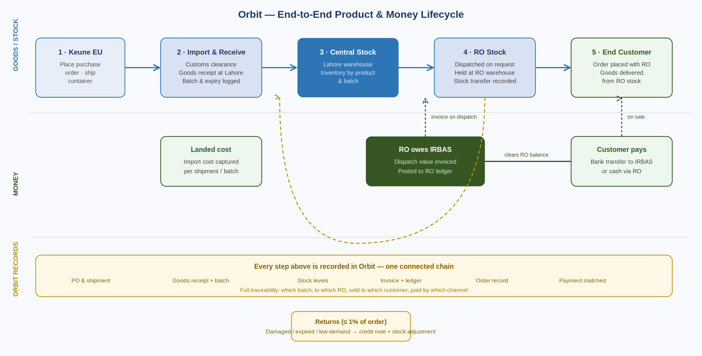
Figure 2: The product and money lifecycle, with the returns loop

Two things move through this chain in parallel — goods and money — and Orbit keeps them aligned. When stock is dispatched to an RO, the same action moves inventory and posts the invoice to the RO's ledger. When the customer pays, that payment clears the RO's balance. Returns flow backward: approved returns issue a credit note and adjust stock at the same time.

4. One Request Engine for Everything
The biggest simplification in Orbit is this: every interaction between an RO and Head Office is a request. Whether an RO is reporting a customer payment, claiming an expense, asking for stock, requesting a salary disbursement, or logging a return — it is the same simple flow. The RO submits with details and proof; Head Office verifies and approves; Orbit applies the right effect automatically and records it.

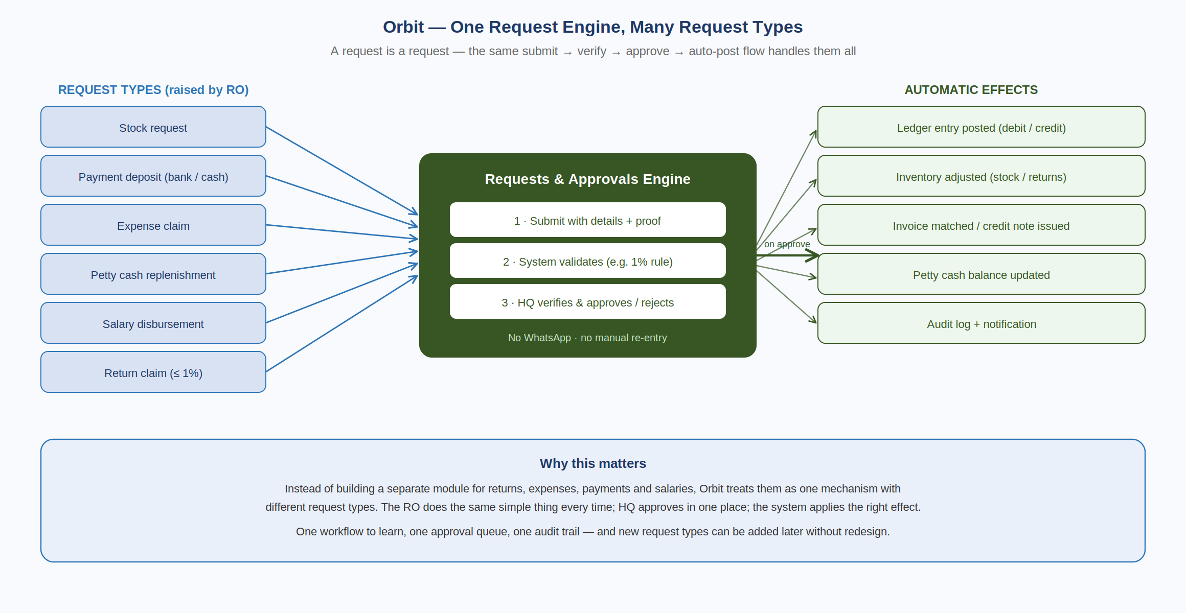
Figure 3: One workflow handles all six request types

This replaces every WhatsApp group in one stroke, and it means there is one thing for ROs to learn, one approval queue for Head Office, and one audit trail for everything. New request types can be added later without rebuilding anything.

4.1 Request types
Request type | Raised by | On approval, Orbit automatically...
Stock request | RO | Dispatches from central stock, moves inventory to the RO, generates the invoice, and posts it to the RO ledger.
Payment deposit | RO | Posts a credit to the RO ledger and matches it against open invoices (bank transfer or cash).
Expense claim | RO | Records the expense by category and deducts it from the RO's petty cash.
Petty cash replenishment | RO | Records the top-up transfer and updates the RO's petty cash balance.
Salary disbursement | RO | Posts the disbursement to the ledger with the per-employee bank/cash split.
Return claim | RO | Checks the 1% limit, issues a credit note, and adjusts inventory for the returned stock.

5. What Orbit Keeps Track Of
These are the core records (entities) Orbit manages. Together they form the connected chain that makes full traceability possible.

Record | What it represents
Product | A Keune item with its pack sizes — the catalog everything references.
Shipment / Import | A consignment ordered from Keune and received at Lahore, with landed cost.
Stock (by batch) | Quantity of a product held at a location (central or an RO), with batch and expiry.
Regional Office | A distribution office with its warehouse, staff, petty cash, and ledger.
End Customer | A pharmacy, chain, or store served by an RO.
Order | A customer's purchase from an RO, fulfilled from RO stock.
Invoice | Generated when stock is dispatched to an RO; tracked to settlement.
Request | Any RO-to-HQ action (the six types) with its proof and approval record.
Ledger Entry | Every debit or credit on an RO's account, traceable to its source.
Employee | Staff record used for salary disbursement and the bank/cash split.

6. Who Uses Orbit — Roles
Orbit uses six clear roles. Earlier thinking had overlapping roles; this streamlined set removes the duplication while adding the warehouse role that physical-stock management requires. Each person sees only what their role needs.

Role | Where | What they do
Executive (CEO) | Head Office | Sees everything: dashboards, RO scorecards, reports, audit trail. Read-focused oversight.
HQ Administrator | Head Office | Manages users, roles, and master data (products, ROs). Runs data migration and configuration.
HQ Finance & Approvals | Head Office | Approves or rejects requests, manages the ledger and invoicing, oversees imports and receivables.
Warehouse Officer | Lahore | Receives imported stock, manages central inventory, and dispatches to ROs.
RO Operator | Regional Office | Raises requests, records customer orders, manages RO stock and petty cash. The day-to-day RO user.
RO Viewer | Regional Office | Read-only access to that RO's ledger and statements.

Note on roles: salary approval is a permission within HQ Finance rather than a separate HR role, and read-only access is a single Viewer role rather than scattered across the system. This keeps the model simple for a business of IRBAS's size — roles can always be split further later if needed.

7. The Value to IRBAS
Today | With Orbit
Stock tracked only as a money figure on dispatch. | Every product tracked from import to sale, by batch and location.
No idea of stock levels at ROs or Lahore. | Live inventory everywhere, with low-stock and expiry alerts.
ROs request ledger statements via WhatsApp. | ROs see their balance and statements in real time, themselves.
Payments, expenses, returns handled in WhatsApp; re-typed into ERP. | One request engine: submit, approve, auto-post. No re-entry.
Returns applied informally with no policy check. | 1% policy enforced automatically; stock and credit handled together.
No central view of orders or customer activity. | Every order recorded and attributed; full sales visibility.
Management asks around to understand performance. | CEO dashboard shows the whole network at a glance, in real time.
No audit trail; changes depend on one person's memory. | Every action logged: who, what, when, with proof.

8. Suggested Delivery Phases
Orbit is delivered in stages so IRBAS gains value early, without waiting for the whole system. Indicative grouping:

Phase | Focus | Delivers
Phase 1 | Foundation & money flow | Product catalog, RO setup, the request engine, RO ledger with self-service view, and data migration. Ends WhatsApp coordination immediately.
Phase 2 | Goods & sales | Imports, central and RO inventory with batch/expiry, distribution & dispatch, customer orders, and returns with the 1% rule.
Phase 3 | Insight & people | Salary disbursement, full CEO dashboard, RO scorecards, stock and receivables reporting.

Next step: a short working session with IRBAS to confirm scope and priorities, settle a few open points (such as the exact ledger convention and the format of imports/landed-cost data), and lock Phase 1. A detailed requirements specification supports this proposal.

