Orbit
A CRM & Distribution Management Platform built for IRBAS

Solution Proposal
From import to sale to settlement — one connected system
Prepared for | IRBAS — Authorized Importer & Distributor of Keune
Prepared by | M. Muhtashim Ali — Technical Lead, ESoftSols
Document | High-Level Solution Proposal (non-technical)
Version | 1.0 — Issued for client review
Date | 15 June 2026
Status | Commercial in Confidence

Contents

1 Executive Summary 3
2 The Opportunity 4
3 Orbit at a Glance 5
4 How Orbit Works — End to End 6
5 The Unified Request Engine 7
6 Functional Coverage 8
7 What We Add, and What We Deliberately Exclude 9
8 Information Orbit Manages 10
9 Roles & Access 11
10 Platform Standards & Safeguards 12
11 The Value to IRBAS 13
12 Delivery Approach 14
13 Assumptions & Points to Confirm 15
14 Next Steps 16

1. Executive Summary
IRBAS imports Keune hair-care products from Europe, holds them at a central warehouse in Lahore, and distributes them through a network of 10–15 Regional Offices (ROs) that sell to pharmacies, retail chains, and stores across Pakistan. The business is healthy, but the systems supporting it are not keeping pace. A legacy ERP covers only invoicing, ledgers, and salaries; everything else — payment proofs, expense approvals, stock requests, returns, order records — is handled through WhatsApp groups, phone calls, and manual data entry.
This creates real and recurring costs: Head Office re-enters data that ROs have already sent, Regional Offices cannot see their own account balances, there is no record of customer orders, returns are applied without policy checks, and management has no consolidated view of the network. None of these problems are isolated — they all stem from the absence of a single system that connects the whole operation.
Orbit is that system. It is a custom CRM and distribution management platform, built specifically around how IRBAS works, that manages the entire operation end to end — from ordering stock from Keune, through warehousing and distribution, to the final sale, payment, and return. It brings the discipline of enterprise software — structured data, approval workflows, role-based access, audit trails, and live reporting — without the bloat of features IRBAS does not need.

The principle behind Orbit
Track the product and the money together, at every stage, in one place — so IRBAS always knows what stock exists, where it is, who owes what, and why. Every interaction between a Regional Office and Head Office becomes a structured, approved, recorded action instead of a WhatsApp message.

This document presents Orbit at a high level: how it works, what it covers, who uses it, the standards it upholds, the value it delivers, and a phased path to delivery. It is intended as a basis for discussion and is supported by a detailed requirements specification.

2. The Opportunity
The table below summarises the core problems Orbit resolves. The first set was raised directly by IRBAS; the remainder emerged from analysing how the operation runs day to day.

Challenge today | Consequence
Regional Offices cannot see their own ledger; they request statements repeatedly via WhatsApp. | Constant manual work at Head Office; ROs operate without visibility of their own balance.
No central record of customer orders. | No sales visibility, no demand insight, no per-RO or per-customer performance view.
Payments are not matched to the invoices they settle. | Outstanding balances and overdue accounts cannot be tracked reliably.
Payment proofs, expenses, and approvals run through WhatsApp, then are re-typed into the ERP. | Duplicated effort, transcription errors, missed items, and no audit trail.
No tracking of physical stock — only the money value of a dispatch. | No visibility of what stock is held, where, or what is nearing expiry.
Returns are handled informally with no policy enforcement. | The 1% return limit is applied inconsistently; no link between credit and stock.
Salaries require manual correction each cycle; bank/cash splits are informal. | Errors, disputes, and no clean disbursement record.

3. Orbit at a Glance
Orbit is organised into clear domains across four layers — operations, finance and workflow, people and master data, and visibility. Each domain has a distinct purpose; together they cover the entire business. The platform connects to three external parties: Keune (supply), IRBAS's bank (payments), and the existing payroll software (salary computation).

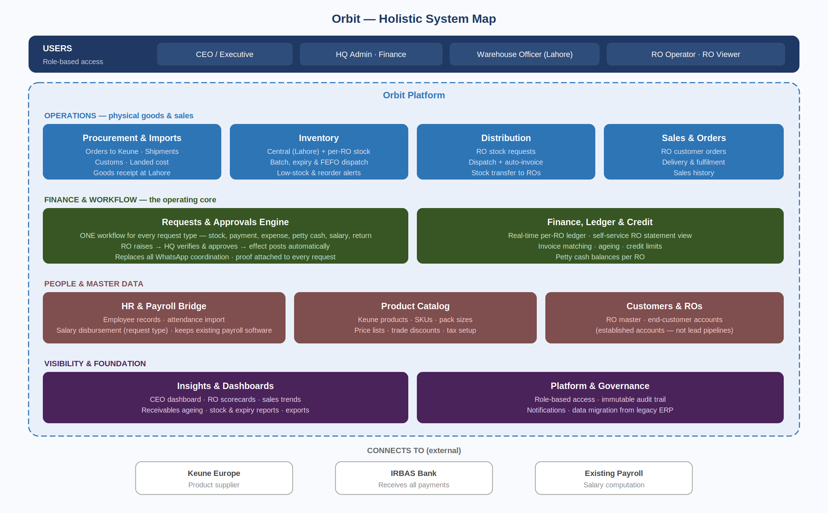
Figure 1: Orbit holistic system map — every domain, grouped by layer

4. How Orbit Works — End to End
The clearest way to understand Orbit is to follow a product from Europe to the end customer, and the money back to IRBAS. Every stage is recorded in one connected chain, giving full traceability: which batch went to which RO, was sold to which customer, and was paid through which channel.

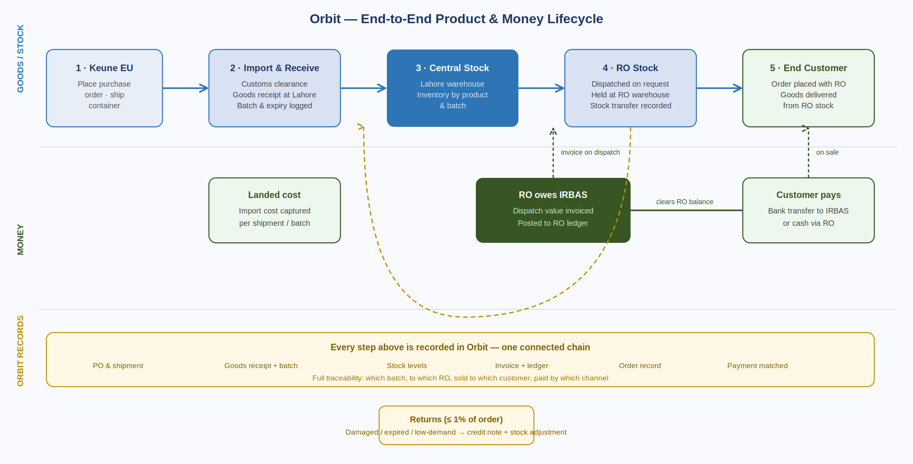
Figure 2: The product and money lifecycle, with the returns loop

Goods and money move through this chain in parallel, and Orbit keeps them aligned. When stock is dispatched to an RO, the same action moves inventory and posts the invoice to the RO's ledger. When the customer pays, that payment clears the RO's balance. Returns flow backward: an approved return issues a credit note and adjusts stock at the same time. Because every step is captured, IRBAS gains an unbroken record from import cost through to final settlement.

5. The Unified Request Engine
The central design idea in Orbit is that every interaction between a Regional Office and Head Office is a request. Whether an RO is reporting a customer payment, claiming an expense, asking for stock, requesting a salary disbursement, or logging a return, it follows the same simple flow: the RO submits with details and proof, Head Office verifies and approves, and Orbit applies the correct effect automatically and records it.

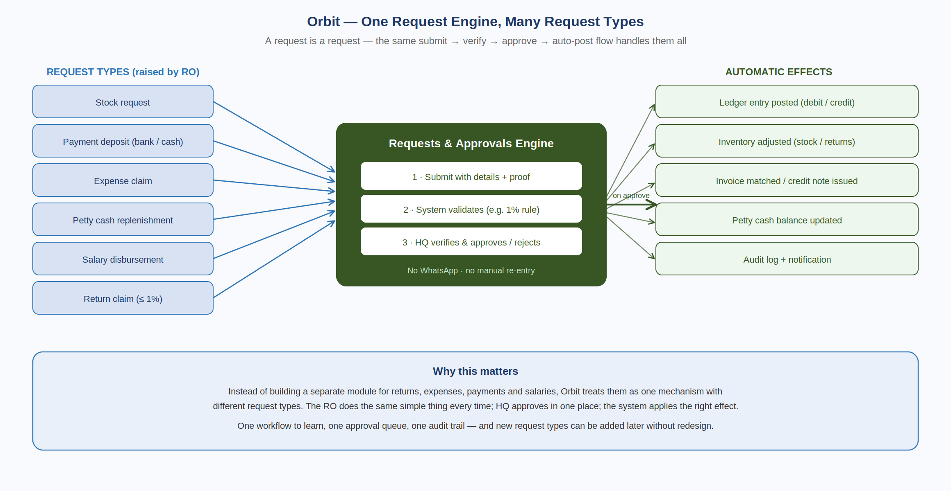
Figure 3: One workflow handles every request type

This single mechanism replaces every WhatsApp group at once. It means one workflow for ROs to learn, one approval queue for Head Office, and one audit trail across everything. New request types can be added in future without redesigning the system.

5.1 Request types
Request type | Raised by | On approval, Orbit automatically…
Stock request | RO | Dispatches from central stock, moves inventory to the RO, generates the invoice, and posts it to the RO ledger.
Payment deposit | RO | Posts a credit to the RO ledger and matches it against open invoices (bank transfer or cash).
Expense claim | RO | Records the expense by category and deducts it from the RO's petty cash.
Petty cash replenishment | RO | Records the top-up transfer and updates the RO's petty cash balance.
Salary disbursement | RO | Posts the disbursement to the ledger with the per-employee bank/cash split.
Return claim | RO | Checks the 1% limit, issues a credit note, and adjusts inventory for the returned stock.

6. Functional Coverage
Orbit has been designed against the standard capability areas expected of a modern distribution and CRM platform, then tailored to IRBAS. The table below maps each capability area to how Orbit delivers it. The status column indicates whether a capability is core to the platform, a standard supporting feature, or configurable to IRBAS's confirmed policy.

Capability area | How Orbit delivers it | Status
Master data | Central catalog of Keune products, plus Regional Offices, end customers, and employees. | Core
Procurement & imports | Purchase orders to Keune, shipment and customs tracking, foreign-currency landed cost, and goods receipt at Lahore. | Core
Inventory & warehousing | Stock by product and batch at the central and RO warehouses, expiry tracking, first-expiry-first-out dispatch, and reorder alerts. | Core
Pricing & discounts | Price lists per product with trade-discount handling, applied to orders and invoices. | Standard
Order management | Customer orders captured at the RO, fulfilment from RO stock, and delivery recording. | Core
Invoicing | Invoices generated automatically on dispatch, with live status (open, partial, settled, overdue). | Core
Receivables & credit control | Per-RO ledger, invoice-to-payment matching, receivables ageing, and credit limits that flag over-limit accounts. | Core
Payments & reconciliation | Bank-transfer and cash-deposit requests with proof, matched to the RO account and invoices. | Core
Returns & claims | Policy-enforced 1% returns against the originating invoice, with automatic credit notes and stock adjustment. | Core
Workflow & approvals | One request engine covering all request types, with proof capture and approval routing. | Core
Sales tax / GST | Tax applied on invoices per IRBAS's confirmed treatment. | Configurable
Reporting & dashboards | CEO dashboard, RO scorecards, receivables ageing, sales trends, and stock/expiry reports, with PDF/Excel export. | Core
Access & security | Role-based access control and an immutable audit trail of every financial action. | Core
Notifications | Alerts for pending approvals, ledger updates, low stock, and request outcomes. | Standard
Mobile access | Responsive interface for Regional Office and field use on phones and tablets. | Standard
Data migration | Structured import of legacy ERP data — ROs, ledgers, open invoices, employees — validated before go-live. | Core

7. What We Add, and What We Deliberately Exclude
A distribution business cannot be run by tracking money alone. The most important additions in Orbit relate to the physical product — the part the legacy ERP ignored entirely. These are not extras; they are what makes Orbit a true distribution system rather than a digital ledger.

What we add | Why it belongs in IRBAS's system
Product catalog & pricing | Inventory, orders, and returns all reference a master list of Keune products, pack sizes, and prices — the foundation everything else is built on.
Procurement & imports | IRBAS's chain begins with importing from Keune. Capturing purchase orders, shipments, customs, and landed cost starts the record where the business actually starts.
Inventory at every location | IRBAS runs a Lahore warehouse and a warehouse at each RO. Knowing what stock is held, and where, is core to distribution — and was entirely absent before.
Batch, expiry & FEFO | Hair and cosmetic products expire. Since expired goods fall under the 1% returns policy, the system tracks batches and expiry and dispatches oldest-expiry stock first.
Credit control | Because ROs carry balances with IRBAS, credit limits flag accounts that are over-extended before more stock is dispatched — protecting IRBAS's cash position.

7.1 What we deliberately exclude
Equally important is what Orbit leaves out. Adding features IRBAS does not need would inflate cost, slow delivery, and complicate adoption. These are intentionally out of scope:

Out of scope | Reason
Full accounting / general-ledger suite | Orbit mirrors IRBAS's existing RO ledger logic; it is not a replacement for formal accounting software. It tracks what IRBAS already tracks, done better.
Payroll computation | IRBAS keeps its existing payroll software for salary calculation. Orbit handles only the disbursement request and its ledger effect.
Sales pipeline / lead management | IRBAS's customers are established accounts. They need order tracking, not a sales-funnel CRM built for chasing new leads.
Customer-facing online store | End customers order through ROs, not a website. An e-commerce portal would solve a problem IRBAS does not have.
HR suite (recruitment, leave, appraisals) | Out of scope. Orbit holds employee records only to the extent needed for salary disbursement.

8. Information Orbit Manages
These are the core records Orbit maintains. Together they form the connected chain that makes end-to-end traceability possible.

Record | What it represents
Product | A Keune item with its pack sizes and price — the catalog everything references.
Shipment / import | A consignment ordered from Keune and received at Lahore, with landed cost.
Stock (by batch) | Quantity of a product held at a location (central or an RO), with batch and expiry.
Regional Office | A distribution office with its warehouse, staff, petty cash, ledger, and credit limit.
End customer | A pharmacy, chain, or store served by a Regional Office.
Order | A customer's purchase from an RO, fulfilled from RO stock.
Invoice | Generated when stock is dispatched to an RO; tracked through to settlement.
Request | Any RO-to-Head-Office action (the six types) with its proof and approval record.
Ledger entry | Every debit or credit on an RO's account, traceable to its source.
Employee | A staff record used for salary disbursement and the bank/cash split.

9. Roles & Access
Orbit uses six clearly separated roles, each seeing only what its function requires. The set is deliberately lean for a business of IRBAS's size, with duties separated so that the people who raise requests are not the people who approve them.

Role | Location | Responsibilities
Executive (CEO) | Head Office | Full visibility: dashboards, RO scorecards, reports, and audit trail. Oversight, not data entry.
HQ Administrator | Head Office | Manages users, roles, and master data (products, pricing, ROs); runs migration and configuration.
HQ Finance & Approvals | Head Office | Approves or rejects requests, manages the ledger and invoicing, and oversees imports and receivables.
Warehouse Officer | Lahore | Receives imported stock, manages central inventory, and dispatches to Regional Offices.
RO Operator | Regional Office | Raises requests, records customer orders, and manages RO stock and petty cash — the day-to-day RO user.
RO Viewer | Regional Office | Read-only access to that RO's ledger and statements.

Note on roles. Salary approval is a permission within HQ Finance rather than a separate HR role, and read-only access is a single Viewer role rather than being scattered across the system. This keeps the model simple to administer; roles can be split further later if IRBAS's structure requires it.

10. Platform Standards & Safeguards
Beyond features, Orbit is built to the operational standards expected of a system that holds a company's financial and stock records. The following safeguards are part of the platform, not optional extras.

Area | Commitment
Security | Every user authenticates to access the system; permissions are enforced by role on the server; data is encrypted in transit.
Accountability | Every financial action — request, approval, ledger entry, configuration change — is logged immutably with the user, time, and supporting proof.
Reliability | Regular automated backups with a defined recovery process, so data is protected against loss.
Availability & performance | Designed for dependable access during business hours across all regions, and to scale comfortably as IRBAS adds Regional Offices.
Accessibility | A responsive interface so Regional Office and field staff can work from phones and tablets, not only desktops.
Localisation | Pakistani Rupee throughout, local date and number formats, and English as the primary language (Urdu labelling can be added if desired).

11. The Value to IRBAS
In plain terms, Orbit changes IRBAS's operation from fragmented and manual to connected and controlled.

Today | With Orbit
Stock is tracked only as a money figure on dispatch. | Every product is tracked from import to sale, by batch and location.
No view of stock levels at ROs or Lahore. | Live inventory everywhere, with low-stock and expiry alerts.
ROs request ledger statements via WhatsApp. | ROs see their balance and statements in real time, themselves.
Payments, expenses, and returns are handled in WhatsApp, then re-typed. | One request engine: submit, approve, auto-post — no re-entry.
Returns are applied informally with no policy check. | The 1% policy is enforced automatically; stock and credit are handled together.
No credit control over ROs that owe money. | Credit limits flag over-extended accounts before more stock is dispatched.
No central view of orders or customer activity. | Every order recorded and attributed; full sales visibility.
Management asks around to understand performance. | A CEO dashboard shows the whole network at a glance, in real time.
No audit trail; changes rely on one person's memory. | Every action is logged: who, what, when, with proof.

12. Delivery Approach
Orbit is delivered in three phases so IRBAS gains value early, without waiting for the whole system. Each phase is usable in its own right, and the sequence respects how the modules depend on one another.

Phase | Focus | What it delivers | Outcome
Phase 1 | Foundation & financial control | Master data (products, ROs, customers, employees), roles and access, legacy-data migration with opening balances, the real-time RO ledger with self-service view, and the request engine for payments, expenses, petty cash, and salary disbursements. | WhatsApp coordination for finance ends; every RO sees its own ledger in real time.
Phase 2 | Supply & distribution | Procurement and imports, inventory with batch/expiry and FEFO, pricing and credit limits, dispatch with automatic invoicing and the stock-request flow, invoice-to-payment matching, and the 1% returns workflow. | Physical stock is fully tracked from import to RO; every rupee dispatched is accountable.
Phase 3 | Sales & insight | Customer orders and fulfilment, customer history, the full CEO dashboard and RO scorecards, and stock, expiry, and receivables reporting. | Complete sales visibility and management reporting across the network.

Phased value. IRBAS does not wait until the end to benefit. From the close of Phase 1, the WhatsApp-and-re-entry cycle is gone and ledgers are live. Phase 2 brings the entire physical-stock operation onto the platform. Phase 3 completes the management picture.

13. Assumptions & Points to Confirm
This proposal reflects our current understanding of IRBAS's operation. A short working session will confirm the following points, each of which shapes the detailed design and delivery plan. None changes the overall shape of Orbit; they refine specific areas.

Point to confirm | Why it matters
The exact ledger convention (how debits and credits are recorded for stock and payments). | Ensures Orbit mirrors IRBAS's existing bookkeeping precisely.
Sales tax / GST treatment on invoices. | Determines how tax is configured and shown on invoices and reports.
Pricing model — a single price list, or different pricing per RO or customer. | Shapes the pricing and invoicing setup.
Whether stock is tracked at item level (proposed) or only by value. | Affects the depth of the inventory modules.
The export format available from the existing payroll and attendance software. | Determines how salary data flows into disbursement requests.
The export format available from the legacy ERP for migration. | Determines the migration approach and effort.
Preference for a responsive web interface (proposed) or a dedicated mobile app. | Affects the Regional Office and field experience.

14. Next Steps
- Review. IRBAS reviews this proposal and confirms the overall approach.
- Working session. A short session resolves the points in Section 13 and aligns on Phase 1 scope.
- Scope & plan. ESoftSols issues a detailed effort estimate, delivery schedule, and Phase 1 statement of scope for sign-off.
- Kick-off. On sign-off, delivery begins, with a nominated IRBAS point of contact and regular progress updates.

Supporting document. A detailed Business & Software Requirements Specification accompanies this proposal, with the full problem analysis, traceable functional and non-functional requirements, and the complete entity and role definitions.
Contact. M. Muhtashim Ali — Technical Lead, ESoftSols.

