1. function [T,d,h_max]=func1(theta,v)%T为总飞行时间,d为落点距离,h_max为最大飞行高度

a0=theta;g=9.8;

vx=v*cos(a0*pi/180);vy=v*sin(a0*pi/180);

T=2*vy/g;

d=vx*T;

h_max=vy^2/(2*g);

for t=0:0.01:T

h=vy*t-g*t^2/2;

x=5+vx*t;

if h>h_max

h_max=h;

end

pause(0.005)

plot(x,h,'or','MarkerSize',5,'MarkerFace',[1,0,0])

grid

axis([0,d+10,0,h_max])

end

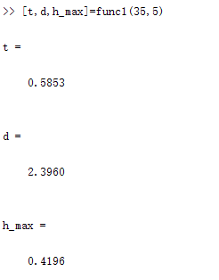

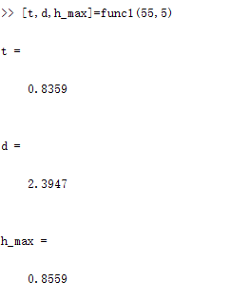

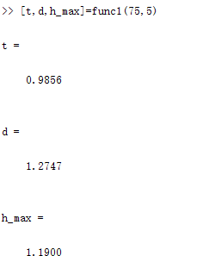

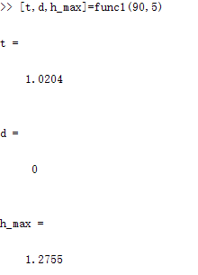

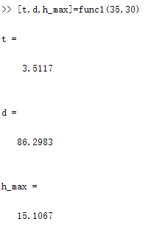

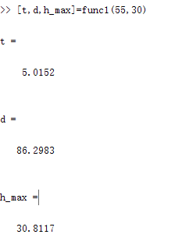

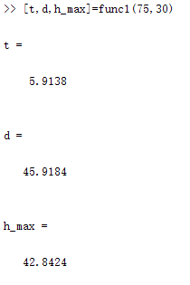

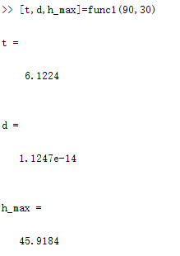

2.(1) function [rent,profit_max]=func2()

profit_max=0;

for i=1000:25:3500

profit=i*(100-(i-1000)/25);

if profit>profit_max

profit_max=profit;

rent=i;

end

end

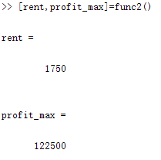

即每月租金为1750时收益最大，最大收益为122500

（2）function [rent,profit_max]=func2()

profit_max=0;

for i=1000:25:3500

profit=(i-20)*(100-(i-1000)/25);%将租金减去维护费即为收益

if profit>profit_max

profit_max=profit;

rent=i;

end

plot(i,profit,'*r','MarkerSize',2)

grid on

hold on

axis([1000,3500,0,profit_max])

end

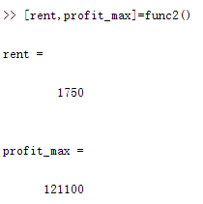

即每月租金为1750时收益最大，最大收益为121100

3. function m=func3(p,i,n)%p0为本金，i为利率，n为年数

for k=1:n

p=p*(1+i);

end

m=p/n;

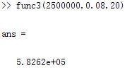

即每年应还582620元

4. %func4.m

P1=2000;P2=3000;h1=5;h2=6;s=20;

syms x

r1=(h1^2+x^2)^(1/2);

r2=(h2^2+(s-x)^2)^(1/2);

a1=asin(h1/r1);

a2=asin(h2/r2);

E1=E(P1,a1,r1);

E2=E(P2,a2,r2);

f=(E1^2+E2^2+2*E1*E2*(sin(a1)*sin(a2)-cos(a1)*cos(a2)))^(1/2);

diff(f,x);

vpasolve(diff(f),x)

%E.m

function y=E(P,a,r)

y=P*sin(a)/(4*pi*r^2);

