**SCOPE AND LIMITATIONS**

This study aims to design and simulate a Flood Monitoring and Alerting System using Tinker Cad Simulation.

* This study focuses only on simulating Flood Monitoring and Alerting system using Tinker cad web application.
* This Flood Monitoring and Alerting System use HC-SR04 Ultrasonic Sensor as main sensor.

**RRL**

* 1. LM35 Temperature Sensor

The LM35 (Figure 1) is a temperature sensor that produces an analog signal proportional to the current temperature. The output voltage can be easily interpreted to generate a temperature reading in degrees Celsius. The LM35 has an advantage over thermistors in that it does not require external calibration. It is also protected from self-heating by the coating. It can measure temperatures ranging from -55 to 150 degrees Celsius. When operated at optimal temperature and humidity levels, the accuracy level is high. The conversion of the output voltage to centigrade is also easy and straightforward [3].

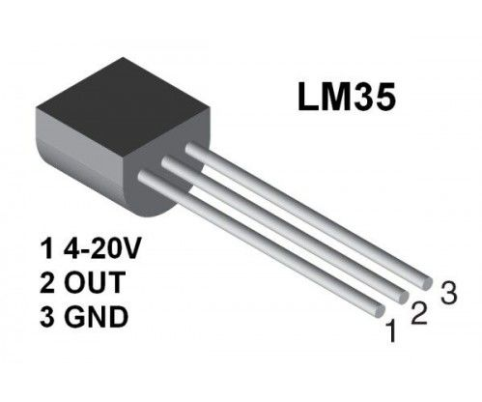**Figure 1**. **LM35 Temperature Sensor**

* 1. LM35 Features and Specifications

In table 1. It shows the parameters of the LM35 Temperature Sensor. The Output voltage is directly proportional to Temperature i.e. there will be rise of 10mV or 0.01V for every 1°C rise in temperature.

|  |  |
| --- | --- |
| Temperature-Voltage scale factor | +10 mV/°C |
| Measurement range | -55 °C to 150 °C |
| Supply Voltage | 4V – 30V |
| Current drain | 60 μA |
| Self-heating | 0.08 °C |
| Accuracy | ±3/4°C |
| Package | TO - 92 |

**Table 1**. LM35 **Temperature Sensor Parameters** [4]

* 1. LM35 Temperature Sensor with Arduino

It is very simple to measure the temperature if a location using an Arduino and any of the commercial temperature sensors available. In Figure 2, shows the pin configuration of the sensor with the Arduino uno. The input pin in the Circuit is the Analog pin A0 of the arduino and connect the LM35 output pin. The +5V is applied to VCC pin of the sensor and ground the Gnd pin. The detected temperature is printed in the 16×2 character lcd [5].

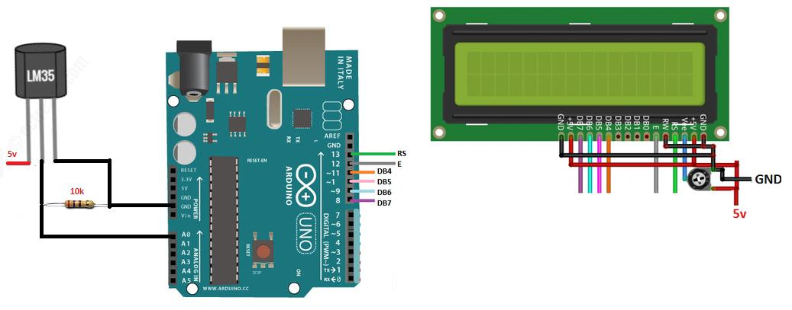

Figure 2. LM35 Temperature Sensor, 16×2 LCD with Arduino

Reference

[3] EG Projects. (n.d.) LM35 Temperature Sensor Pin Out, Interfacing guide, Circuit Construction and working Principals. Retrieved from <https://engineersgarage.com/lm35-description-and-working-principal/>

[4] ŠKULÉTY, E., PIVARČIOVÁ, E., KARRACH, L., (2018). The Comparing of the Selected Temperature Sensors Compatible With The Arduino Platform. Management System in Production Engineering. 26(3), 168-171

[5] Arduino – Temperature Sensor. Tutorials Point. Retrieved from [https://www.tutorialspoint.com/arduino/arduino_temperature_sensor.htm#](https://www.tutorialspoint.com/arduino/arduino_temperature_sensor.htm)