Developing Temperature Sensor for Flood Monitoring System (ACM:IA-I-RRL- PM-R-A)

Michael Jhon Madrona (Student)

Bachelor of Science Electrical Engineering, College of Engineering, Architecture and Industrial Design, Bohol Island State University-Main Campus, [michaeljhon.madrona@bisu.edu.ph](mailto:michaeljhon.madrona@bisu.edu.ph)

MAX ANGELO DAPITILLA PERIN (INSTRUCTOR)

Faculty of Department of Electrical Engineering, College of Engineering, Architecture and Industrial Design, Bohol Island State University-Main Campus, [maxangelo.perin@bisu.edu.ph](mailto:maxangelo.perin@bisu.edu.ph)

**Imaginative Abstract:** In a flood monitoring system, there are several kinds of sensor used to determine the danger of the calamity. Temperature sensor is one of the major components that are widely used for monitoring the possible rising of waters in rivers. For the flood monitoring system, the researchers will use the LM35 temperature sensor. The temperature sensor ranges from negative fifty-five degrees Celsius to One hundred fifty degrees Celsius. The temperature sensor will be place with the other components in the Flood Monitoring system hardware. The sensor will be place in the Arduino Uno board along the five volts of bolt WIFI module. The temperature sensor will send data to Arduino and convert the temperature degrees.

CCS CONCEPTS • Hardware • Emerging Technologies • Electromechanical Systems • Microelectromechanical Systems

Additional Keywords and Phrases: Arduino Uno, Flood monitoring, Alert System, Temperature sensor

ACM Reference Format:

**Michael Jhon Madrona. MAX ANGELO DAPITILLA PERIN**. 2022. **Developing Temperature Sensor for Flood Monitoring System (ACM:IA-I-RRL- PM-R-A).** In Research Project Presentation for Bachelor of Science in Electrical Engineering 3 in CPE 03 – Microprocessor Systems S.Y. 2021-2022, 2nd Semester, Bohol Island State University-Main Campus, Tagbilaran City, Republic of the Philippines. ACM, New York, NY, USA

1. INTRODUCTION

Natural disasters such as typhoons, volcanic eruptions, and earthquakes have frequently struck the Philippines, despite the government’s best efforts to mitigate the damages. These disasters leave heavy losses to country’s economy and claimed hundreds of lives every year [1]. The Philippines, one of the nations most vulnerable to tropical storms, is expected to see roughly 20 typhoons annually, with an average of 6 to 9 of them reaching landfall [2]. The increase of climate change is one of the main reason why typhoons are getting stronger and experiencing heavy rainfalls anytime of the year. Flood warning system is one of the solutions for the local government reducing the risks of flash floods. Warning systems helps alerting and notify the community and the public when there are possible flash floods. This paper focuses on the flood warning system specifically on the changes in weather system. The weather system can be detected by the temperature sensor in Flood warning system.

1. REVIEW OF RELATED LITERATURE

One of the major parts of a Flood monitoring and Alerting System is the temperature sensor. It is a type of electronic device that measures the temperature of its surroundings and converts the measured data into electronic data in order to record, monitor, or signal temperature changes. LM35 temperature sensor is a common sensor used in weather monitoring system. It is a sensor that output voltage can easily interpreted to obtain a temperature reading in Celsius. The LM35 temperature sensor has different parameters and it is widely used with the Arduino.

* 1. LM35 Temperature Sensor

The LM35 (Figure 1) is a temperature sensor that produces an analog signal proportional to the current temperature. The output voltage can be easily interpreted to generate a temperature reading in degrees Celsius. The LM35 has an advantage over thermistors in that it does not require external calibration. It is also protected from self-heating by the coating. It can measure temperatures ranging from -55 to 150 degrees Celsius. When operated at optimal temperature and humidity levels, the accuracy level is high. The conversion of the output voltage to centigrade is also easy and straightforward [3].

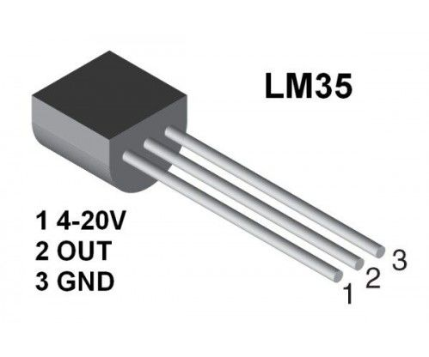Figure 1. **LM35 Temperature Sensor**

* 1. LM35 Features and Specifications

In table 1. It shows the parameters of the LM35 Temperature Sensor. The Output voltage is directly proportional to Temperature (i.e.) there will be rise of 10mV (0.01V) for every 1°C rise in temperature.

|  |  |
| --- | --- |
| Temperature-Voltage scale factor | +10 mV/°C |
| Measurement range | -55 °C to 150 °C |
| Supply Voltage | 4V – 30V |
| Current drain | 60 μA |
| Self-heating | 0.08 °C |
| Accuracy | ±3/4°C |
| Package | TO - 92 |

Table 1. LM35 **Temperature Sensor Parameters** [4]

* 1. LM35 Temperature Sensor with Arduino

It is very simple to measure the temperature if a location using an Arduino and any of the commercial temperature sensors available. In Figure 2, shows the pin configuration of the sensor with the Arduino uno. The input pin in the Circuit is the Analog pin A0 of the arduino and connect the LM35 output pin. The +5V is applied to VCC pin of the sensor and ground the Gnd pin. The detected temperature is printed in the 16×2 character lcd [5].

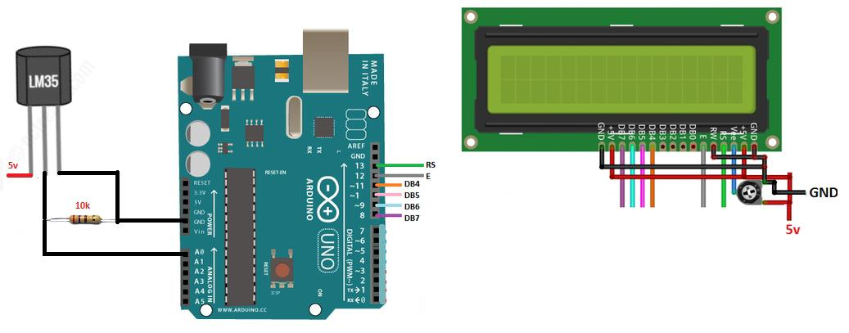Figure 2. **LM35 Temperature Sensor, 16×2 LCD with Arduino**

1. PROPOSED METHODOLOGY

This Study focuses on sensing the Temperature of the place as part of the Flood monitoring system. In this study, Arduino uno will be used as main controller and LM35 temperature sensor for main sensing. The design will be simulated in the Tinkercad simulator. The three terminals will be connected as follows; the +Vs is connected to the +5V of the Arduino Uno board, the Vout is connected to the Analog0 (A0) of the Arduino board, and the GND is connected to the Gnd of the Arduino board. Arduino IDE software will be use for data process of the system.

* 1. Important Code

void setup()

{

pinMode(LED_BUILTIN, OUTPUT);

}

void loop()

{

digitalWrite(LED_BUILTIN, HIGH);

delay(1000); // Wait for 1000 millisecond(s)

digitalWrite(LED_BUILTIN, LOW);

delay(1000); // Wait for 1000 millisecond(s)

}

REFERENCES

[1] Japan International Cooperation Agency. (2004). The study on Flood Control Project Implementation System for Principal Rivers in the Philippine. Retrieved July 3, 2022, from <https://openjicareport.jica.go.jp/pdf/11775665.pdf>

[2] Strobl, E. (2019). The Impact of typhoons on economic Activity in the Philippines: Evidence from Nightlight Intensity. <https://www.adb.org/publications/impact-typhoons-philippines>

[3] EG Projects. (n.d.) LM35 Temperature Sensor Pin Out, Interfacing guide, Circuit Construction and working Principals. Retrieved from <https://engineersgarage.com/lm35-description-and-working-principal/>

[4] Skultety, E., Pivarciova, E., Karrach, L., (2018). The Comparing of the Selected Temperature Sensors Compatible With The Arduino Platform. Management System in Production Engineering. 26(3), 168-171

[5] Arduino – Temperature Sensor. Tutorials Point. Retrieved from https://www.tutorialspoint.com/arduino/arduino_temperature_sensor.htm#

APPENDICES

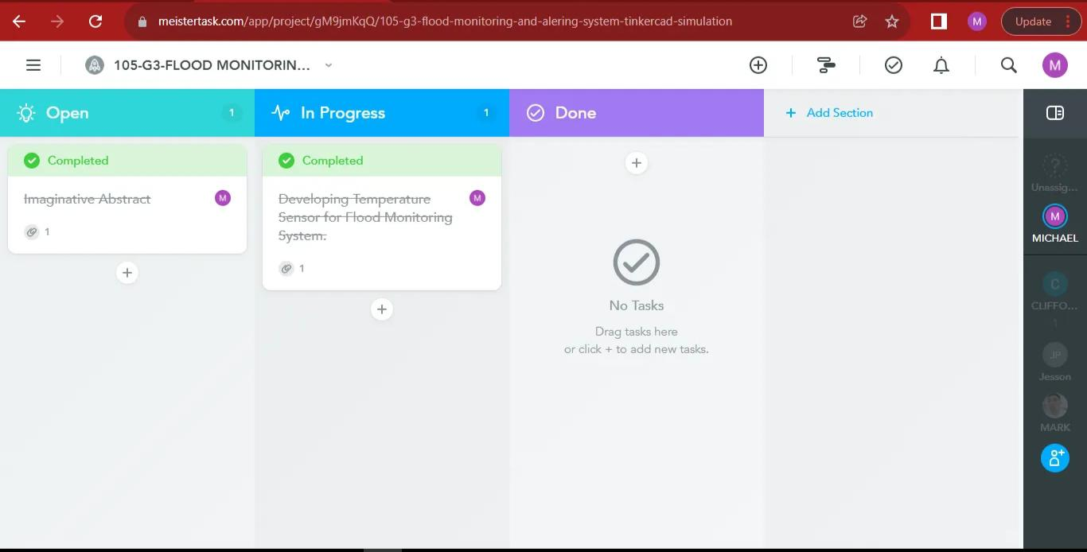

Figure 3. Meistertask Contribution via ( <https://www.meistertask.com/app/project/gM9jmKqQ/105-g3-flood-monitoring-and-alering-system-tinkercad-simulation> )

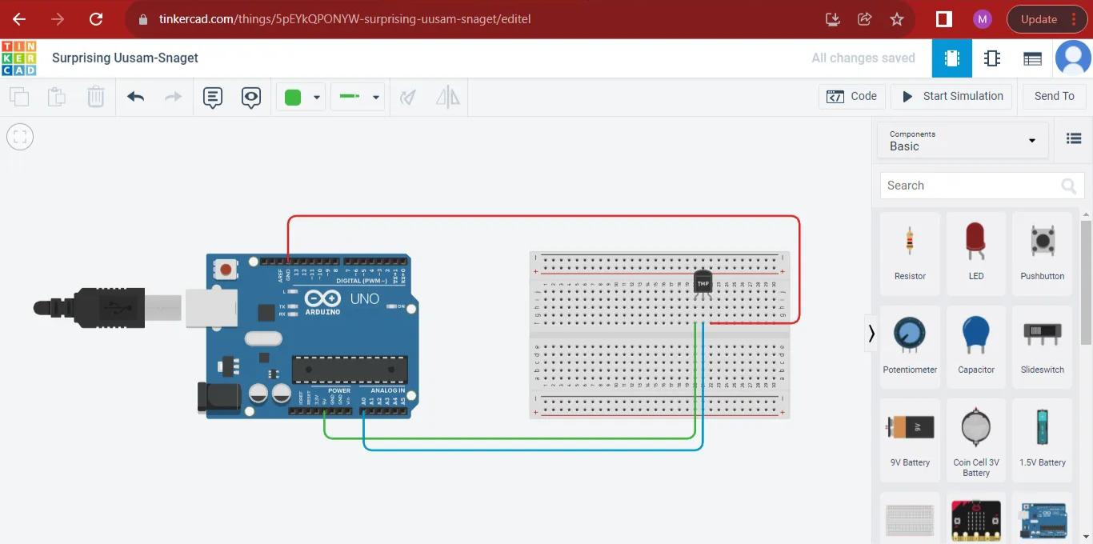

Figure 4. Tinkercad simulation via ( <https://www.tinkercad.com/things/5pEYkQPONYW-surprising-uusam-snaget/editel?sharecode=5gM4yxlstrnvzqk6YDFsHsGwBH86fwCSzECuHNLp1qs> )

Flood Monitoring and Alert System (Temperature Sensor) Sketch

Float temp;

Int tempPin = 0;

Void setup() {

Serial.begin(9600);

}

Void loop() {

Temp = analogRead(tempPin);

// read analog volt from sensor and save to variable temp

Temp = temp * 0.48828125;

// convert the analog volt to its temperature equivalent

Serial.print(“TEMPERATURE = “);

Serial.print(temp); // display temperature value

Serial.print(“*C”);

Serial.println();

Delay(1000); // update sensor reading each one second

}