**Objectives of the Study**

The following specific objectives will be undertaken:

* Design a circuit diagram of flood monitoring and alerting system using tinkercad simulation.
* Develop a code for the Arduino and Ultrasonic Sensor according to the desired work.
* Develop a working simulation of flood monitoring and alerting system using tinkercad simulation.

**Theoretical Background**

Flooding is one of the major disasters occurring in various parts of the world. With climate change, the frequency and severity of floods are projected to increase (Allen et al., 2019). Over the past decades, flood management has shifted from structural measures (i. e., physical flood protection structures) to non-structural measures, such as the distribution of flood warnings (UNISDR, 2018).

A local flood warning system typically serves a small community situated in a headwater area and exposed to flash floods or rapid riverine floods. Forecasts of such flood events are characterized by short lead times and large uncertainties. A Bayesian theory is formulated for a local flood warning system built of three functional components: monitor, forecaster, and decider. The theory offers a modeling framework and mathematical concepts necessary for (1) developing optimal decision rules for issuing warnings based on imperfect forecasts, (2) evaluating system performance statistically, and (3) computing the ex-ante economic benefits from a system (Zheng, 2021). Bayes' Theorem, named after 18th-century British mathematician Thomas Bayes, is a mathematical formula for determining [conditional probability](https://www.investopedia.com/terms/c/conditional_probability.asp). Conditional probability is the likelihood of an outcome occurring, based on a previous outcome having occurred in similar circumstances. Bayes' theorem provides a way to revise existing predictions or theories (update probabilities) given new or additional evidence.

Formula

$$P\left(A | B\right)=\frac{P\left(B | A\right)∙P(A)}{P(B)}$$

A, B = events

P(A|B) = probability of A given B is true

P(B|A) = probability of B given A is true

P(A), P(B) = the independent probabilities of A and B

Alerts are characterized by a higher lead-time (i.e., the time between warning issuing and predicted impact) and/or lower predicted impact compared to emergency warnings. The latter are used for more severe flood forecasts and shorter lead-times (Golding, 2009). Flood warnings often fail to be received, understood or evoke adequate responses (O’Sullivan et al., 2012; Rollason et al., 2018; Sukhwani et al., 2019; Zhu et al., 2010). To reach all targeted audiences, both traditional media (e.g., radio and TV) as well as digital communication channels (e.g., web sites and applications, social media) should be employed for flood warning dissemination. The inadequacy of responses to flood warnings has two common causes: low individual risk perception and a lack of self-efficacy. Put simply, people underestimate the risk posed by floods and/or perceive themselves as unequipped to mitigate this risk. Thus, effective flood warnings should raise individual flood risk perception, hereby increasing the likelihood of recipients to follow recommended protective actions. To evoke adequate action among recipients, flood warnings should contain all the information required to take sufficient action. Besides the characteristics of a warning itself, an individual’s response to a flood warning is shaped by personal attributes (e.g., age, knowledge of hazard, trust in authorities) and situational factors (e.g., personal experience with floods, location of housing) that influence personal risk perception (Kellens et al., 2013; Lechowska, 2018; Wachinger et al., 2013).

1. REVIEW OF LITERATED LITERATURE

This among other reasons have necessitated automated sensing that could be recorded for future reference and also remote. Samuel Bango was the first person to invent a motion detector whereby he came up with a burglar alarm in the early 1950s. Doppler Effect is the main principle upon which Bango motion detector is based on [4]. Majority of motion detectors today still employ the same principle for example, use of the Doppler Effect to sense gestures [5]. Other sensors include IR sensors, ultrasonic sensors and microwave sensors which by the change in the frequencies they emit they are able to sense motion [6].

* 1. HC-SR04 Ultrasonic Sensor

The HC-SR04 ultrasonic sensor (like the one shown in figure 2.1) uses SONAR to determine the distance of an object just like the bats do. It offers excellent non-contact range detection with high accuracy and stable readings in an easy-to-use package from 2 cm to 400 cm or 1” to 13 feet. The operation is not affected by sunlight or black material, although acoustically, soft materials like cloth can be difficult to detect. It comes complete with ultrasonic transmitter and receiver module.

The ultrasonic sensor uses the reflection of sound in obtaining the time between the wave sent and the wave received. It usually sent a wave at the transmission terminal and receive the reflected waves. The time taken is used together with the normal speed of sound in air (340ms-1) to determine the distance between the sensor and the obstacle. The Ultrasonic sensor has been used by several researchers to sense the movements of the objects as they approach it [7].

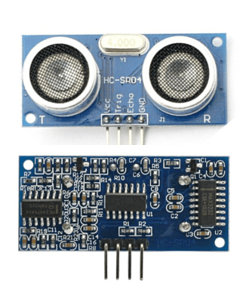

Figure 2.1. Ultrasonic sensor

* + 1. HC-SR04 Ultrasonic Sensor Features and Specifications.

In table 2.1.1 it shows some of the HC-SR04 ultrasonic sensor features and specifications.

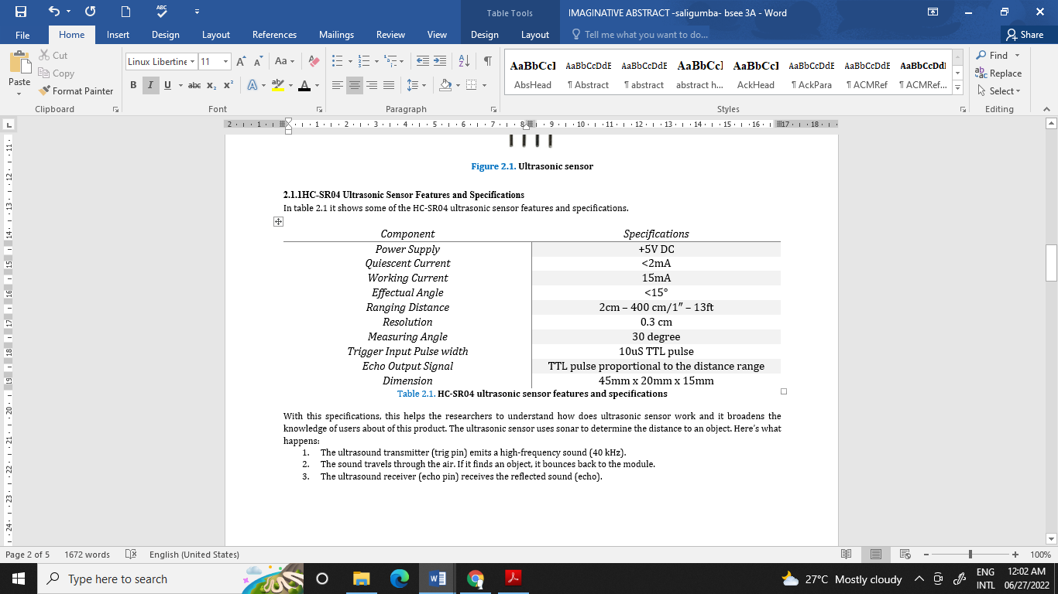

Table 2.1.1. HC-SR04 ultrasonic sensor features and specifications

With this specifications, this helps the researchers to understand how does ultrasonic sensor work and it broadens the knowledge of users about of this product. The ultrasonic sensor uses sonar to determine the distance to an object. Here’s what happens:

1. The ultrasound transmitter (trig pin) emits a high-frequency sound (40 kHz).
2. The sound travels through the air. If it finds an object, it bounces back to the module.
3. The ultrasound receiver (echo pin) receives the reflected sound (echo).

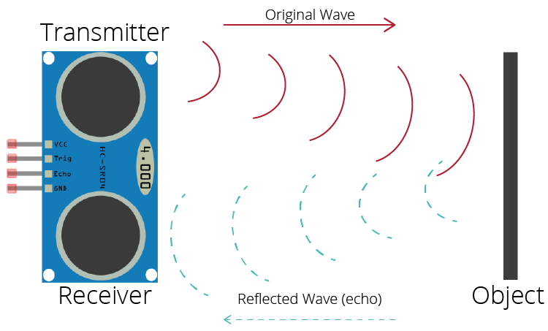

Figure 2.2. Shows how Ultrasonic sensor work

Figure 2.2 shows how ultrasonic sensor work, ultrasonic sensor uses the reflection of sound in obtaining the time between the wave sent and the wave received. It usually sent a wave at the transmission terminal and receive the reflected waves [8].

* 1. Configuration of HC-SRO4 ultrasonic sensor with Arduino

This sensor operates as a transmitter-receiver system for ultrasound waves. Figure 2.4.a, illustrates the pin configuration of this sensor module with the Arduino board. The power pins represented by the VCC and GND which are attached to the 5 V and GND pins respectively on power pins of Arduino. The other two pins are the trig and the echo which are used to trigger the transmitter to generate 8 ultrasonic pulses and receive the reflected echo from an object within the detected range. For the calculation of the distance of any object, let an object located at 10 cm away from the sensor, it is well-known that the speed of the sound is 340 m/s and to make the calculation more convenient for the case of experimental circuits, the speed is considered as 0.034 cm/µs. so, in order to measure the distance (D), we need to count the elapsed time (t) of wave travelling towards the object and return back, then use it as in equation from Figure 2.3 [9].

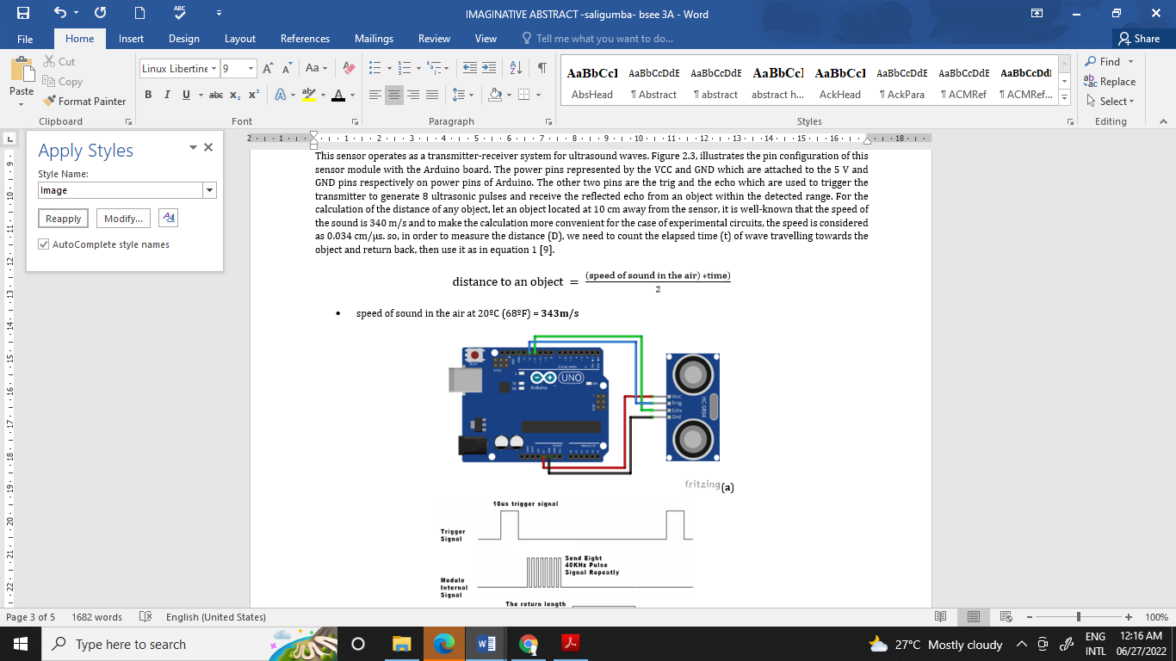

Figure 2.3. Equation of Distance to an Object

* speed of sound in the air at 20ºC (68ºF) = **343m/s**

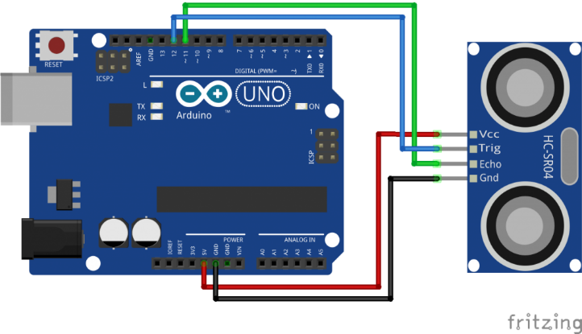

Figure 2.4.a. Ultrasonic Sensor module connections

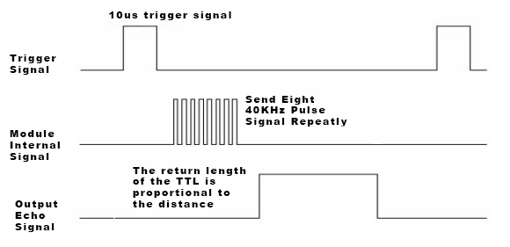

Figure 2.4.b. Shows Ultrasonic Sensor module operation principle

References

* WMO, 2013. Flood forecasting and early warning. World Meteorological Organization. Geneva, Switzerland. Retrieved from <https://library.wmo.int/doc_num.php?explnum_id=4269>.
* Allen, M., Antwi-Agyei, P., Aragon-Durand, F., Babiker, M., Bertoldi, P., Bind, M., et al., 2019. Technical Summary: Global warming of 1.5◦ C. An IPCC Special Report on the impacts of global warming of 1.5◦ C above pre-industrial levels and related global greenhouse gas emission pathways, in the context of strengthening the global response to the threat of climate change, sustainable development, and efforts to eradicate poverty.
* UNISDR, 2018. UNISDR Annual Report 2017 United Nations Office for Disaster Risk Reduction. Geneva, Switzerland. Retrieved from <https://www.undrr.org/publication/unisdr-annual-report-2017>.
* Ye Zheng, Yazhou Xie, Xuejiao Long, A comprehensive review of Bayesian statistics in natural hazards engineering, Natural Hazards, 10.1007/s11069-021-04729-2, **108**, 1, (63-91), (2021).
* Golding, B.W., 2009. Long lead time flood warnings: reality or fantasy? Meteorol. Appl. 16 (1), 3–12.
* O’Sullivan, J.J., Bradford, R.A., Bonaiuto, M., De Dominicis, S., Rotko, P., Aaltonen, J., et al., 2012. Enhancing flood resilience through improved risk communications. Nat. Hazards Earth Syst. Sci. 12 (7), 2271–2282. [https://doi.org/10.5194/nhess-12- 2271-2012](https://doi.org/10.5194/nhess-12-%202271-2012).
* Kellens, W., Terpstra, T., De Maeyer, P., 2013. Perception and communication of flood risks: a systematic review of empirical research. Risk Anal. 33 (1), 24–49.