Base on the first row:

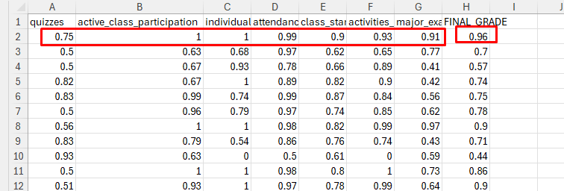

100 epochs - 0.8735853329478164

500 epochs - 0.8988735110963797

1000 epochs - 0.9040214726275044

2000 epochs - 0.9057082239941944

5000 epochs - 0.9065213685774043 (I choose 5000 epochs)

10000 epochs - 0.9041664532848191

6000 epochs - 0.9016330608904617

