Design and Implementation of BiBi Checker: A Web Based Image Processing System for Entrance Examination Checking

Jerald Agbon Sarte

Bachelor of Science in Computer Science 3, Bohol Island State University-Bilar Campus, jerald.sarte@bisu.edu.ph

Eloisa Gulayan Sagaray

Bachelor of Science in Computer Science 3, Bohol Island State University-Bilar Campus, eloisa.sagaray@bisu.edu.ph

Christian Balde

Bachelor of Science in Computer Science 3, Bohol Island State University-Bilar Campus, christian.balde@bisu.edu.ph

MAX ANGELO DAPITILLA PERIN (INSTRUCTOR)

Department of Computer Science, Bohol Island State University-Bilar Campus, maxangelo.perin@bisu.edu.ph

This paper presents the design and implementation of BiBi Checker, a web-based image processing system developed specifically for automating entrance examination checking at Bisu Bilar Campus. The system integrates image preprocessing techniques to enhance paper quality, utilizes optical character recognition (OCR) for digitizing handwritten responses, and incorporates automated grading based on predefined answer keys. Implemented using Python for image processing and OCR tasks, alongside a web framework for the front-end interface and backend integration, BiBi Checker ensures scalability and reliability to handle peak examination loads. Key features include secure user authentication, role-based access controls, and an intuitive interface for administrators to manage examination data and generate result reports efficiently.

CCS CONCEPTS • Software and its Engineering • Software creation and management • Designing software

Additional Keywords and Phrases: Automated Grading, Image Processing, Optical Character Recognition (OCR), Web-Based System

ACM Reference Format:

JERALD AGBON SARTE, ELOISA GULAYAN SAGARAY, CHRISTIAN BALDE, MAX ANGELO DAPITILLA PERIN. 2024. Design and Implementation of BiBi Checker: A Web Based Image Processing System for Entrance Examination Checking in Bisu-Bilar Campus. In Research Project Presentation for Bachelor of Science in Computer Science 3 in CS 324 – Web Development/Enterprises S.Y. 2023-2024, 2nd Semester, Bohol Island State University-Bilar Campus, Zamora, Bilar, Republic of the Philippines. ACM, New York, NY, USA

1. INTRODUCTION

(Sarte, BiBi Checker, a web-based image processing system streamlining entrance examination checking, designed with efficiency and accuracy in mind, this innovative solution aims to alleviate the burdensome tasks of manually grading large volume of exam papers[1]. The system’s architecture combines advanced image processing algorithms and web technologies to offer a seamless experience for both administrators and examiners.)

(Sagaray, BiBi Checker, harnesses the power of image processing techniques to automatically analyze and evaluate examination papers submitted digitally. Leveraging computer vision algorithms, the system is capable of recognizing and interpreting handwritten responses, ensuring precise grading while minimizing human error[2]. Also, its web-based nature allows for easy accessibility from device with internet connection, enabling administrators to oversee the examination process remotely.)

(Balde, the implementation of BIBi Checker involves a meticulous integration of various components, including image acquisitions, preprocessing, feature extraction, and grading modules through a carefully organized workflow, the system efficiently handles the complexities of exam paper analysis, offering swift and accurate results[3]. Furthermore, its user interface promotes user friendly experience that enhances productivity and reliability. Overall, BiBi Checker represents a groundbreaking advancement in the realm of entrance examination assessment, promising to revolutionize the way educators manage and evaluate academic assessments.)

1. METHODOLOGY

This research project focused on creating a web-based BiBi Checker for entrance examination checking in Bisu Bilar with a central Admin Module. The methodologies used for database management, backend development, frontend design, are outlined as follows:

* 1. Database

(Sagaray, The database management of Bibi Checker using SQLyog is crucial for organizing and maintaining data related to entrance examination processes. Bibi Checker utilizes an online database named "bisubilar_bibic" managed through SQLyog, a graphical MySQL database management tool. This setup ensures data integrity through structured tables for student details, examination information, image processing results, and user accounts within the "bisubilar_bibic" database. SQLyog enforces relationships between these tables and implements validation rules to uphold data accuracy, supporting efficient querying, performance optimization, backup, and recovery processes. Overall, SQLyog's features empower Bibi Checker to manage data effectively, supporting its functionalities with robustness and integrity within the "bisubilar_bibic" online database.)

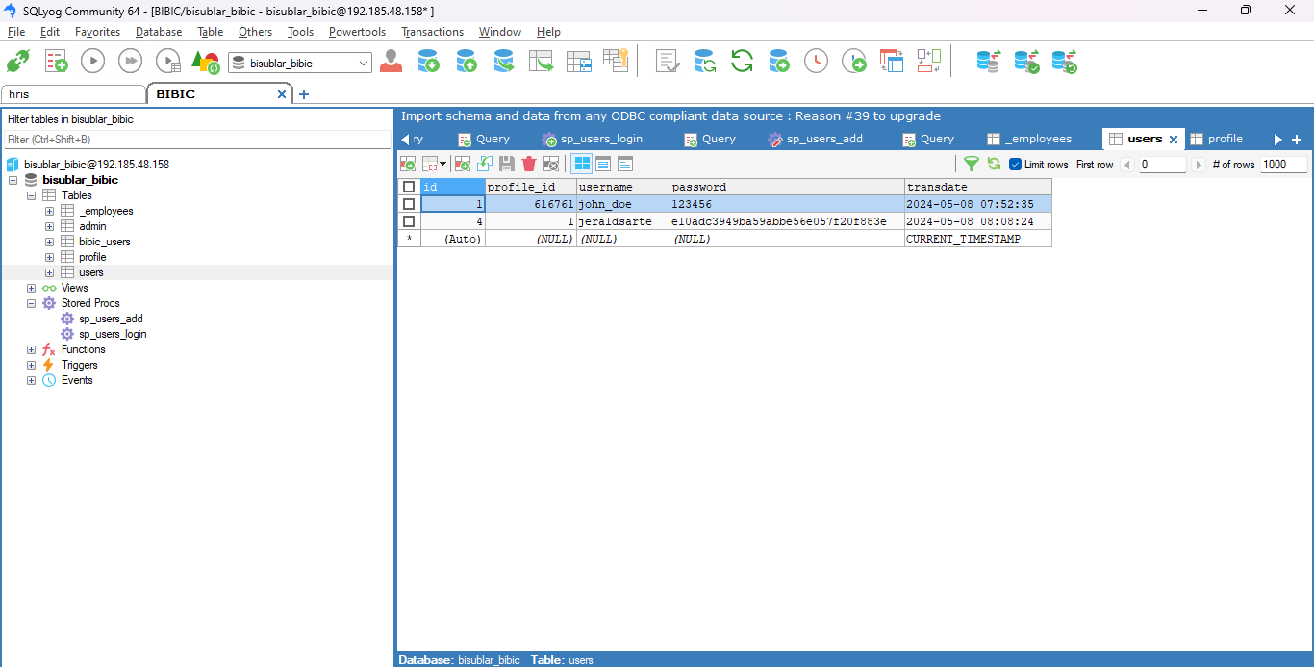

Figure 1: Users Database

(Sarte, Figure 1 shows the users database within Bibi Checker, managed using SQLyog, serves as a critical component for user authentication and access control within the system. This database contains tables storing user credentials, profiles, and permissions necessary for secure login and operation of Bibi Checker. SQLyog facilitates the creation and management of these tables, allowing for the enforcement of data integrity constraints such as primary keys and unique identifiers. Through SQLyog, administrators can efficiently query and update user information, ensuring that access privileges are accurately maintained and managed. Additionally, SQLyog supports security measures like encryption and access controls, enhancing the overall integrity and protection of user data within the Bibi Checker system's users database.)

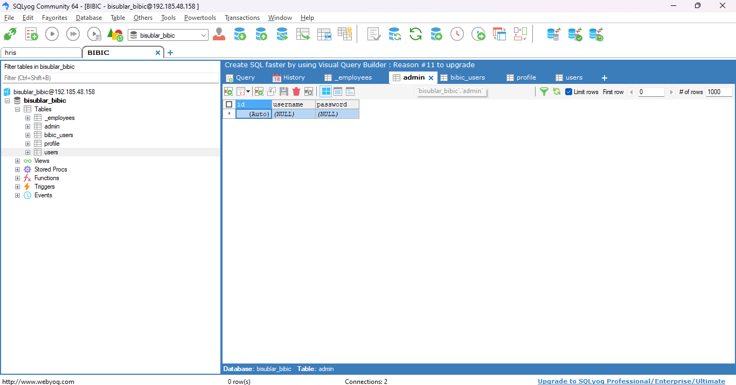

Figure 2: Admin Database

(Sagaray, Figure 2 shows the admin database within Bibi Checker, administered using SQLyog, is fundamental for managing administrative functions and user roles within the system. This database contains tables that store details specific to administrative users, such as usernames, passwords, and assigned privileges or roles. SQLyog facilitates the creation and maintenance of these tables, enabling administrators to efficiently manage and update administrative user information. Through SQLyog's capabilities, administrators can enforce security measures such as access controls and authentication protocols to safeguard sensitive administrative data. This database plays a pivotal role in controlling system access and maintaining the integrity of administrative functions within the Bibi Checker system.)

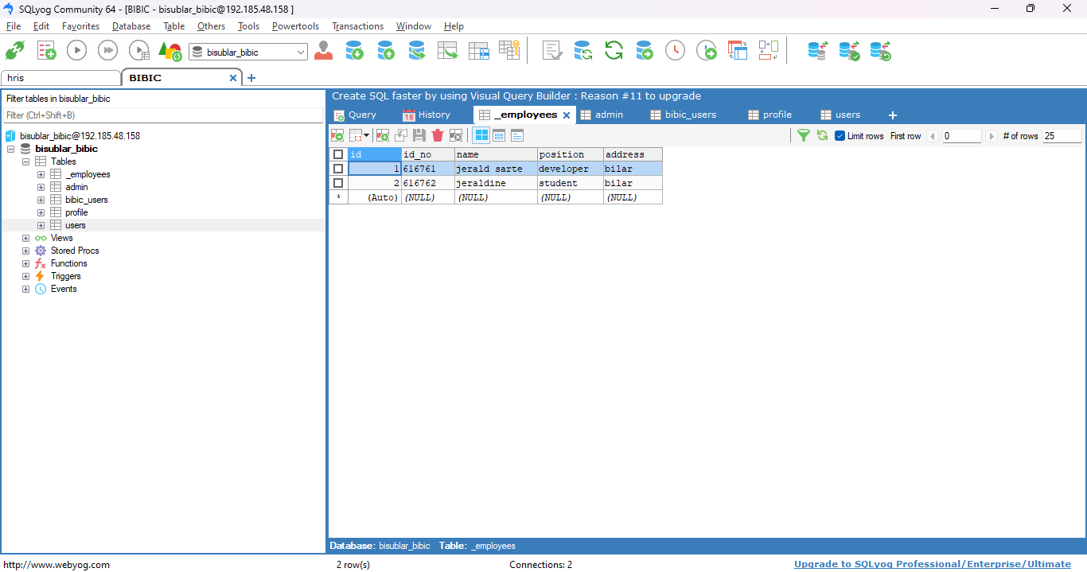

Figure 3: Employees Database

(Balde, Figure 3 shows the employees database within Bibi Checker, managed using SQLyog, is designed to store and organize information related to system personnel involved in the operation and maintenance of the Bibi Checker system. This database includes tables that capture employee details such as names, contact information, roles, and work assignments. SQLyog facilitates the creation and management of these tables, allowing administrators to efficiently update and query employee data. The database supports data integrity through the enforcement of constraints such as unique identifiers and relationships between tables. SQLyog's capabilities enable administrators to maintain accurate and up-to-date employee records, ensuring effective management of personnel resources within the Bibi Checker system.

* 1. Backend

(Balde, The backend login feature of the Bibi Checker, a web-based image processing system for entrance examination checking, plays a critical role in ensuring secure access and management of the system. This feature operates through a login page where authorized users enter their credentials (username and password) for authentication. The system verifies these credentials against a secure database, employing encryption protocols to protect sensitive information during transmission and storage. Once authenticated, users are granted access based on predefined roles, such as administrators, examiners, or support staff, each with specific permissions tailored to their responsibilities. Session management is implemented to maintain authenticated sessions and automatically expire inactive sessions, enhancing security. Additionally, measures like password management and brute force protection are in place to further secure user accounts and prevent unauthorized access attempts. Overall, the backend login feature contributes to the system's robust security posture, ensuring that only authorized personnel can access and manage the examination checking functionalities while maintaining the integrity and confidentiality of the examination data.)

* + 1. Web-based Backend Log in Feature

(Sarte, This code snippet showcases an Express API router (api) that implements user authentication and employee management functionalities using Node.js and Sequelize for database interactions. The API includes endpoints for user login, token verification, and adding new employees, integrating JWT token validation and stored procedure calls for database operations.

const express = require("express");

const api = express.Router();

const db = require("../database/config");

const jwt = require("jsonwebtoken");

api.post("/login", (req, res) => {

db.sequelize

.query("CALL sp_users_login(:username, :password)", {

type: db.sequelize.QueryTypes.SELECT,

replacements: {

username: req.body.username,

password: req.body.password,

},

})

.then((data) => {

const data_ret = db.MultiQueryResult(data);

const userDetails = [data_ret.result0[0]]; // Wrap the user details in an array

})

.catch((err) => {

res.send({ error: true, message: "No data found" });

});

});

api.post("/verify-token", (req, res) => {

const authorizationHeader = req.headers.authorization;

if (!authorizationHeader || !authorizationHeader.startsWith("Bearer ")) {

res.json({ error: true, message: "Invalid token" });

return;

}

const token = authorizationHeader.substring(7);

jwt.verify(token, process.env.PUBLICVAPIDKEY, (err, decoded) => {

if (err) {

res.json({ error: true, message: "Invalid token" });

} else {

const userDetails = decoded.data;

// Perform additional validation or database checks if required

res.json({ error: false, userDetails });

}

});

});

const Sequelize = require("sequelize"); // Assuming Sequelize is installed

api.post("/add", async (req, res) => {

try {

const { id_no, name, address, username, password } = req.body;

// Validate user input (e.g., using a validation library)

// const transaction = await db.sequelize.transaction(); // Start a transaction

try {

const result = await db.sequelize.query(

"CALL sp_users_add(:id_no, :name, :address, :username, :password)",

{

replacements: {

id_no: parseInt(id_no),

name,

address,

username,

password,

},

// transaction, // Pass the transaction object

}

);

const ret = result[0]["_ret"];

if (ret === "no_employee_from_ismis") {

res.send({ error: true, message: "Employee does not exist in ISMIS." });

} else if (ret === "employee_duplicate") {

res.send({ error: true, message: "Account already exists." });

} else if (ret === "name_does_not_match") {

res.send({

error: true,

message:

"Name does not match the employee associated with the ID number.",

});

} else if (ret === "name_and_id_does_not_match") {

res.send({

error: true,

message: "Both name and ID number do not match the employee record.",

});

} else {

res.send({ error: false, message: "Employee added successfully!" });

}

// await transaction.commit(); // Commit the transaction if successful

} catch (err) {

// await transaction.rollback(); // Rollback the transaction on error

console.error("Error adding employee:", err);

res.send({

error: true,

message: "An error occurred while adding the employee.",

});

}

} catch (err) {

console.error("Unexpected error:", err);

res.status(500).send({ error: true, message: "Internal server error." });

}

});

module.exports = api;

The API defines several HTTP POST endpoints to facilitate specific functionalities:

Firstly, the /login endpoint processes incoming POST requests containing user credentials (username and password). It utilizes Sequelize to execute a stored procedure (sp_users_login) with the provided username and password replacements. Upon successful retrieval of user details from the database, the endpoint prepares a response with the user information.

Secondly, the /verify-token endpoint is responsible for validating JWT tokens sent in POST requests. It extracts the token from the authorization header, decodes it using the specified public key (PUBLICVAPIDKEY), and checks its validity. If the token is valid, the endpoint responds with decoded user details; otherwise, it returns an error message indicating an invalid token.

Lastly, the /add endpoint allows the addition of new employees to the system. This endpoint expects parameters (id_no, name, address, username, password) in the request body, performs input validation using try-catch blocks, and executes a stored procedure (sp_users_add) to insert the employee into the database. Depending on the return value (_ret) from the stored procedure, the endpoint sends an appropriate success or error response.)

* 1. Frontend

(Sagaray, The frontend of Bibi Checker, a web-based image processing system for entrance examination checking, provides a user-friendly interface facilitating image upload and processing, authentication, and result display. It features intuitive elements like forms and visual displays for easy navigation and operation. Users can upload answer sheets directly through the browser, initiating image processing algorithms like OCR or handwriting recognition. The frontend displays examination outcomes, including graded answers and statistical analyses. It incorporates user authentication and responsive design for accessibility across devices, with interactive features like drag-and-drop uploads and real-time updates. Integration with the backend ensures data consistency and reliability, optimizing educational assessment tasks within the Bibi Checker system.)

* + 1. Web based Frontend Log in Feature

(Sagaray, The frontend login feature of Bibi Checker is the user-facing component that allows individuals to securely access the system using their credentials. This feature is crucial for authenticating users and controlling access to the examination checking functionalities.)

return (

<div className="App">

{loggedIn ? (

<div className="success">

<div className="background-container"></div>

<nav className="navbar">

<div className="logo-container">

<img src={logo} alt="bisu-logo" className="bisu-logo" />

<div className="campus-name">

<p className="text">

BOHOL ISLAND STATE UNIVERSITY

<br />

BILAR CAMPUS

<br />

Zamora, Bilar, Bohol

</p>

</div>

</div>

<img src={web} alt="website" className="website" />

</nav>

<div className="user-info-container">

<div className="user-info">

<div className="top-info-container">

<div className="top-info">

<h2>Welcome, {name}!</h2>

<div className="user-info-input">

<p>

<strong>Profile ID:</strong> {profileID}

</p>

<p>

<strong>Name:</strong> {name}

</p>

<p>

<strong>Position:</strong> {position}

</p>

<p>

<strong>Address:</strong> {address}

</p>

</div>

</div>

<button className="logout" onClick={handleLogout}>

Logout

</button>

</div>

</div>

</div>

</div>

) : (

<div>

<div className="background-container"></div>

<nav className="navbar">

<div className="logo-container">

<img src={logo} alt="bisu-logo" className="bisu-logo" />

<div className="campus-name">

<p className="text">

BOHOL ISLAND STATE UNIVERSITY

<br />

BILAR CAMPUS

<br />

Zamora, Bilar, Bohol

</p>

</div>

</div>

<img src={web} alt="website" className="website" />

</nav>

<div className="container">

<div className="login-container">

<div className="user-logo">

<img src={user} className="user-image" alt="user-logo" />

<div className="vertical-line"></div>

<p className="bibic-header">

Bisu Bilar

<br />

Enrollment Checker

</p>

</div>

{register ? (

<SignUp />

) : (

<form onSubmit={handleLogin}>

<div className="register-info">

<div>

<input

type="text"

placeholder="Email"

value={email}

onChange={handleEmailChange}

/>

<input

type="password"

placeholder="Password"

value={password}

onChange={handlePasswordChange}

/>

{loginError && (

<p className="login-error">{loginError}</p>

)}

</div>

<button

className="login"

type="submit"

disabled={isLoading}

>

{isLoading ? <div className="loader"></div> : "Login"}

</button>

<div>

<p>

Don't have an account?{" "}

<span

className="register-link"

onClick={handleRegisterLinkClick}

>

Click here

</span>

</p>

</div>

</div>

</form>

)}

</div>

</div>

</div>

)}

</div>

);

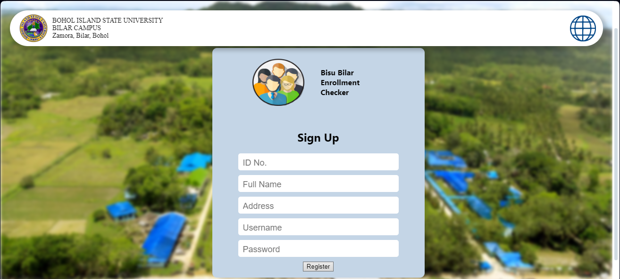

Figure 4: User Interface of Sign up Feature

(Balde, Figure 4 shows the user interface (UI) for the sign-up feature of Bibi Checker, a web-based image processing system for entrance examination checking, is designed to streamline and enhance the registration experience for new users. The UI prominently displays a registration form with fields for essential information like name, email address, and password, incorporating validation to ensure accuracy and completeness of user input. Clear error handling is integrated to guide users through correcting any invalid or incomplete information, fostering a smooth registration process. Additionally, the UI may include a password strength indicator to encourage users to create secure credentials. Emphasizing clear instructions, responsive design, and visual feedback, the UI ensures a user-friendly experience across different devices. Upon form submission, backend integration validates and processes user information, optimizing efficiency and security in account creation. Ultimately, the sign-up UI of Bibi Checker aims to provide a seamless, secure, and efficient registration process, enhancing overall user experience.)

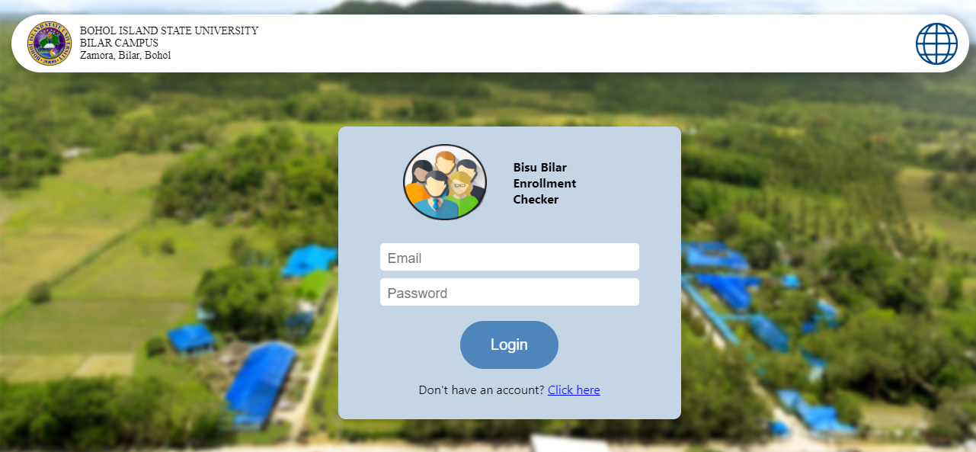

Figure 5: User Interface of Log in Feature

(Sagaray, Figure 5 shows the user interface for the login feature of the Bibi Checker, a web-based image processing system used for entrance examination checking, serves as the initial access point for authorized users. This interface includes standard components such as fields for entering usernames and passwords, a login button to initiate authentication, and links for password recovery or user registration if needed. Designed with the institution's branding and user-friendliness in mind, the layout ensures ease of use and accessibility, catering to a diverse user base. Security measures like encrypted transmission of credentials and robust authentication mechanisms are implemented to safeguard user data. Additionally, the interface incorporates error handling to provide clear feedback in case of login issues, ensuring a smooth and secure user experience. Upon successful login, users are directed to the Bibi Checker system's main dashboard, enabling them to carry out image processing tasks for entrance examination checking seamlessly.)

1. RESULTS AND DISCUSSION

The implementation of BiBi Checker, a web-based image processing system for entrance examination checking at BISU Bilar Campus, has significantly improved the efficiency and accuracy of evaluation processes. By automating image processing, the system reduces manual effort and enhances data integrity. It has also led to quicker turnaround times for releasing examination results, improving the responsiveness of the evaluation process. BiBi Checker's user-friendly interface and secure database management contribute to a streamlined experience for administrators and users. Moving forward, challenges include optimizing algorithms for different answer sheet formats and enhancing scalability. Overall, BiBi Checker represents a notable advancement in modern examination management, with potential for ongoing innovation and enhancement in academic assessment technologies.

REFERENCES

<bib id="bib1"><number>[1]</number>R. Rajesh & R. Kanimozhi. (2019). Digitized exam paper evaluation. In IEEE International Conference on System, Computation, Automation and Networking (ICSCAN) (pp. 1-5). doi: 10.1109/ICSCAN.2019.8878791</bib>

<bib id="bib2"><number>[2]</number>G. Sanuvala & S. S. Fatima. (2021). A study of automated evaluation of students' examination paper using machine learning techniques. In International Conference on Computing, Communication, and Intelligent Systems (ICCCIS) (pp. 1049-1054). doi: 10.1109/ICCCIS51004.2021.9397227</bib>

<bib id="bib3"><number>[3]</number>Puno, R. R. N., Nicdao, Y. A., Deinla, C. D. S., Hernandez, G., Javier, M., Macalino, D., … Sicat, G. (2023). E-Chequer: A smart exam-checking machine using image processing technique. Asian Journal of Multidisciplinary Studies, 6(1),77–86. <https://www.asianjournals.org/online/index.php/ajms/article/view/508></bib>

A APPENDICES

GitHub Contributions

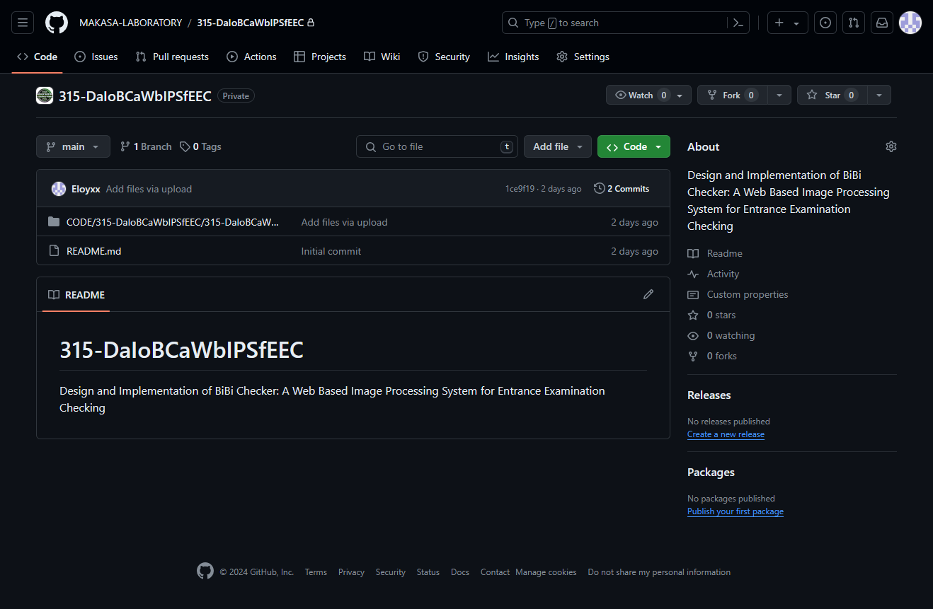

<https://github.com/MAKASA-LABORATORY/315-DaIoBCaWbIPSfEEC>