**ARDUINO BASED LIGHTS CONTROLLER SYSTEM USING ANDROID AND BLUETOOTH FOR CLASSROOMS IN CEA BUILDING OF BISU**

College of Engineering, Architecture and Industrial Design

**BOHOL ISLAND STATE UNIVERSITY**

Main Campus, Tagbilaran City, Bohol

George Jr Gesite

Claire Ann Lampios

Robert Kin Gohil

Jelian Kate Jotojot

**ARDUINO BASED LIGHTS CONTROLLER SYSTEM USNG ANDROID AND BLUETOOTH FOR CLASSROOMS IN CEA BUILDING OF BISU**

______________

Research Project Presentation for Bachelor of Science in Computer Engineering

**BOHOL ISLAND STATE UNIVERSITY**

Main Campus, Tagbilaran City, Bohol

______________

In Partial Fulfillment of the Requirements of the Course

**CPE 323 - Microprocessor Systems**

______________

George Jr Gesite

Claire Ann Lampios

Robert Kin Gohil

Jelian Kate Jotojot

June 2022

**IMAGINATIVE ABSTRACT**

There are several gadgets available off the shelf that will allow you to manage items in your house, but these devices are usually quite expensive. They normally come with a remote control, even if they are wireless. In this project, we will take a different approach and use Bluetooth to control lights directly from your smartphone. The system included three main components: an Arduino microcontroller for connecting the relay and lightbulbs, a Bluetooth module for signal transmission, and a smartphone with an Android software for controlling the lights. This automation system can be used in the classrooms of CEA building in BISU to instantly turn off/on the lights without having the hassle of walking room by room to manually turn it off or on.

**Chapter 1**

**INTRODUCTION**

Technology advancements nowadays motivate people to think creatively, not only to find new things, but also to improve existing technological performance to make human labor easier in everyday life. With the increasing activity of each individual community and its numerous irregular activities and times, an automatic control system is required. As a result, numerous home duties, such as turning on or off the lights in every room at night and in the morning, are delayed. One solution that meets the needs of today's automatic controllers is a smart home system. A smart home system is a home or structure that is outfitted with integrated technology and uses a tool or tools, such as a computer or another device, such as a smartphone, to give all of the comfort, safety, security, and energy savings in an automated and programmed manner.

A wireless connection connects a smart classroom system to an autonomous lighting controller via Bluetooth. This project can make teaching easier for teachers, students & building facilitators. Class teachers and students did not use the typical switch to turn on and off the light because they were impatient they will just controls the lightning with their smartphone using Bluetooth. Lessons were more effective and ran more smoothly because to the benefit of the wireless technology. It is not only adaptable, but also cost-effective and may reduce energy losses.

The electric cooperative of the province of Bohol have issued a notice that they will increase their electric power rate starting May 2022. This paper aims to provide a better solution in minimizing the electrical wastage at home. This study also intent to provide increased quality of life and comfort to users at home. In this project, a Bluetooth based home automation system using android phone and microcontroller Arduino Uno is being develop. This study describes about home automation system, which would use to ON/OFF home lighting, garage door motor, water pumping motor or any load in home or office by using a smart phone application with Bluetooth wireless technology.

Traditional smart classroom systems use many types of wire to regulate and communicate. Expanding or upgrading the system to accommodate new appliances or devices is quite complex. It may improve classroom teaching:

1. More efficiently processing
2. Smoother operation
3. It also saves electricity and improves safety.

When leaving the classroom, teachers and students frequently forget to turn off devices. It will result in energy waste. This project has the potential to reduce electricity waste and within 10 minutes, all lights in the classroom will be turned off and Bluetooth will be disabled.

**Chapter 2­**

**REVIEW OF THE RELATED LITERATURE**

­­­­ Home automation was originally offered to the world market in the 1970s, but it fell short of people's expectations and proved to be a failure. The failure of the home automation system was caused by a number of factors. The system was neither easy to use nor cost effective. The most important consideration when creating a home automation system is that it be cost-effective and simple to install.

Authors in [1] presented model for home automation using Bluetooth via PC.This application of Bluetooth technology in home automation and networking environment. They proposes a network, which contains a remote, mobile host controller and several client modules (home appliances). The client modules communicate with the host controller through Bluetooth devices. The researchers even built a new protocol on top of the Bluetooth software stack, called Home Automation Protocol (HAP), to make the communication between devices possible. The device controller is connected to electronic devices through the I2C Bus. The system allows more than one device controller to be connected to the host controller. But unfortunately the system lacks to support mobile technology.

In [2] the author also proposes a home automation system using Bluetooth that can be accessed remotely through GPRS. The researchers use a cellphone equipped with Bluetooth connectivity as a host controller and a GSM modem that provides Internet connectivity. Home devices are fitted with Bluetooth communication adapters so that they can communicate with the host controller phone via Bluetooth. The paper discusses remotely controlling and updating home devices along with fault diagnostics and detection.

Several remote controlled home automation systems have been studied. Author in [3] research work provided full functionality to remotely control home appliances via wireless communication between the Arduino BT and cell phone using Bluetooth technology. Arduino BT board was connected with home appliance and it was controlled by a Symbian OS cell phone application.

The study in [4] presented a home control and enviromental monitoring system. This uses an Arduino microcontroller for accessing and controlling devices remotely. This uses a a smartphone as a platform. Authors in [5] also presented a system that monitors and controls the home electrice appliances ion the real-time environment with the potential benefits in terms of flexibility, scalability, security in the sense of data protection throught cloud-based data storage protocol, and energy efficiency.

In [6], the Bohol 1 Electric Cooperative has released an advisory to its entire consumer on its official Facebook account that starting May 2022 there will be an increased on electrical power rate amounting to P1.8908 per kWh. This new rates were implemented due to increase of fuel cost. They strongly encouraged their consumers to exercise energy saving measures to avoid electric power bills.

In support of this study, the Authors in [7] in their similar study concluded that the IR sensor detects the motion or the movement of the person whenever a person enters or leaves the room. Then, the IR sensor sends the signal to the microcontroller Arduino UNO which in turn increments the value of the counter by one which is displayed on the App. Now the user has the access to switch the circuit on or off using the on or off button on the App. When the on button of a particular relay is pressed on the app then the lights or fans connected to that particular relay gets switched on. As the number of persons entering the room increases so do the value of the counter displayed on the app screen. When the persons leave the room then the IR sensor sends a signal to the microcontroller Arduino UNO to decrease the value of the counter by one. When the last person of the room leaves the room, then the value of the counter reaches zero. Then the microcontroller Arduino sends a signal to the relay module that disconnects the supply from the lights and fans and every device connected to the relay module gets switched off automatically.

In [8], the authors have built up a system that helps elderly and handicapped people live a more independent life. They have created a system that the user can control all the appliances in the house via Bluetooth receivers. Allowing all the clients to have access to all the appliances in the house including air conditioners, and lights, with a single click on a mobile phone to turn it either ON or OFF. In their result, it shows an efficient outcome. Cost efficient and user-friendly system is taken into account and achieved. The project is comprised of components such as a Bluetooth module, an Arduino board, an Android mobile device, optocouplers, and an Android application (LMBT). Using an Android mobile phone, a Smart Home is created and controlled with a smart phone.

There are several journal papers that have been published based on the smart lighting which is the hot topic in the current research. Efforts are made to improve the current approaches for the lighting system for better efficiency and low power consumption with hybrid approach. Richu Sam Alex et al. proposed a system which reduces the power consumption of the street lighting system about 30% compared to conventional design. This 2 system is fully automated. It also uses Arduino so that control station can also analyze all the performances of the system.[9]

Daeho Kim et al. worked on smart LED lighting system by using Infrared and Ultrasonic sensors together. Here they proposed a model which continuously tracks the human motion. Output based on the human tracking data which is obtained by these sensors are responsible for determining the On-Off control of the LED lighting. Previously existing system fails in continuously monitoring the motion of an object by using each sensor separately. For the same reason, the efficiency of the existing system is low. By the hardware implementation they developed a model to improve the efficiency which helps in smart lighting. The proposed approach make use of sensors in which IR sensor sends the sensed data to the MCU board which in turn sends the same data to the LED control layer. Depending on the results of the sensed data LED control layer turns on the lighting system. Human presence is detected by IR sensor and continuous tracking is possible by the Ultrasonic (US) sensor. As before the sensed values are sent to the MCU board by US sensor which controls the On-Off of the lighting. US-IR positioning based system has to be studied in future [10].

Raja R et al, worked on the energy saving concepts. Here, smart sensor networks in DC electrical appliances like lighting, helps for monitoring of energy usage. Conventional lamps are powered by AC grid but for LED DC supply is sufficient. Dimming of light can also be achieved by using appropriate protocol helps in energy saving. Replacing the traditional lamp by LED makes 44% energy saving.[11] Michele Mango et al. proposed a low cost, wireless, adaptable sensor based smart lighting system which makes use of PIR sensors and motion sensors. It is helpful for controlling the light intensity and power consumption using LED light. Dimming of light is achieved using PIR sensor only in presence of obstacles around. Main advantage of this system is energy conservation.[12]

[13] Home Automation using cloud-based system focuses on design and implementation of home gateway to collect data about data from home appliances and then send to the cloud-based data server to get store on Hadoop Distributed File System, it is process using MapReduce and use to implement a monitoring tasks to Remote user Presently home Automation System is persistently developing its resilience by assimilating the current 2 characteristics which gratify the rising interest of the people. This paper presents the design and development of home automation system that use the cloud computing as service. The current system consists of three important units: the first part is cloud server, handle and controls the data and information of client and users and the status of devices The hardware interface module is the second part which implement the relevant connection to the actuators and sensing devices which give the physical service. Last part is Home Server, which construct the hardware device and gives the user interface. This paper focus to build the web services using cloud which is need for security and storage and availability of the data. The current system is cost efficient, reliable and comfortable which also gives a secured home automation system for entire family. The system is made up of various client modules for various platforms.

Cloud server Cloud Server is a central server aims on implementing services to the other sub modules. Central server serves as the data respiratory system and brain It implements three connections to the three sub modules viz home system, web configuration tool and mobile. The server evaluates the data it takes from the house, send current status to the mobile device and vice versa. A database is managing by the server and it is status gets updated as per the changes done at home end. Embedded Program for Hardware Circuit Microcontroller, and. Internet Client for any desktop or mobile phones.

**Chapter 3**

**PROPOSED METHODOLOGY**

**3.1 Hardware Overview**

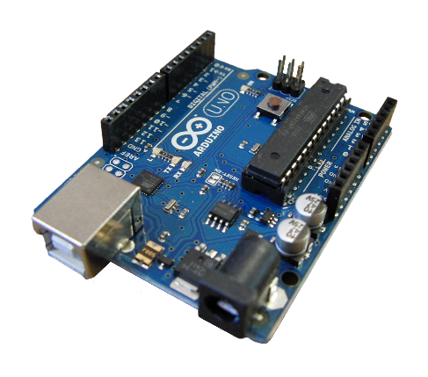1. Arduino Uno-The microcontroller board based on the Microchip ATmega328P microcontroller that controls the Inputs/output of the lights control system.

2. Bluetooth Module (HC06) - HC-06 Bluetooth Module is an easy to use Bluetooth SPP (Serial Port Protocol) module, designed for transparent wireless serial connection setup. This module used as receiving data from the android app 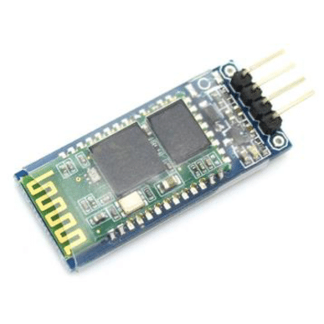Bluetooth transmitter.

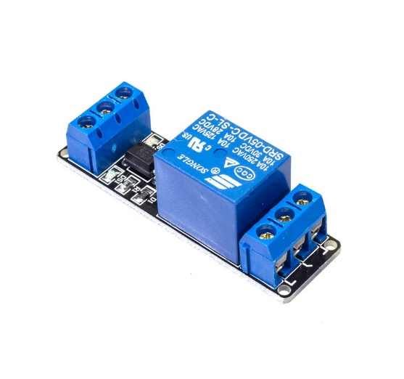3. Relay Module - The relay module drives (switches ON/OFF) the appliance according to the keypad pressed in the remote control. The relay module is controlled by the microcontroller. It allows a low power 5V circuit to switch a relatively high current on or off for example a bulb connected to the 220V mains supply

|  |
| --- |
| **COMPONENTS** |
| Arduino Uno |
| Bluetooth Module HC06 |
| Relay Module |
| Light Bulb (7w) |
| Plug |
| #12 Stranded Wire |
| Jumper Wires |

**Table 1:** List of Components of implemented project

**3.2 Block Diagram**

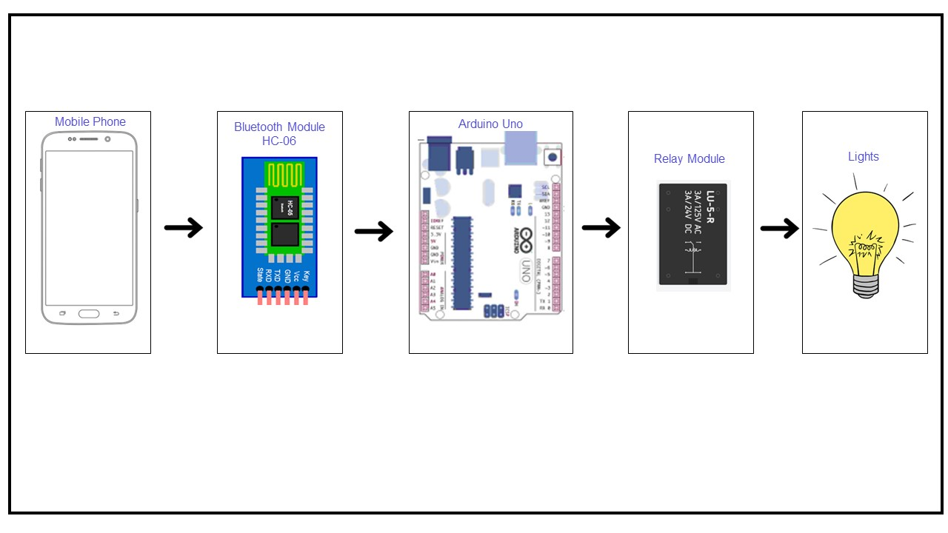

**Figure 1. Block Diagram of implemented project**

For this Project Lights Controller System open source android platform is used. The Android application connects to the Bluetooth module HC-06 and controls home appliance devices such as lighting from any mobile device. Bluetooth connection of application and Bluetooth device requires password upon pairing for allowed use for the safety of this project. After that, a confirmation message for a successful Bluetooth connection appears, followed by a list of available devices in the Android app that can be controlled as remote devices.

(a) Input from Bluetooth module via Android application apk controlled by the user.

(b) Arduino UNO microcontroller processing.

(c) Relay module receives go signal and turns on/off the lights.

**3.3 Circuit Diagram**

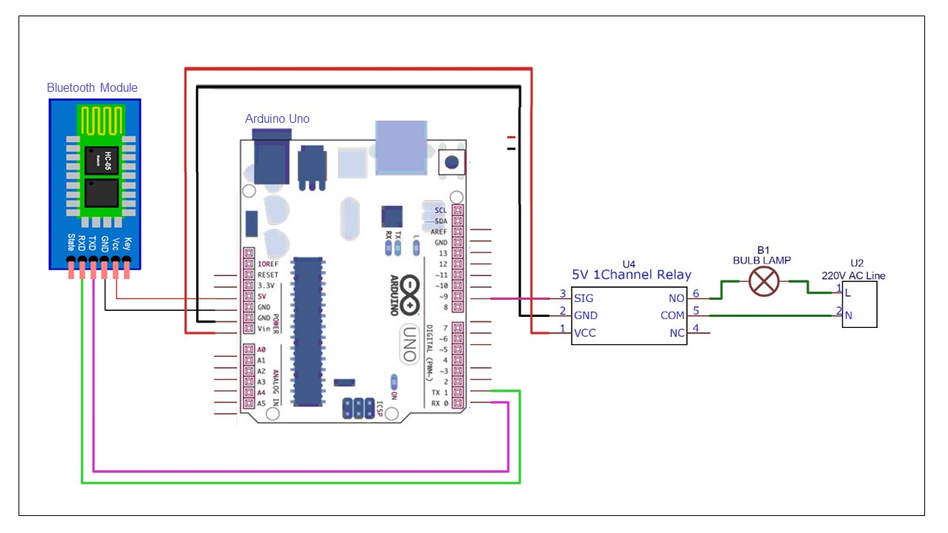

**Figure 2. Schematic Diagram of implemented project**

The schematic diagram shows clearly that the Bluetooth module has 4 – pins: VCC, TX, RX and GND. VCC and GND are connected to 5V and ground from Arduino UNO respectively. The TX and RX pins of the Bluetooth module must be connected to RX and TX pins of the Arduino. When the power is turned on, LED on the Bluetooth module starts blinking with red indicator light once the app in our smartphone gets connected to the Bluetooth module, the LED indicator stops blinking and is still red. The relay module is then connected to the arduino so that when the bluetooth module receives the go signal, A red LED indactor will turn on. The light being loaded to the relay module will turn ON as it is connected to the Naturally Open (NO) terminal in the schematic. When the user presss on, the relay module red LED indacator turns on and so will your light.

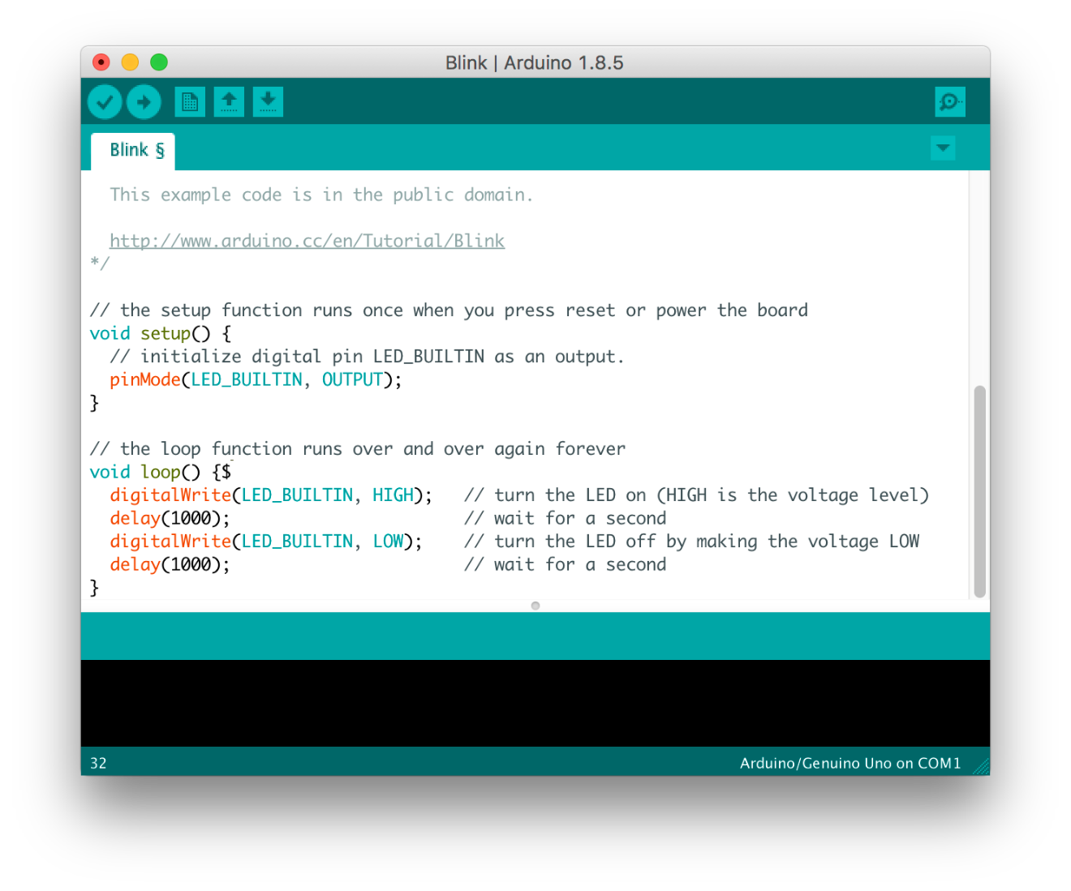**3.4 Arduino IDE**

**Figure 3. Arduino IDE software**

The Arduino IDE has specific code structure guidelines to support the languages C and C++. The Wiring project is a software library that is included with the Arduino IDE and provides numerous common input and output processes. User-written code only needs two simple methods to start the sketch and run the main program loop, which are built and linked into an executable with a program stub main.

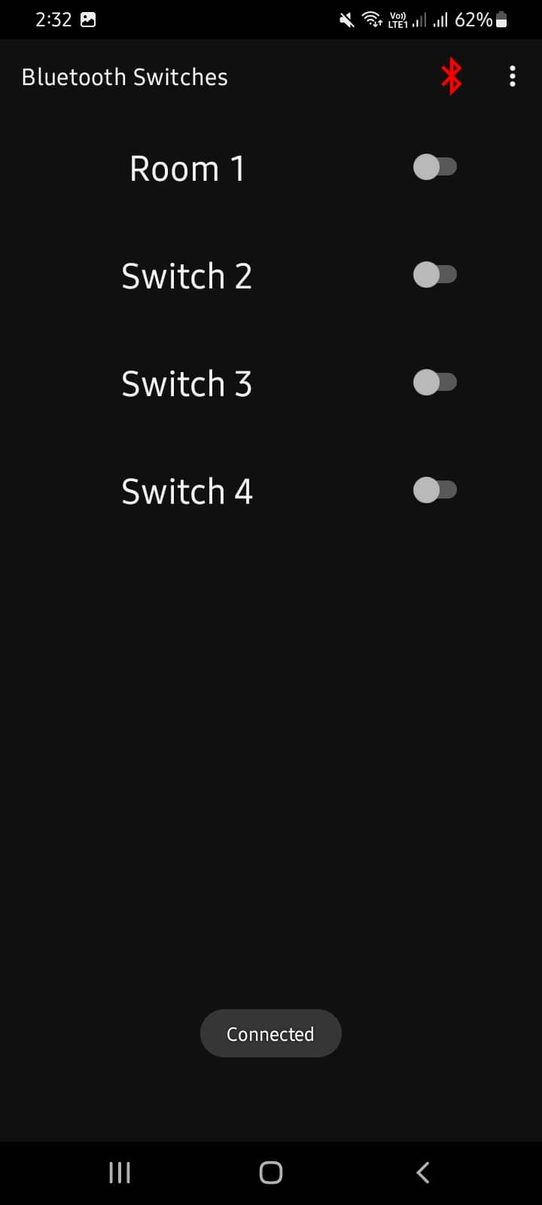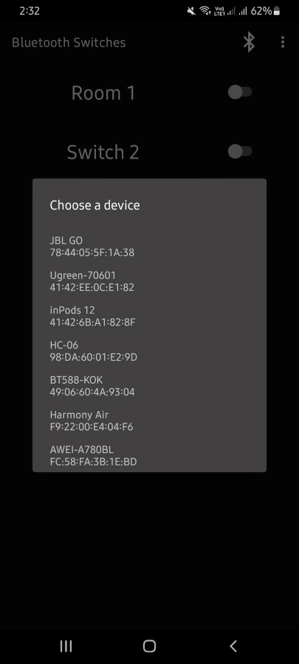**3.5 Android App UI (Arduino Bluetooth Controller)**

**Figure 4. Arduino Bluetooth Controller (Android App)**

The mobile app that we are about to use can be downloaded in github or dircetly in google play store. Any ardunio bluetooth controller will do. The connection between the hc-06 bluetooth module and android phone must be setup before using the app. Pair the module with your phone.The pairing code will be 1234 or 0000. A simple button to turn off and on the ligts. Anybody can use it as long as you are authorized to connect to the bluetooth module.

**3.6 TinkerCad Simulation**

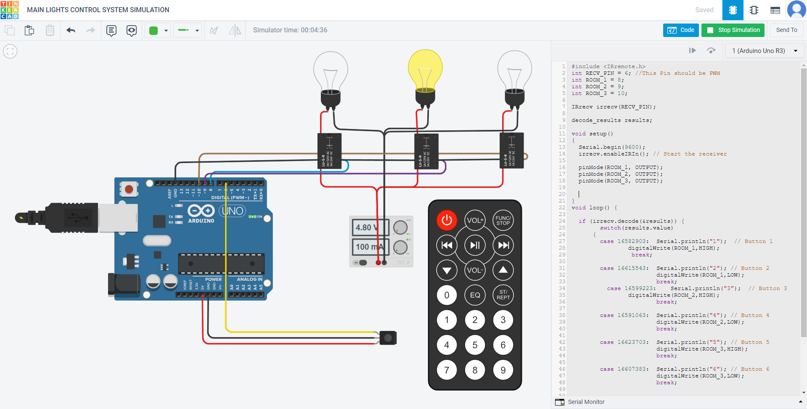

**Figure 5. System TinkerCad Simulation**

In the TinkerCad Simulation, the code is quite similar but the only difference is the parts used. The simulation uses IR remote and IR sensor as a substitute to mobile app control and bluetooth module.

**Reference List**

[1] N. Sriskanthan and Tan,Karande. “Bluetooth Based Home Automation System”. Journal of Microprocessors and Microsystems, Vol. 26, pp.281- 289, 2002.

[2] H. Kanma, N. Wakabayashi, R. Kanazawa, H. Ito, “Home Appliance Control System over Bluetooth with a Cellular Phone,” IEEE Transactions on Consumer Electronics, vol. 49 , no. 4, pp.1049-1053, Nov. 2003.

[3] R. Piyare and M. Tazil, "Bluetooth based home automation system using cell phone," 2011 IEEE 15th Tnternational Symposium on Consumer Electronics (ISCE), Singapore, 2011, pp. 192-195.

[4] David, N., Chima, A., Ugochukwu, A., & Obinna, E. (2015). Design of a home automation system using arduino. International Journal of Scientific & Engineering Research, 6(6), 795-801. Retrieved on October 2016 goo. gl/6Miyyj

[5] Saini R.P., Singh B.P., Sharma M. K., Wattanawisuth N., and Leeprechanon ,N.,Designing of smart home automation system based on Raspberry Pi, American Institute of Physics, 2016. Retrieved on October 2016 from goo. gl/SqxVmn

[6] Bohol 1 Electric Cooperative, INC. (2022). Public Announcement

[7] Bag, Kuntal & Das, Shuvam & Bhunia, Siddhartha & Das, Rupam & Das, Pritam & Pattanayak, Debjit. (2018). Micrcocontroller Based Home Automation System

[8] Kumar, Ayush. (2016). Home Automation Via Bluetooth Using Arduino Uno Microcontroller

[9] Richu Sam Alex, R Narciss Starbell “Energy efficient Intelligent Street Lighting System using Sensors”, International Journal of Engineering and Advanced Technology (IJEAT), Vol-3, Issue 4, April 2014

[10] Daeho Kim, Junghoon Lee, Yeongmin Jang and Jaesang Cha. “Smart LED lighting system implementation using Human tracking US/IR sensor” 2011 IEEE (ICTC 2011).

[11] Raja R, Dr. K. Udhaya kumar ”Development in Smart Sensor Network for Energy Saving” International Journal of Advanced Research in Electrical, Electronics and Instrumentation Engineering, Vol. 3, Special Issue 2, April 2014. [12] Michale Mango, Tommaso Poloneli, Luca Benini “A Low Cost, Highly Scalable Wireless Sensor Network Solution to Achieve Smart LED Light Control for Green Buildings” IEEE Sensors Journal, vol. 15, no. 5, May 2015.

[13] Mamun, Md & Hossain, Mohammad & Rahman, Md. Atiqur & Abdullah, Md & Hossain, Md. (2020). Smart Home Automation System using Arduino and Android Application. 10.5281/zenodo.3816960.

**APPENDICES**

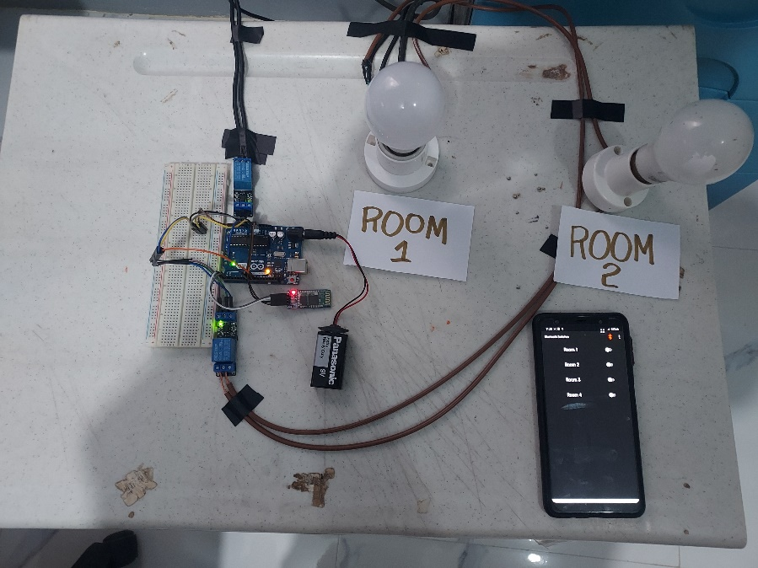 **IMAGE OF THE SYSTEM**

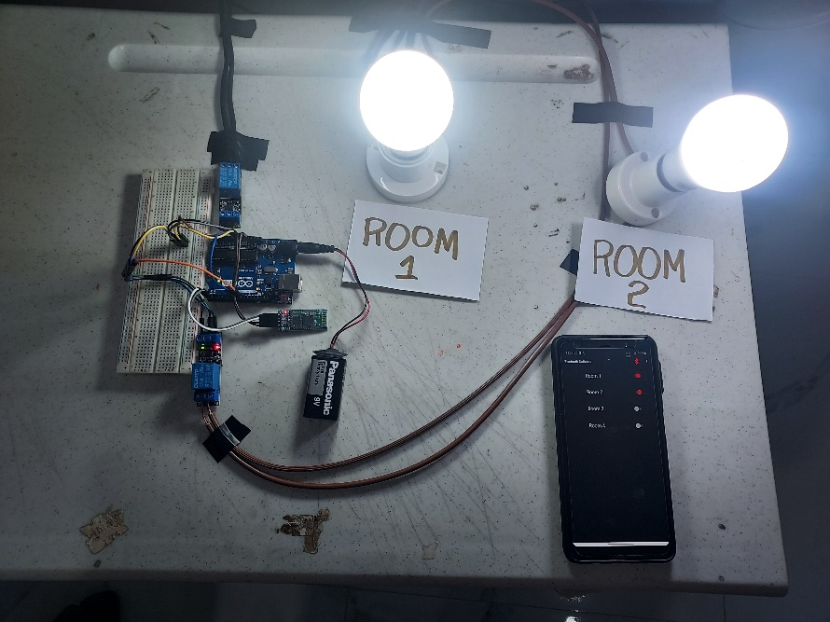**Figure 5A: Lights off, Mobile app button is off**

**Figure 5B: Lights on, Mobile app button is on**

**ACM Individual Research Papers**

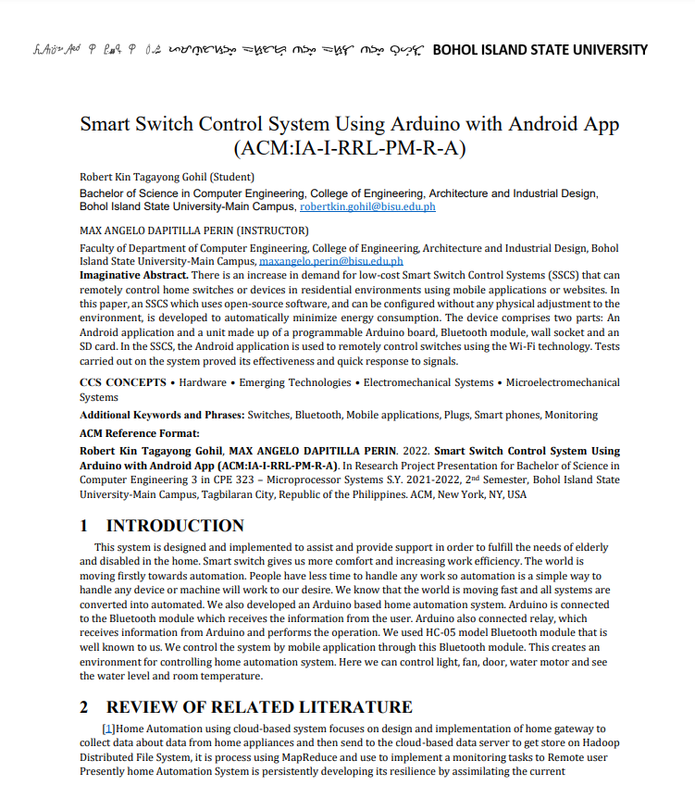

**Figure 6:** Screenshot of SSCSUAA by Robert Kin Gohil

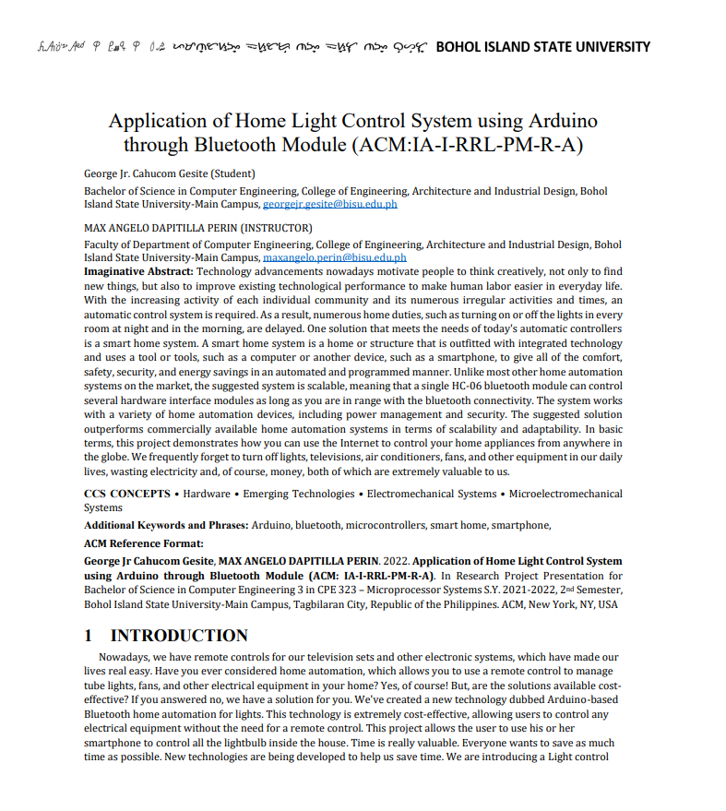

**Figure 7:** Screenshot of AHLCSUATBM by George Jr Gesite

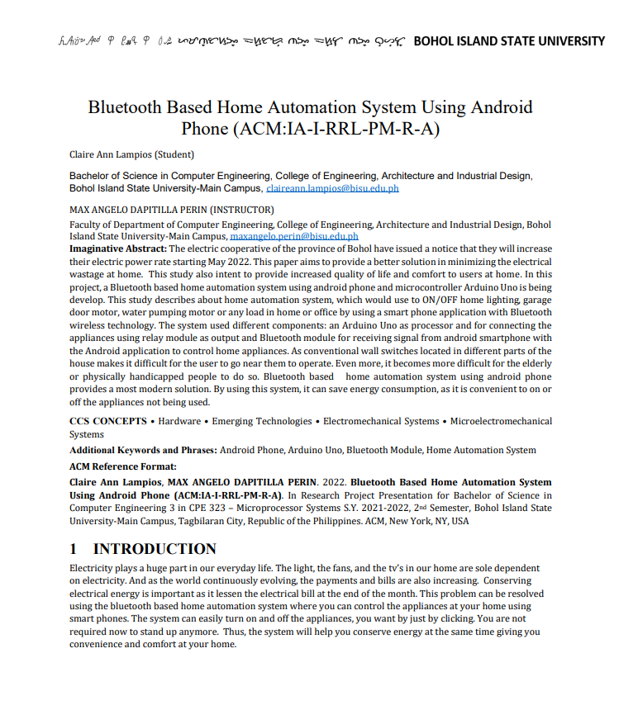

**Figure 8:** Screenshot of BBHASUAP by Claire Ann Lampios

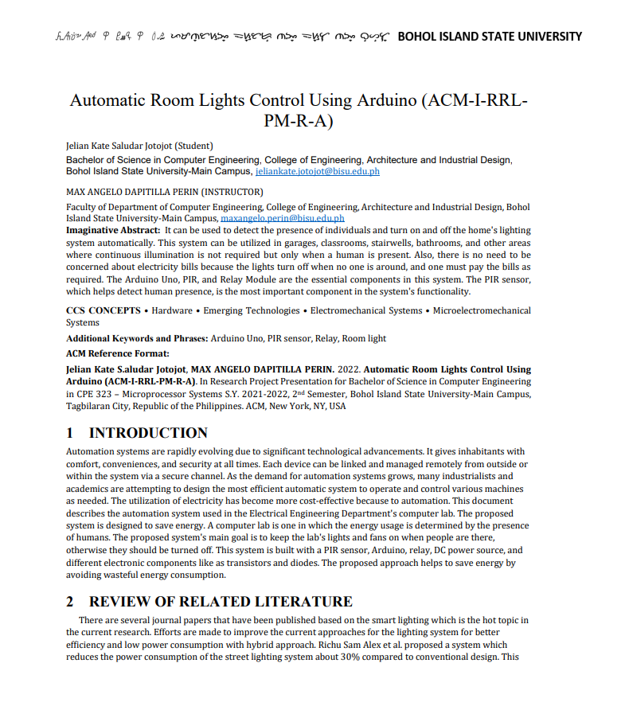

**Figure 8:** Screenshot of ARLCUA by Jelian Kate Jotojot

**Full Code (Arduino Sketch)**

char ch;

int ROOM_1 = 8;

int ROOM_2 = 9;

int ROOM_3= 10;

int ROOM_4 = 11;

void setup() {

// put your setup code here, to run once:

Serial.begin(9600);

pinMode(ROOM_1,OUTPUT);

pinMode(ROOM_2,OUTPUT);

pinMode(ROOM_3,OUTPUT);

pinMode(ROOM_4,OUTPUT);

digitalWrite(ROOM_1,HIGH);

digitalWrite(ROOM_2,HIGH);

digitalWrite(ROOM_3,HIGH);

digitalWrite(ROOM_4,HIGH);

}

void loop() {

// put your main code here, to run repeatedly:

if(Serial.available()!=0){

ch = Serial.read();

Serial.write(ch);

doWork(ch);

}

}

void doWork(char ch){

switch(ch){

case 'A': //code for switch 1 turned on

digitalWrite(ROOM_1,HIGH);

break;

case 'a': //code for switch 1 turned off

digitalWrite(ROOM_1,LOW);

break;

case 'B': //code for switch 2 turned on

digitalWrite(ROOM_2,HIGH);

break;

case 'b': //code for switch 2 turned off

digitalWrite(ROOM_2,LOW);

break;

case 'C': //code for switch 3 turned on

digitalWrite(ROOM_3,HIGH);

break;

case 'c': //code for switch 3 turned off

digitalWrite(ROOM_3,LOW);

break;

case 'D': //code for switch 4 turned on

digitalWrite(ROOM_4,HIGH);

break;

case 'd': //code for switch 4 turned off

digitalWrite(ROOM_4,LOW);

break;

// add more lights if you wish

}

}.