Arduino Based Humidity Tracker Using DHT11 Sensor

Peter Neil Imboy Ilogon(Student)

Student of Bachelor of Science in Computer Engineering in College of Engineering, Architecture and Design, Bohol Island State University, peterneil.ilogon@bisu.edu.ph

Max Angelo Dapitilla Perin (Instructor)

Faculty of Department of Computer Engineering, College of Engineering, Architecture and Industrial Design, Bohol Island State University-Main Campus, maxangelo.perin@bisu.edu.ph

Imaginative Abstract

Keeping track of the humid content of your room helps you maintain your wood and metal objects. The device will track and monitor the level of humidity in a normal bedroom. The project will need the DHT11 Sensor which is on the less expensive price and it will help the project easier to obtain data of humidity and temperature. The Humidity Tracker will receive and project data gathered from the saturation changes in air temperature and calculates it. By keeping track of the humid content in a room, we can estimate and control the airflow and temperature in a room. Having things in a room with wood materials in our place gives us a hard time because once cold air and water enters the wood, the wood will easily warp and same case for metal things but instead it will rust. This is to prevent warping and rusting in our things and help maintain to always keep in quality.

CCS CONCEPTS • Hardware • Electronic Systems • Microcontroller Systems • Monitoring System

Additional Keywords and Phrases: DHT11 Sensor, humid content, humidity tracker, system, temperature

ACM Reference Format:

Peter Neil Imboy Ilogon, Max Angelo Dapitilla Perin. 2022. Arduino Based Humidity Tracker Using DHT11Sensor (ACM: IA-IRRL-PM-R-A). In Research Project Presentation for Bachelor of Science in Computer Engineering 3 in CPE 03 – Microprocessor Systems S.Y. 2021-2022, 2nd Semester, Bohol Island State University-Main Campus, Tagbilaran City, Republic of the Philippines. ACM, New York, NY, USA

1. Introduction

Humidity can heavily damage our homes, specifically in very closed-rooms. If humid content is too high or too low, it can do lasting damage to property like rusting and warping of objects. High humid creates excess moisture and condensation that potentially leads to mold or rot, while low humidity has been linked to the rapid spread of virus like cold and flu. This article contains about how to make, use and know the advantages of having a Humidity Tracker. Humid issues can be solved by using this technology. The technology uses DHT11 Sensor to gathers the data of the room temperature and program the Arduino Uno to do some calculations for the humid content and show results to an LCD Display. The owner can to put it anywhere in a closed room and it will automatically keep on tracking the humid content of the room.

1. Review of Related Literature

There are a lot of implementations and applications of DHT11 Sensor. In [1], the authors designed and implemented a project that controls temperature and humidity for condensation. By this study, the authors aimed to control condensation by using a controller board, a larger temperature sensor, amplifier, level booster, peltier element, relay modules and power supply. Having it as a reference, I can look for components that I need to use in creating the humidity tracker feature in a less expensive project.

Arduino is an open-source platform that enable us to quickly build electronic projects. [2] The authors designed a simple weather station using Arduino Uno to program, calculate the output data and display the weather. This solves the forecasting future weather by using present data. The collected data of trials shows that at 100% of relative humidity, we tend to feel hotter than the actual temperature. When the relative humidity is low, we can feel much cooler than the actual temperature.

There are a lot of electronic sensors that can be used in this project, but this project will only need the minimum to operate. In [3], the authors are trying to solve in identifying the air temperature in a wider and lager area with a wider range of temperature. They are using DHT22 Sensors which is used to collect data of the temperature which range is from 0 to 125+ degree Celsius. The sensor that they are using is expensive but works accurately and have better specifications. I came to a conclusion to try and use the alternative. The DHT11 Sensor is the alternative and low spec version of the DHT22. This sensor is enough to cover and collect temperature data in a room and it is a lot cheaper than DHT22 Sensor. In [2][3], the projects used with the same LCD, RGB Backlight LCD – 16x2”. In [3], the algorithm is coded in the Arduino IDE. The authors designed and implanted a humidity monitor using only a computer to monitor and view the data collected from the sensors. To start the project, they added a library file to the Arduino IDE which will help to code the system and you can find it in github, MFRC library.

1. Proposed Methodology

This project will be using a few electronic components. All electronic components to be used in this study are listed in table 1. The major components will be described and explained in the content of this chapter along with the block diagram shown in figure 1, circuit diagram shown in figure 2, used for the digital prototype of this project and constructed code used in Arduino to manipulate the data gathered in the sensor.

* 1. Hardware Overview

**Arduino Uno:** The Arduino UNO R3 is frequently used[microcontroller board](https://www.elprocus.com/avr-atmega8-microcontroller-architecture-applications/) in the family of an Arduino. This is the latest third version of an Arduino board and released in the year 2011. The main advantage of this board is if we make a mistake, we can change the microcontroller on the board. The main features of this board mainly include, it is available in DIP (dual-inline-package), detachable and ATmega328 microcontroller. The programming of this board can easily be loaded by using an Arduino computer program. This board has huge support from the Arduino community, which will make a very simple way to start working in embedded electronics, and many more applications.

**DHT11 Temperature – Humidity Sensor:** The DHT11 is a basic, ultra – low – cost digital temperature and humidity sensor. It uses a capacitive humidity sensor and a thermistor to measure the surrounding air, and spits out a digital signal on the data pin. It’s fairly simple to use, but requires careful timing to grab data. You can get data from it once every 2 seconds, so when using the library from Adafruit, sensor readings can be up to 2 seconds old.

**Standard LCD 16x2:** Standard HD44780 LCDs are useful for creating standalone projects. It has a display of 16 characters with 2 rows. The LCD can be fully controlled with only 6 digital lines with built in character support sets like English and Japanese. It can display temperature, time or any project that requires simple display.

* 1. Components

Table 1: Lists of components used in the study

|  |  |
| --- | --- |
| Components |  |
| Arduino Uno | DHT11 Sensor |
| Standard LCD 16x2 | 4.7k ohm Resistor |
| 10k ohm Variable Resistor | 330ohm Resistor |
| Jumper Wires | Prototype Board |

* 1. Block Diagram

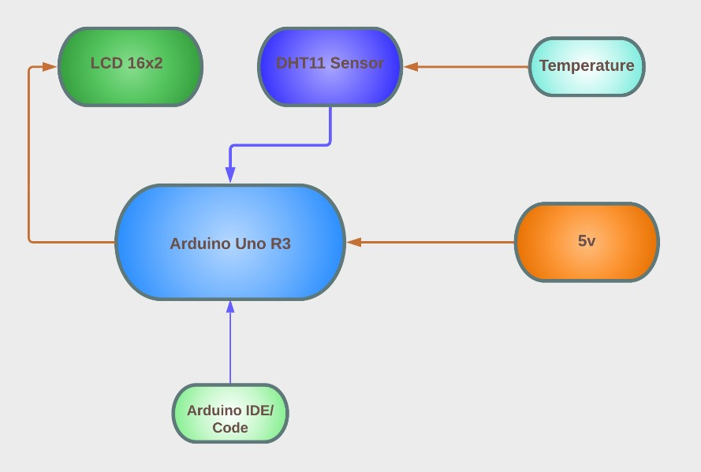

Figure 1: Block Diagram Arduino Based Humidity Tracker Using DHT11 Sensor

* 1. Circuit Diagram

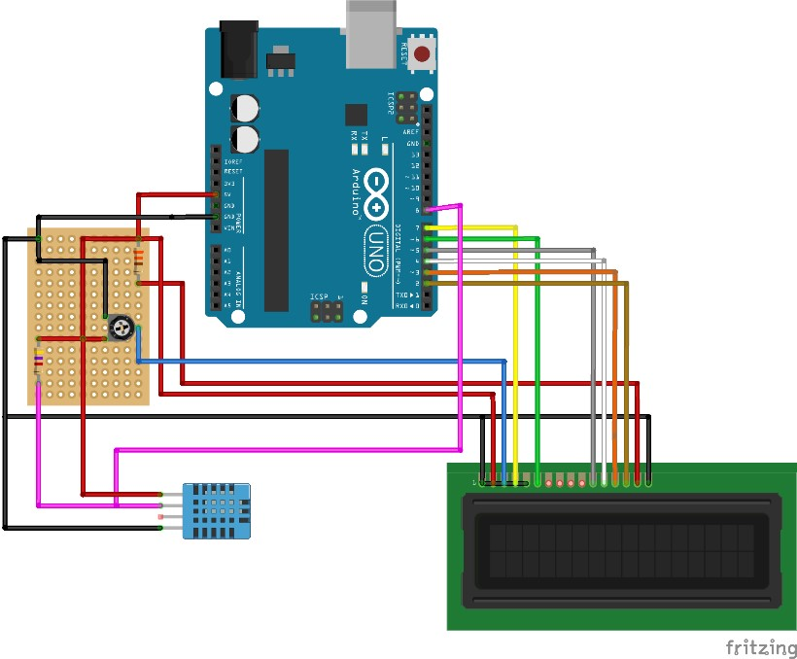

Figure 2: Circuit Diagram Arduino Unp R3, LCD 16x2, DHT11 Sensor, Trim Pots, 2 Resistors

* 1. Important Code

Arduino IDE code

}

temperature[7] = Temp / 10 + 48;

temperature[8] = Temp % 10 + 48;

temperature[11] = 223;

humidity[7] = RH / 10 + 48;

humidity[8] = RH % 10 + 48;

lcd.setCursor(0, 0);

lcd.print(temperature);

lcd.setCursor(0, 1);

lcd.print(humidity);

}

Appendices

ABHTUDS (Arduino) **Sketch**

#include <LiquidCrystal.h>

#include <DHT.h>

#define DHTPIN 8

LiquidCrystal lcd(7, 6, 5, 4, 3, 2);

#define DHTTYPE DHT11

dht(DHTPIN, DHTTYPE);

char temperature[] = “Temp = 00.0 C “;

char humidity[] = “RH = 00.0 % “;

void setup() {

lcd.begin(16, 2);

dht.begin();}

void loop() {

delay(1000);

byte RH = dht.readHumidity();

byte Temp = dht.readTemperature();

if (isnan(RH) || isnan(Temp)) {

lcd.clear();

lcd.setCursor(5, 0);

lcd.print(“Error”);

return;

}

temperature[7] = Temp / 10 + 48;

temperature[8] = Temp % 10 + 48;

temperature[11] = 223;

humidity[7] = RH / 10 + 48;

humidity[8] = RH % 10 + 48;

lcd.setCursor(0, 0);

lcd.print(temperature);

lcd.setCursor(0, 1);

lcd.print(humidity);

}

References

[1] Rohit Gupta, Ranjan Ganguly, Ankit Roy, Amitava Datta – “Arduino Based Temperature and Humidity Control for Condensation on Wettability Engineered Surfaces”, March 2018 – pg. 2-3

[2] Pius Uagbae Ejodanem, Victor E. Ekong, Udoinyang Inyang – “Arduino Based Weather Based Monitoring System”, February 2018 – pg. 3-8

[3] Sohel Datta, Yugandhara Wadikar, Trupti Gopinath – “Temperature and Humidity Sensor Using Arduino”, May 2020 – pg. 1-2

<https://www.airthings.com/resources/home-humidity-damage#:~:text=High%20humidity%20creates%20excess%20moisture,%2C%20and%20even%20Covid%2D19>.