Automatic Plug In or Out using Relay Module (ACM:IA-I-RRL-PM-R-A)

Jack Danielle Ladaran Granada (Student)

Bachelor of Science Computer Engineering, College of Engineering, Architecture and Industrial Design, Bohol Island State University-Main Campus, [jackdanielle.granada@bisu.edu.ph](mailto:jackdanielle.granada@bisu.edu.ph)

MAX ANGELO DAPITILLA PERIN (INSTRUCTOR)

Faculty of Department of Computer Engineering, College of Engineering, Architecture and Industrial Design, Bohol Island State University-Main Campus, [maxangelo.perin@bisu.edu.ph](mailto:maxangelo.perin@bisu.edu.ph)

**Imaginative Abstract:** Home automation is a growing trend among those who desire to operate their devices without being physically present in the same area. When a device is turned off or unplug, an automatic plug saves energy and helps to keep your monthly power bill low. Smart plugs assist to maintain a power-to-function balance and can avoid a harmful overload, which can cause damage or worse. This study provides a programmable electrical plug relay that may be controlled by an Arduino or any other microcontroller. It is used to programmatically turn on and off devices that can utilize high voltage and/or high current. The relay module is a separate piece of hardware used to switch distant devices. It allows you to control things from a distance via a network or the Internet. In the application of the smart plug, instructions provided over a local or wide area network can turn devices on or off remotely. You can operate computers, peripherals, and other powered equipment from anywhere in the workplace or around the world.

CCS CONCEPTS • Hardware • Communication Hardware, interface and storage • Signal processing Systems • Digital processing Systems

Additional Keywords and Phrases: Home automation, power-to-function balance, relay module, smart plugs.

ACM Reference Format:

**Jack Danielle Ladaran Granada, MAX ANGELO DAPITILLA PERIN**. 2022. **Automatic Plug In or Out using Relay Module (ACM: IA-I-RRL-PM-R-A)**. In Research Project Presentation for Bachelor of Science in Computer Engineering 3 in CPE 323 – Microprocessor Systems S.Y. 2021-2022, 2nd Semester, Bohol Island State University-Main Campus, Tagbilaran City, Republic of the Philippines. ACM, New York, NY, USA

1. INTRODUCTION

In our daily lives, technology and devices have become ubiquitous. As smart home systems become more popular, smart plug applications are increasing. Smart Plugs can be used on their own or as part of home monitoring systems. With the power of a switch relay, you can control anything in your home. This study proposes an Arduino-based system for remotely controlling and monitoring electrical devices and sensors for power conservation and protection purposes. Unexpected power outages can cause a power surge, which can cause damage to appliances or gadgets as well as produce high-voltage electricity. To avoid damage, we must unplug the appliances or gadgets before power is restored. This power outlet may be controlled by the Arduino to transform the electrical equipment or appliance into a smart device that is connected to a relay module that is controlled by the Arduino. A relay module serves as the link between the Arduino and the power outlet. The power outlet box has a switch that may be used to turn on or off the appliance plugged into the smart plug. The relay can control the appliance because it is linked to the smart plug.

1. REVIEW OF RELATED LITERATURE

The efficient and effective use of energy in a building or a home is a major focus of Internet of Things (IoT) research [1], [2]. According to the Indonesian Ministry of Energy and Mineral Resources (2017), national energy consumption continues to rise as people get access to electricity and their lifestyles change. According to the data, Indonesia's energy usage per capita in 2017 was 1,012 kilowatt hours (KWH), increasing 5.9% over the previous year. The government expects public power usage to rise to 1,129 kwh/capita this year. Electricity use is increasing every year, according to the data. We could construct an automated system in the building to reduce energy usage [3], [4]. As a result, a gateway is required to connect between devices and the internet, allowing users to remotely monitor and manage them [5], [6], and [7]. To create an IoT using a rudimentary system such as the Arduino Uno and sensors to interface directly with devices [8]. All internet-connected devices in the house, such as the air conditioner, television, light, and home security system, may be managed remotely using a smartphone. Using on/off control in electrical outlets, this study is developing an Internet of Things (IoT) tool. Wireless transmission at a frequency of 2,4 GHz is used to communicate between the gateway and the internet. The database server stores the on/off status that shows on the dashboard. Users may use Android or the web to operate the gadget remotely.

The project provides an effective IoT (Internet of Things) implementation for monitoring and managing household appliances through the Internet. Smart plugs serve as the user interface for a home automation system. By connecting the appliances to the smart plug, they may connect to a home automation network via an Internet gateway and low-power communication protocols such as Wi-Fi. This project uses Wi-Fi as a communication protocol and the Arduino Uno as a server system to control household appliances via smartphone. The user will engage directly with the system via a web-based interface, whilst household appliances will be managed remotely via a simple webpage. An additional feature that improves the aspect of accident safety is its capacity to automatically turn off the smart plugs so that, in the case of any electrical accidents or overload electrical breakouts, a message is delivered to the Smartphone. The server will be connected to relay hardware circuits that will control the household appliances. The user can choose the right device thanks to the server's communication. The user can choose an approved device after communicating with the server. The relays are communicated with by the server. The embedded system board will control and run the appliances domestically even if the web connectivity or server is unavailable. We provide a scalable and cost-effective home automation solution as a result of this [9].

1. PROPOSED METHODOLOGY

The study will be conducted through an experimental method by the researchers. The main component of the system is the Arduino Uno R3 and Relay Module. Aside from that, this project cannot be done without the necessary components shown in the [Table 1](bookmark://tb1) below. The program code will execute and require to automatic switch on and off by the relay.

* 1. Components Used

Below [Table 1](bookmark://tb1) are components and tools utilized to make time control system in this study are shown below.

|  |  |
| --- | --- |
| **Materials** | |
| **Components required:** | **Tools required**: |
| Arduino Uno R3 | Wire cutter |
| Jumper wires | Screw Driver |
| Relay Module |  |
| 220 V Light Bulb |  |
| Socket |  |
| Wire |  |

* 1. Block Diagram

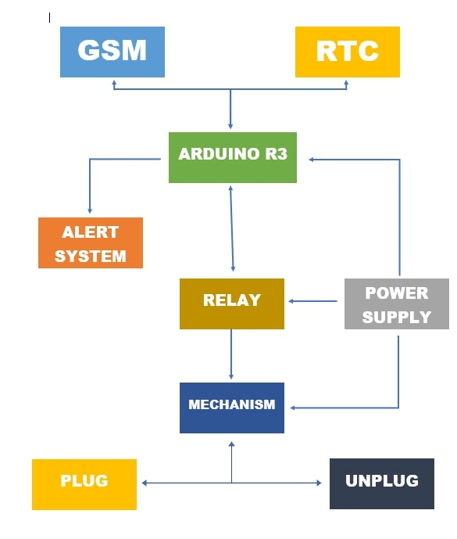Figure 1. The block diagram that will used to guide the working flow of system.

Figure 1: Block Diagram

* 1. Circuit Diagram

Figure 2. The circuit diagram that will be used as a reference in producing the product.

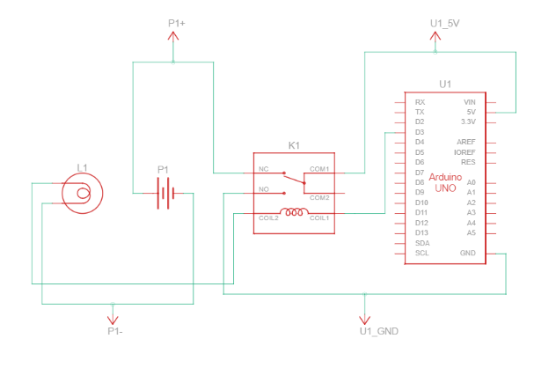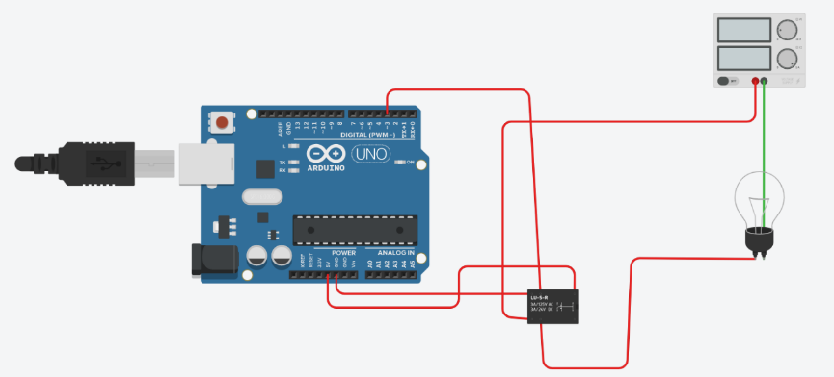

**Figure 2:** Circuit and Schematic Diagram

REFERENCES

<bib id="bib1"><number>[1]</number> J Pan, R Jain, S Paul, T Vu, A Saifullah, and M Sha 2015 IEEE Internet Things J. 2(6), 527– 537 </bib>

<bib id="bib2"><number>[2]</number> C. Bekara 2014 Procedia Comput. Sci. 34 532–537,. </bib>

<bib id="bib3"><number>[3]</number> V S Gunge and P S Yalagi 2016 Int. J. Comput. Appl. Natl. Semin. Recent Trends Data Min. Rtdm 975–8887 </bib>

<bib id="bib4"><number>[4]</number> V Marinakis and H Doukas 2018 Sensors (Switzerland) 18(2) </bib>

<bib id="bib5"><number>[5]</number> V K. Sagar N and K S M 2015 Int. Res. J. Eng. Technol. 2395–56,. </bib>

<bib id="bib6"><number>[6]</number> K Sarath, C Kotcherlakota, V Bharadwaj and R Chinta 2016 J. Eng. Res. Appl. 6(5) 77–80 </bib>

<bib id="bib7"><number>[7]</number> D Kunal, D Tushar, U Pooja, Z Vaibhav and V Lodha 2016 Int. J. Adv. Res. Comput. Commun. Eng. 5(2) 576–578 </bib>

<bib id="bib8"><number>[8]</number> R Piyare 2013 Int. J. Internet Things 2(1) 5–11 </bib>

<bib id="bib9"><number>[9]</number> [2015 Global Conference on Communication Technologies (GCCT)](https://ieeexplore.ieee.org/xpl/conhome/7325162/proceeding) </bib>

APPENDICES

Image of the Device using Relay Module

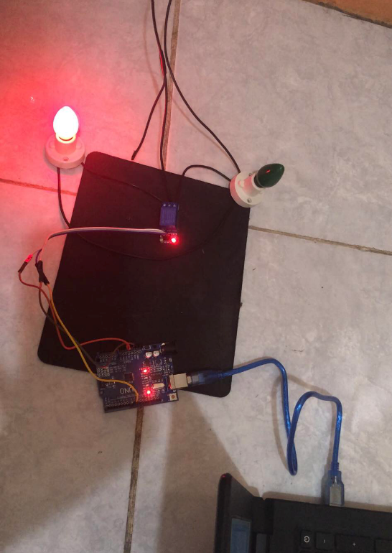

* 1. Simulation Code – Tinkercad

Tinkercad is used in simulate the code of the research. The code in this research are significant to function the Automatic Sitch On and Off.

**void setup()**

**{**

**pinMode(3, OUTPUT);**

**}**

**void loop()**

**{**

**digitalWrite(3, HIGH);**

**delay(1000); // Wait for 1000 millisecond(s)**

**digitalWrite(3, LOW);**

**delay(1000); // Wait for 1000 millisecond(s)**

**}**