### Python网络运维 Lab3

#### 1.正则表达式测试 1

字符串为MAC地址表内容: '166 54a2.74f7.0326 DYNAMIC Gi1/0/11'

使用正则表达式匹配，并且格式化打印后结果如下图:

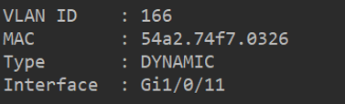

作业标准:

* 提供完整的代码（Windows或者Linux）粘贴后注意行间距-参考作业标准
* 对打印结果进行截图

import re

mac = '166 54a2.74f7.0326 DYNAMIC Gi1/0/11'

vlanid = re.search('(\d+)',mac)

print('VLAN ID : ', vlanid.group())

# 匹配数字多次

mac1 = re.search('([0-9|a-f]{4}.){2}[0-9|a-f]{4}', mac)

print('MAC : ', mac1.group())

# 匹配数字或者字母，次数4，重复2次。匹配数字或者字母，次数4

type = re.search('[D].*[C]',mac)

print('Type : ', type.group())

# 匹配D之后的字母多次，到C

interface = re.search('[G].*',mac)

print('Interface : ', interface.group())

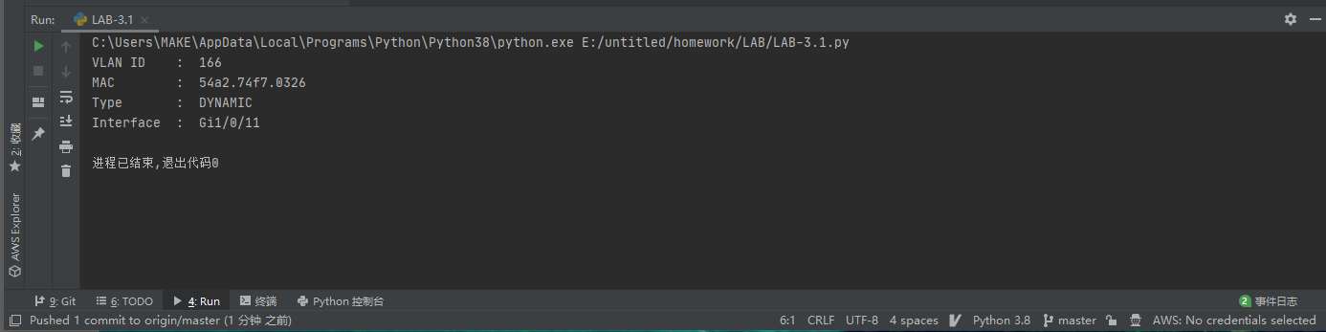

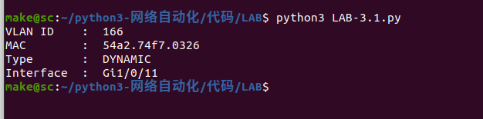

#### 2.正则表达式测试 2

字符串为ASA防火墙show conn（查看连接内容): 'TCP server 172.16.1.101:443 localserver 172.16.66.1:53710, idle 0:01:09, bytes 27575949, flags UIO'

使用正则表达式匹配，并且格式化打印后结果如下图:

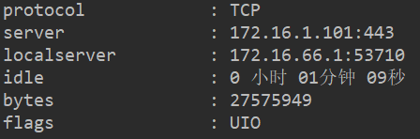

作业标准:

* 提供完整的代码（Windows或者Linux）粘贴后注意行间距-参考作业标准
* 对打印结果进行截图

import re  
  
firewall = 'TCP server 172.16.1.101:443 localserver 172.16.66.1:53710, idle 0:01:09, bytes 27575949, flags UIO'  
  
server = re.search('([0-9]|[a-f]{3}.)(.*?)(:[0-9|a-f]{3})', firewall)  
protocol = re.search('\w+', firewall)  
localserver = re.search('([0-9]|[a-f]{3}.)(.*?)([0-9|a-f]{5})', firewall)  
idle = re.search('([0-9]{1}:)([0-9]{2}:)([0-9]{2})', firewall)  
bytes_num = re.search('([0-9]{8})', firewall)  
flags = re.search('[U].*[O]', firewall)  
  
localserver = localserver.group()[-17:-1]  
  
info = f'''  
protocol :{protocol.group():<20}  
server :{server.group():<20}  
localserver :{localserver:<20}  
idle :{idle.group():<20}  
bytes :{bytes_num.group():<20}  
flags :{flags.group():<20}  
'''  
  
print(info)

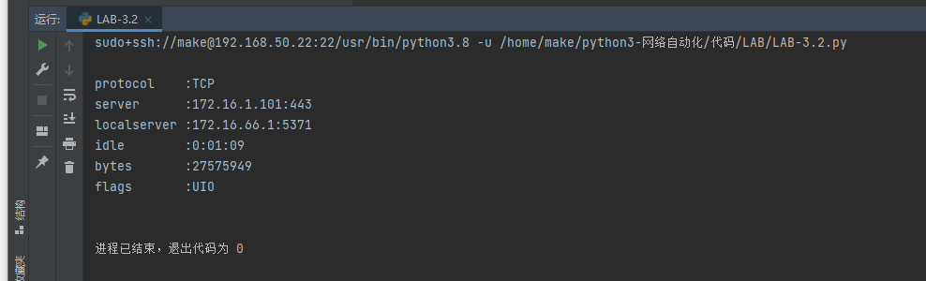

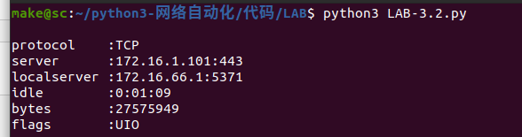

#### 3.正则表达式测试3

使用正则表达式，找到ifconfig中的IP和MAC

提示：使用如下方法可以得到ifconfig的内容清单

import os

ifconfig_result = os.popen(“ifconfig “+” ens160”).read() # 执行并返回命令的结果

如果没有Linux可以直接使用如下字符串：

ens160: flags=4163<UP,BROADCAST,RUNNING,MULTICAST> mtu 1500

inet 192.168.80.50 netmask 255.255.255.0 broadcast 192.168.80.255

inet6 fe80::fcfe:a168:df5c:e0b6 prefixlen 64 scopeid 0x20<link>

ether 00:0c:29:54:db:7d txqueuelen 1000 (Ethernet)

RX packets 21 bytes 6089 (5.9 KiB)

RX errors 0 dropped 0 overruns 0 frame 0

TX packets 48 bytes 5691 (5.5 KiB)

TX errors 0 dropped 0 overruns 0 carrier 0 collisions 0

使用正则表达式匹配，并且格式化打印后结果如下图:

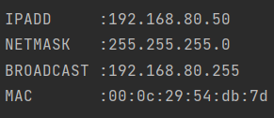

作业标准:

* 提供完整的代码（Windows或者Linux）粘贴后注意行间距-参考作业标准
* 对打印结果进行截图

import re  
import os  
  
# ifconfig_result = os.popen("ifconfig "+" ens33").read()  
# print(ifconfig_result)  
  
# windows直接用下面数据  
ifconfig_result = '''  
eth0: flags=4163<UP,BROADCAST,RUNNING,MULTICAST> mtu 1500  
 inet 172.17.21.74 netmask 255.255.192.0 broadcast 172.17.63.255  
 inet6 fe80::216:3eff:fe06:c29a prefixlen 64 scopeid 0x20<link>  
 ether 00:16:3e:06:c2:9a txqueuelen 1000 (Ethernet)  
 RX packets 12760634 bytes 12226198574 (11.3 GiB)  
 RX errors 0 dropped 0 overruns 0 frame 0  
 TX packets 6475573 bytes 11686436753 (10.8 GiB)  
 TX errors 0 dropped 0 overruns 0 carrier 0 collisions 0  
'''  
  
# print(ifconfig_result)  
  
IP = re.search('([0-9]{3}.)([0-9]{2}.){2}([0-9]{2})', ifconfig_result)  
NETMASK = re.search('([0-9]{3}.){3}[0]', ifconfig_result)  
BROADCAST = re.search('([0-9]{3}.)([0-9]{2}.){2}([0-9]{3})', ifconfig_result)  
MAC = re.search('([0-9|a-f]{2}:){5}([0-9|a-f]{2})', ifconfig_result)  
  
info = f'''  
IPADD : {IP.group():<20}  
NETMASK : {NETMASK.group():<20}  
BROADCAST : {BROADCAST.group():<20}  
MAC : {MAC.group():<20}  
'''  
  
print(info)

