**EEOB-563 Final Project Proposal**

**Introduction**

While animal mitochondrial DNA (mtDNA) has traditionally been depicted as a uniform, circular molecule encompassing a conserved set of genes (Gray et al. 1999, 2004; Gualberto et al. 2014; Smith and Keeling 2015), multiple exceptions to this general picture exist (Lavrov and Pett 2016). In particular, transitions from circular to linear mitochondrial genome architecture have occurred independently in at least three groups of animals, having been reported extensively among non-bilaterian lineages such as Medusozoa (Cnidaria) and Calcarea (Porifera) and within Bilateria in at least fifteen species of isopods (Bridge et al. 1992; Doublet et al. 2012; Lavrov et al. 2013).

Linear mtDNA architecture is ubiquitous among the medusozoan cnidarians, suggesting that it is an ancestral trait that first evolved in the group's common ancestor. Medusozoan mtDNA also includes an extra open reading frame (ORF) resembling DNA-polymerase, termed polB, and inverted terminal repeats (ITRs) that, in some hydrozoans, may contain a portion of *cox1* (Kayal et al. 2012). Within Calcarea, all mitogenomes appear linear and multipartite (Lavrov et al. 2013, 2016). There appear to be two unique cases of linear mtDNA within calcarea. Within *Clathrina* the mtDNA exists as a few chromosomes where a large proportion of it is repetitive DNA and the ends of the chromosomes are identical. While in others it appears to be composed of many chromosomes, with nearly 1 gene per chromosome, and many of these are “empty chromosomes” containing no identifiable coding sequences. Among isopod crustaceans, multiple members of the family Oniscidea have a mitogenome consisting of two molecules, a circular dimer formed from the fusion of two monomers in opposite polarities and a linear monomer (Doublet et al. 2012). The differences among linear mtDNA within metazoan suggests that perhaps there are more than one mechanism that can lead to linearization of mtDNA.

Outside metazoa, linear mtDNA with ITRs has been reported in multiple lineages of fungi, plants, and other eukaryotes (Zardoya 2022). Within fungi, linear mtDNA arrangement is hypothesized to result from the integration of linear mitochondrial plasmids that encode DNA polymerase B (Mouhamadou et al. 2004). It has been hypothesized that among Medusozoa the transition to the linear mtDNA occurred via a similar process, as supported by the presence of a DNA-polymerase-B-like ORF (Kayal et al. 2012). However, the transition mechanism between circular and linear genome architecture in animals remains uncertain.

*Acanthella acuta* (Bubarida, Demospongiae) is a relatively common sponge species found in the Mediterranean Sea and the Atlantic Ocean and was one of the species sampled for our demosponge phylogeny project (Lavrov et al. 2019). Our previous analysis of the *A. acuta* mtDNA shows that is possesses a single, relatively large linear mtDNA molecule. The large size of its mt-genome is attributed to the presence of a large ORF resembling DNA-polymerase and RNA-polymerase, inverted terminal repeats, as well as 3 introns within the genes *cox1*, *cox2* and *rnl*. We believe the mechanism involved in the linearization of the *A. acuta* mtDNA is similar to that in medusozoans, as evidenced by the presence of a DNA-polymerase-like ORF and ITRs. Previous phylogenetic analysis of the ORF and introns suggests they occur in the *A. acuta* mtDNA as a result of horizontal gene transfer. In order to better understand the linearization of mtDNA, it may be pertinent to learn when such HGT events would have occurred and how they impacted the *A. acuta* mtDNA architecture.

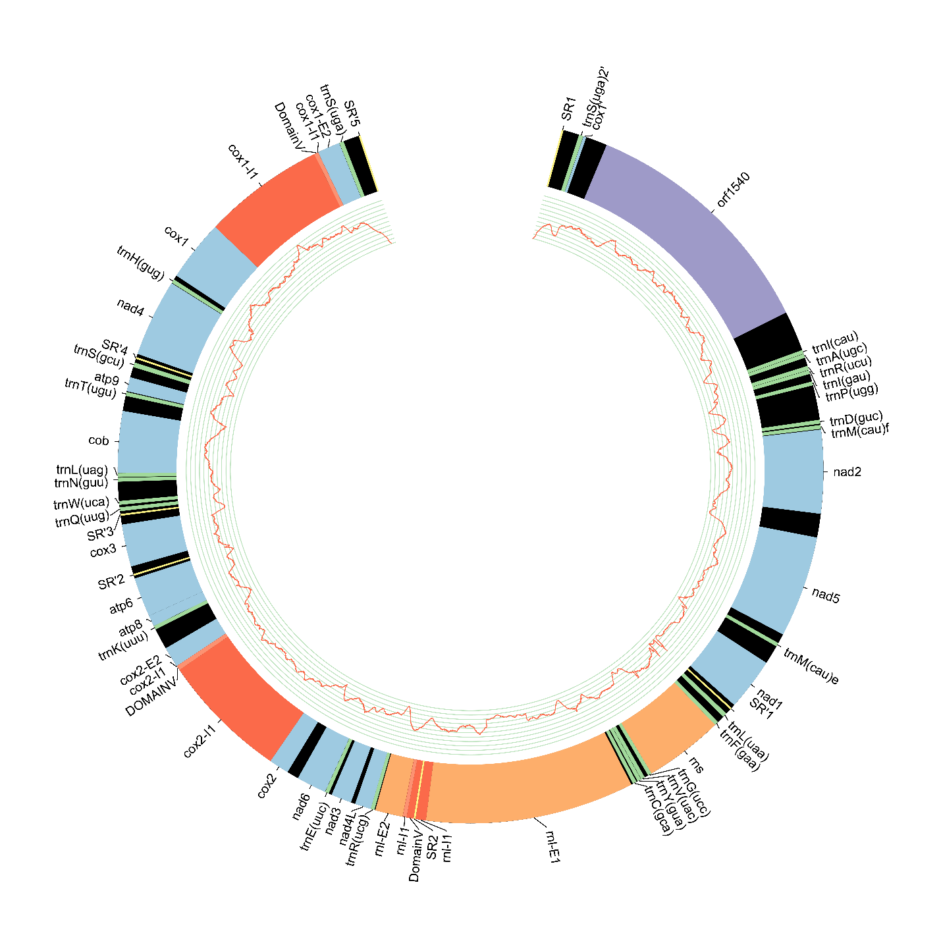

Figure 1 Acanthella acuta mtDNA

**Main questions**

* When did the *A. acuta* mtDNA acquire the DNA-polymerase like ORF?
* When did the *A. acuta* mtDNA acquire the introns within its genes?
* When did the *A. acuta* mtDNA acquire the ITR on its mt-chromosome?
* What can the order of acquisition of these genomic elements tell us about the process of linearization?

**Proposed methods**

Use phylogenetic tools to run a molecular clock analysis on the *A. acuta* mtDNA to estimate when each of the HGT events might have occurred. Tools used will be CD-HIT, MAFFT, RAxML-NG.

**Sources of data**

* Previously available mtDNA sequence for A. acuta.
* NCBI/GenBank data for other demosponge mtDNA