|  |  |  |  |
| --- | --- | --- | --- |
| **CS102** | **Spring 2017/18** | Project Group | 2D |
| Instructor: | **David Davenport** |  |  |
| Assistant: | Nazanin Jafri |  |  |

|  |  |  |
| --- | --- | --- |
| **Criteria** | **TA/Grader** | **Instructor** |
| Presentation |  |  |
|  |  |  |
|  |  |  |
|  |  |  |
| Overall |  |  |

~ VESTIUM ~

Semicolons

Muhammad Arham Khan, Mohamad Fakhouri, Sarah Javaid, Syed Abdullah Qutb, Amir-Hossein Maghsoudi, Esra Nur Deniz, Ahmet Berk Eren

|  |
| --- |
| User-Interface Stage  (Version 2)  16 April 2018 |

# Introduction

View this template in "Print Layout" form. To use it, begin by editing the preceding section to include information related to your project & the report you are writing (for help, press F1 when the text cursor is in a field.)

Using Styles

As far as possible, do not change any of the formatting, but rather use the existing styles. For example, place the cursor in the text "Using Styles" above. Notice the Style is "Normal." Try changing it to "Heading 2," then to "Heading 1." Note the numbering of subsequent sections is changed automatically.

# Features

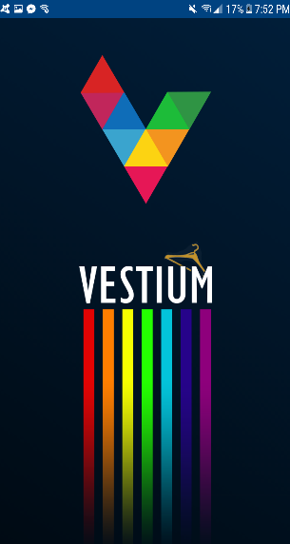**The splash screen:** acts as a buffer between Activity transitions and removes the possibility of blank white screens during the load time.

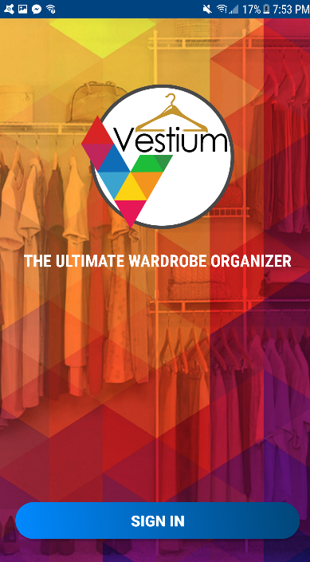**‘Sign In’ Page:**

On opening the app, the user is presented with a sign in page. On tapping the sign in button on the bottom of the page, the user is asked the choice of google account they want to sign in from. Upon selecting the account, the home screen of the application shows. If internet is not available, the sign in page simply shows a message that internet is not available if the user is not signed in yet. But, if the user had signed in previously, regardless of internet availability, the app opens the home page for the user instead of the login page.

**THE HOME SCREEN**

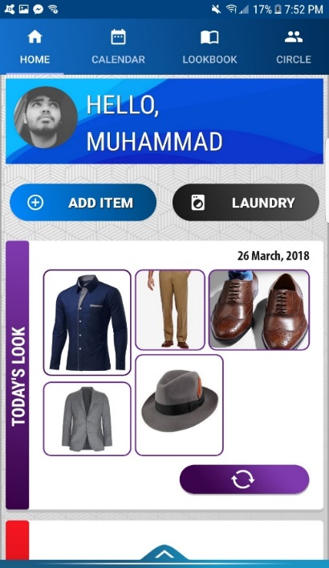Top Tabs bar Options: The tabs bar at the top of the page displays four options. The user can either swipe left or right to access each activity or even tap on one of the four icons.

* Home: This takes the user to the home page.
* Calendar: Takes the user to the calendar page where they are able to add an outfit look to a specific date.
* Look-Book: Takes the user to the page where all the user’s outfit looks are displayed in a block design layout.
* Circle: Takes the user to the friend circles page, where the user is able to interact with friends.

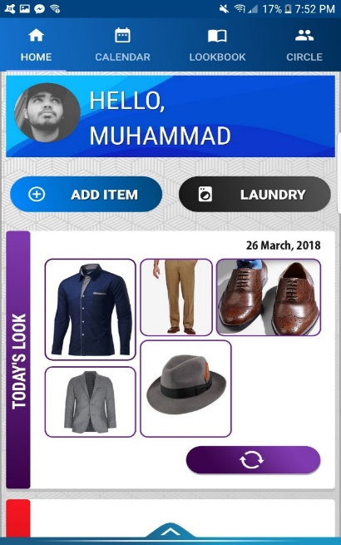‘Add Item’ button: Displayed right after the top page tabs bar, this button allows the user to add items to their wardrobe. When the user taps on it, a pop up menu is displayed showing two options: ‘Camera’ and ‘Gallery’. Tapping the camera option opens the camera app. The user takes a picture of the relevant clothing item and is asked for confirmation. Upon confirming positive, the picture is displayed to the user. On the bottom of the displayed picture, there are two text fields. One of them is for the name of the clothing item, where the user can enter the name, and the second one is for any additional description they want to associate with that specific item. There are also three drop down menus, with a red star after 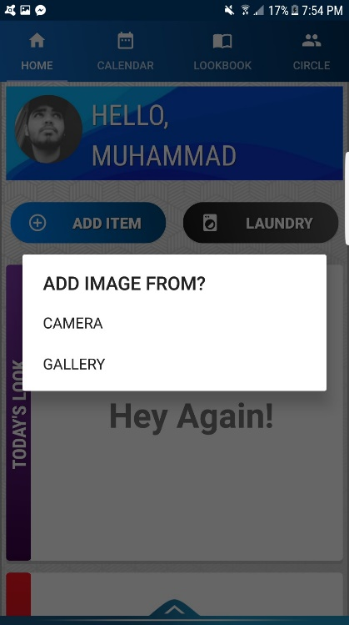each which means that the user cannot proceed with adding that clothing item without choosing one of the options. They are present below the text fields. The first one is for the category, which shows the possible categories of the clothing item: ‘Shirt’, ‘Pants’, ‘Shoes’, ‘Jacket’, ‘Sweater’, ‘Watch’, ‘Belt’ etc. The second one shows the possible styles of the clothing item and the third one is for the possible colours. After the user fills in the text fields and selects the desired option from the drop down menus, they can tap the button which says “ADD” and are taken back to the home page and a message appears on the bottom of the screen saying “Item added to wardrobe”, the clothing item is, thus, saved in their wardrobe. If the user taps the gallery option, they are simply taken to their phone’s gallery and the user can select the image they want to add.

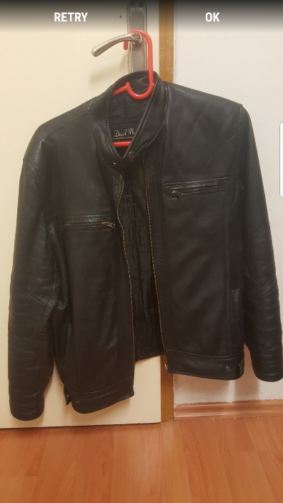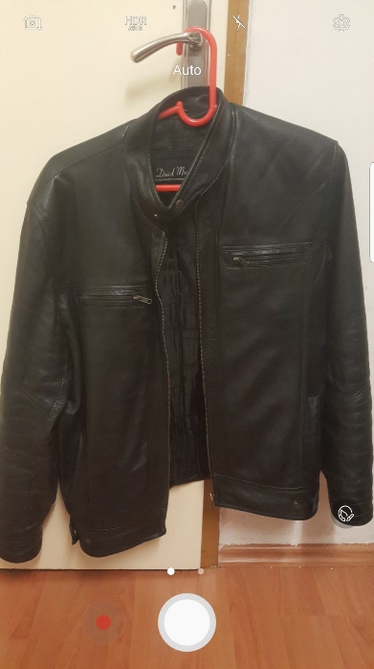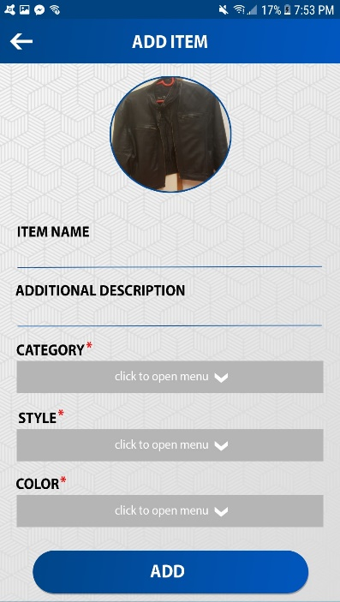

Laundry button: Present at the right of the ‘Add item’ button, tapping this button takes the user to the laundry activity where they can manage the clothing items that were added to the laundry. This button is also present in the menu bar (discussed later), but this one being on the home screen acts as a quick access button.

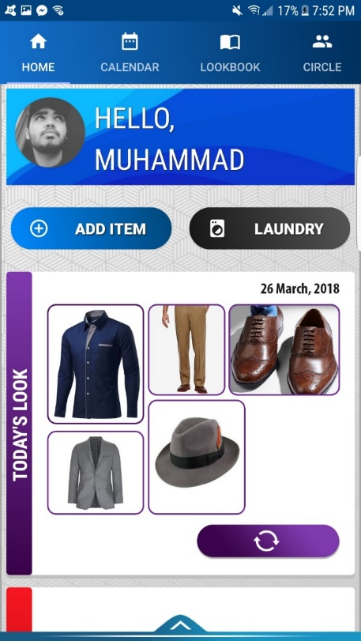

‘Today’s Look’ pane: The suggested look for the current day is displayed below the ‘Laundry’ and ‘Add Item’ buttons. It shows all the items of clothing in the outfit look in a block design layout. If the user is not satisfied with the suggestion, they can tap the ‘reload’ button at the bottom right side of the pane, which causes the program to suggest a different outfit for the day. The top right corner of the pane shows the current date.

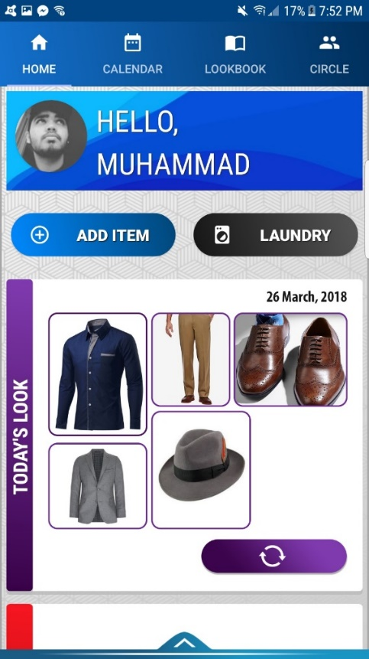

‘Notifications’ pane: Below the ‘Today’s Look’ pane is the notifications section. It contains notifications about friend polls, latest deals, or any notification about laundry or donations. The user is able to tap any of the notifications and they are taken to the relevant page. For example, if the notification is about one the user’s friends creating a new poll, tapping it would take the user to the page where that poll will be displayed. Similarly, tapping the one which says “6 items have been away for laundry for 15…” will take the user to the laundry activity.

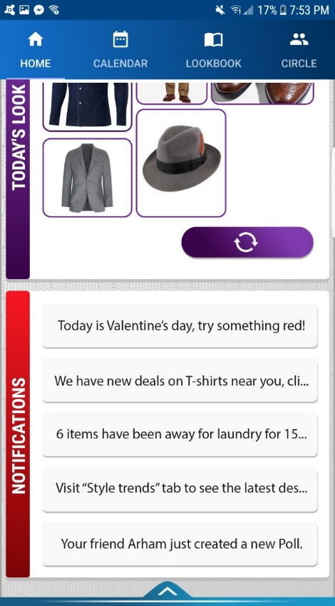

‘Polls’ pane: Present right below the ‘Notifications’ pane, is the current ‘Polls’ pane. It shows the on-going poll that has been created by the user for their friends to vote on which clothing item should they wear for the day. The two choices are displayed in two separate circles. The one with higher votes is bordered in a bigger, green circle and the one with the lesser votes is inside a smaller, red circle. Below each circle, the number of votes each clothing item has gotten is showed. On the bottom right side of the panel is a button that says ‘End Poll’ which can be used by the user to delete the on-going poll. On the top right side of the panel, the date on which the poll was created is displayed.

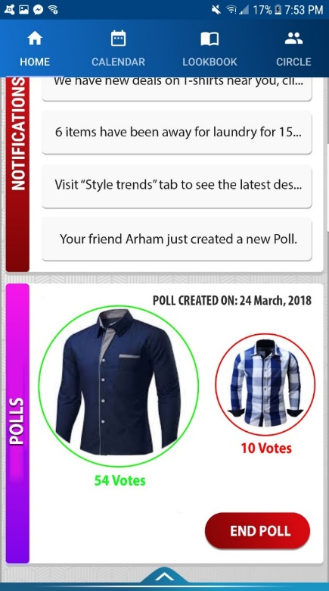

The menu bar: There is an arrow, facing upwards, present at the very bottom of the home screen. Tapping that arrow brings forth the menu options panel. The panel slides from the bottom of the screen and is displayed to the user. The menu options panel consists of the following button options:

* Wardrobe: Takes the user to their wardrobe.
* Shopping: Takes the user to the shopping activity.
* Style Trends: Takes the user to the page where the latest style trends are displayed.
* Laundry: This is the same button as the one discussed before, which takes the user to page displaying the user’s laundry.
* Settings: Takes the user to the settings page.

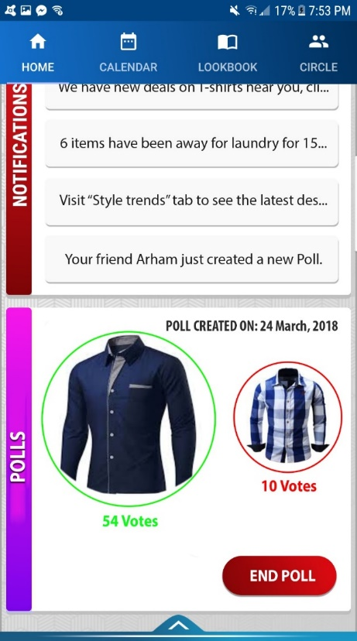

# Conclusions

And finally… don’t forget that Word can help to check your spelling (and grammar!)

Maintaining lists of research references that can be reused when writing journal articles can be a real pain, especially when citation styles vary so much from journal to journal. When you have time I suggest you look at reference managers (e.g. JabRef for BibTeX, or websites such as CiteSeer), as well as other document creation options (e.g. LyX, LateX and OpenOffice.)

Good Luck.