**CS 202**

**Section 03**

Spring 2019

Muhammad Arham Khan

21701848

Homework # 3: Heaps and AVL Trees

Q1: Insert the values 13, 9, 10, 21, 11, 16 into an empty AVL tree.

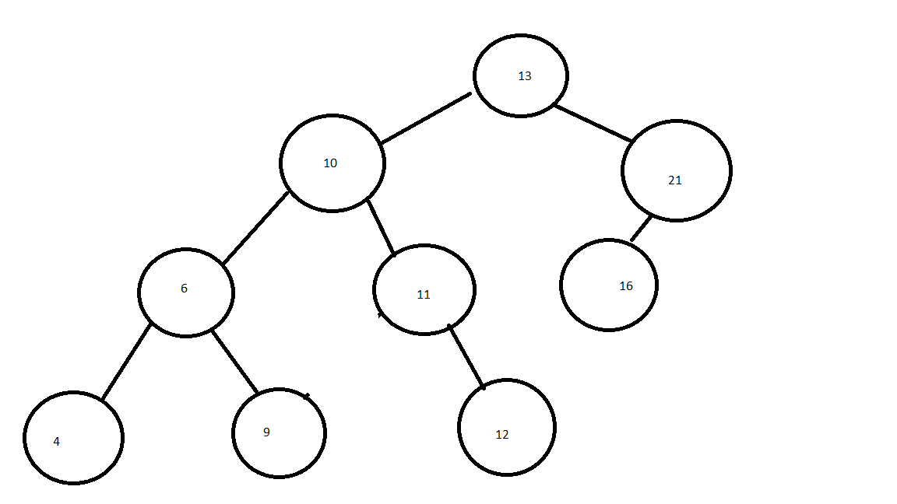

Now delete 10, 9, 6

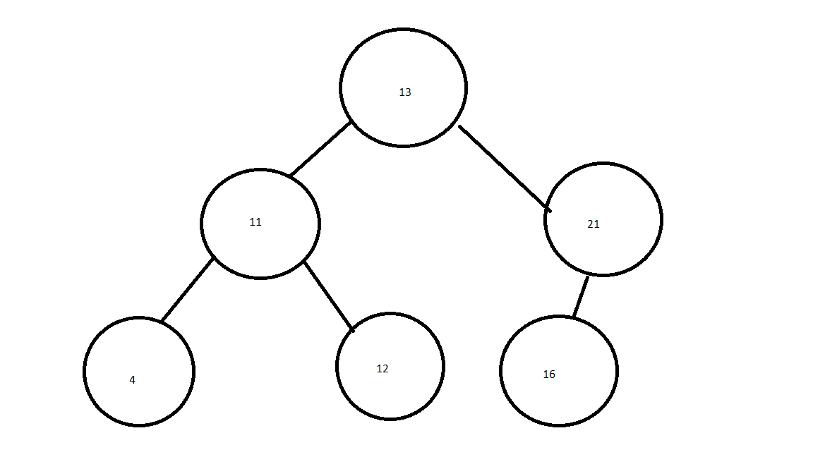

b) insert 15, 13, 9, 5, 12, 8……………..into an empty min-heap

