**DIGITAL DESIGN**

**CS223**

**FINAL PROJECT REPORT**

**NAME: MUHAMMAD ARHAM KHAN**

**BILKENT ID: 21701848**

**SECTION: 2**

**DATE: 26 NOV, 2018**

**TRAINING PACK: 47**

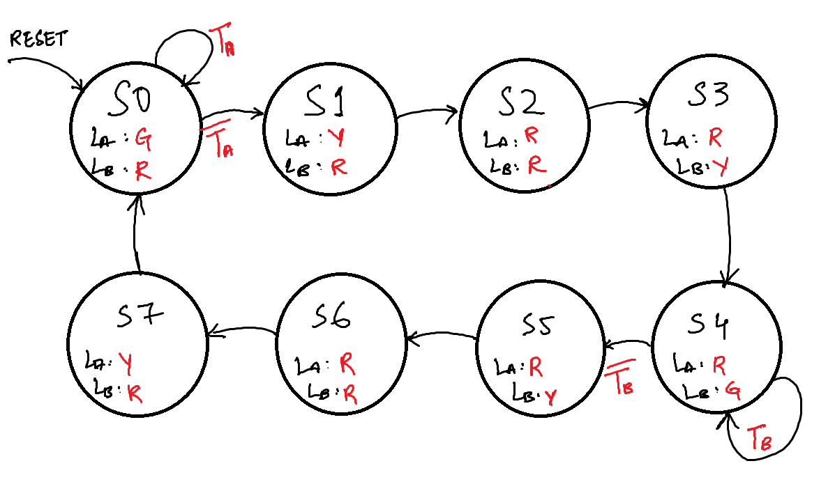**MOORE FINITE STATE MACHINE (FSM) TRANSITION DIAGRAM**

**STATE ENCODINGS**

|  |  |  |  |
| --- | --- | --- | --- |
| **STATE** | **ENCODING S2:0** | | |
| **S2** | **S1** | **S0** |
| S0 | 0 | 0 | 0 |
| S1 | 0 | 0 | 1 |
| S2 | 0 | 1 | 0 |
| S3 | 0 | 1 | 1 |
| S4 | 1 | 0 | 0 |
| S5 | 1 | 0 | 1 |
| S6 | 1 | 1 | 0 |
| S7 | 1 | 1 | 1 |