**DIGITAL DESIGN**

**CS223**

**FINAL PROJECT REPORT**

**NAME: MUHAMMAD ARHAM KHAN**

**BILKENT ID: 21701848**

**SECTION: 2**

**DATE: 24 DEC, 2018**

**TRAINING PACK: 47**

**FINITE STATE MACHINE (FSM) TRANSITION DIAGRAM**

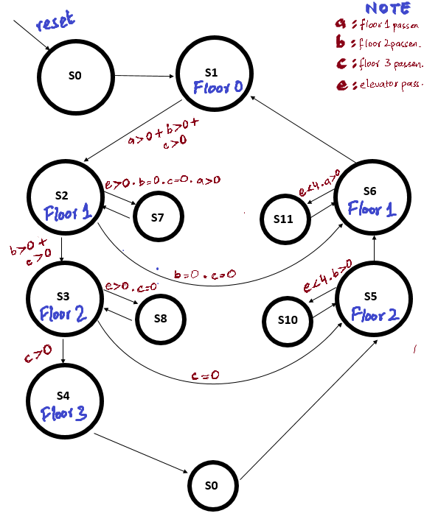

**S9**

**STATE ENCODINGS**

|  |  |  |  |  |
| --- | --- | --- | --- | --- |
| **STATE** | **ENCODING S3:0** | | | |
| **S3** | **S2** | **S1** | **S0** |
| S0 | 0 | 0 | 0 | 0 |
| S1 | 0 | 0 | 0 | 1 |
| S2 | 0 | 0 | 1 | 0 |
| S3 | 0 | 0 | 1 | 1 |
| S4 | 0 | 1 | 0 | 0 |
| S5 | 0 | 1 | 0 | 1 |
| S6 | 0 | 1 | 1 | 0 |
| S7 | 0 | 1 | 1 | 1 |
| S8 | 1 | 0 | 0 | 0 |
| S9 | 1 | 0 | 0 | 1 |
| S10 | 1 | 0 | 1 | 0 |
| S11 | 1 | 0 | 1 | 1 |

**STATE DESCRIPTIONS**

|  |  |
| --- | --- |
| **STATE** | **DESCRIPTION** |
| S0 | This state is the reset state where the passenger counts on floors, timer, elevator passenger count and the led matrix is reset to the starting position. |
| S1 | This is floor 0 where the elevator’s passenger count gets reset to 0 and we check if there are more pessengers to go pick up or terminate the evacuation process and stop timer. |
| S2 | This is Floor 1 while the elevator is going up and it checks if the floors above it have passengers and go above or else go into the passenger waiting state S7 to pick up passengers. |
| S3 | This is Floor 2 while the elevator is going up and it checks if the floor 3 above it has passengers and go above or else go into the passenger waiting state S8 to pick up passengers. |
| S4 | This is Floor 3 while the elevator is going up and it progresses to the passenger reducing state S9 to add passengers to the elevator |
| S5 | This is Floor 2 while the elevator is going down and it checks if the elevator has empty slots and if Floor 2 has passengers waiting. If so, it goes to passengers waiting state S10 to pick up more passengers from Floor 2. It then progresses down to Floor 1. |
| S6 | This is Floor 1 while the elevator is going down and it checks if the elevator has empty slots and if Floor 1 has passengers waiting. If so, it goes to passengers waiting state S11 to pick up more passengers from Floor 1. It then progresses down to Floor 0. |
| S7 | This is the passenger reducing/ waiting state for Floor 1 (S2) while the elevator is going up. It adds passengers to elevator until elevator is full or floor is empty and then progresses back to state S2. |
| S8 | This is the passenger reducing/ waiting state for Floor 2 (S3) while the elevator is going up. It adds passengers to elevator until elevator is full or floor is empty and then progresses back to state S3. |
| S9 | This is the passenger reducing/ waiting state for Floor 3. It adds passengers to elevator until elevator is full or floor is empty and then progresses forward to floor 2 (state S5) |
| S10 | This is the passenger reducing/ waiting state for Floor 2 (S5) while the elevator is going down. It adds passengers to elevator until elevator is full or floor is empty and then progresses back to state S5. |
| S11 | This is the passenger reducing/ waiting state for Floor 1 (S6) while the elevator is going down. It adds passengers to elevator until elevator is full or floor is empty and then progresses back to state S6. |

**HARDWARE USED**

* Basys 3 board
  + Seven segment display
  + Push buttons
* Beti Logic board
  + 4x4 button keybad
  + 8x8 RGB led display

**CODE DESCRIPTIONS**

1. The FSM mechanism controls the time delay between states and implements the high-level finite state machine control using id statements/ case logics to handle waiting time.
2. The nextState mechanism controls which state will the system next go to and hence, utilizes values like each floors passenger count and elevators passenger count and the passenger number to know which state next go to and hence, control the elevator.
3. The timer (seven segment) display mechanism independently controls the second count on the display and responds to posedge reset and clock signals to increment the display after each second.
4. The timer includes a 10bit binary number that increments each second and the mechanism converts value of binary to three individual digits for the seven segment displays input.
5. The forward loader/ backward loader modules are functions that are connected in an always_ff module with a 250ms clock that either moves the loader forward or reverses it to back based on the current state number
6. The ledMatrixController section controls the led lights ouput on the matrix using the values of currentState, nextState, elevatorPassengerCount and each floors passenger count.