**LAB REPORT**

**Lab 06**

MUHAMMAD ARHAM KHAN

21701848 - CS

SECTION 06

SPRING 2019

**Dated: 05 May, 2019**

**DIRECT MAPPED**

Matrix 1 – Row Sums – Direct Mapped (Size 50) – Cache size vs. words per block

|  |  |  |  |  |  |
| --- | --- | --- | --- | --- | --- |
|  | 4 words | 8 words | 16 words | 32 words | 64 words |
| 512 bytes | 672 (21%) | 338 (11%) | 171 (5%) | 87 (3%) | 45 (1%) |
| 1024 bytes | 672 (21%) | 338 (11%) | 171 (5%) | 86 (3%) | 44 (1%) |
| 2048 bytes | 672 (21%) | 338 (11%) | 171 (5%) | 86 (3%) | 44 (1%) |
| 4096 bytes | 672 (21%) | 338 (11%) | 171 (5%) | 86 (3%) | 44 (1%) |
| 8192 bytes | 672 (21%) | 338 (11%) | 171 (5%) | 86 (3%) | 44 (1%) |

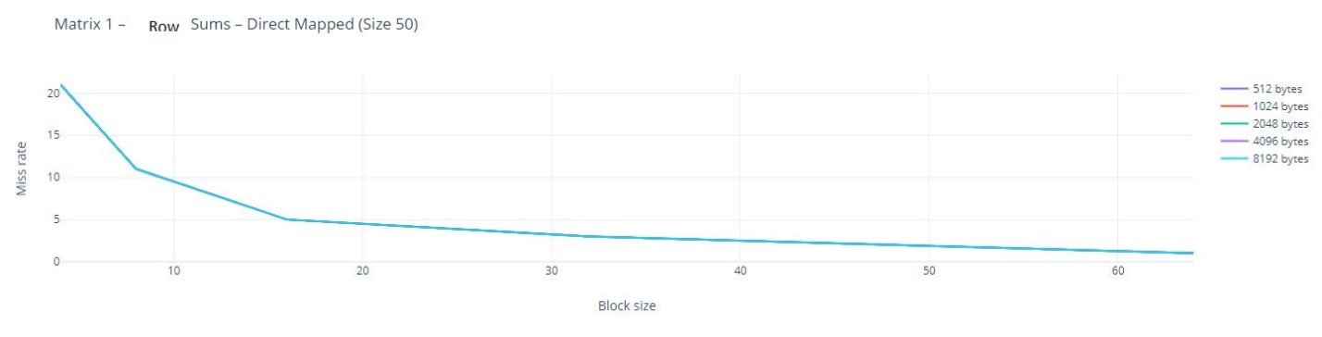

Matrix 1 – Column Sums – Direct Mapped (Size 50) – Cache size vs. words per block

|  |  |  |  |  |  |
| --- | --- | --- | --- | --- | --- |
|  | 4 words | 8 words | 16 words | 32 words | 64 words |
| 512 bytes | 1812 (56%) | 2525 (79%) | 2513 (78%) | 2508 (78%) | 1959 (61%) |
| 1024 bytes | 1138 (35%) | 1549 (48%) | 2513 (78%) | 2507 (78%) | 1958 (61%) |
| 2048 bytes | 1138 (35%) | 1037 (32%) | 1626 (51%) | 2507 (78%) | 1958 (61%) |
| 4096 bytes | 1138 (35%) | 1037 (32%) | 985 (31%) | 1640 (51%) | 1958 (61%) |
| 8192 bytes | 1123 (35%) | 1014 (32%) | 958 (30%) | 930 (29%) | 736 (23%) |

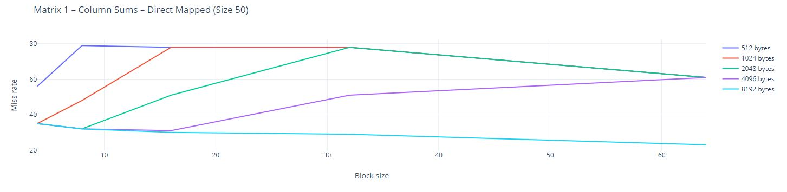

Matrix 2 – Row Sums – Direct Mapped (Size 35) – Cache size vs. words per block

|  |  |  |  |  |  |
| --- | --- | --- | --- | --- | --- |
|  | 4 words | 8 words | 16 words | 32 words | 64 words |
| 512 bytes | 354 (18%) | 179 (9%) | 91 (5%) | 47 (2%) | 25 (1%) |
| 1024 bytes | 354 (18%) | 179 (9%) | 91 (5%) | 46 (2%) | 24 (1%) |
| 2048 bytes | 354 (18%) | 179 (9%) | 91 (5%) | 46 (2%) | 24 (1%) |
| 4096 bytes | 354 (18%) | 179 (9%) | 91 (5%) | 46 (2%) | 24 (1%) |
| 8192 bytes | 354 (18%) | 179 (9%) | 91 (5%) | 46 (2%) | 24 (1%) |

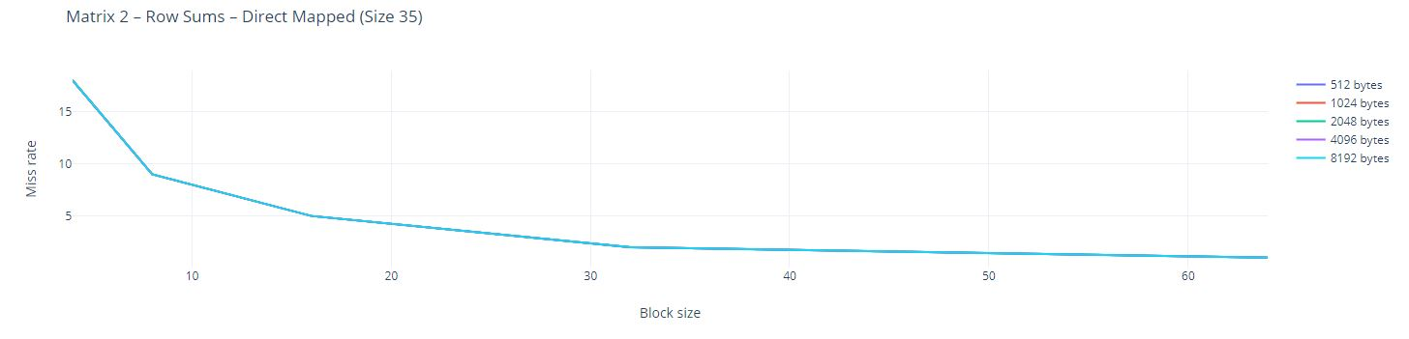

Matrix 2 – Column Sums – Direct Mapped (Size 35) – Cache size vs. words per block

|  |  |  |  |  |  |
| --- | --- | --- | --- | --- | --- |
|  | 4 words | 8 words | 16 words | 32 words | 64 words |
| 512 bytes | 1271 (66%) | 1250 (65%) | 1238 (64%) | 1233 (64%) | 679 (35%) |
| 1024 bytes | 822 (42%) | 873 (45%) | 1104 (57%) | 1232 (64%) | 678 (35%) |
| 2048 bytes | 379 (20%) | 209 (11%) | 530 (27%) | 1174 (61%) | 678 (35%) |
| 4096 bytes | 361 (19%) | 188 (10%) | 251 (13%) | 399 (21%) | 244 (13%) |
| 8192 bytes | 353 (18%) | 179 (9%) | 90 (5%) | 46 (2%) | 24 (1%) |

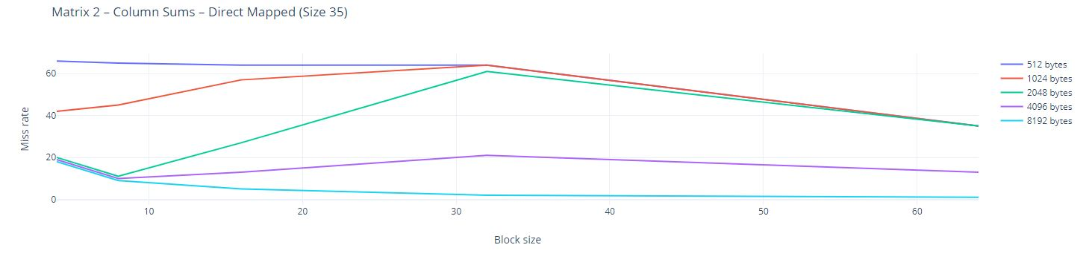

**FULLY ASSOCIATIVE**

Matrix 1 – Row Sums – fully associative (Size 50) – Cache size vs. words per block

|  |  |  |  |
| --- | --- | --- | --- |
|  | Direct Mapped | Fully assoc. (LRU) | Fully assoc. (random replacement) |
| 4 words/ 512 bytes | 79% | 79% | 79% |
| 16 words/ 2048 bytes | 95% | 95% | 95% |
| 64 words/ 8192 bytes | 99% | 99% | 99% |

Matrix 1 – Column Sums – fully associative (Size 50) – Cache size vs. words per block

|  |  |  |  |
| --- | --- | --- | --- |
|  | Direct Mapped | Fully assoc. (LRU) | Fully assoc. (random replacement) |
| 4 words/ 512 bytes | 44% | 21% | 37% |
| 16 words/ 2048 bytes | 49% | 22% | 47% |
| 64 words/ 8192 bytes | 77% | 39% | 78% |

Matrix 2 – Row Sums – fully associative (Size 35) – Cache size vs. words per block

|  |  |  |  |
| --- | --- | --- | --- |
|  | Direct Mapped | Fully assoc. (LRU) | Fully assoc. (random replacement) |
| 4 words/ 512 bytes | 82% | 82% | 82% |
| 16 words/ 2048 bytes | 95% | 95% | 95% |
| 64 words/ 8192 bytes | 99% | 99% | 99% |

Matrix 2 – Column Sums – fully associative (Size 35) – Cache size vs. words per block

|  |  |  |  |
| --- | --- | --- | --- |
|  | Direct Mapped | Fully assoc. (LRU) | Fully assoc. (random replacement) |
| 4 words/ 512 bytes | 34% | 34% | 57% |
| 16 words/ 2048 bytes | 73% | 36% | 74% |
| 64 words/ 8192 bytes | 99% | 99% | 99% |

**N-WAY SET ASSOCIATIVE**

Matrix 1 – Column Sums – N-way (Size 50) – Bad config.

|  |  |  |  |  |
| --- | --- | --- | --- | --- |
|  | n = 2 | n = 4 | n = 8 | n = 16 |
| Miss rate | 75% | 79% | 79% | 79% |
| Misses | 2420 | 2546 | 2546 | 2546 |

Matrix 1 – Column Sums – N-way (Size 50) – Average config.

|  |  |  |  |  |
| --- | --- | --- | --- | --- |
|  | n = 2 | n = 4 | n = 8 | n = 16 |
| Miss rate | 63% | 78% | 78% | 78% |
| Misses | 2021 | 2513 | 2513 | 2513 |

Matrix 1 – Column Sums – N-way (Size 50) – Good config.

|  |  |  |  |  |
| --- | --- | --- | --- | --- |
|  | n = 2 | n = 4 | n = 8 | n = 16 |
| Miss rate | 34% | 55% | 61% | 61% |
| Misses | 1082 | 1774 | 1958 | 1958 |

Matrix 1 – Row Sums – N-way (Size 50) – Bad config.

|  |  |  |  |  |
| --- | --- | --- | --- | --- |
|  | n = 2 | n = 4 | n = 8 | n = 16 |
| Miss rate | 21% | 21% | 21% | 21% |
| Misses | 672 | 672 | 672 | 672 |

Matrix 1 – Row Sums – N-way (Size 50) – Average config.

|  |  |  |  |  |
| --- | --- | --- | --- | --- |
|  | n = 2 | n = 4 | n = 8 | n = 16 |
| Miss rate | 5% | 5% | 5% | 5% |
| Misses | 171 | 171 | 171 | 171 |

Matrix 1 – Row Sums – N-way (Size 50) – Good config.

|  |  |  |  |  |
| --- | --- | --- | --- | --- |
|  | n = 2 | n = 4 | n = 8 | n = 16 |
| Miss rate | 1% | 1% | 1% | 1% |
| Misses | 44 | 44 | 44 | 44 |

Matrix 1 – Column Sums – Direct Mapped (Size 100) – Cache size vs. words per block

|  |  |  |  |  |  |
| --- | --- | --- | --- | --- | --- |
|  | 4 words | 8 words | 16 words | 32 words | 64 words |
| 512 bytes | 12635 (43%) | 10025 (6%) | 10013 (7%) | 10018 (7%) | 10015 (7%) |
| 1024 bytes | 7946 (26%) | 10025 (6%) | 10013 (7%) | 10007 (7%) | 10013 (7%) |
| 2048 bytes | 2546 (76%) | 7925 (26%) | 10013 (7%) | 10007 (7%) | 10007 (4%) |