**BILKENT UNIVERSITY**

**ENGINEERING FACULTY**

**DEPARTMENT OF COMPUTER ENGINEERING**

**CS 299**

**SUMMER TRAINING  
REPORT**

**Muhammad Arham Khan**

**21701848**

**Performed at**

**P.I. Works**

**June 10, 2019 – August 1, 2019**

Table of Contents

1 Introduction 3

2 Company Information 3

2.1 About the company 3

2.2 About your department 4

2.3 About the hardware and software systems 5

2.4 About your supervisor 5

3 Work done 5

3.1 Learning new technologies 5

3.2 Phase 1 – Front End Development 6

3.2.1 AngularJS 6

3.2.2 Testing 6

3.2.3 Webpack 6

3.2.4 Node Package Manager (NPM) 6

3.3 Phase 2 – Full Stack Development 7

3.3.1 ASP.NET Core (C#) 7

3.3.2 Learning Management System 7

3.3.3 Refactoring 8

3.3.4 Testing and Packaging 8

3.3.5 Review and Deployment 8

3.4 Presentations 8

3.4.1 Chrome Dev Tools 8

3.4.2 Website performance analysis tools 9

4 Performance and Outcomes 9

4.1 Applying Knowledge and Skills Learned at Bilkent 9

4.2 Solving Engineering Problems 9

4.3 Team Work 9

4.4 Multi-Disciplinary Work 10

4.5 Professional and Ethical Issues 10

4.6 Impact of Engineering Solutions 10

4.7 Locating Sources and Self-Learning 11

4.8 Knowledge about Contemporary Issues 11

4.9 Using New Tools and Technologies 11

5 Conclusions 11

References 12

Appendices 13

# Introduction

This is a detailed report of my summer internship as a Software Development Intern at P.I. Works (Istanbul, Turkey) from 10th June 2019 to 1st August 2019.

P.I. works is an IT firm that specializes in cellular network planning, management and optimization and develops technologies for telecom companies to improve the mobile experience of their users [1].

My motivation behind choosing P.I. works was not only the company’s global impact on mass users but also the emphasis the company puts in learning and training of interns. While a majority of the company’s I received an offer from wanted their interns to use their existing knowledge and develop products, P.I. works promised on supplementing my current knowledge with industry-standard skills in the first two weeks and then giving me the chance to choose what teams I wanted to be a part of. Seeing this as an opportunity to learn new and upcoming technologies and being able to contribute to projects that solve real-world issues like network optimization and efficient network-cell planning with industry-standard technologies and procedures, I decided to choose to do my summer training at P.I. works.

As a part of the Research and Development(RD) Department’s front-end team for the first half of my internship, I was responsible to learn JavaScript and AngularJS [3] (the prime stack P.I. works uses for their front-end development) and then utilize it to develop modules for their upcoming project: A Learning Management System which the company planned to use as an employee training/ analysis platform to make these processes faster and more efficient. For the latter part, I transitioned to full-stack development and started learning ASP.NET (company’s prime choice for backend development) and then went on the contribute to the LMS by developing the front-end and backend API services for multiple modules including but not limited to statistical reporting, code analysis and flexible course content generation.

The project I worked was significant to the company and in general because in today’s rapidly changing and developing world, it has become increasingly hard for firms to test candidate skills during the hiring process and then to keep the developers updated with the latest stack being used by the company. Hence, P.I. Works decided to solve that issue by developing their own LMS system that would not only enable them to hire efficiently, but to keep all employees updated with the latest technology stack and to analyze employee skillset in real-world environments.

# Company Information

## About the company

P.I. Works is a multi-national network planning and optimization firm that caters to the needs of telecom providers with the software solutions. The company is based out of Istanbul, Turkey (with their head office in Istanbul Teknopark) but has offices in USA, UK, Romania and Singapore.

P.I. Works’ prime software is a network planning and optimization software called uSON which not only enables telecom providers to locate optimal locations for network towers and make fast, uninterrupted connectivity possible for all users, it also enabled the company to make network infrastructure maintenance and organization very easy and straightforward [1].

The products the company develops are generally not open to the mass public and are targeted towards telecom network provider companies. Some other products that P.I. Works offers include “CentralizedSON” that allows end-to-end network planning towards 5G networking and “GeoAnalytics” which is an analytics platform for companies to know their subscribers’ usage patterns and heat-maps for network usage [1]. P.I. works has major clients in the telecom sector including

* Turk Telekom
* TurkCell
* Sprint
* Bolt
* Lifecell
* Telefonica Group

As of recent, the company has also started integrating A.I. algorithms to their platform in order to make the optimization and maintenance outcomes more effective.

P.I. Works has received various notable awards and mentions for their services in the field of connectivity. Some awards/ mentions include:

* “Pushing the Mobile Limits” award at GLOTEL awards 2016
* Leadership Award for automated network planning by Frost & Sullivan
* One of Top IT Service Exporters in Turkey by Turkish Exporter Assembly
* Among Top 100 ICT companies in Turkey

## About your department

The department I interned in was the Research and Development (R&D) Department and its prime focus is to overlook the development process of the company’s products. While the Product Services Department decides on the features to integrate and the new products to launch and the Support Engineering Department deploys the developed and tested products, the R&D department focuses primarily on developing and intensively testing the products of the firm.

The department comprised of 52 full-time employs and 12 interns spread across the various offices of P.I. works all over the world and was led by Ozgur Dustegor. But even within the department, there were small teams that were each headed by Relevant Heads. I was a part of the Front-End Design Team whose prime responsibility was developing and testing an easy-to-use front façade of the company’s complex software.

Our team was led by Mr. Altay Karakuş and although the team was supposed to work on the front-end development only, our supervisor believed in us learning the company’s products and development process holistically so encouraged us having a go at Backend Development as well.

## About the hardware and software systems

All interns were allocated standard Dell Latitude laptops having the following specifications:

* Intel Core i7 5th generation processors
* 8 GB ram
* 256GB SSD and unlimited shared server storage

The software suites we were provided for development were as follows:

* Microsoft Visual Studio 2019 Pro (registered to company’s domain) which we utilized for ASP.NET Development of the software’s backend API Services
* Visual Studio Code, which we utilized to develop and test the front-end AngularJS LMS application
* Mercurial Version Control System (VCS)

## About your supervisor

I had two supervisors guiding me through my internship program. Their details are:

1. Mr. Ozgür Düştegör:
   * Position: Research & Development Manager
   * Graduated from: Marmara University, 2002
   * B.S. in Computer Engineering
2. Mr. Altay Karakuş:
   * Position: Front End Team Lead
   * Graduated from: Istanbul Technical University, 2003
   * B.S. Aerospace Engineering

# Work done

## Learning new technologies

My internship was structured in a way that all interns were required to be on the same page before the actual work started and it was required of all interns to learn the main development stack the company utilizes for front-end development which included Html & CSS, JavaScript, AngularJS and Webpack [3, 4].

During the first week, we were tasked with completing the Html & CSS and JavaScript (ES5 and ES6) tutorials available on Freecodecamp.org [2]. We utilized the content available on the site to learn the languages/ scripts and then went on to take their tests to reaffirm our knowledge. The upper edge I had in this learning process was that since I had already studied Java at Bilkent and had some experience working with Website Development, I didn’t have to put in as much an effort to learn the new technologies.

## Phase 1 – Front End Development

### AngularJS

Starting week 2, considering we had the skills to actually develop, I was tasked with learning AngularJS framework by developing CRUD applications using any major openly accessible API service. AngularJS is a vastly popular framework for development of fast single-page web applications and was the prime framework P.I. Works used for their front-end development because of the framework’s ease of use and maintenance and efficiency as compared to conventional Web Application front-end frameworks.

I started off learning AngularJS from the official documentation and then decided to utilize OMDb API to make a movie indexing/ suggestion application called *MovieMate* [9]. This application utilized the API to load top grossing movies for the month and allowed the user to see the details of the movie and save favorites or make lists of movies. The application also had a “I’m Feeling Lucky” button that suggested a random movie to the user from the top trending list.

This project not only allowed me to learn AngularJS but also introduced me to the company’s code style and policies as our supervisor regularly visited us for code review and progress updates and critiqued our coding patterns and taught us industry standard styles of development.

### Testing

During the front-end development learning process, I was also introduced to the concept of test automation: delegating the task to scripted tests that run automatically and compare the test outcome to a predefined expected one. I used Karma for unit-testing and Protractor for end-to-end testing of the AngularJS application I developed [10].

### Webpack

After having developed this web application, I was tasked with packaging this application with Webpack [4]. Webpack is a smart web application optimization and packaging library that takes current codebase of the web application and then merges them into one single file that’s ready for deployment to the mass public. Having features like code uglification and minification, this allows developers to vastly improve the load times and propriety code security of their web applications. For the same reasons, P.I. Works utilized Webpack to package all of their products before mass deployment.

### Node Package Manager (NPM)

All the tasks other than the core front-end and back-end modules would not have been possible without a package-manager. I used Node Package Manager (NPM, often written as npm) to handle front-end package management. NPM streamlined the development process by shifting the responsibility of dependency management away almost completely away from me, leaving me free to focus on the core of the solution. NPM also enabled the integration of the testing and bundling platforms as plugins packages, while scripts for NPM even further automated the two processes, needing only a single command-line call to be invoked.

## Phase 2 – Full Stack Development

After completing the learning and front-end development phase of the internship in the first three weeks, I was asked by my supervisor about which department I would like to be a part of. Since I was interested in Backend Development since the beginning but was intrigued by Front-End development as well, I decided to go for a full stack position in our assigned project.

### ASP.NET Core (C#)

Since I had substantial experience in front-end development by now, I was required to learn ASP.NET (.NET Core) for backend web API development. The development department hosted a series of presentations on the development process for ASP.NET Core applications and introduced us to Visual Studio 2017, Microsoft SQLExpress and Nuget Package Manager. With the necessary tools and knowledge from a demo API at hand, I started learning Web API development from TutorialsPoint [11] and practicing *MovieMate*’s backend implementation with ASP.NET Core.

### Learning Management System

After getting confident in backend API development using ASP.NET Core, I joined a team of interns that were tasked with developing a Learning Management System to address complicated tasks like candidate skill testing during the hiring process and employee training/ analysis to ensure all teams are updated with the latest technology stack. The project comprised of an AngularJS single-page client application with ASP.NET API service controller application on the backend.

I was assigned with developing the following functionalities/ modules in the Learning Management System (LMS):

* Reporting test statistics, test sets, solution sets and test outcomes in Excel and Pdf formats
* Flexible test generation by enabling Excel file parsing to create or update tests
* Optimizing the current codebase to make it easily maintainable and less bulky
* Implementing the test-user hierarchy (tests can be assigned to teams, teams can have many users, users can have many teams) and making the test assignment process more straightforward on the front-end.
* Packaging the application with Webpack
* Writing unit tests testing it on the company’s TeamCity testing server before deployment [5].

Starting off with developing the ASP.NET Web controllers for reporting, I progressed my way through to excel parsing, line graph generation using Microsoft’s Chart Control Library and finally pdf/excel generation of the generated reports/ objects. The pdf reports were generated using iTextSharp library for C# and had to be designed with bare-hand coding as no visual designer is available for the library yet [8]. Once all variants of the reports were designed, I went on to make the reporting controllers (containing data fetch, sort, chart generation and rendering functions) and once that was final, I moved on to integrating blob API calls to the reporting controller in the front-end AngularJS application in order to receive the generated pdf blob stream from the server-side ASP.NET application. After the reporting feature was working, I added a reporting view to the AngularJS application and checked that feature into GitHub as final.

Then I moved on to developing the excel parsing controllers on the server ASP.NET end that would parse excel file blobs received in POST requests and then save the data in them as lessons, tests, questions or solutions for courses in the LMS. This parsing was done using the OpenXML library and once the data was parsed, it was straightforward to manipulate the existing database records with that data [7].

### Refactoring

Finally, I went on to refactoring the existing code base of the project. The existing project consisted of one controller controlling all aspects of the application (both on the front-end and the back-end). Utilizing the knowledge, I acquired at Bilkent, I went on to divide the controllers into model/controllers hierarchy to make the code easy to read and maintain and making teamwork more efficient.

### Testing and Packaging

Once the codebase for my features was finalized, I went on to packaging the front-end AngularJS application with webpack and then writing unit tests to test the use case scenarios of the application [4]. After writing unit tests and running them on my localhost, I deployed the packaged application to the company’s TeamCity servers and tested the compilation and test cases.

### Review and Deployment

Once the demo of features was approved by the supervisor and the test cases were working fine (after a couple iterations of bug hunting) on the TeamCity Servers, I checked in my code features to the company’s GitHub repo for review. After approval of the codebase from the supervisor, I also uploaded the code to company’s local server and finalized my internship tasks.

## Presentations

During the course of my internship, I was required to make two presentations on any topics related to web development.

### Chrome Dev Tools

Being an avid user of features like Console, Elements, Sources and Network, I decided to make my first presentation on “Chrome Developer Tools”. I utilized the default documentation and Google Demo videos to gain more insight into the features and realized what a great learning opportunity this was. After giving the presentation to more than 40 members of the development team, I feel proud to state that I learned a lot about debugging front-end design and so did the members of the front-end design team attending my presentations.

### Website performance analysis tools

The second presentation was a more general one involving tips and tools to utilize to make a web application/ website optimized and make load-times and performance better. I made my presentation on using GTMetrix, scaled images, persistent browser caching, code minification, defer JavaScript parsing, attribute compression, charset descriptors, asynchronous data calls etc. This presentation aimed to increase the developers’ knowledge on optimized web development and considering the positive response I received, I believed it was a great learning opportunity for everyone that attended.

# Performance and Outcomes

## Applying Knowledge and Skills Learned at Bilkent

The internship was a great way to showcase and utilize the skills I learned during the courses I took at Bilkent. To begin with, the most advantageous part was the knowledge of Java and algorithm debugging I learned during CS101 and CS102 that allowed me to learn JavaScript and ASP.NET fairly easily and utilize my debugging skills to write error free code. Furthermore, using the self-learning skills acquired during CS102 projects, I was able to handle tools like Git VCS and webpack fairly well as compared to others with little to no prior experience at all. Finally, the coding skill set (conventions, organization and problem-solving) I acquired in CS201 and CS202 are what helped me ace the interview and perform well at the internship in general as when work was assigned to me, I was already experienced in coming up with solutions to problems and felt confident in tackling complicated tasks at the internship.

## Solving Engineering Problems

Being a network optimization company at the forefront of the industry, P.I. Works had a vast majority of Engineering Problems that had to be solved on a daily basis and as an intern, a decent share of that was passed on to our teams. For instance, during the very beginning of our internship, all intern teams were required to have an ice-breaker challenge where I was required to develop a cell optimization algorithm that placed cell towers on a coordinate grid to optimize tower count with network coverage. From then on, in our LMS, we were required to solve technical issues every day to modify the current existing libraries and frameworks optimized to our needs. For instance, the issue of making the code judge/ solutions exporter’s impact lowest on the servers, we had to utilize dockerized environments for the code and had to package it on the front-end side to make its load-times low. Similarly, to ensure the sites was cached and loaded swiftly while any updated were loaded from server instead of the local cache, we had to implement caching headers and webpack filename subscripting. So basically having numerous challenges like these, I had to solve engineering problems in my internship on a daily basis.

## Team Work

Team work was one of the primary themes highlighted in the entire tenure of my internship as collaborative effort is a very important part of the work culture at P.I. Works. So to begin with, all interns were divided into two teams (development and support) and then further divided into cross-dependent teams of individual features on a project. So, utilizing features like Microsoft Teams, Git/ Mercurial VCS and regular feature update meetings, we were able to work on bigger features divided across the team in a more efficient and robust way [6]. So basically, this internship helped me enhance my team working skills and taught me some useful tools to enable swift and real-time collaboration.

## Multi-Disciplinary Work

The best examples of multidisciplinary work in my internship can be obtained from the fact that I started off as a learner, progressed to developing front-end applications, transitioned to writing unit tests for the app, started working on backend of the application (Full-Stack) and then experienced DevOps (Packing, deployment and testing), all while regularly having meetings/ presentations about the business and product end of the company. So basically when the title states that I was a Software Development Intern, there is serious emphasis on the holistic participation required by me in a variety of domains and learning a lot of things in a span of one internship.

## Professional and Ethical Issues

During the course of my internship, I was introduced to some professional and ethical issues that only working in a corporate company with a global impact could get you. To begin with, the issue of user data privacy was significantly highlighted throughout the internship and was a major player in a majority of the team decisions about projects. Furthermore, there was the case of code privacy where a holistic NDA and team training every now and then and packaging solutions ensured that the proprietary code being developed at the company remained within the walls.

## Impact of Engineering Solutions

In my opinion the project(LMS) we developed has major impacts on the process of talent recruitment and team training and would not only enable companies to perform these tasks efficiently and more effectively, but would also lift the burden from the employee end to learn technologies unguided and hence, reduce the overall workload and stress. With such systems being employed by companies, it is expected that employees can be analyzed better and be assigned to projects in a better way according to their skill sets in a particular domain and can also learn any relevant skill in a more focused way. Finally, such a system will enable both the companies and potential employees to skip the hassle of interviewing for a job that doesn’t match their skill set as they will be filtered out in the initial stages of their application using the LMS. And finally, I think such a system is the future of Human Resource Management and should be implemented by every company.

Apart from the work I was doing, I was also focused on the core products of the company and realized their importance in todays connected world. Their software (uSON), an intelligent engineering marvel, enabled telecom providers to optimize their costs and provide better networking to all users by collecting and analyzing mass-sourced data from user devices and telecom towers and then analyzing it to generate optimized updates, simulating them and then implementing them automatically. This made me realize the future of networking is automated and to enable the hyper-connected the world we live in today; some major engineering solutions are at play.

## Locating Sources and Self-Learning

A major part of the internship comprised of self-learning as we were required to learn the entire development stack of the company on our own and be ready for development within a course of two weeks. So, we utilized google/ official documentations and YouTube lectures with demo projects to ensure that we learned all the technologies needed. During the internship, I learned Javascript, HTML & CSS, AngularJS, C#, ASP.NET MVC and WebAPI, webpack, TeamCity and MercurialVCS [3, 5, 6].

## Knowledge about Contemporary Issues

Looking at the contemporary issues, as I discussed earlier in section 4.2, the professional recruitment and training market today has troubles filtering out and updating the skillset of their human resource in today’s vastly connected and rapidly-changing market and it has become increasingly difficult for both to go through tedious/ lengthy training processes. Furthermore, there is an issue of developing fast-performing applications that simplify use-cases like HR Management and Network Planning (the two implications I worked on) and hence, developers have to come up with new solutions (like Webpack, Animations, flexible usage) to increase the applications usability and performance on the user end. Hence, during my internship, I learned and developed the applications keeping contemporary issues in mind as a true Engineer should do.

## Using New Tools and Technologies

Although most of the tools we used were well-implemented in the market, I did get to learn a couple new technologies that the industry uses to overcome modern-day challenges in deployment and implementation. For instance, we used “webpack” to package the application we developed. This intelligent tool allowed developers to minimize the package size of their app and make it harder to copy proprietary code while using caches to dramatically increase load times. Furthermore, we used a cloud based testing platform called TeamCity[5] that automatically pulls stable code from Github and tests it (using custom and predefined test cases) and rejects/ requests reviews on any commits that cause errors in the larger system. So basically, this enabled developers and project managers to make bug hunting/ integration testing way more efficient and makes the final product more reliable and well tested.

# Conclusions

My internship as a Software Developer Intern at P.I. Works was a remarkable way for me to practice the knowledge I acquired at Bilkent University in a professional, real world environment. Not only did I get to learn new technologies and frameworks that are in high demand in the job market, but also got a sense of corporate culture and team-collaboration in a professional environment. So all in all, I believe that this internship, supplemented with my learnings at Bilkent, would greatly benefit me in my future endeavors and I am happy to have worked for a multi-national company with products that impact the mass-user on a daily basis.

# References

[1] “P.I. Works”

https://www.piworks.net/about/company [Accessed Oct 17, 2019]

[2] “FreeCodeCamp”

<https://www.freecodecamp.org> [Accessed Oct 17, 2019]

[3] “AngularJS Tutorial”

<https://docs.angularjs.org/tutorial> [Accessed Oct 17, 2019]

[4] “Webpack”

<https://webpack.js.org> [Accessed Oct 17, 2019]

[5] “Teamcity”

<https://www.jetbrains.com/teamcity> [Accessed Oct 17, 2019]

[6] “Mercurial SCM”

<https://www.mercurial-scm.org/> [Accessed Oct 17, 2019]

[7] “Open XML”

<https://www.nuget.org/packages/DocumentFormat.OpenXml/> [Accessed Oct 17, 2019]

[8] “iTextSharp”

<https://www.nuget.org/packages/iTextSharp/> [Accessed Oct 17, 2019]

[9] “OMDb API”

http://www.omdbapi.com/ [Accessed Oct 17, 2019]

[10] “Protractor”

<https://www.protractortest.org/#/> [Accessed Nov 25, 2019]

[11] “TutorialPoint ASP.NET”

<https://www.tutorialspoint.com/asp.net_core/index.htm> [Accessed Nov 25, 2019]

[12] “GTMetrix”

<https://gtmetrix.com/> [Accessed Nov 25, 2019]

# Appendices

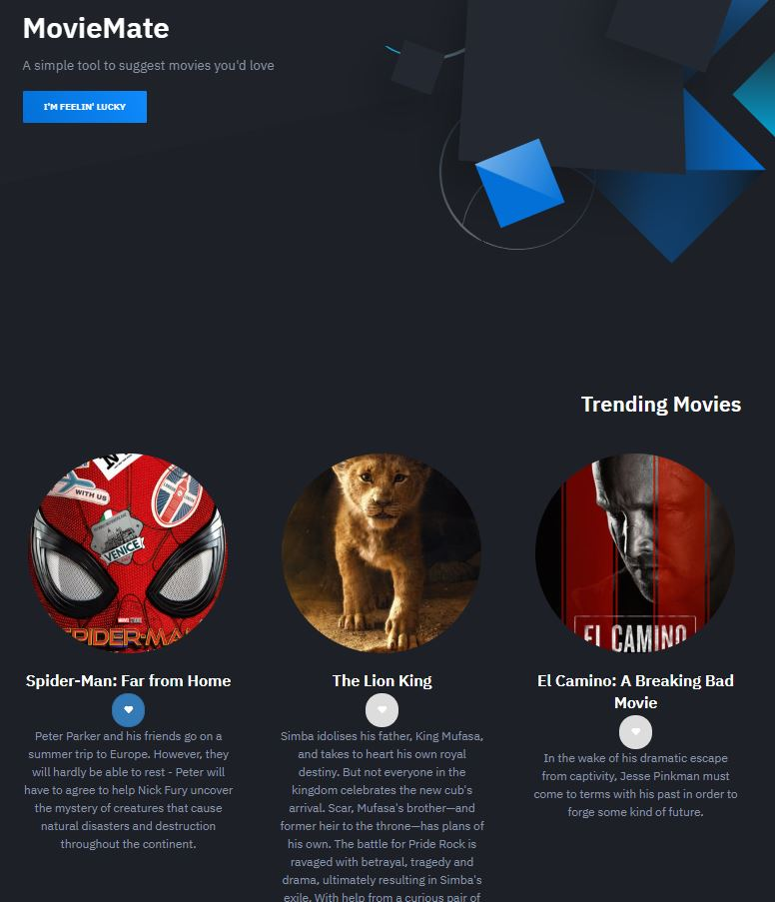

Figure : Demo AngularJS app developed for learning purpose

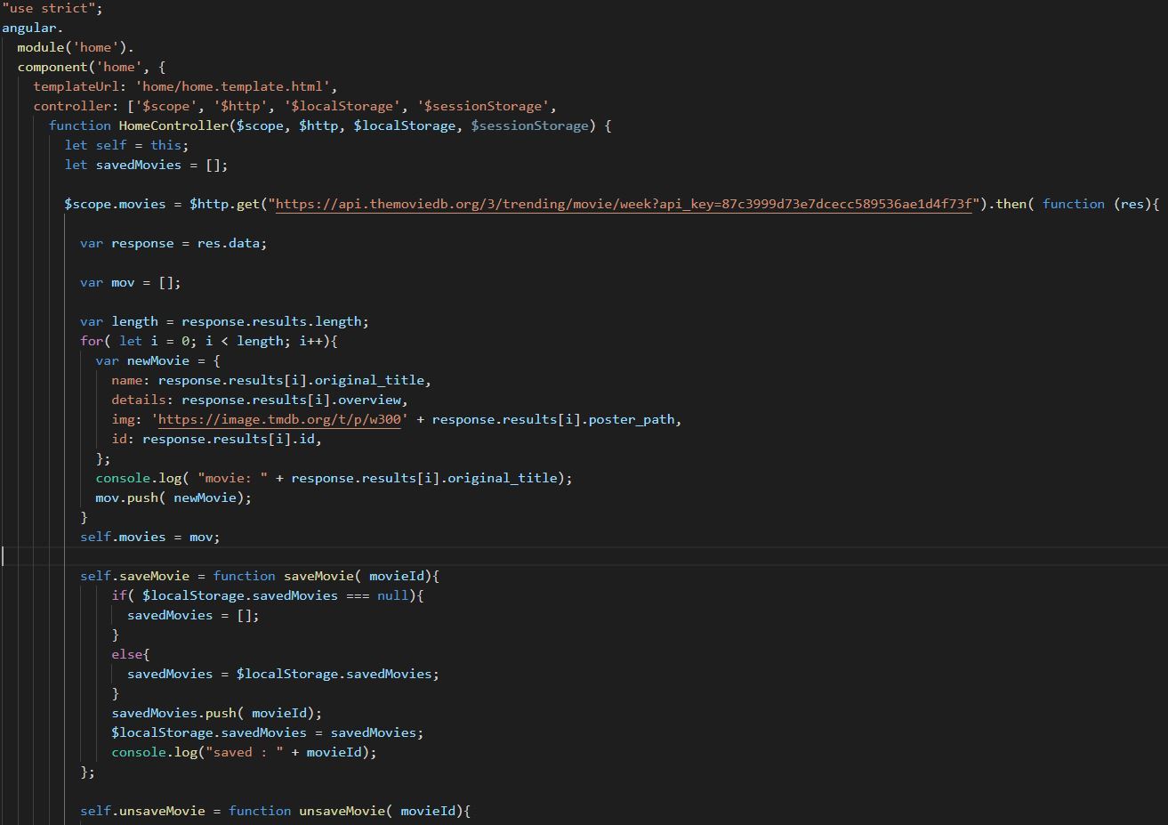

Figure : sample code for the demo moviemate application in Fig1

**Self-Checklist for Your Report**

*Please check the items here before submitting your report. This signed checklist should be the final page of your report.*

* Did you provide detailed information about the work you did?
* Is supervisor information included?
* Did you use the Report Template to prepare your report, so that it has a cover page, the 8 major sections and 13 subsections specified in the Table of Contents, and uses the required section names?
* Did you follow the style guidelines?
* Does you report look professionally written?
* Does your report include all necessary References, and proper citations to them in the body?
* Did you remove all explanations from the Report Template, which are marked with yellow color? Did you modify all text marked with green according to your case?

Signature: _______________________