Khasmamad Shabanovi

21701333

Section 3

Fall 2019 Homework 1 Due by Oct 7, 2019

CS 319 Object-Oriented Software Engineering

**Q1) Weekly Meeting Hours [2 pts]**

Wednesday 10:40 AM-12:40 PM

Sunday 10:40 AM-12:40 PM

**Q2) CASE Tool and Object Modeling [3 pts]**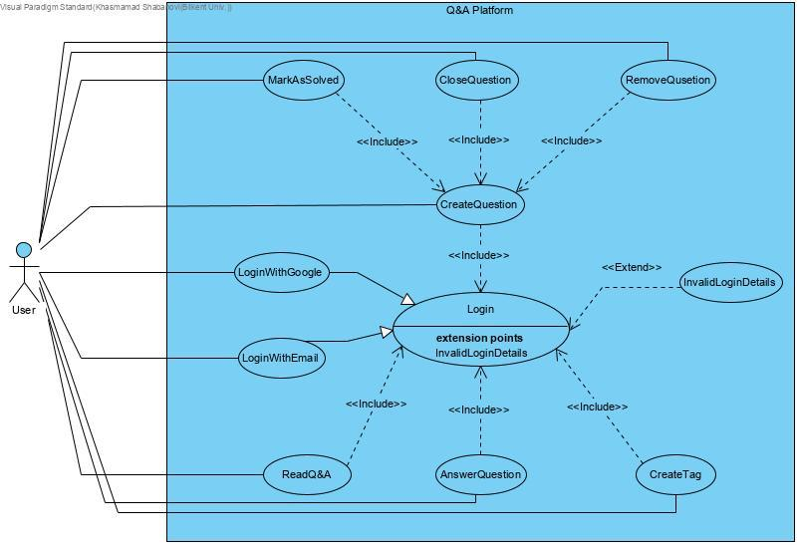

**Q3) User Interface Mockups [3 pts]**

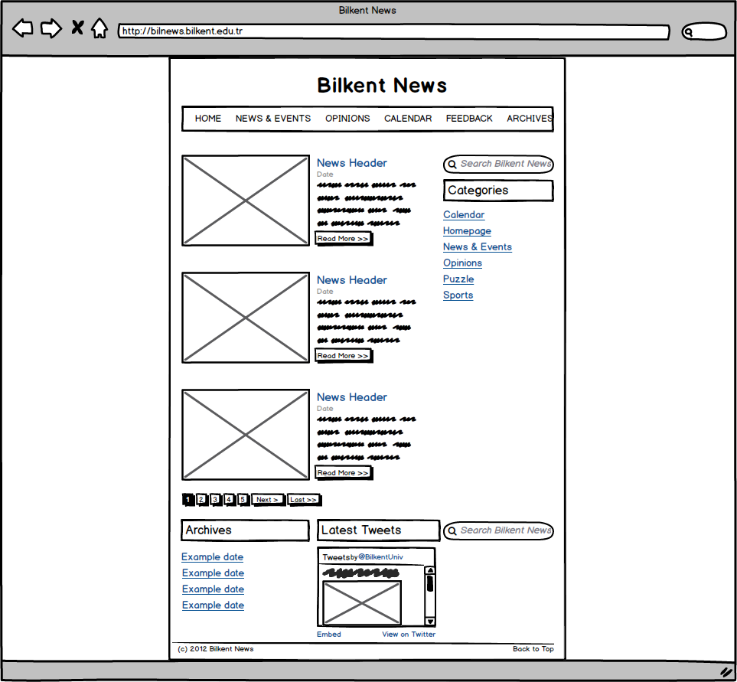

**Q4) GitHub [2 pts]**

<https://github.com/MAKman1/CS319-3H-SW>

I hereby affirm that the work submitted in this homework is my own exclusively unless asked otherwise.

**Name & Signature**: Khasmamad Shabanovi