**CS319**

**Object-Oriented Software Engineering**

**Fall 2019 Homework 1**

**Muhammad Arham Khan**

**21701848**

**Section 3**

**Q1) Weekly Meeting Hours**

* Wednesday 10:40-12:40
* Sunday 10:40-12:40

**Q2) CASE Tool and Object Modeling**

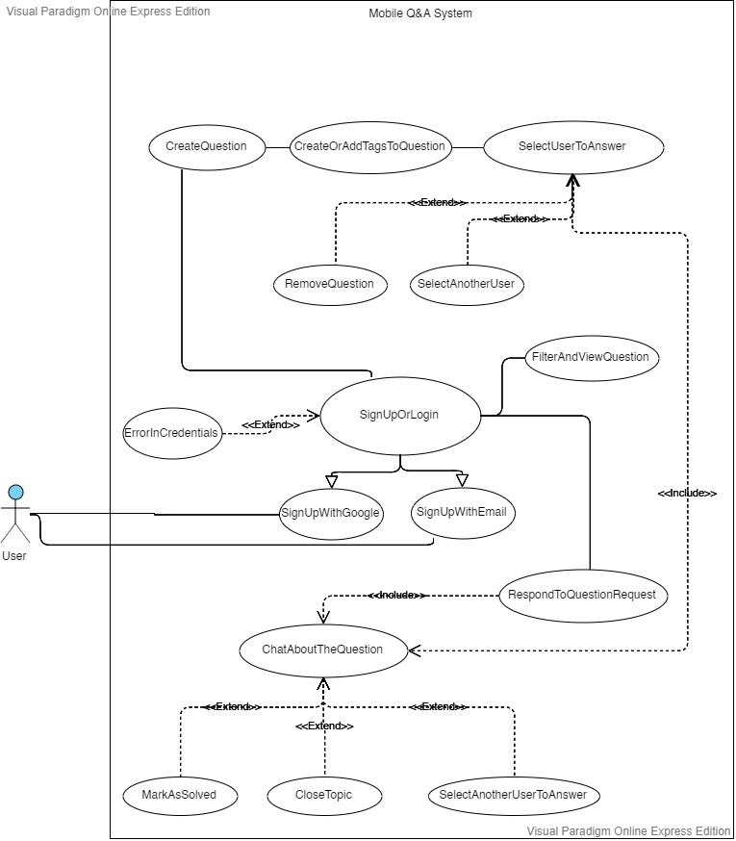

**Q3) User Interface Mockups**

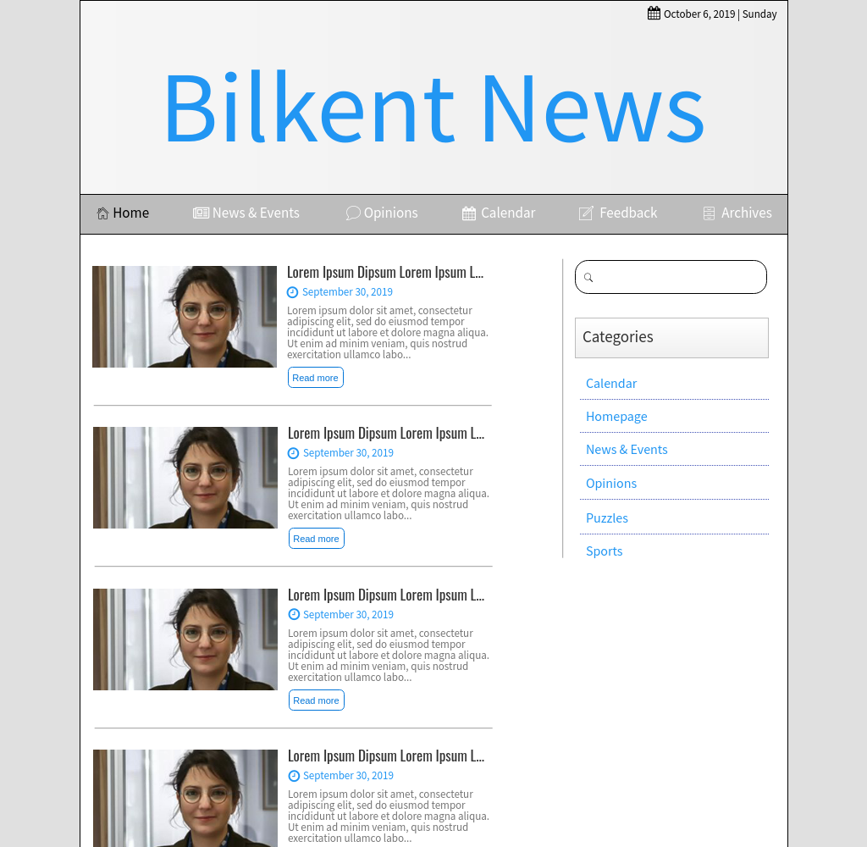

**Q4) GitHub**

<https://github.com/MAKman1/CS319-3H-SW>

I hereby affirm that the work submitted in this homework is my own exclusively unless asked otherwise.

**Name & Signature: Muhammad Arham Khan**