**CS353**

**Homework 1**

**Muhammad Arham Khan**

**21701848**

**CS353 – Section 2**

**24 Feb 2020**

**Part A: ER Diagram**

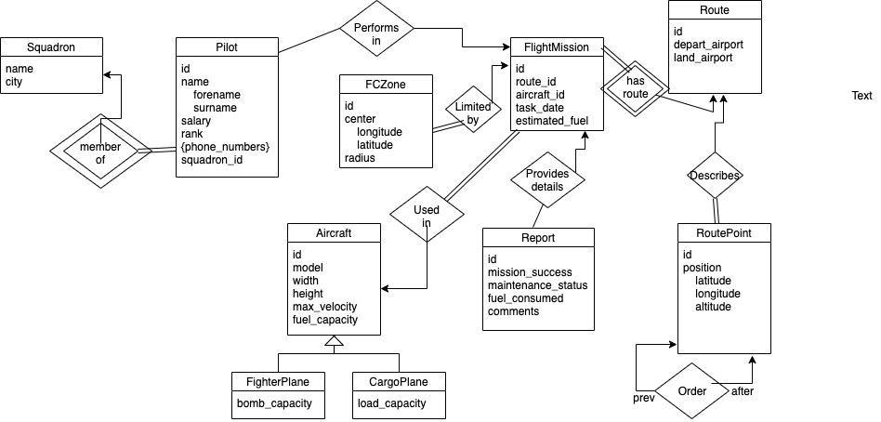

**Part B: Relational Schema**

FlightMission = (id, route_id, aircraft_id, task_date, estimated_fuel)

Foreign Key “aircraft_id” references from “id” in “Aircraft” table

Foreign Key “route_id” references from “id” in “Route” table

Report = (id, mission_id, mission_success, maintenance_status, fuel_consumed, comments)

Foreign Key “mission_id” references from “id” in “FlightMission” table

FCZone = (id, center, radius)

“center” column contains values for longitude and latitude

Aircraft = (id, model, height, width, max_velocity, fuel_capacity)

CargoPlane = (id, load_capacity)

Foreign Key “id” references from “id” in “Aircraft” table

FighterPlane = (id, bomb_capacity)

Foreign Key “id” references from “id” in “Aircraft” table

Route = (id, depart_airport, land_airport)

RoutePoint = (route_id, position)

Foreign Key “route_id” references from “id” in “Route” table

Position columns contains values for latitude, longitude and altitude

Order = (previous_id, next_id)

Foreign Key “previous _id” references from “id” in “RoutePoint” table

Foreign Key “next _id” references from “id” in “RoutePoint” table

Pilot = (id, squadron_id, name, rank, salary, phone_number)

Foreign Key “squadron _id” references from “id” in “Squadron” table

Squadron = (name, city)