**EEE391**

**Basics of Signals and Systems**

**MATLAB Assignment 1**

**Muhammad Arham Khan**

**21701848**

**3rd March, 2020**

**Part 1:**

**x1(t) = sin (2πfot).**

Frequency 440Hz:

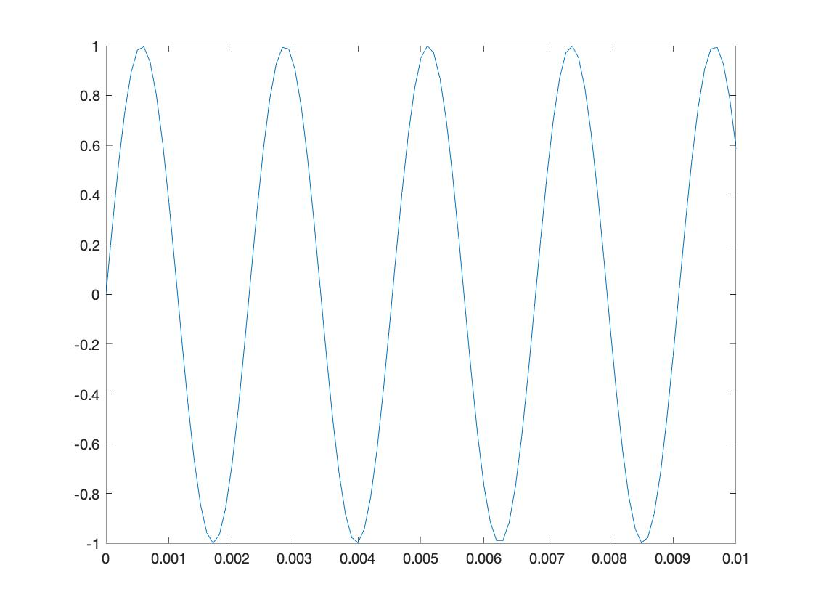

Frequency 880Hz:

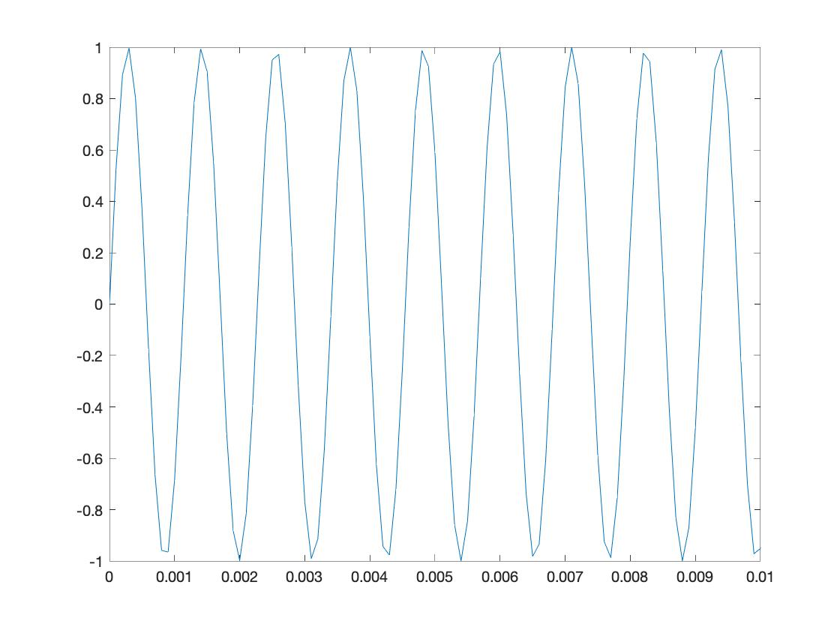

Frequency 1760Hz:

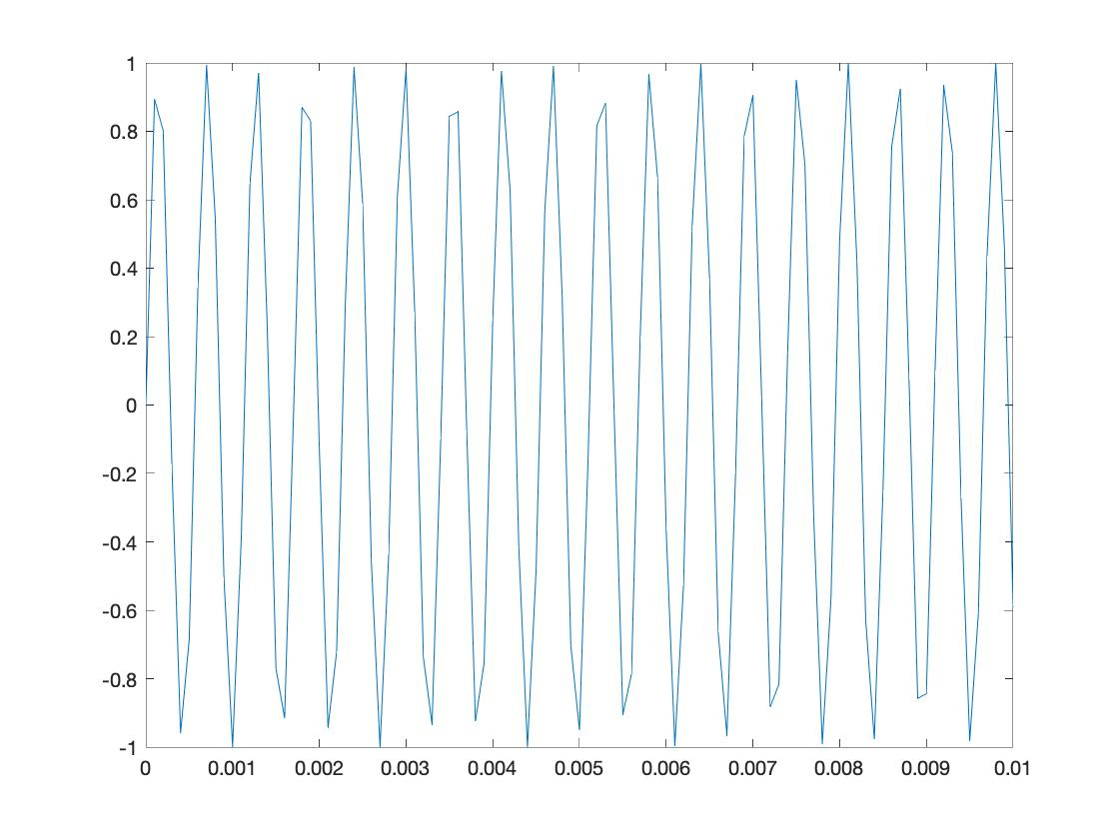

**Analysis:** As we increase the frequency of the signal (from 440Hz to 1760Hz), the pitch of the sound produced increases as well and the sound sounds sharper

**s(t) = sin(2π440 t) + sin(2π554 t) + sin(2π659 t)**

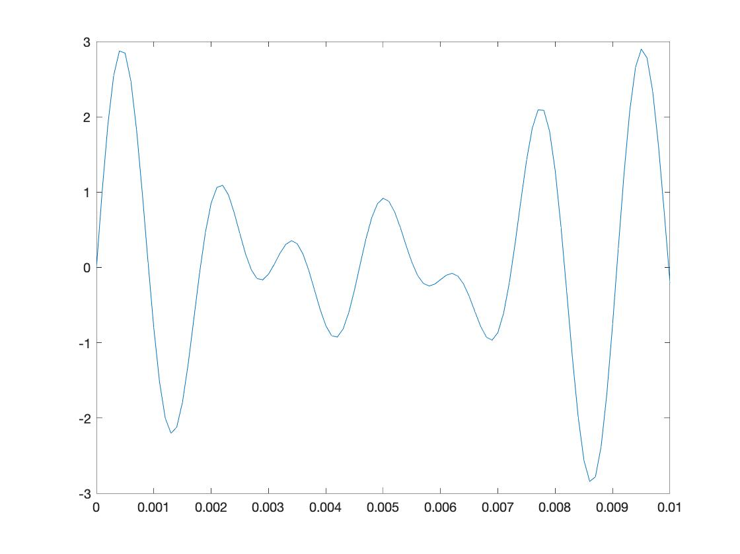

**Part 2:**