Muhammad Arham Khan

21701747

GE461

Homework 4

**Part a:**

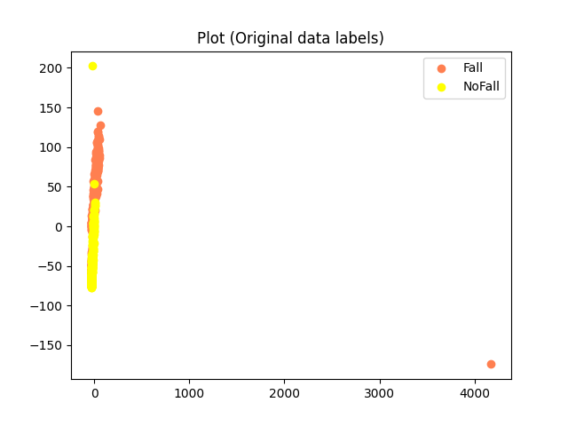

There are two outliers found in this data. One is at the end of x-axis, the other is at the end of the y-axis. Apart from these, the data shows a reasonable separability so we need to clear out these outliers for the PCA.

The first PCA explains 75.3% of the variance while the second one explains a mere 8.5%.

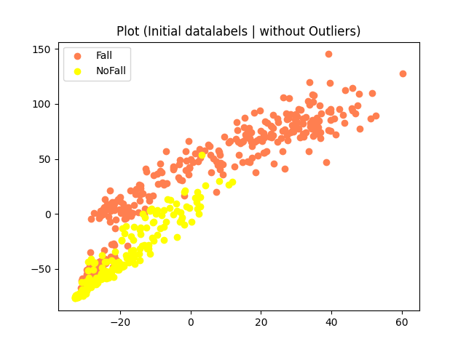

This plot shows the PCA with outliers present and it shows its unseucessful as demonstrated by the left region

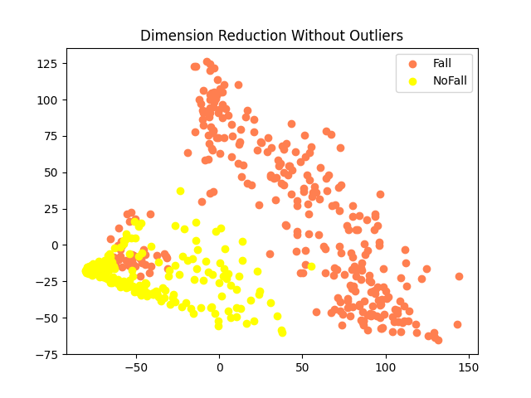

After removing the outliers rpesenting in the first image, this is the PCA outcome. This pattern presents a better outcome and represents a better idea of the unsupervised learining.

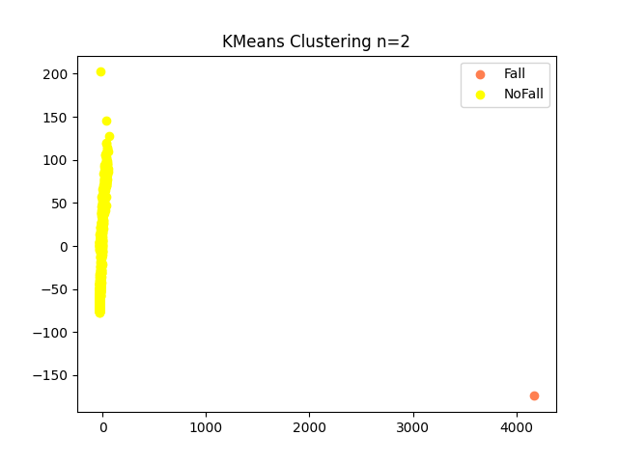

As demonstrated by the graph, the K gains are slightly unsuccessful when outliers are very different than other values. The ornage color is Fall but the results are not good as demonstrated by the graph.

