**MUHAMMAD ARHAM KHAN – 21701848 – MBG110-5 (PREASSIGNMENT 4)**

**CLONING CALICO CATS: THE OUTCOMES?**

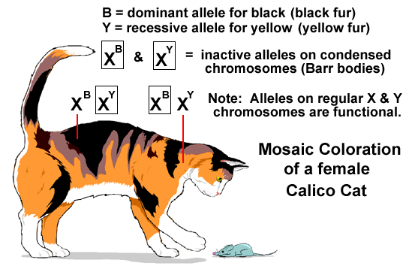During zygote fertilization, the zygote either inherits two X sex chromosomes from both parents (gametes) to be a female or one X and one Y sex chromosomes from parents to be a male (most commonly). So, why do both sexes have the same amount of genes available required for protein synthesis even though females have two X sex chromosomes with a higher number of gene alleles as compared to males with just one X sex chromosomes?

This happens because of a phenomenon called “X inactivation” in which one of the X chromosomes in a female somatic cell are compacted (nearly inactivated) in the Barr body. Now, since this X inactivation occurs early in the embryonic development entirely randomly, one X gene is turned off during embryonic development. Now, once an X chromosome has been turned off, all other replicated cells from this cell will have the same copy turned off and will be exactly identical to the original cell due to a process called epigenetic inheritance. But, there is a random chance for the original embryonic cell to have either of the two X sex chromosomes inactivated. So, speaking statistically, half of the somatic cells will have one X inactivated while other half will have other turned off.

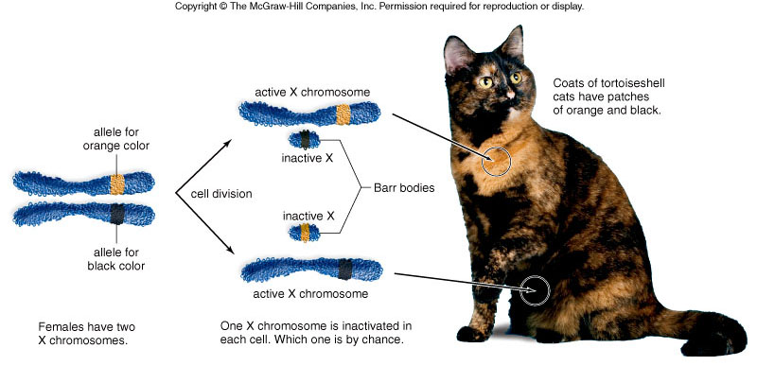So, if a female is heterozygous for X sex chromosomes, half of its cell will display one characteristic inherited from the father gamete while other half will display other characteristic inherited from mother. Now, in calico cats, there are two different alleles available for fur coloration: one black and one orange. Now, since these genes are found on the X chromosome, so, a heterozygous female calico cat has some somatic cells with orange fur color while others will have a black fur color allele due to random X-inactivation in females. So, these female calico cats will have patches of orange and black fur on them, forming a tortoise shell phenotype. So, if we try to replicate a calico cat, we will end up with cloned cats having different fur colorations (different phenotypes). This will happen because some male cats might inherit the orange color allele from mother (and some heterozygous females from both parents) and be orange completely, while some might inherit black or white and be that color. On the other hand, females, due to X inactivation, might have varying colors ranging from orange and black spotted, orange/black/white spotted and so on. So, to conclude, owing to a process called X-inactivation, calico cat cloning will output cats with very different and varying fur colorations.

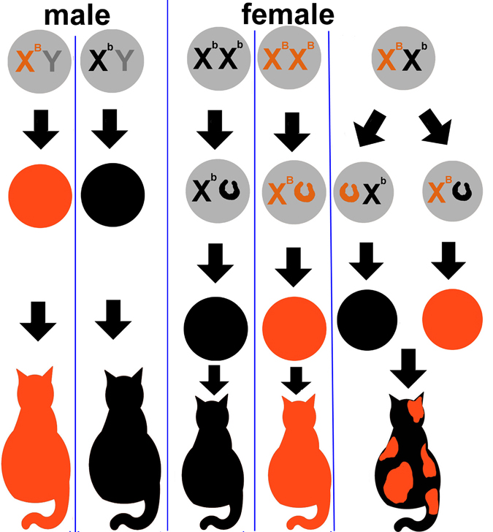

Figure :a few of the possible outcomes of the cloning

**SOURCES:**

* **Cambell biology 8th edition, page 251.**
* [**https://www.nottingham.ac.uk/biosciences/documents/burn/2011/why-are-cloned-cats-not-identical--emma-stubbs.pdf**](https://www.nottingham.ac.uk/biosciences/documents/burn/2011/why-are-cloned-cats-not-identical--emma-stubbs.pdf)
* [**https://i.pinimg.com/originals/4c/4f/c5/4c4fc573983d4b6df5b690daca697664.jpg**](https://i.pinimg.com/originals/4c/4f/c5/4c4fc573983d4b6df5b690daca697664.jpg)
* [**http://www.bio.miami.edu/dana/pix/calico_overview.jpg**](http://www.bio.miami.edu/dana/pix/calico_overview.jpg)
* [**http://www2.palomar.edu/users/warmstrong/images/calico.gif**](http://www2.palomar.edu/users/warmstrong/images/calico.gif)