

**BILKENT UNIVERSITY**

**PHYS101 GENERAL PHYSICS I**

**SECTION 9**

**PROJECT REPORT**

**Group 3**

**Muhammad Arham Khan - 21701848**

**Selimcan Gulsever - 21601033**

**Yigit Gorgulu - 21702323**

**“ONE MASS MOVEMENT BETWEEN TWO SPRINGS”**

1. **OBJECTIVE**

The objective of this experiment is to prove the principle of conservation of energy and to analyze the different types of kinematics during the motion of single mass attached to two springs on either sides and then put to oscillation.

1. **THEORY**

The principle of conservation of energy states the total energy of a system remains constant and although it may change form over time, the total sum remains constant. Hence, energy can neither be created and nor be destroyed. So, considering this principle, in such a setup of one mass being attached to two springs, an initial force to move the mass and compress one spring while decompressing the other spring will cause the accumulation of elastic potential energy in both springs. The sum of this energy will be the total energy in system (considering friction to be negligible) and hence, when the mass is set free, it will convert the elastic potential energy to kinetic energy and move towards the rest position and then due to inertia, would end up reversing its orientation.

This way, the object ends up oscillating between the two springs. At the end of oscillation, it has maximum elastic potential energy and zero kinetic energy and at the mean (center) position, it has maximum kinetic energy and zero elastic potential energy. So, owing to this conversion of energy, the object is set into oscillatory motion which can be analyzed.

1. **PROCEDURE**

Our aim is to prove energy conservation in this experiment, to do this we need two springs with different or equal spring constants and also a mass that we can connect from both sides to the springs. Mass will be attached to these springs by left and right sides when at the same time, the springs will be attached to stationary wall in a horizontal plane.

We will utilize the following setup to calculate the spring’s elastic constant *k:*

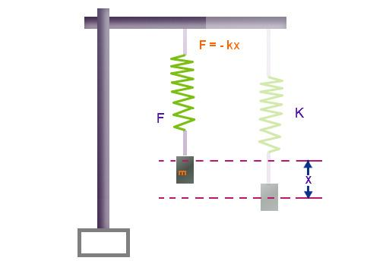

During the experiment, we will use a mass M and put it on an air table to avoid friction. Then we will connect two springs to its sides and set it to oscillation and then record it’s motion.

After we set the experiment, the equation of motion can be calculated as one of the spring is lengthening by a distance x; and other one is compressed with a distance x. We realize that this system is a representation of a simple harmonic oscillator, so we get;

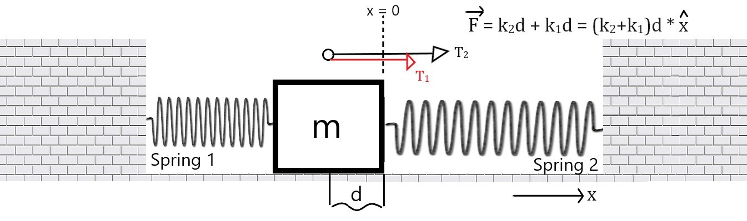

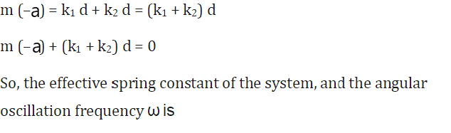

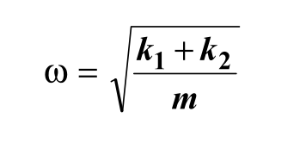

The longer equations to find the value of ω is shown below:

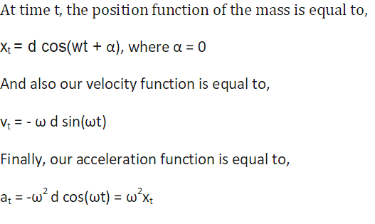

During the experiment, we will try to calculate energy conversion of the mass between the springs with respect to these position, velocity and acceleration equations.

1. **DATA AND RESULTS**

First, we calculate the spring constant k1 and k2 of spring 1 and spring 2 respectively; using the equation F = kΔx

So, using the formula, the spring constant **k = mg/Δx**

Spring 1:

|  |  |  |
| --- | --- | --- |
| **Mass hanged (kg)** | **Extension Δx (m) x10-2** | **Spring constant k1** |
| 0.1 | 9.2 | 0.12 |
| 0.2 | 20.1 | 0.09 |

Spring 2:

|  |  |  |
| --- | --- | --- |
| **Mass hanged (kg)** | **Extension Δx (m) x10-2** | **Spring constant k2** |
| 0.1 | 4.9 | 0.20 |
| 0.2 | 10.2 | 0.19 |

And hence, average values of spring constant are:

**k1 = 0.11**

**k2 = 0.20**

Next, we calculate the practical values of the angular frequency of the mass oscillating in simple harmonic motion due to the presence of the two springs. We utilize three different tables and record values with following experiments

1. Spring 1 attached on both sides of mass
2. Spring 2 attached on both sides of mass
3. Spring 1 attached to one side while Spring 2 attached to other.

And mass of the object (m) will be kept constant and friction negligible with air table.

**m = 0.426 kg**

Considering the equation for mass’ position in motion:

Xt = dcos(⍵t + ɑ)

Where d is the amplitude of motion while ɑ = 0 due to no initial shift displacement, we get

**⍵ = cos-1(xt / d) / t**

Table1: Spring 1 on both sides

|  |  |  |  |
| --- | --- | --- | --- |
| **xt (m) x10-2** | **t (s)** | **Δt (s)** | **⍵ (rads-1)** |
| 6.5 | 0 | 0 | 0 |
| -6.3 | 0.51 | 0.51 | 0.48 |
| 6.0 | 0.92 | 0.41 | 0.43 |
| -5.8 | 1.32 | 0.40 | 0.36 |
| 5.4 | 1.75 | 0.43 | 0.34 |
| -4.9 | 2.29 | 0.54 | 0.32 |
| 4.5 | 2.80 | 0.51 | 0.29 |

Table2: Spring 2 on both sides

|  |  |  |  |
| --- | --- | --- | --- |
| **xt (m) x10-2** | **t (s)** | **Δt (s)** | **⍵ (rads-1)** |
| 4.5 | 0 | 0 | 0 |
| -4.2 | 0.30 | 0.30 | 1.22 |
| 4.1 | 0.52 | 0.22 | 0.86 |
| -3.9 | 0.85 | 0.33 | 0.69 |
| 3.6 | 1.18 | 0.32 | 0.61 |
| -3.5 | 1.45 | 0.27 | 0.48 |
| 3.7 | 1.81 | 0.36 | 0.39 |

Table3: Spring 1 on one side and spring 2 on other side

|  |  |  |  |
| --- | --- | --- | --- |
| **xt (m) x10-2** | **t (s)** | **Δt (s)** | **⍵ (rads-1)** |
| 6.9 | 0 | 0 | 0 |
| -6.6 | 0.21 | 0.21 | 1.40 |
| 5.1 | 0.39 | 0.18 | 1.37 |
| -4.7 | 0.62 | 0.23 | 1.32 |
| 4.4 | 0.81 | 0.19 | 1.08 |
| -3.9 | 1.02 | 0.21 | 0.96 |
| 4.1 | 1.25 | 0.20 | 0.75 |

Plotting the values obtained from the three experiments using position (x) against time t for all three experiments,

Plot 1:

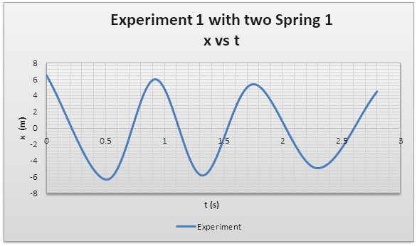

Plot 2:

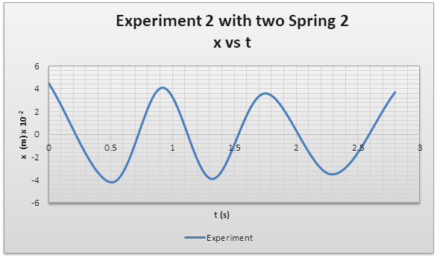

Plot 3:

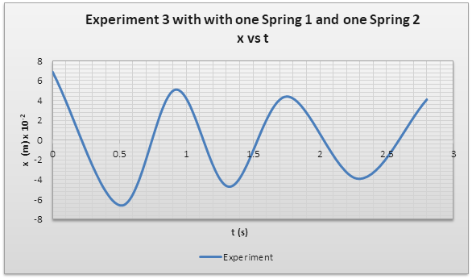

Now, we calculate the average angular frequency(**⍵avg**) of the simple harmonic motion from the data obtained for each of the three experimental setups.

**Experimental angular frequencies(⍵):**

**Experiment 1: ⍵1 = 0.37**

**Experiment 2: ⍵2 = 0.71**

**Experiment 3: ⍵3 = 1.13**

Plotting ⍵ against time t to show the constant nature of ⍵ during the experiment.

Plot 1:

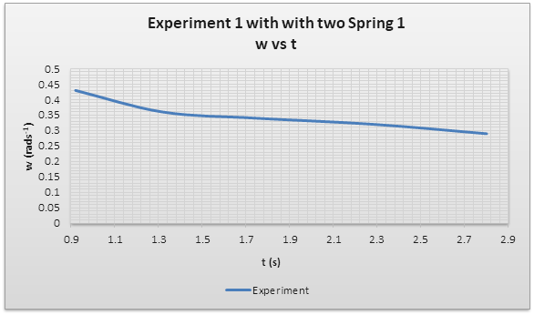

Plot 2:

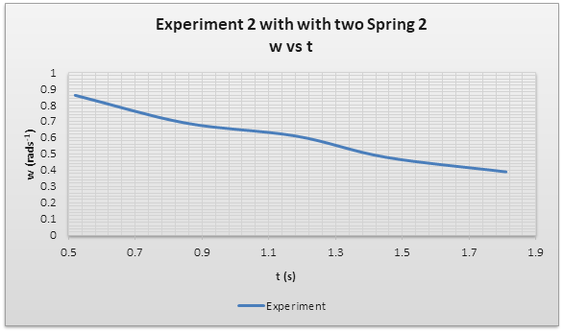

Plot 3:

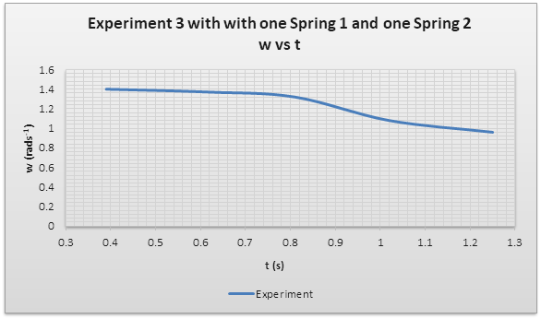

And now, using the formula for angular frequency(⍵), we calculate the theoretical values for the ⍵.



**So, theoretically,**

**Experiment 1: ⍵1 = 0.51**

**Experiment 2: ⍵2 = 0.92**

**Experiment 3: ⍵3 = 0.85**

Now, we calculate the error percentage in the practical values obtained.

**% error = ( |⍵obtained - ⍵theoritical| / ⍵theoritical) x 100**

**% error in ⍵1 = 37.8%**

**% error in ⍵2 = 26.2%**

**% error in ⍵3 = 34.1%**

**5. CONCLUSIONS**

Conclusively, this experiment proved that energy is conserved during the “one mass two spring” experiment as the mass observes simple harmonic motion as shown by plots 1, 2 and 3. Similarly, this also demonstrates that when friction is considered negligible, the energy is conserved and it converts from elastic potential energy in one spring to kinetic energy of mass and back, in a cycle.

As is evident from the “displacement - time” graphs for the three experiments, the mass observes simple harmonic motion and oscillates.

Similarly, as the “angular frequency - time” graphs for the three experiments show, the angular frequency of an oscillating mass remains constant during its simple harmonic motions as the total energy is conserved.

The experiment also demonstrated that since energy is conserved, the Time Period of oscillations is constant and hence, the value of angular frequency (⍵) is constant as well throughout the motion of mass.

But, as the data and plots reveal, there is a decrease in the values of ⍵ and the “displacement-time” graphs also follow a negatively decreasing trend whereas they should theoretically remain constant. This happens because of uncontrollable factors in the real world environment like friction.

There seemed to be errors in the practical values obtained of ⍵ as they differed slightly with the theoretical values we calculated. This might have been caused due to friction on the table or the effect of air resistance causing loss of energy. Also the first applied force by a human (in this experiment, the observer) might cause an error at the beginning of the experiment, so we should not collect data from a reasonable time amount at the beginning. And the spring’s length might not be perfectly equal or there might be inconsistencies between the spring’s constants. Furthermore, the possibility of human reaction time errors in timing might have caused additional error in the values recorded and deviated the ⍵’s value.

**6. REFERENCES**

*8.01x - Module 15.03 - Two Springs with an Object (m) between Them*. 2015, <https://www.youtube.com/watch?v=SGjzWPS7rOo>[.](http://paperpile.com/b/F0Bybn/9Et5)

Physics Work Manual. Princeton University Press. <http://www.physics.princeton.edu/~mcdonald/examples/ph101_1996/ph101lab6_96.pdf>[. Accessed 9 Dec. 2018.](http://paperpile.com/b/F0Bybn/WBpc)

[Weisstein, Eric W. “Springs--Two Springs and a Mass -- from Eric Weisstein’s World of Physics.” *Wolfram Research, Inc.*,](http://paperpile.com/b/F0Bybn/4gX7) <http://scienceworld.wolfram.com/physics/SpringsTwoSpringsandaMass.html>[. Accessed 9 Dec. 2018.](http://paperpile.com/b/F0Bybn/4gX7)

[*Website*.](http://paperpile.com/b/F0Bybn/L2Et) <https://ux1.eiu.edu/~cfadd/1350/Hmwk/Ch13/Ch13.html>[. Accessed 9 Dec. 2018.](http://paperpile.com/b/F0Bybn/L2Et)