Muhammad Arham Khan – 21701848 – MBG110(5)

Sickle cell disease carrying allele is much more common in African-Americans. Why?

INTRODUCTION:

This disease is recessive homozygous disease (first recorded 7,800 years ago in Sahara region): both similar genes are needed for the disease to emerge. This is what differentiates between sickle cell disease and trait; people with trait might not even know it exists and will continue living a healthy life while passing on the trait to their offsprings. On the other hand, people with the disease develop sickle cell anemia and eventually die before maturing. People having the sickle cell trait have the heterozygous gene: Normal RBCs are dominant. Where as the people with sickle cell disease have both sickle cell alleles.

A baby has a 50% chance of having sickle cell disease if both his parents have the defect in their gene. Similarly, If only one of the parents has the sickle cell trait, there’s a 25% chance of the baby will have this trait.

People with sickle-cell disease have a weird-shaped hemoglobin molecules (S- shaped). These molecules attach to one another, forming stick-like structures. These structures cause stiffening of RBCs (red blood cells) resulting in a sickle-shaped RBCs. Such abnormal shaped RBCs result in clogs, and cause damage to vital organs.

These sickle cells are immediately destroyed by the body, which results in anemia and eventually, death. Now if people with sickle cell disease don’t live long enough to reproduce, how is is that this trait keeps passing on to generations in African-Americans?

WHY IS IT COMMON IN AFRICAN AMERICANS?:

Malaria typically requires a normal RBC as its host and is unable to affect abnormal RBCs with sickle cell traits. This occurs mainly because the body gets rid of sickled RBCs before the meroziotes of malaria cell can affect the body. Due to this, people with the sickle shaped RBCs have a better chance at preventing malaria disease than normal people. According to studies caries out in 1946, 15.3% people with normal RBCs had malaria while, only 9.3% of the people with sickle cell trait had malaria. Further tests proved that presence of sickle cell trait actually does act as a shield against malaria.

Therefore, in regions with abundant cases of malaria (ie: Africa, Middle East, Caribbean), sickle cell trait, acts as a cure for malaria. As a result of intra-tribe marriages during middle ages, this sickle cell trait became much more common in African-American children. Now, since the children with sickle cell disease died early, only the people with this trait survived to pass on the trait and not the disease (around 20% African Americans have sickle cell traits but only 2% have the disease). Thus, over time, natural selection has removed the people with sickle cell diseases predominantly. This resulted in African-American children having sickle cell traits much more commonly and not the sickle cell disease.

Since condominance exists in a few genes , this causes some genes in sickle cells to be partly dominant and partly active and also cause the simultaneous existence of normal blood cells (Hba) and sickle shaped RBCs(Hbs).

Now since the people with sickle cell trait (sickle cell RBCs) tend to battle malaria (a deadly disease) better, people with sickle cell traits tend to have a survival advantage in regions with malaria saturation. This results in people with sickle trait surviving longer and over the course of time, being in the majority as compared to people with normal RBCs. Thus, the dominance of malaria has kept the frequency of sickle-cell-allele more in the African-American people.

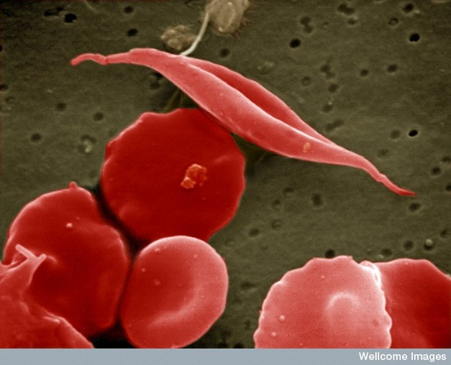
Illustration 1: Sickle-shaped cell
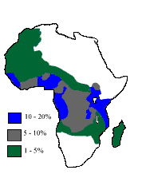
Illustration 2: The distribution of sickle-cell traits existence is high in African regions
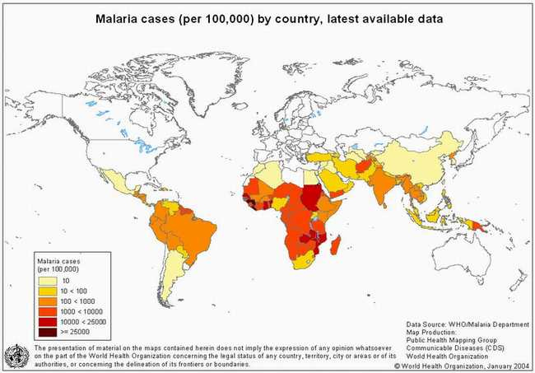
Illustration 3: Malaria cases are also high in African regions too.

REFERENCES:
1) http://www.nslc.wustl.edu/sicklecell/part3/biogeography.html
2) https://www.ncbi.nlm.nih.gov/pmc/articles/PMC3116635/

