THE HERSHEY-CHASE BLENDER EXPERIMENT
A LOOK INSIDE!

MUHAMMAD ARHAM KHAN (21701848)

In 1928, A British medical officer named Frederick Griffith, who was studying strains of bacterium realized that a non-pathogenic strain of bacteria inherited pathogenic capabilities from dead pathogenic bacteria when mixed with it. This led to a conclusion that there was some component in the bacterium that caused the inherited capabilities.

Following this finding, in 1952, Alfred Hershey and Martha Chase performed the famous Hershey-Chase blender experiment that clarified that DNA was the genetic component and not the proteins (although the previous belief was entirely opposite due to the apparent complexity of proteins).

In the experiment, they took samples of T2, a bacteriophage that affects the bacterium Escherichia coli in the intestines of mammals. Now, since the knew that T2 comprised solely of two components (a protein and a DNA) and was able to reprogram the E.coli to produce new phages, it was a clear experiment to illustrate if protein was the genetic component or the DNA (because only these two existed in T2 and whichever would get passed on to the host would be the genetic component. This ideology is a perfect illustration of devising a clear and evident experiment that rules out the chances of doubt and for this very reason, T2 was chosen.

Now, the real question was, how to identify which component is being inherited (passed-on)? To counter this issue, Hershey and Chase took aid of radioactive elements Sulfur (35S) and Phosphorus (32P). Now, since proteins contain sulfur, one sample of T2 and E.coli culture was put in a radioactive sulfur solution, which resulted in sulfur being incorporated in a few bacteriophages.

On the other hand, another sample of T2 and E. coli culture was put into a sample of radioactive phosphorus solution. Now, since the DNA of the phages contains phosphorus only, the radioactive phosphorus was incorporated into the DNA of the phages.

This was done to label the two components separately and then know which one was found in the bacterial cells and identify which component was genetic. For separation purposes, the samples were spun in a centrifuge, which caused the solid pellet-shaped cells to get separated from the excess phages as a liquid.

Now, the separated samples were tested for radioactivity. They found that the one with radioactive phosphorus in the DNA had a higher radioactivity count in the cells (pellets) while the one with radioactive sulphur in the proteins had a higher radioactivity count in the empty phage shells in the liquid.

This clearly illustrated that the DNA was the genetic component that was being passed on to the bacterium.

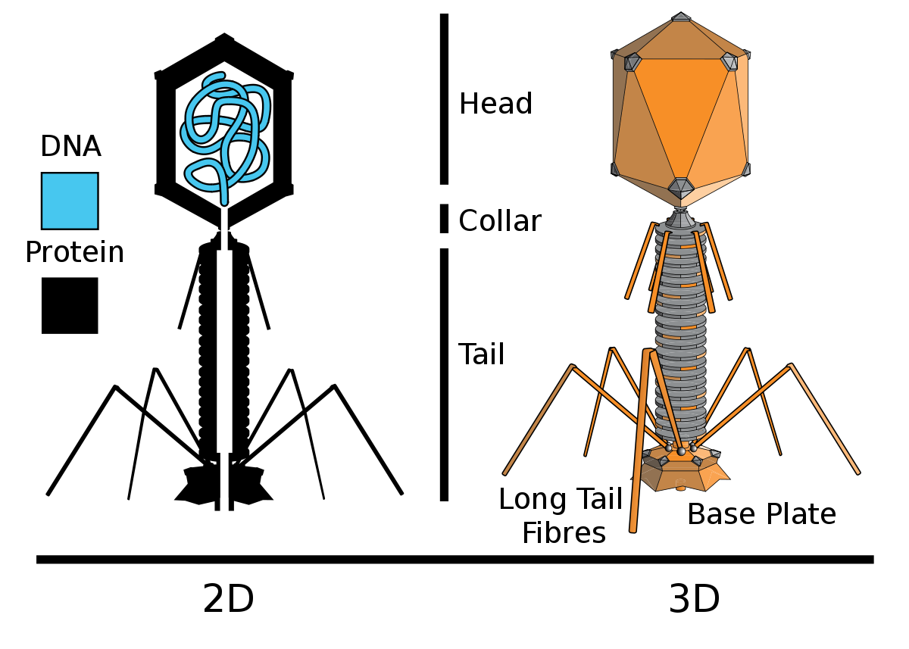
Illustration 2: The structure of T2 (showing the sole two components)
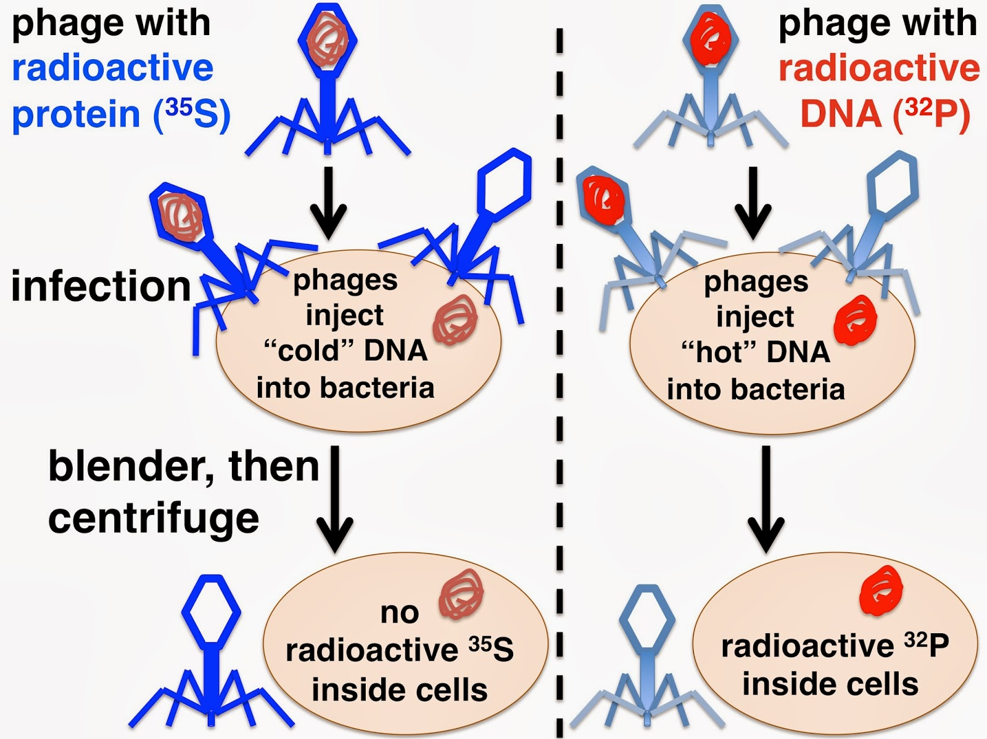
Illustration 1: The process of the experiment

SOURCES:
1) CAMPBELL BIOLOGY (concepts and connections | 8th edition)
2)http://3.bp.blogspot.com/-mC2CML7CEQE/Um1FMPQ5ZQI/AAAAAAAAAoQ/Zsw3t3dOeTc/s1600/Hershey+Chase+expt.jpg

3) https://paulingblog.wordpress.com/2009/08/18/the-hershey-chase-blender-experiments/

