# Introduction

In 1983, Polar Electro launched the world's first heart rate monitor based on a simple concept of having a chest strap as a sensor and a wristwatch as a heart rate display, memory and user interface [1].

In those days, the key question was if the heart rate measurement with the chest strap and a small sensor attached to it is as accurate as measurement with a hospital grade ECG monitor. Scientific studies showed that this was the case [2], and nowadays it is taken for granted that as a technical solution a chest strap is a reliable method for heart rate measurement.

The H10 sensor presents the 5th generation of Polar Heart Rate (HR) technology and offers measurement performance [3] that allows us to open the ECG signal from the sensor to be openly used by 3rd party users via Polar SDK.

# Technology Background

The Electrocardiogram (ECG) measures the electrical activity of the heart. Each heart beat is associated with corresponding signal phase and characteristics on the ECG. For heart rate measurement, the most important signal phase is the QRS complex that represents the contraction of the ventricles (Fig 1).

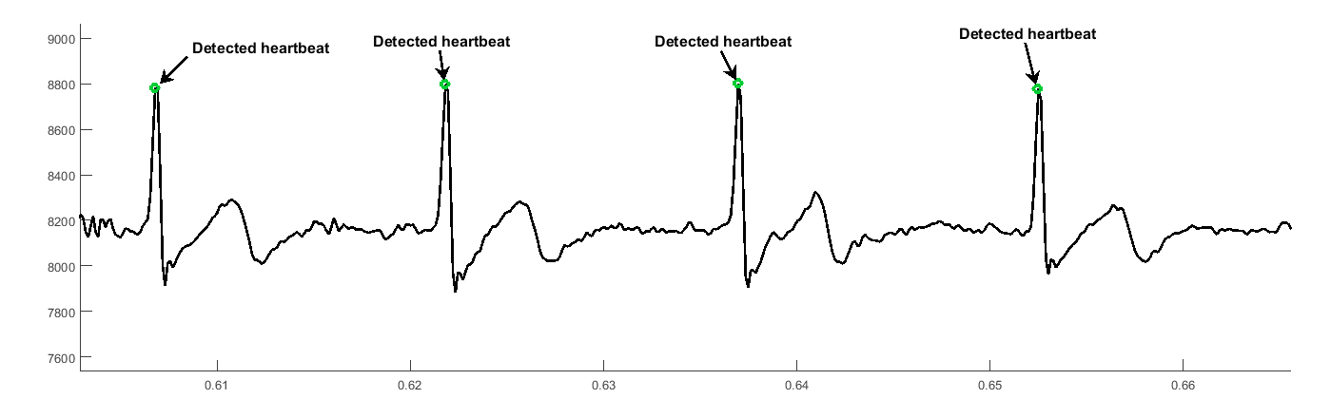

*Figure 1. Example of good quality ECG measured with H10 sensor and Polar ProStrap.*

In theory, measuring the heart rate accurately is straightforward as it only needs accurate detection of the change in the electrical polarity of the heart. However, doing this correctly and consistently during sport activities is very demanding. Polar ProStrap (Fig 2.) is especially designed for sport use and contain novel technical solutions to overcome poor signal conditions.

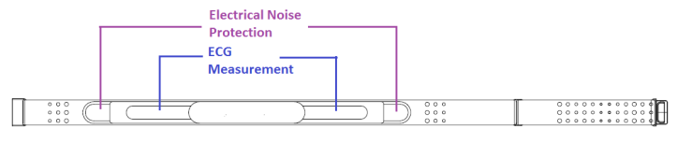

*Figure 2. Polar ProStrap with integrated dry electrodes.*

[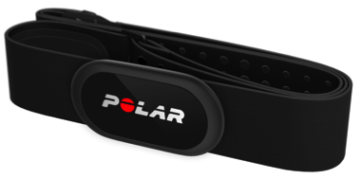](https://www.google.fi/url?sa=i&rct=j&q=&esrc=s&source=images&cd=&cad=rja&uact=8&ved=0ahUKEwitlp6ZlKfWAhUqAZoKHZQSDe0QjRwIBw&url=https://www.polar.com/blog/whats-new-polar-h10-gopro-connectivity/&psig=AFQjCNH_Ex4--eV5mPzYxyjSMsaFN2Epcw&ust=1505563743791799)

*Figure 3. Polar H10 with Pro Strap.*

# H10 Technical Specification

ECG recording = single-lead

Input impedance = 2 MΩ (with moistened ProStrap)

Bandwidth = 0.7 - 40 Hz (with moistened ProStrap)

Dynamic input range = +- 20 000 µV

Sample rate = 130 Hz ± 2 % (Tamb = +20 … +40 °C)

130 Hz ± 5 % (Tamb = -20 … +70 °C)

Accurate timestamps of samples available

# Patents

US6600942B2, US8489021B2,   
US20160000336A1 (Pending)

# References

1. R. Laukkanen, P.Virtanen, “Heart rate monitors: State of the art”, J. Sport Sciences, vol. 16, Special Issue, pp.3-7, Summer 1998.
2. M. Kingsley, M. Lewis and R. Marson, "Comparison of Polar 810s and an ambulatory ECG system," International Journal of Sports Medicine, vol. 26, pp. 39-43, 2005.
3. Gilgen-Amman R. et al. RR interval signal quality of a heart rate monitor and an ECG Holter at rest and during exercise. Submitted to Eur Journal of Applied Physiology, December 2018