**LAB #2 : floorplanning**

1. Runs with folder created 17th July
2. 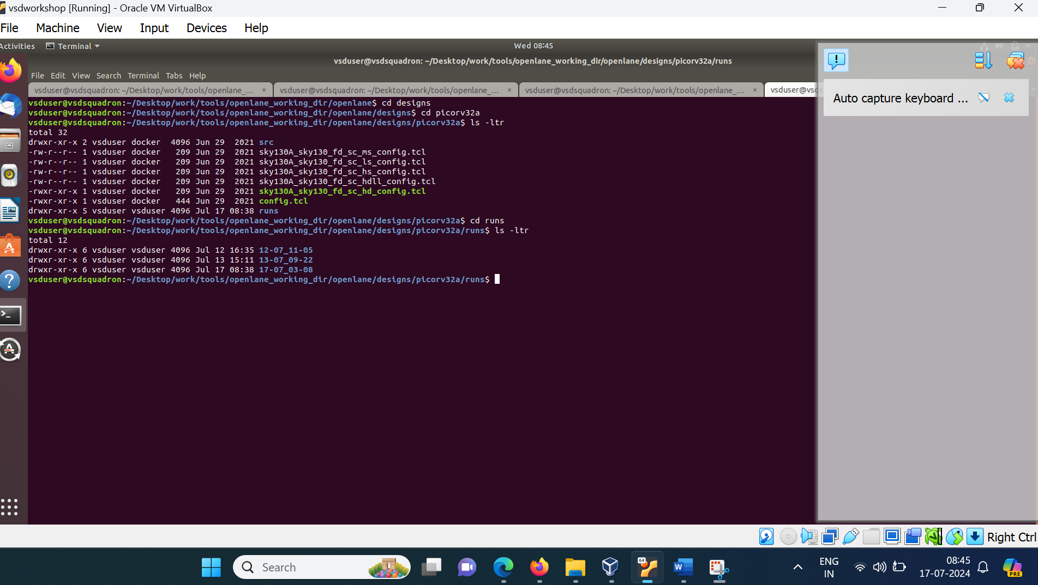

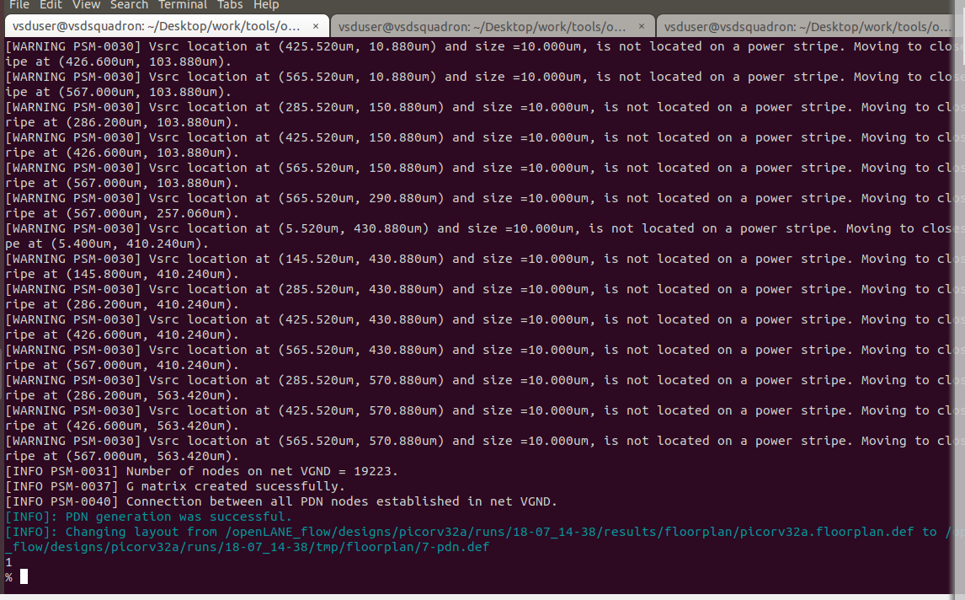

1. Merged lef files

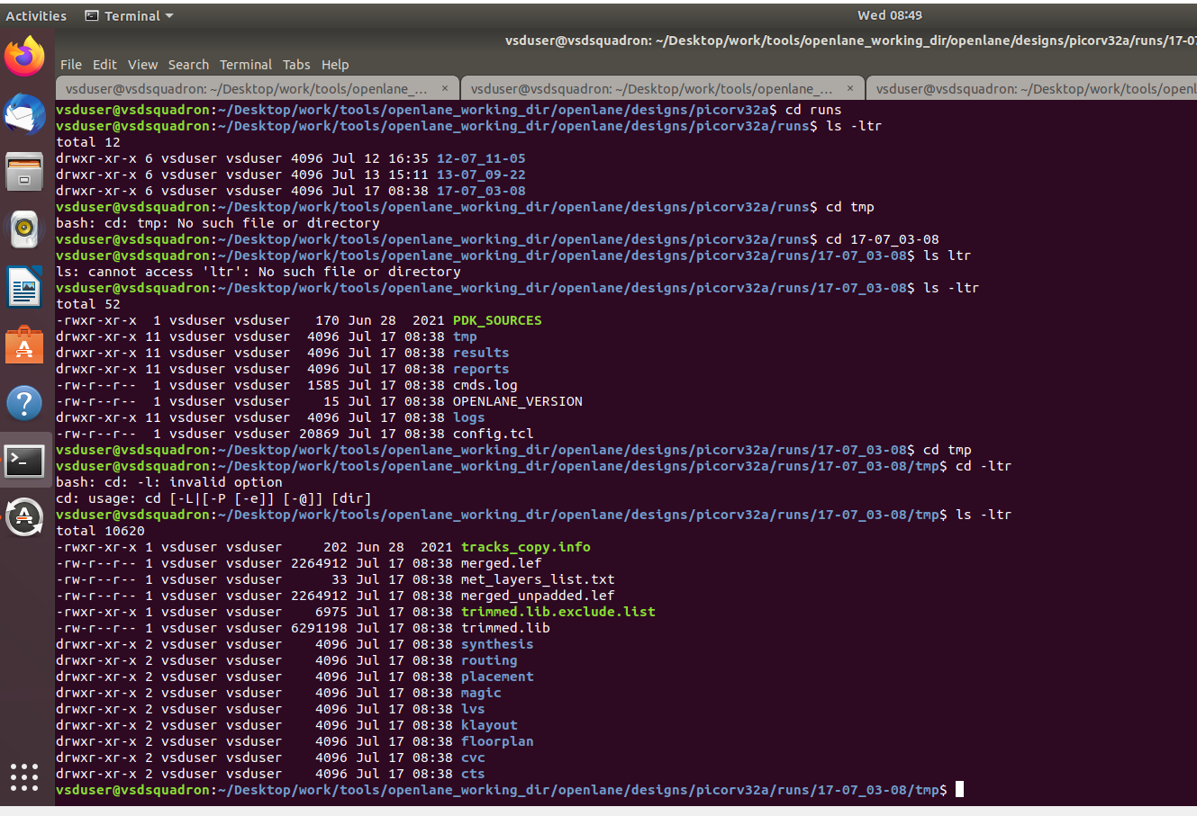

1. Number of metal layers found in the floorplan.tcl is
2. 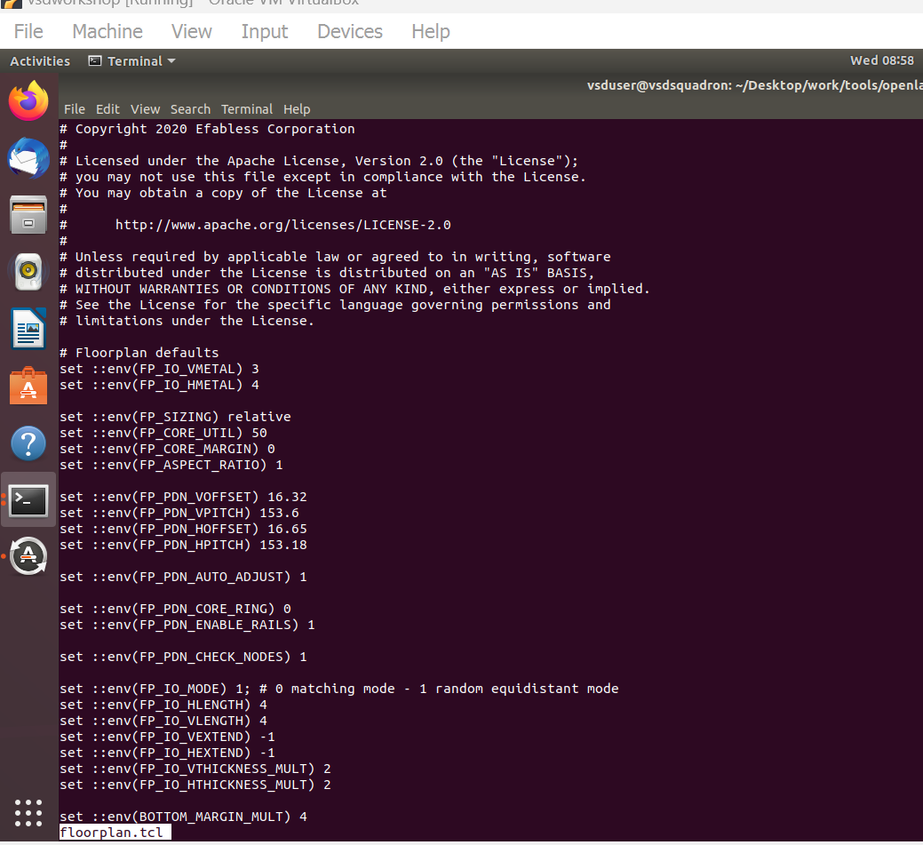

VMETAL=3+1

HMETAL=4+1

1. With these settings run floorplan on 18th July

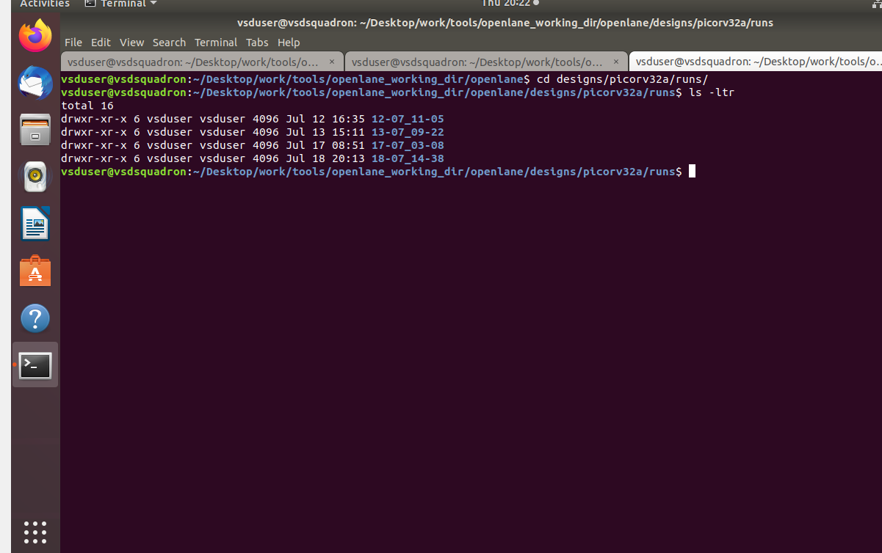

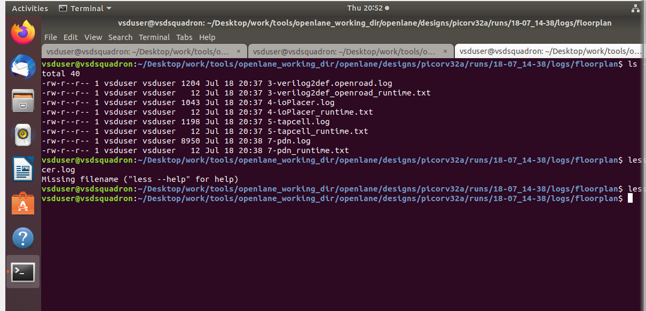

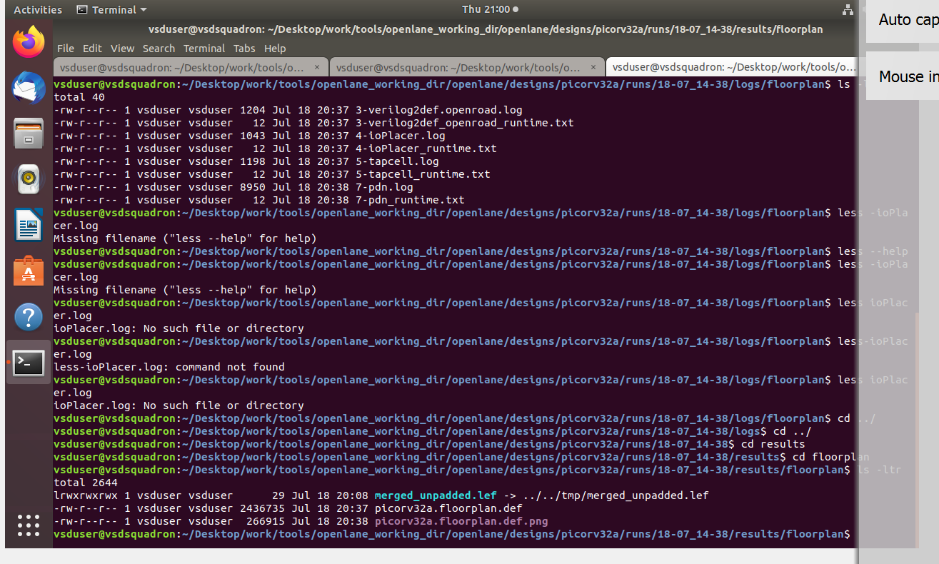

Finding Die area:

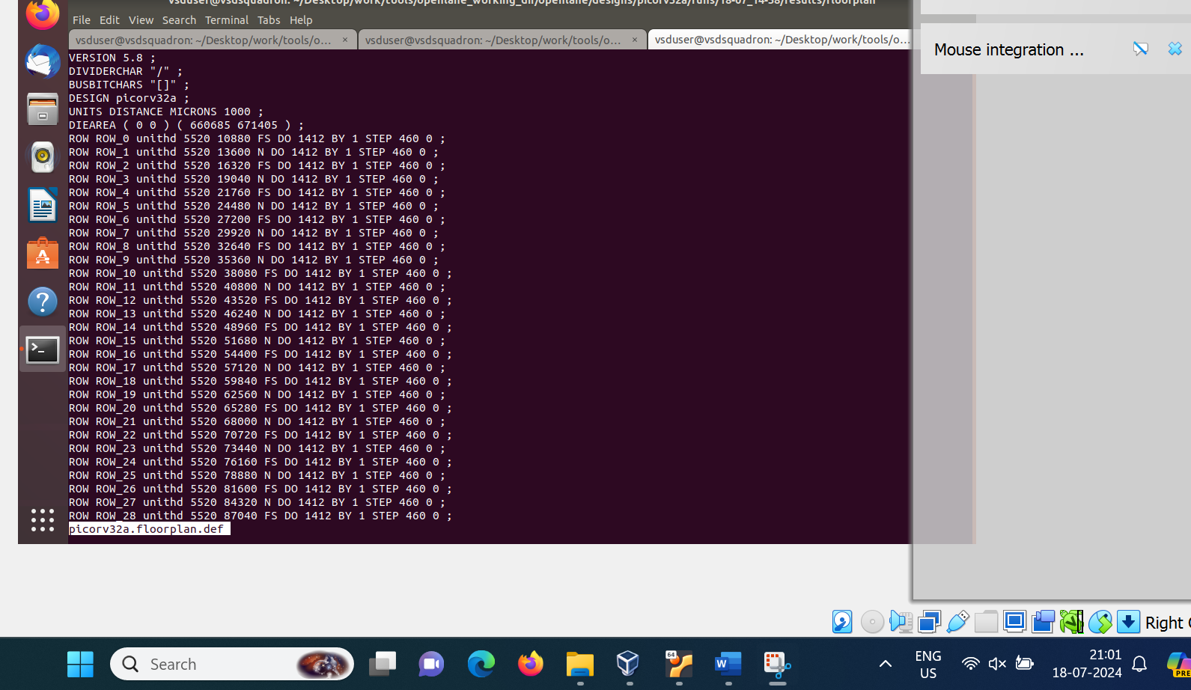

1. Magic T location:

~Desktop/work/tools/openlane_working_dir/pdks/sky130A/libs.tech/magic/sky130A.tech.lef read ../../tmp/merged.lef def read picorv32a.floorplan.def

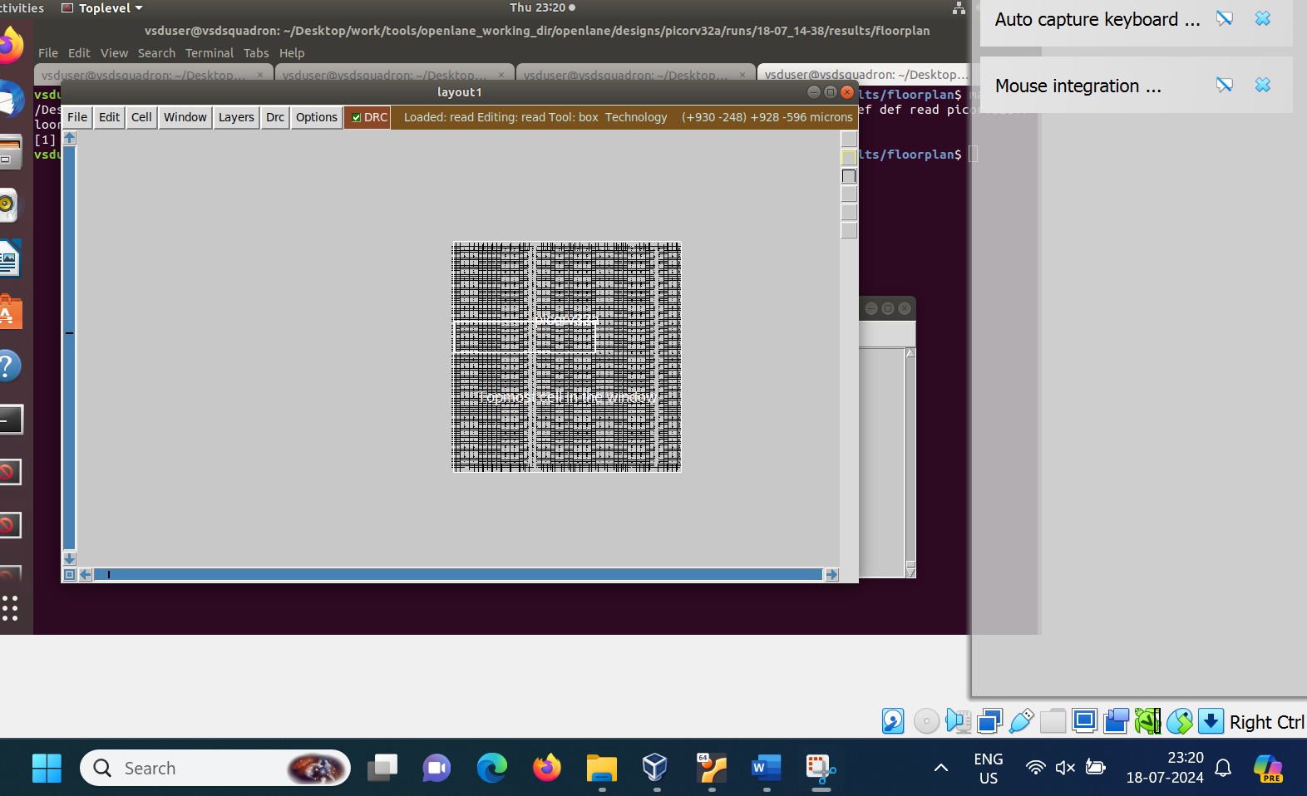

Placement :

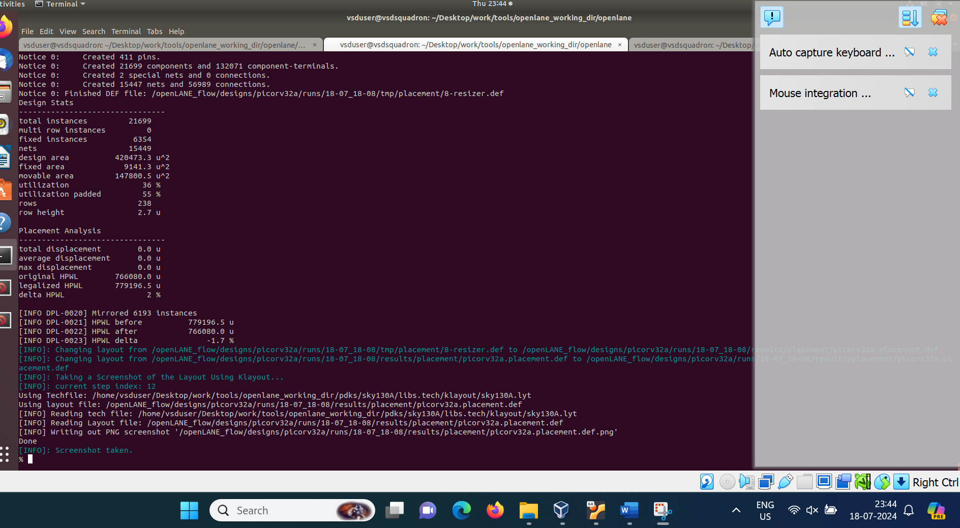

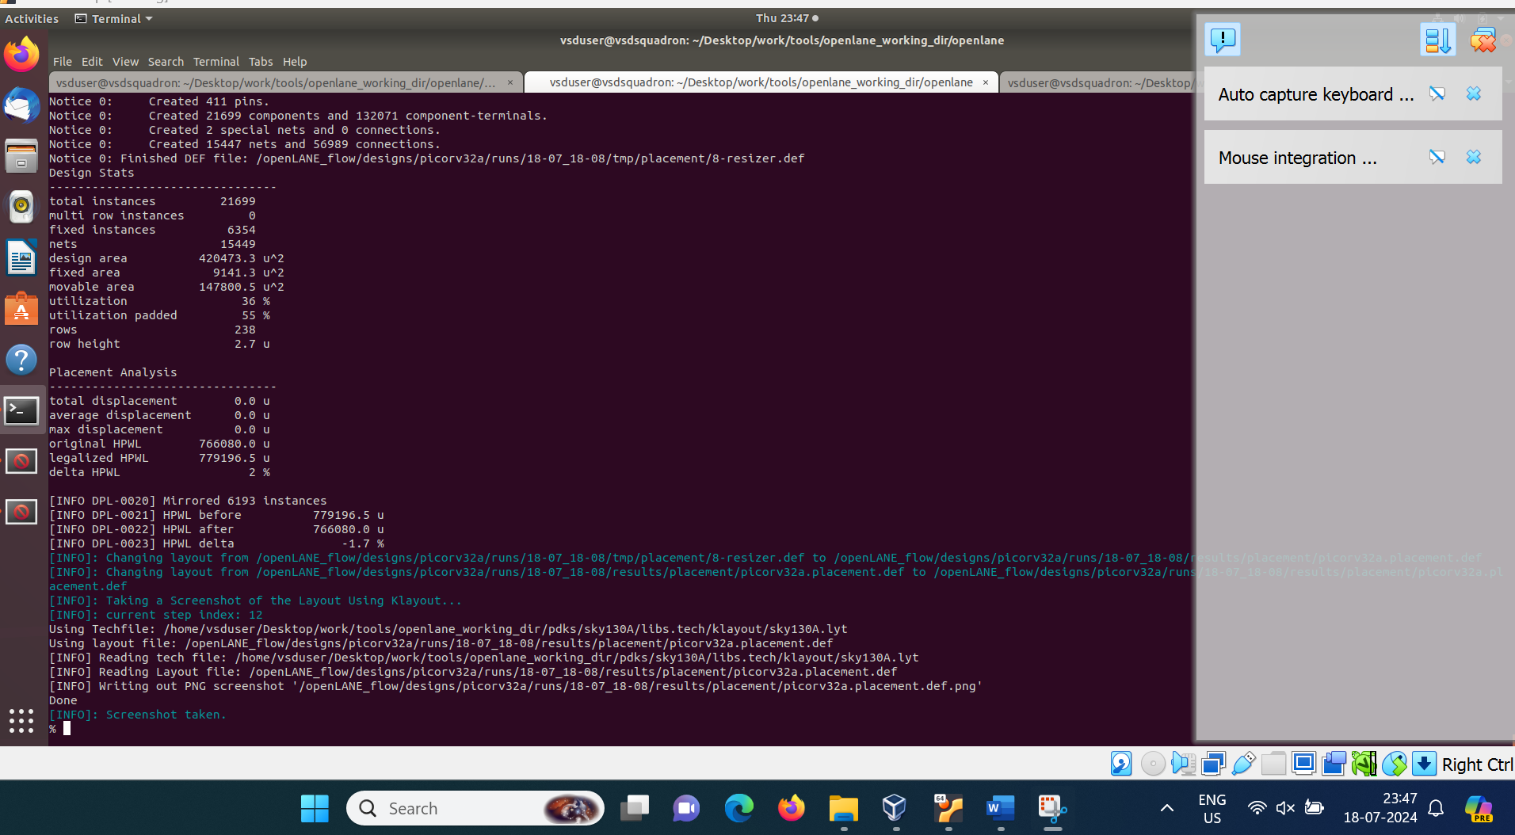



1. Presence check of switches- Lower to higher order

* Openlane Default switches setting of layer numbers found in configurations directory and in file floorplan.tcl- step 4 in my document
* Config.tcl -second priority found in the directory picorv32a