Lab#3 SPICE SIMULATIONS

From github clone:

url: https://github.com/The-OpenROAD-Project/OpenSTA.git

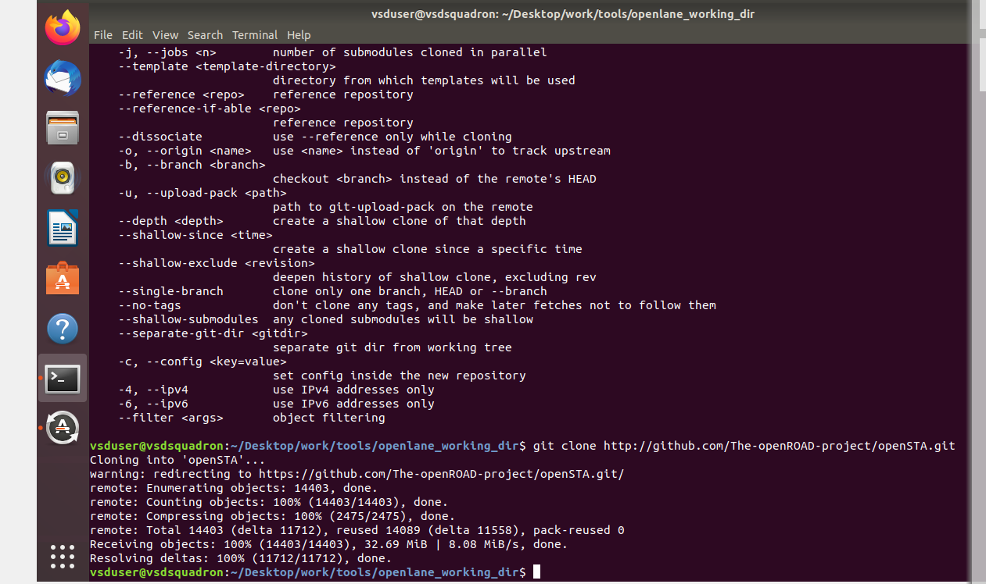

Folder vsdstdcelldesign while listing check for file : sky130_inv.mag file

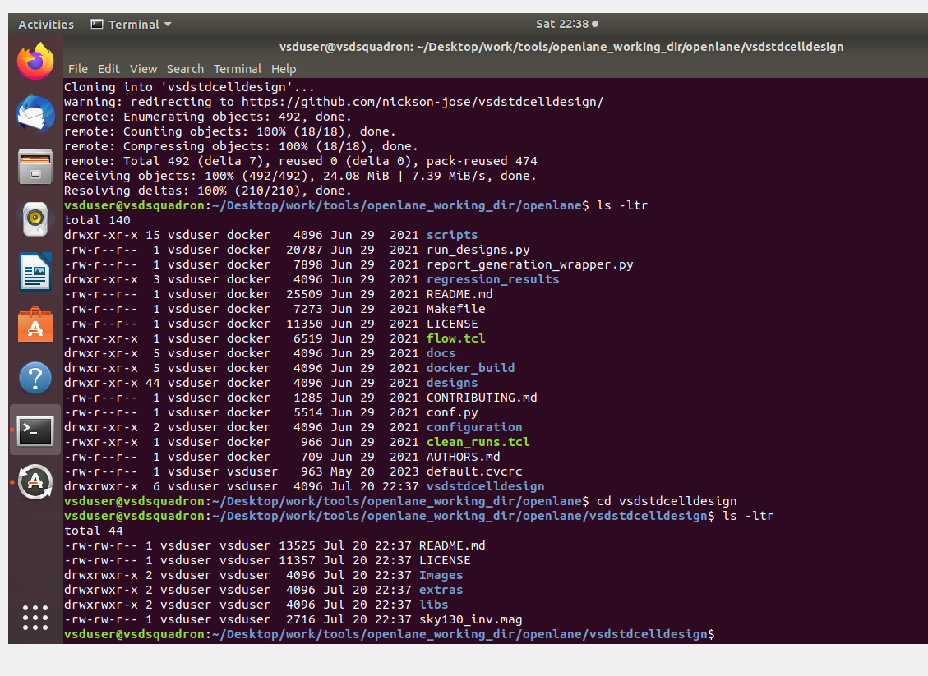

Copy the .tech file magic folder to vsdstdcelldesign folder having mac file



Now , both tech and .mag are in folder vsdstdcelldesign

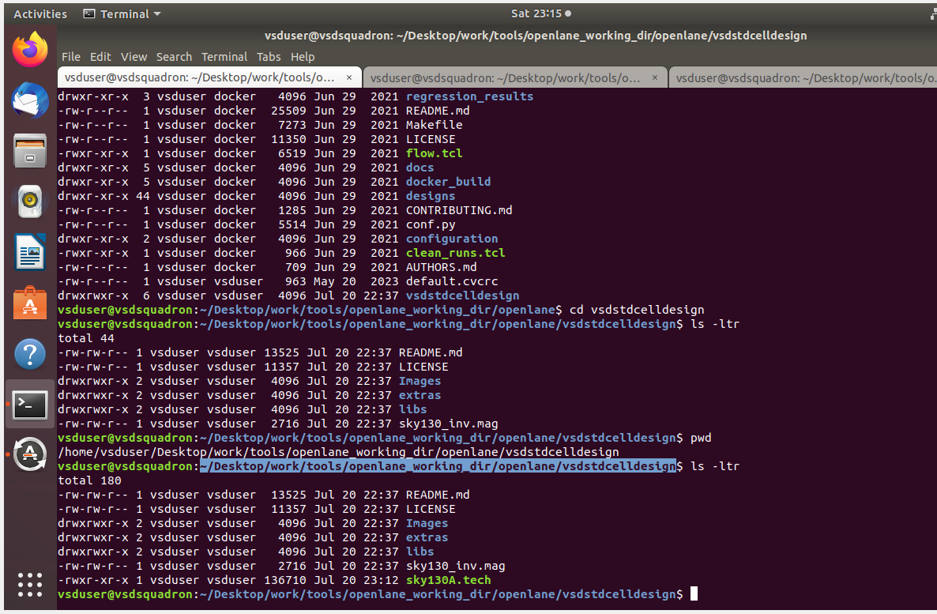

Inverster layout in magic :

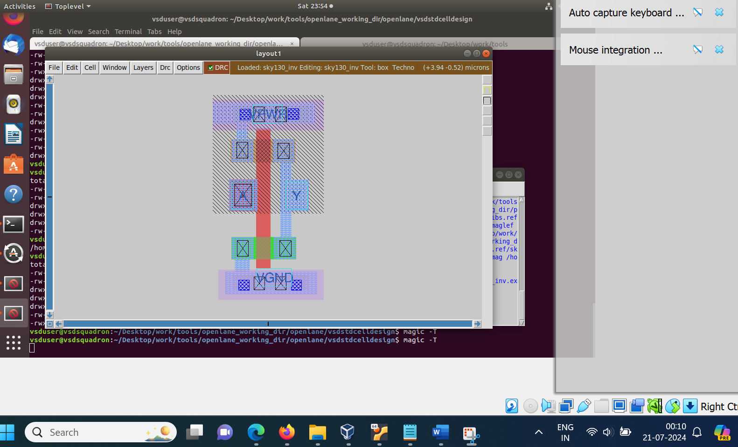

Extraction is completed

