**LAB #4 : Pre-layout timing analysis ( vsdstdcelldesign of inverter to be synthesized in picorv32a design and check for floorplane, placement )**

1. Custom layout of inverter
2. Commands:

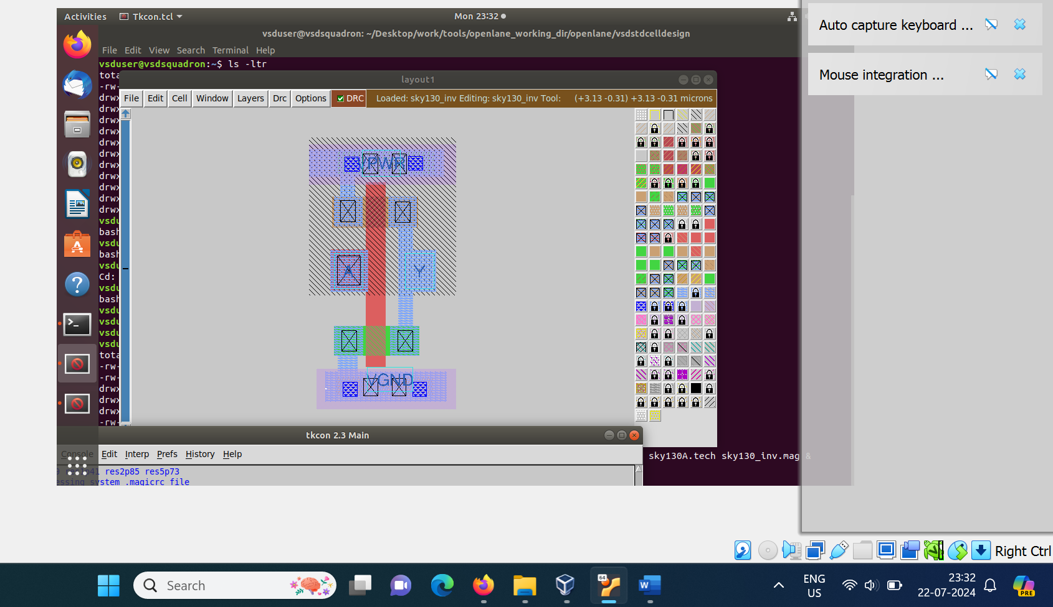

1. Creating sky130_vsdinv.mag

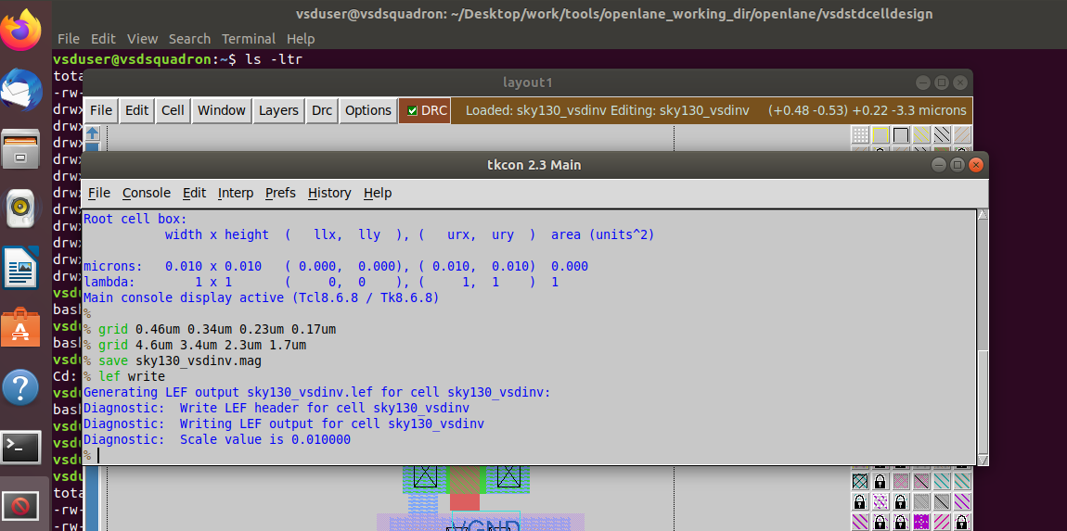

1. Check for file sky130_vsdinv.mag in the folder vsdstdcelldesign

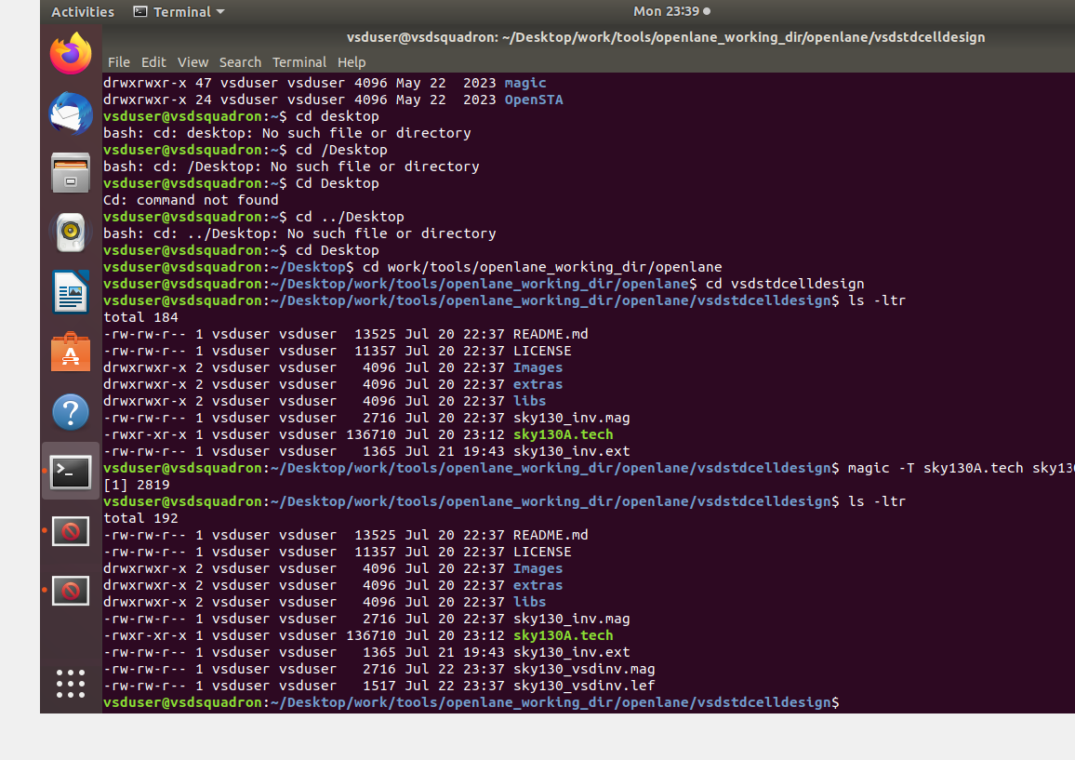

1. Editing config.tcl

To add extra lef file

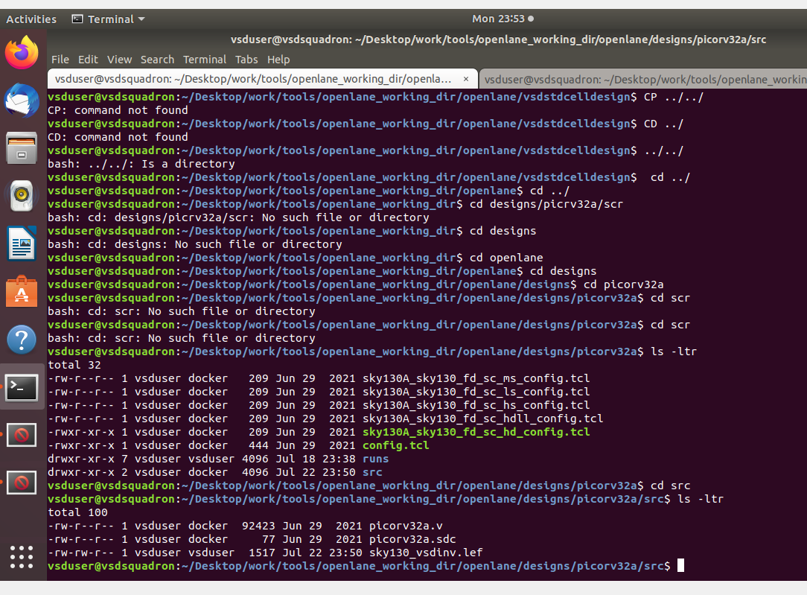

1. Segregating all lib files under src

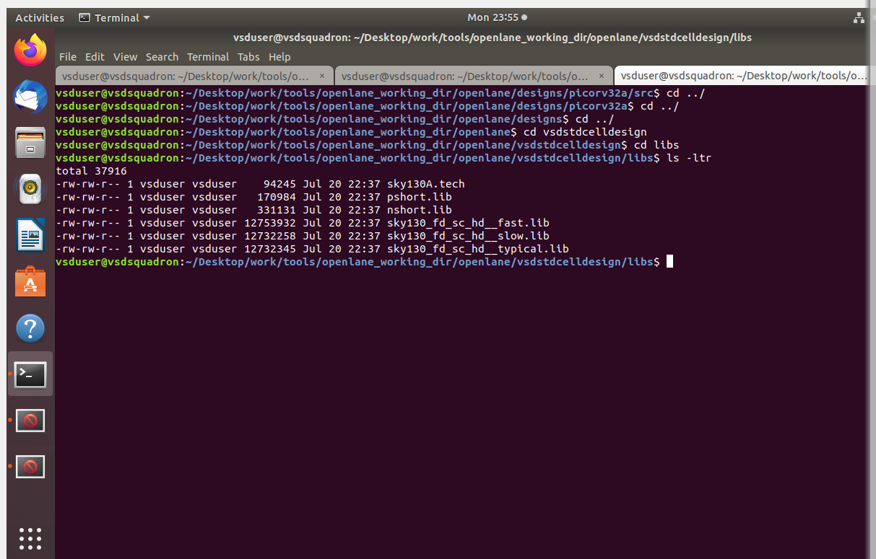

1. Copy the last 3 .lib files to scr

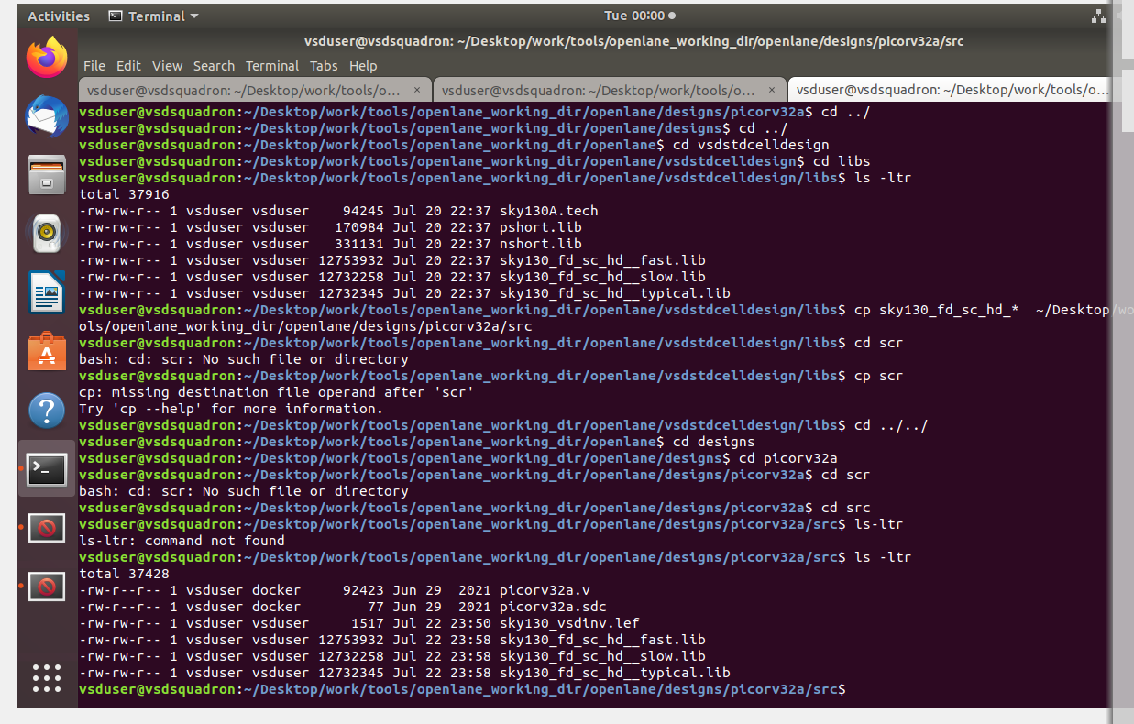

1. Modify the configuration file.

Original config.tcl file

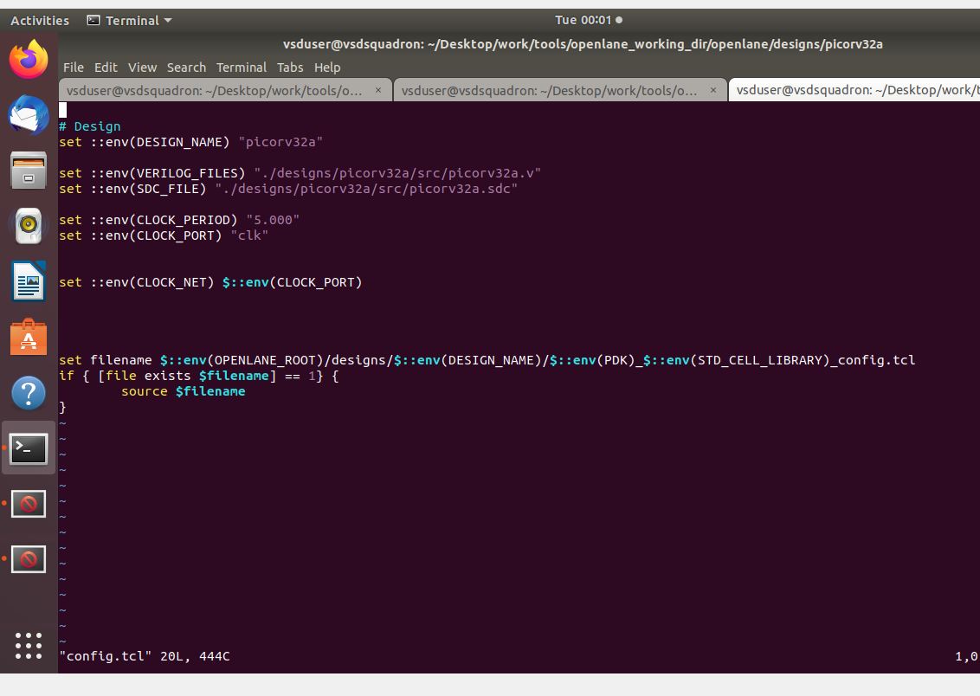

1. % prep -design with recent dir
2. 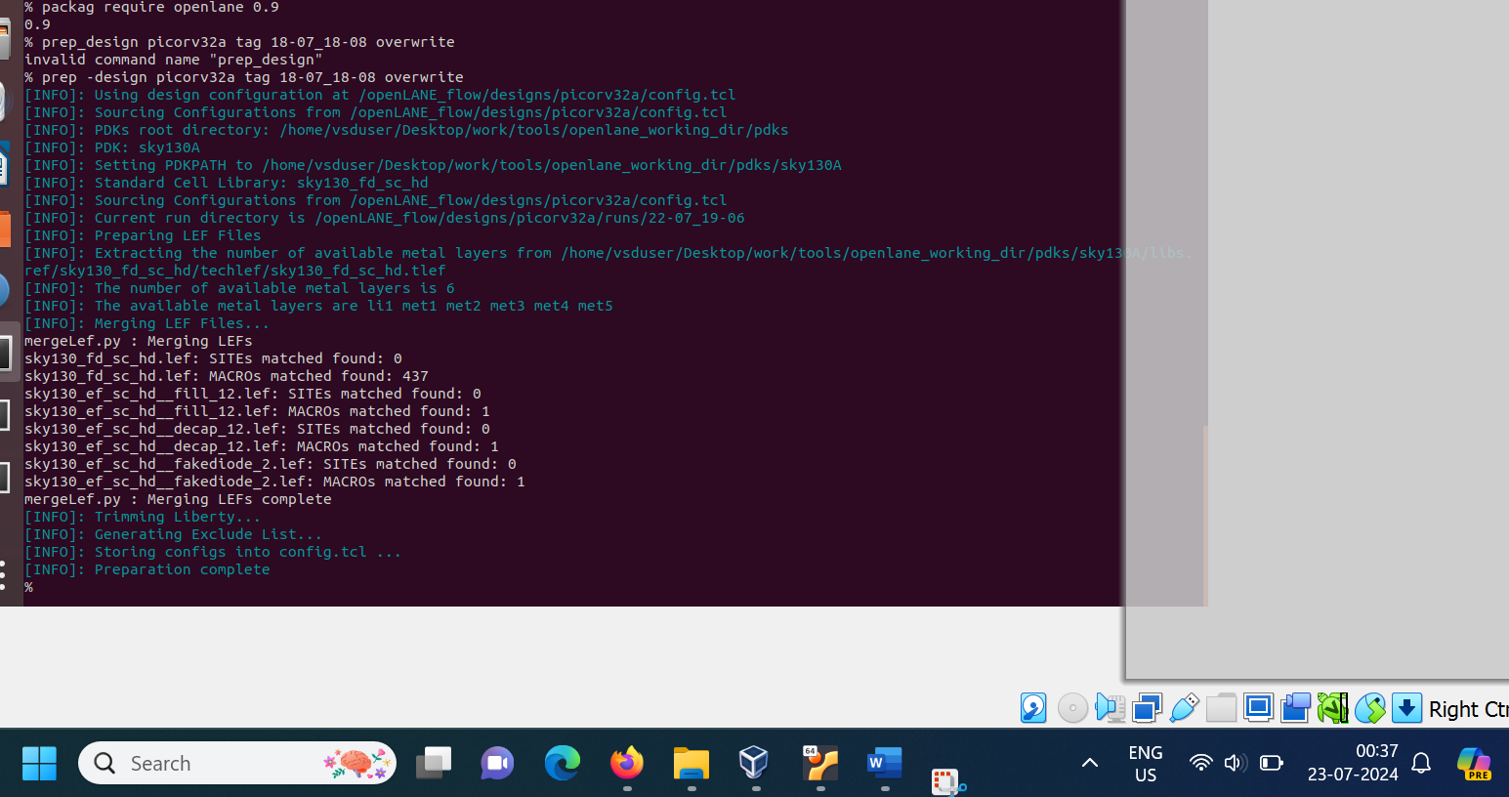
3. Synthesis with custom design
4. 