Reparametrization of GFN2-xTB for the MsrB cysteine active site
Methods and results for the ORCA-referenced GFN2-xTB re-fit of the cysteine MsrB variant (S-only, msrb_50rep), produced with this repository. The selenocysteine variant is treated in a companion document (to be added). Bracketed [...] items are placeholders to fill or cite.

1. Reference data
Reference single-point calculations were performed with ORCA [ver.] at the B3LYP-D4/def2-TZVP level (EnGrad task) on the capped quantum-mechanical region of the MsrB active site: a 47-atom cluster of composition C₁₂H₂₇N₄O₂S₂ (net charge +1, singlet). The EnGrad task yields, for every structure, the total energy, the Cartesian nuclear gradient, and the atomic (Mulliken and Löwdin) charges. Calculations were carried out in the gas phase on the isolated QM region, following the rationale that fitting the intrinsic semiempirical Hamiltonian—rather than a specific electrostatic embedding—yields parameters that transfer between environments and avoids overfitting to a particular MM context [Velázquez-Libera et al., J. Chem. Theory Comput. 2025, 21, 5118].
Configurations were sampled along the characterized reaction path, comprising 48 nodes (positions along the reaction coordinate, node 1 = reactant … node 48 = product) with 50 replica snapshots per node, for a nominal total of 2400 reference structures. Each structure was stored as a compact per-structure JSON record (total energy, and, per atom, element, Cartesian coordinates, Mulliken/Löwdin charge, and gradient). A self-consistent-field / quality-control screen with stock GFN2-xTB flagged a small number of pathological geometries (non-converged or duplicate snapshots), which were excluded prior to fitting; all remaining structures were retained.
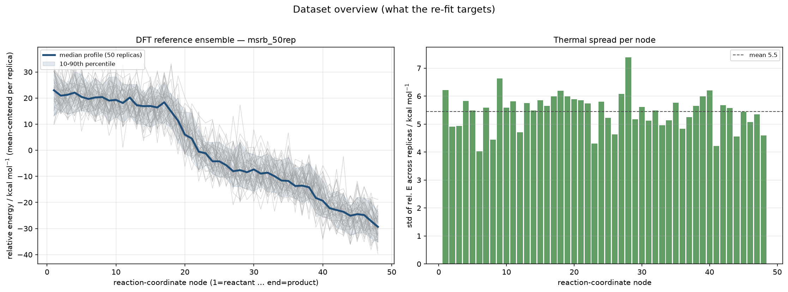
Figure 1. What the re-fit targets. Left: the DFT (B3LYP-D4) reference ensemble — the per-replica relative-energy profile along the 48-node reaction coordinate (thin grey traces, 50 replicas; the 10–90th percentile band shaded), with the median profile in blue. The reaction is markedly exothermic, spanning ≈ +23 kcal·mol⁻¹ (reactant) to ≈ −30 kcal·mol⁻¹ (product). Right: the thermal spread (standard deviation of the mean-centered relative energy across the 50 replicas) at each node, mean ≈ 5.5 kcal·mol⁻¹ — this is the intrinsic conformational noise the semiempirical model must reproduce on average, not fit point-by-point.

2. ORCA reference ingestion
The optimization engine is the multiobjective evolutionary reparametrization framework of Velázquez-Libera et al. (gfn2-xtb_paramfitter), which natively consumes Gaussian outputs via cclib. To use ORCA reference data we added a program-agnostic ingestion layer that parses the compact ORCA EnGrad JSON records and assembles them into the array-based dataset consumed by the framework's JSON objective (ECGFittingV3Json / JSONCurveHandler). During assembly, units are harmonized to those expected by the fitter—energies converted to kcal·mol⁻¹, coordinates to Bohr, gradients retained as the energy gradient (dE/dx, Eₕ·Bohr⁻¹; internally negated to forces), and charges in e—and the replica snapshots are grouped into independent relative-energy "curves" (one curve per replica index, each spanning the 48 nodes). This route also sidesteps program-specific conventions (e.g. the sign difference between Gaussian "Forces" = −gradient and ORCA "CARTESIAN GRADIENT" = +gradient). Per-system structure exclusions and train/validation partitioning (by replica index) are applied at this stage.
Because several near–transition-state geometries have small HOMO–LUMO gaps, all xTB single points were evaluated with Fermi smearing at an electronic temperature of 500 K and up to 300 SCF iterations, a setting verified to guarantee convergence across the dataset while perturbing well-behaved structures negligibly (per-atom Mulliken change ≲ 0.003 e).
The tunable GFN2-xTB parameters for this system comprise the element-specific parameters of H, C, N, O and S (75 parameters; the stock bundled HCONS template). Both sulfur atoms of the QM region are therefore fully tunable; no non-standard elements are present, so the default parameter set applies without extension. (The reactive selenocysteine variant requires additionally exposing selenium's 20 element parameters — 95 tunable in total — and is documented separately.)

3. Multiobjective reparametrization
Parameters were optimized against the DFT reference by simultaneously minimizing the discrepancy in three properties:
- the relative potential-energy profile along each replica curve (both its shape, via the non-redundant matrix of pairwise energy differences, and its RMSE after mean-centering);
- the atomic Mulliken charges; and
- the atomic gradients (norm of the force-difference vector).
These are combined into a single global score, defined as the product of the gradient, charge and energy sub-scores, each constructed with exponential penalty terms that heavily weight large local deviations [Velázquez-Libera et al.]. Because the present reaction spans ≈ 60 kcal·mol⁻¹ end-to-end, the energy-penalty reference scale (ref_ener) was set to 60 kcal·mol⁻¹ to keep the product objective finite and well-conditioned.
The score was minimized with the Dynamic Domain Genetic Algorithm (DDGA): a Latin-hypercube-initialized population (seeded with the stock GFN2-xTB parameters), tight variable bounds of ±2 % about each stock value, and dynamic expansion of the search domain toward promising regions. Production settings were population 80, up to 50 generations, with early stopping after 12 generations without improvement; the run used 40 CPU cores and completed in ≈ 7.9 h. The optimized parameters are exported as a standard GFN2-xTB parameter file (param_gfn2-xtb.txt) for direct use in QM/MM.
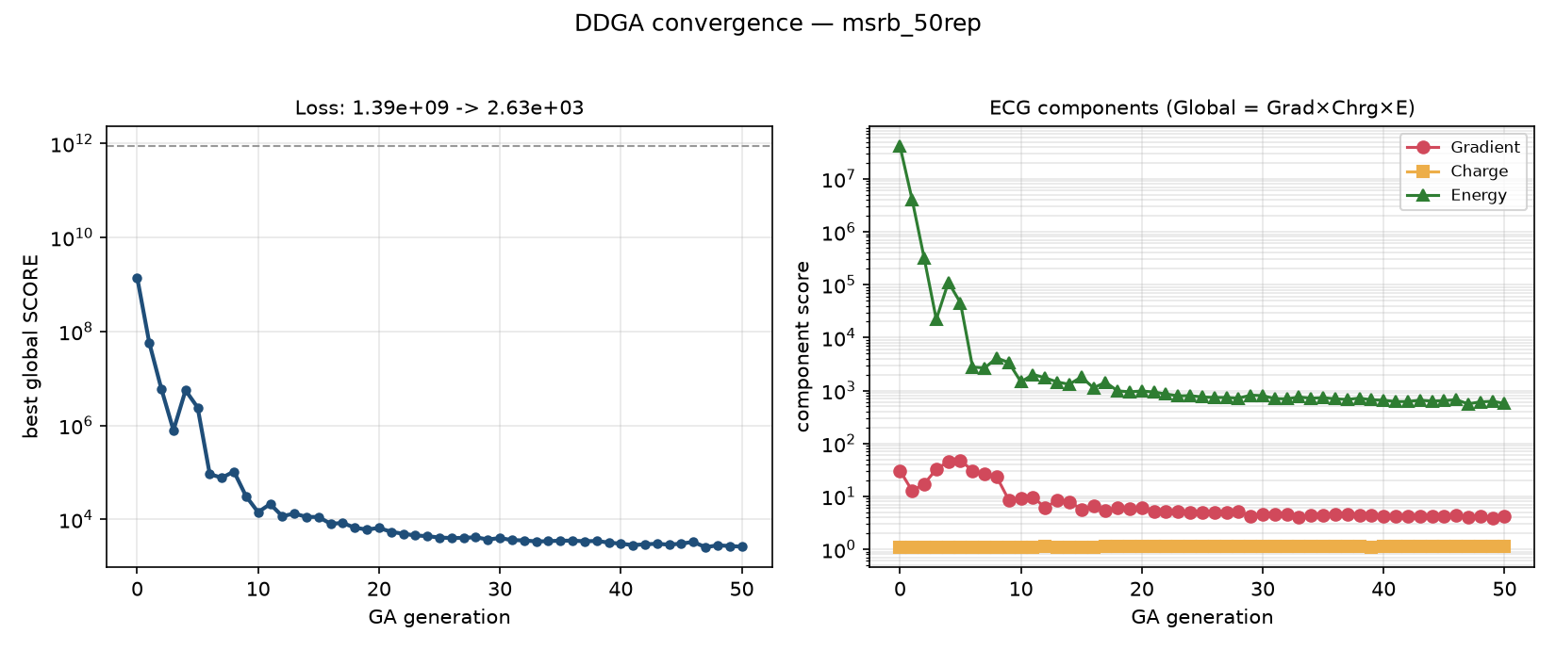
Figure 2. DDGA convergence. Left: the best global score across generations, falling from ≈ 1.4 × 10⁹ (generation 0) to ≈ 2.5 × 10³ at convergence (dashed line marks the stock default score, ≈ 8.6 × 10¹¹). Right: the three multiplicative components of the objective (Global = Gradient × Charge × Energy). The energy term (green) dominates and drives essentially all of the improvement; the gradient term (red) is refined modestly; the charge term (orange) is already near-optimal for this S-only system and stays ≈ 1 throughout — foreshadowing the near-flat charge parity below.

4. Results

4.1 Fit quality on the training set
The production fit was evaluated against the full training ensemble. Correlation (predicted-vs-reference) improves sharply for the energies and appreciably for the forces; the Mulliken charges — already well described by stock GFN2-xTB for this system — are essentially unchanged.
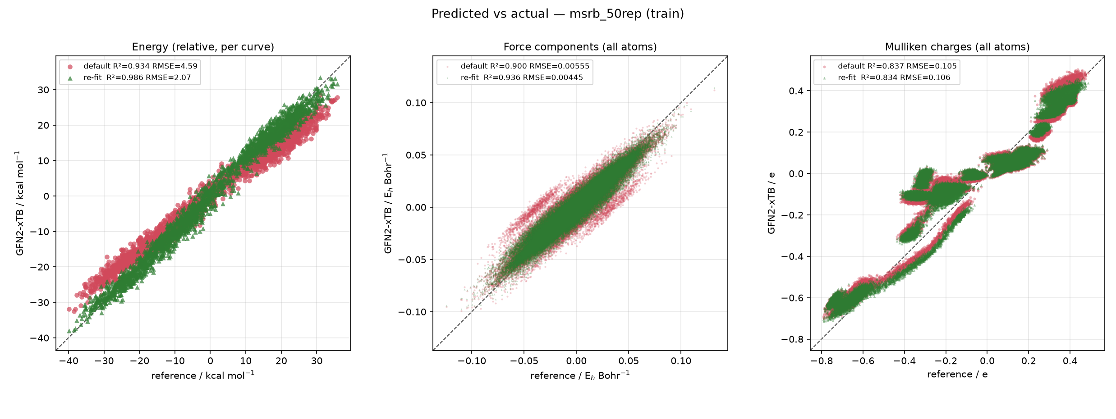
Figure 3. Predicted vs. reference on the training set (stock GFN2-xTB in red, re-fit in green; dashed = ideal y = x).
Property | Stock GFN2-xTB | Re-fit | Unit
Energy (relative, per curve) | R² = 0.934, RMSE = 4.59 | R² = 0.986, RMSE = 2.07 | kcal·mol⁻¹
Force components (all atoms) | R² = 0.900, RMSE = 0.00555 | R² = 0.936, RMSE = 0.00445 | Eₕ·Bohr⁻¹
Mulliken charges (all atoms) | R² = 0.837, RMSE = 0.105 | R² = 0.834, RMSE = 0.106 | e
The re-fit more than halves the energy RMSE (4.59 → 2.07 kcal·mol⁻¹) and tightens the force correlation, while leaving charges statistically unchanged — consistent with the component decomposition in Figure 2, where the charge score was already saturated.

4.2 Reaction profile
Averaged over replicas, the re-fit reproduces the DFT reaction profile far more faithfully than stock GFN2-xTB, which systematically overstabilizes the reactant plateau and the product well.
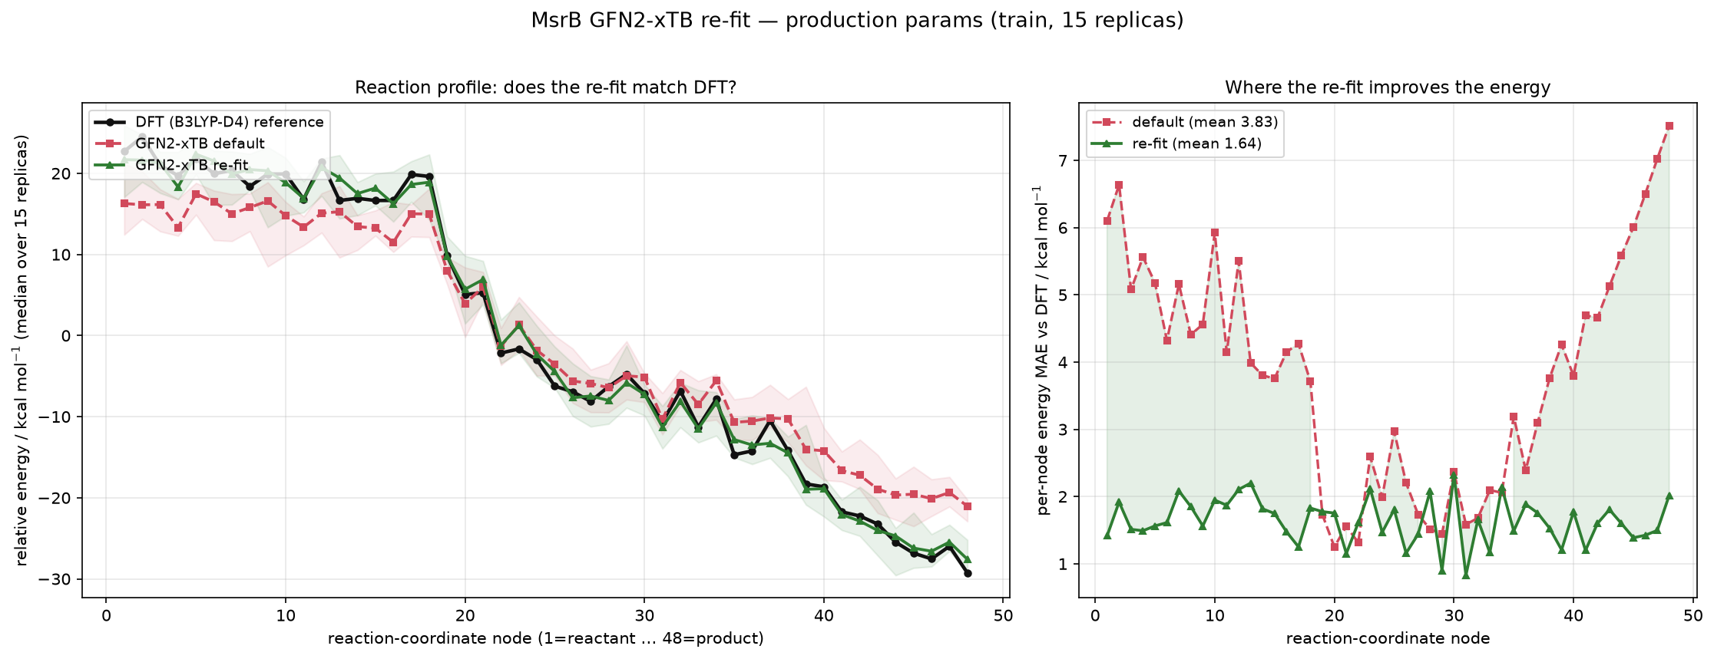
Figure 4. Median reaction profile vs. DFT. Left: the median relative-energy profile along the reaction coordinate — DFT reference (black), stock GFN2-xTB (red), and re-fit (green), with shaded replica bands. Right: the per-node energy MAE against DFT; the re-fit (green) reduces the mean per-node error from 3.83 to 1.64 kcal·mol⁻¹ and, crucially, removes the large systematic errors at the reactant (nodes ≈ 1–18) and product (nodes ≈ 40–48) termini where stock GFN2-xTB deviates by 4–7 kcal·mol⁻¹.

4.3 Generalization (out-of-sample validation)
Because the production parameter set is fit to all replicas (for maximum use in MD), two independent held-out protocols were run to estimate generalization. Errors are reported as the mean after skipping gross outliers (> 10 × MAD); the fully robust median is given in parentheses.
(A) Random 80/20 split (node-agnostic; interpolation within the sampled region):
Quantity | Stock | Re-fit (train) | Re-fit (val) | Val median | Gap (val−train)
E (kcal·mol⁻¹) | 3.79 | 1.54 | 1.55 | 1.12 | +0.003
q (e) | 0.088 | 0.079 | 0.079 | 0.066 | ≈ 0
F (Eₕ·Bohr⁻¹) | 0.0030 | 0.0025 | 0.0025 | 0.0017 | ≈ 0
The near-zero train→validation gap indicates the model interpolates reliably across thermal conformations at a given point on the reaction coordinate — the regime relevant to QM/MM sampling.
(B) Per-node leave-node-out CV (6 contiguous folds; extrapolation to unseen points on the reaction coordinate): held-out energy MAE 3.79 → 1.64 kcal·mol⁻¹ (median 1.32); charge 0.088 → 0.069 (median 0.057); force 0.0030 → 0.0027 (median 0.0019). The largest residual held-out energy errors concentrate at the reaction termini (nodes 30, 48, 12, 18, …), flagging where additional DFT sampling would most improve the fit.

5. Use in free-energy (PMF) calculations
The re-fitted GFN2-xTB parameters serve as the QM Hamiltonian in subsequent QM/MM simulations, in which the reduced computational cost relative to DFT permits the extensive conformational sampling required to converge the potential of mean force along the reaction coordinate [method, e.g. Adaptive String Method / umbrella sampling], while reproducing the higher-level reference energetics that stock GFN2-xTB fails to capture (Figures 3–4). The small out-of-sample errors (§4.3) support using a single parameter set across the full reaction coordinate.

Reproducing this fit
XTBFIT_PARAMSET=HCONS \
XTBFIT_INPUT=/path/to/data/msrb_50rep/engrad \
XTBFIT_OUTPUT=$HOME/xtb_runs/msrb_50rep \
XTBFIT_NCPUS=40 \
nohup bash run_all.sh > $HOME/xtb_runs/msrb_50rep/run_all.log 2>&1 &
Production settings (Stage 2): POP 80, ITERS 50, MNIWI 12, bounds ±2 %, ref_ener 60, XTB_ETEMP 500 K, XTB_MAXITER 300. The figures above are the pipeline's own outputs (dataset_overview.png, loss_curve.png, parity_plots.png, profile_median_clean.png).

Key references
- C. Bannwarth, S. Ehlert, S. Grimme. J. Chem. Theory Comput. 2019, 15, 1652 (GFN2-xTB).
- E. Caldeweyher et al. J. Chem. Phys. 2019, 150, 154122 (D4 dispersion).
- J. L. Velázquez-Libera, R. Recabarren, E. Vöhringer-Martinez, Y. Salgueiro, J. J. Ruiz-Pernía, J. Caballero, I. Tuñón. J. Chem. Theory Comput. 2025, 21, 5118 (MOOP/DDGA reparametrization).
- [Adaptive String Method / PMF reference, e.g. Zinovjev & Tuñón, J. Phys. Chem. A 2017, 121, 9764.]

