Earth Shard



Game Design Document

Version 1.0

Contents

2 Overview 4

2.1 Concept 4

2.1.1 Genre 4

2.1.2 Gameplay loop 4

2.1.3 Main Objective 4

2.2 Look and feel 4

2.3 Scope 4

2.3.1 Locations 4

2.3.2 Levels 4

2.3.3 Player abilities 4

2.3.4 Enemies 4

3 Design 4

3.1 Narrative 4

3.2 Environment 4

3.3 Characters 4

3.3.1 Player 4

3.4 User Interface 4

3.4.1 Menus 4

3.4.2 HUD 4

3.5 Camera Positioning 4

3.6 Sound Effects 4

3.7 Music 4

4 Levels 5

4.1 Level 1 – Dunes 5

4.1.1 Synopsis 5

4.1.2 Map 5

4.2 Level 2 – Labyrinth 5

4.2.1 Synopsis 5

4.2.2 Map 5

4.3 Level 3 – The climb 5

4.3.1 Synopsis 5

4.3.2 Map 5

4.4 Level 4 – Rite of passage 5

4.4.1 Synopsis 5

4.4.2 Map 5

5 Mechanics 5

5.1 Collisions and physics 5

5.2 Player Mechanics 5

5.2.1 Movement 5

5.2.2 Abilities 5

5.2.3 Player Health 5

5.2.4 Arm animations 5

5.2.5 Interactions 5

5.3 Enemies (rock golems) 5

5.3.1 AI (state machine) 6

5.3.2 Enemy Health 6

5.4 Interactable entities 6

5.4.1 Switches 6

5.4.2 Signs 6

5.4.3 Buttons 6

6 Appendices 6

6.1 Concept art 6

6.2 Unused content 6

# Overview

## Concept

You are an Earth elementalists and must face 4 trials to prove yourself to the master of Earth manipulation! You must use your abilities wisely to solve puzzles and defeat foes! Only then will you be able to become a master!

Earth Shard is a First-person shooter / puzzle game where you take the role of an initiate who is has discovered that they wield the power of earth manipulation and must face a series of trials to prove you have the wits and power to become a master of the element earth.

### Gameplay loop

The gameplay loop shifts slightly between the levels, but the main focus is on puzzle solving and combat.

#### Combat

The combat loop involves dodging enemy projectiles and shooting your own projectiles back to take them down. Earth shard uses Unity’s physics systems here and you must consider the angle in which you shoot your projectiles as they are affected by gravity.

#### Puzzle solving

On level 2 onwards puzzles solving takes a larger focus with Level 1 having you wander a maze shooting at switches to open a door at the end of it and level 3 using the ground raise ability to platform out of a pit. Level 4 combines some of the puzzle aspects of 2 and 3 with the combat of level 1.

### Main Objective

The main objective of Earth Shard is to make it to the end of each level and eventually become a master of the earth element by defeating all 4 trials.

## Look and feel

Earth Shard has an arid rocky feel to its environment to really embody the element of earth. The art style takes on a low poly aesthetic, this is both just an aesthetic choice and a practical choice as low poly assets are easy to blend and make if necessary.

## Scope

### Locations

The main overall location is a very arid desert mesa. There is a temple you enter in level 2 that will then exit to canyon that you escape from that opens into a rockier mesa much like the first location in Level 1.

### Levels

There are 4 levels each focusing on a different aspect of earth shard with the last level aiming to combine them all. The levels aim to scale in complexity as the earth shard progresses to keep the player engaged. With the final level aiming to really challenge the skills the player has learned from the other 3 levels.

### Player abilities

The player has 2 abilities they can utilise, one is a combat focused ability they can use to attack enemies or interact with switches. The second ability allows the player to raise themselves up which is useful for platforming or getting height advantage on enemies.

### Enemies

The enemies are rock golems to embody that earth element. The enemies use a state machine to control their AI with 3 different states: patrol, search and attack. The enemies when attacking will throw rocks at the player.

# Design

## Narrative

## Environment

## Characters

### Player

The players character itself doesn’t have a design as it is never seen from a 3rd person perspective. The player is represented through two arms that animate with abilities.

The player also has no voice lines. This is following the trope set in older first-person games such as halo and half-life where the player character can be a self-insert of the person playing the game.

A design may later be considered for the player if any art requires them to be represented but as of now the player is just some arms. 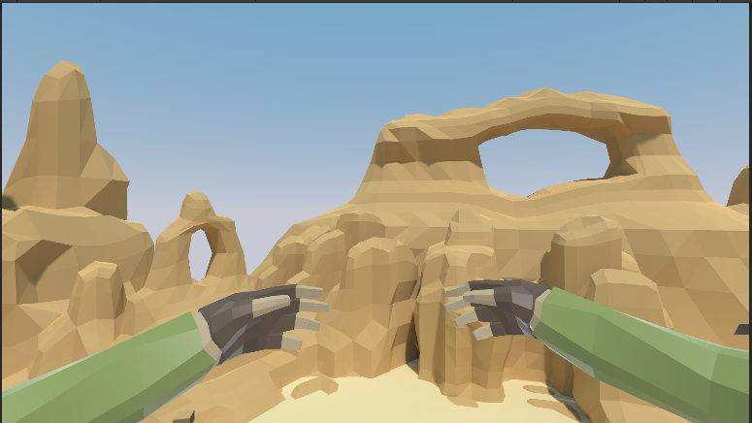

### Rock Golems

## User Interface

The UI of earth shard has rocky appearance with buttons looking like stones. The HUD is rather minimalistic as to not obstruct the gameplay and provide more immersion.

### Menus

//Insert menu flowchart here

#### Main Menu

#### Level Select

#### Credits

### HUD

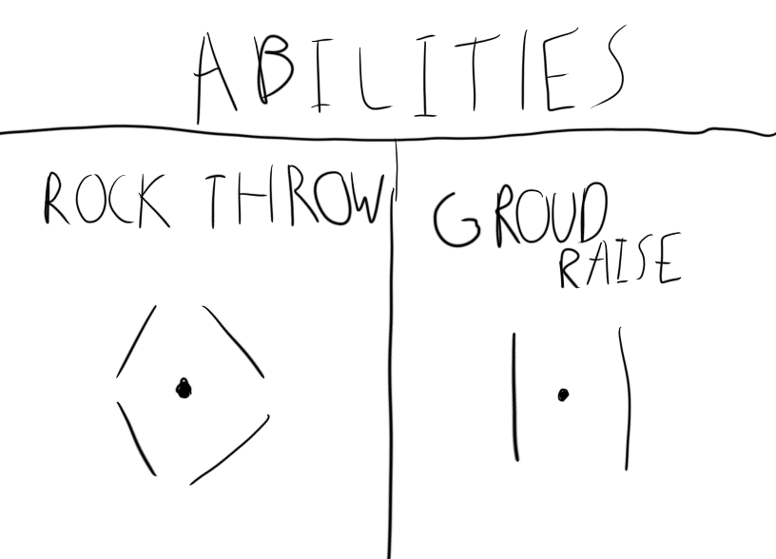The HUD is only shown as the crosshair that changes shape based on what ability is equipped at the time. When the player takes damage, a red glow will appear and when the players health is low the red glow will remain on screen before disappearing after some passive healing. There is no displayed health bar as it felt obstructive.

## Camera Positioning

Being a first-person game, the camera will always be position from the perspective of the player. In the menus the camera will show environments in the background with the menu overlayed.

## Sound Effects

Most interactions in the game have sound effects. Any collision or interaction will have a sound to give feedback to the player. The player movement itself also has sound effects.

Ambient sounds of the environment will add to the immersion with the sound of wind blowing in the open desert sections cave like sounds within the temple area.

The enemies will also have some ambient sounds to alert the player of their location.

## Music

Music is sourced from 3rd party assets and will play through each level and in the menu. There are considerations to make some music for the game but that must wait till towards the end of development if time permits it.

# Levels

## Level 1 – Dunes

### Synopsis

Level 1 is rather open and only involves killing enemies to progress, keeping it simple will allow players to learn the controls and one of the main abilities before moving into more complex mechanics.

### Objective

Kill enemies in two sections; after killing all enemies in each section a door will open with the last door opening to the entrance of a temple leading to the next level.

### Map

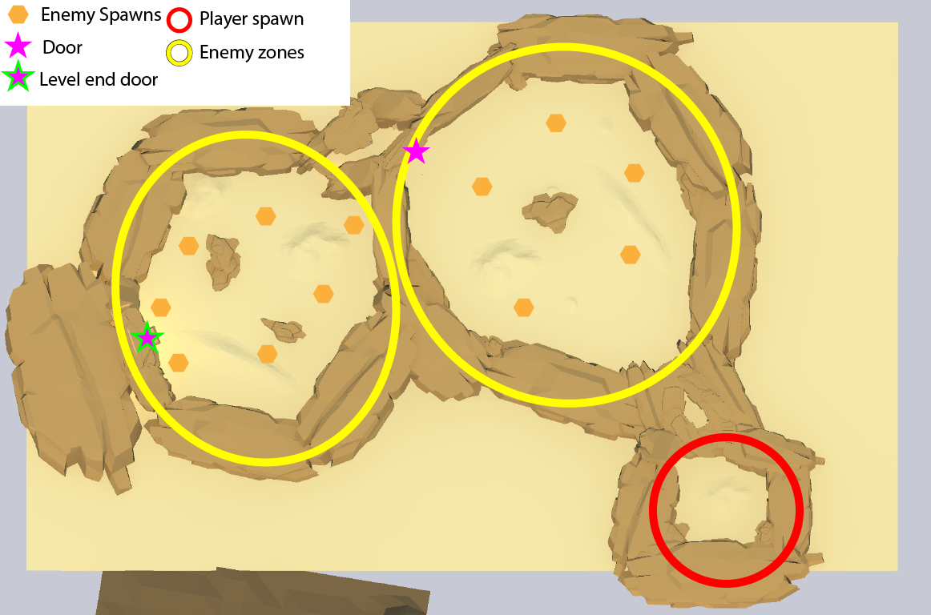

## Level 2 – Labyrinth

### Synopsis

Level 2 is more puzzle focused, the player is introduced too the switches which are found throughout the labyrinth and the player must then use the switches to open a door at the end of the labyrinth.

### Objective

The main objective of this level is to activate 3 switches hidden throughout the level. Once all 3 switches are activated the door at the end of the level will open and allow the player to progress to level 3.

### Map

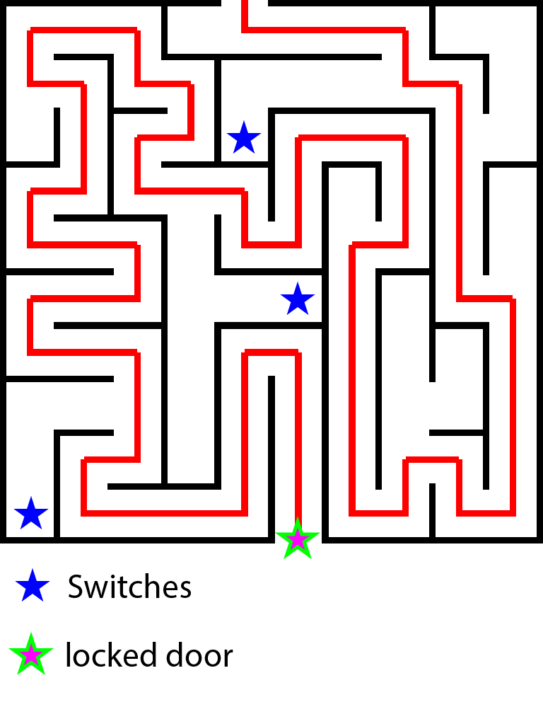

### Minotaur (rejected idea)

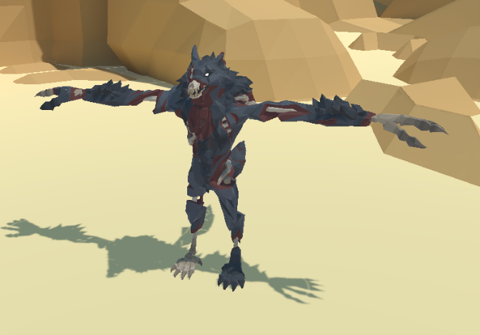The minotaur was supposed to be an invincible enemy that would stalks the labyrinth and chase the player when they were in range of it. A minotaur model that matched the low poly art style could not be sourced so an undead werewolf was used instead. But due to complications with animations and AI the idea was scrapped as it would take up far too much time.

## Level 3 – The climb

### Synopsis

### Objective

### Map

## Level 4 – Rite of passage

### Synopsis

### Objective

### Map

# Mechanics

## Controls

Earth Shard was built mainly on keyboard and mouse but also has controller support due to the ease of Unity’s new Input system.

### Keyboard and Mouse

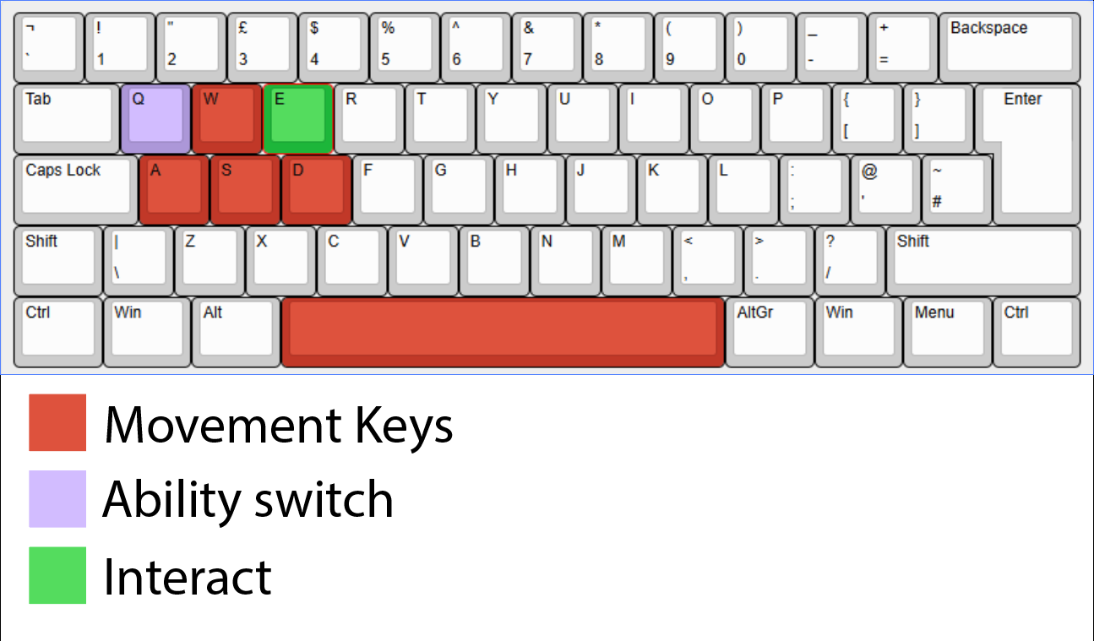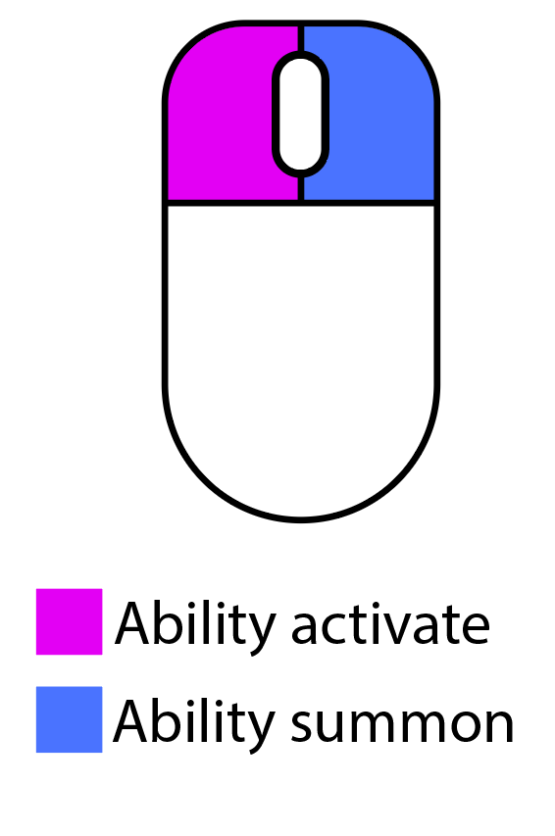

## Collisions and physics

Earth Shard uses Unity’s built in physics and collision system. Standalone colliders are only for static objects that make up the environment. For dynamic Objects like the Player, Enemies and projectiles will use rigid body components for better calculations and physics simulation.

## Player Mechanics

### Movement

The movement in Earth Shard is modelled after what is used in nearly all games in the FPS genre with lateral movement and jumping affected by gravity.

### Abilities

Earth Shard has 2 abilities each serving a different purpose with rock throw as a more combat focused ability and ground raise as a more puzzle solving related ability.

The abilities in earth shard can be switched between each other once reaching level 3, using the ability switch key. The player will start with the rock throw ability at first. The selected ability is shown by the crosshair symbol present.

#### Rock throw

The rock throw ability is the first ability the player can use. The player can with summon the rock with the ability summon click and fire the rock with the ability activate click.

When the rock is summoned, it is held in front of the player and has no collisions until it is fire in which it will have force applied in whatever direction it is facing, it will also be affected by gravity as it will have its rigid body activated upon being fired.

The destroys itself on collisions with a particle effect and can interact with enemy health and switches.

//gif of rock firing

#### Ground raise

The ground raise is the second ability the player unlocks at level 3. The ground raise ability works by spawning a rock under the player with ability summon click and is raised up ability activate click. The platform that raises the player will raise to maximum of 5 metres and will slow its speed of ascension as the player reaches the max height.

The platform will always spawn in the same direction as the player and when summon ability is used again the platform will be destroyed and will need to be summoned again. When destroyed the platform create a particle effect and play a sound.

The player does not need to be standing on the platform to raise it.

//gif of platform raising

### Player Health

The player health is scaled with 100 hit points, but this is not displayed to the player. The player will see a red glow around the edges of the screen when taking damage. When the health is below a threshold of 25 the glow will stay on the screen.

The player passively heals over time when out of combat.

### Arm animations

The players arms animate when abilities are summoned or activated and play different animations depending on the ability equipped.

The rock throw animation will show the arms moving up as a rock is summoned and the arms pushed forward when thrown.

The ground raise animation has the player move hands upwards when the ability is activated.

### Interactions

Interactable objects will have text display on screen showing its interactable and pressing the interact key will cause a function to trigger. The function can be programmed depending on the object.

## Enemies (rock golems)

### AI (state machine)

#### Patrol State

#### Attack State

#### Search State

### Enemy Health

## Interactable entities

### Switches

### Signs

### Buttons

# Appendices

## Concept art

## Unused content