3RD PARTY TESTING DATA AND ANALYSIS


Contents
3rd party data from survey 3
Charts 3
Question and answers 7
Evaluating feedback 9
Links 10
Released builds that were tested 10
Link to tester form 10

3rd party data from survey

Charts
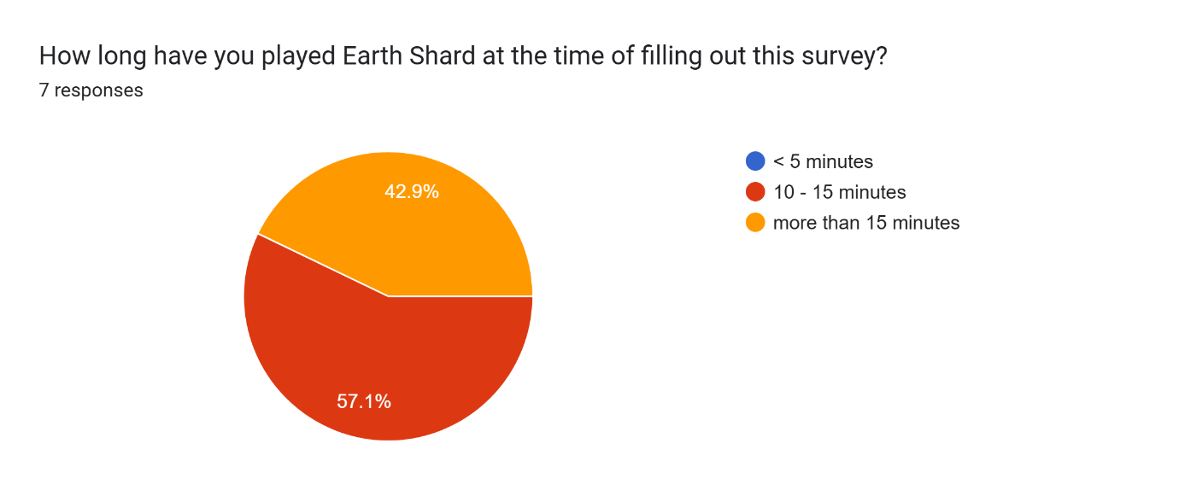
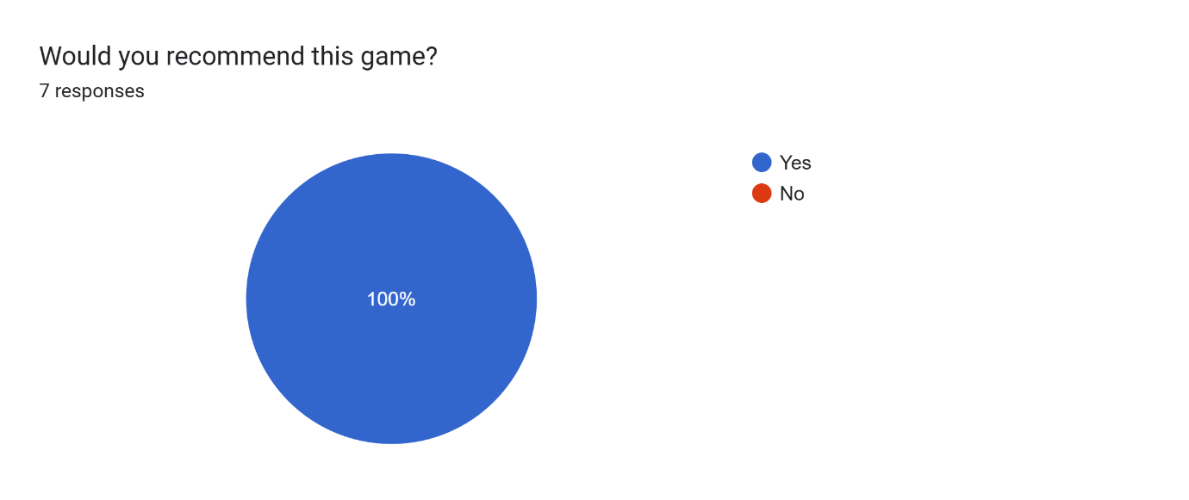
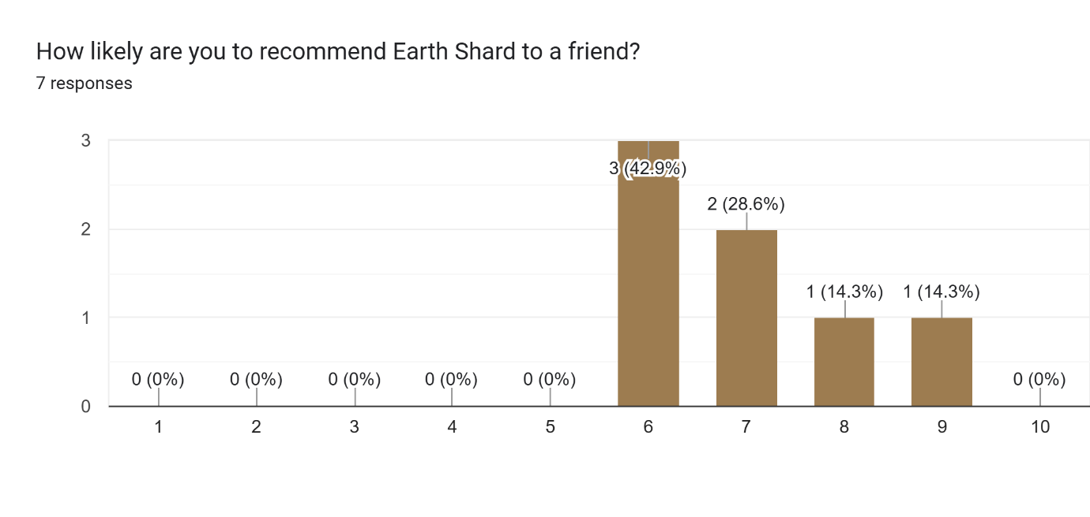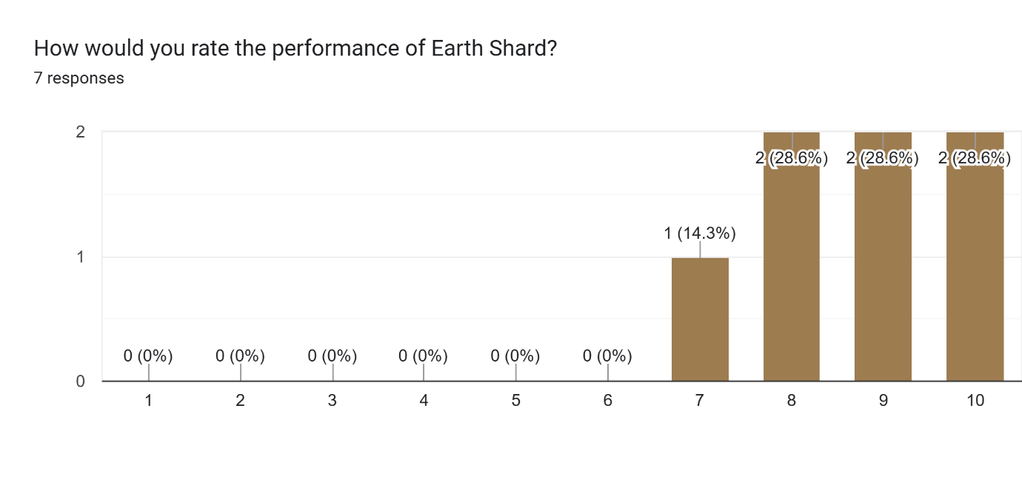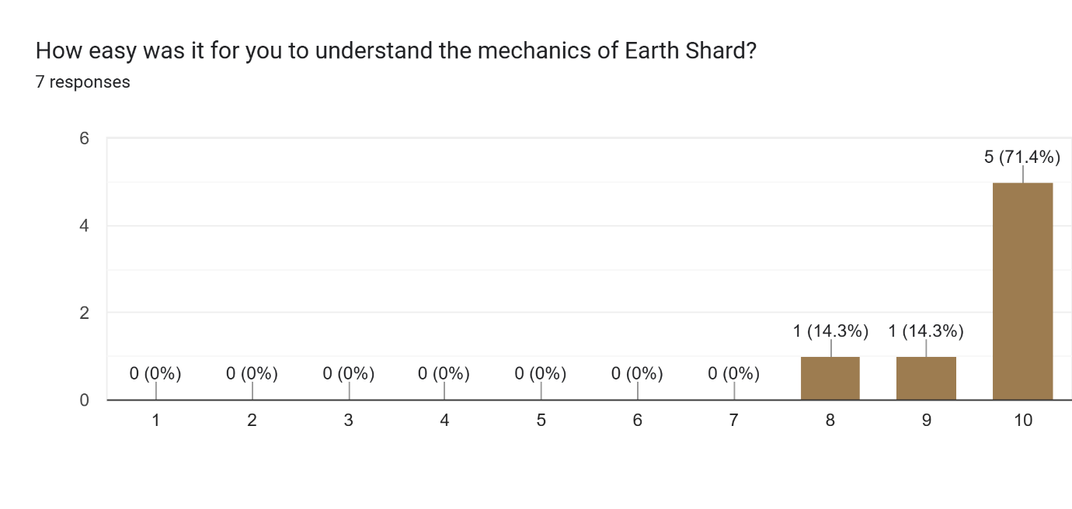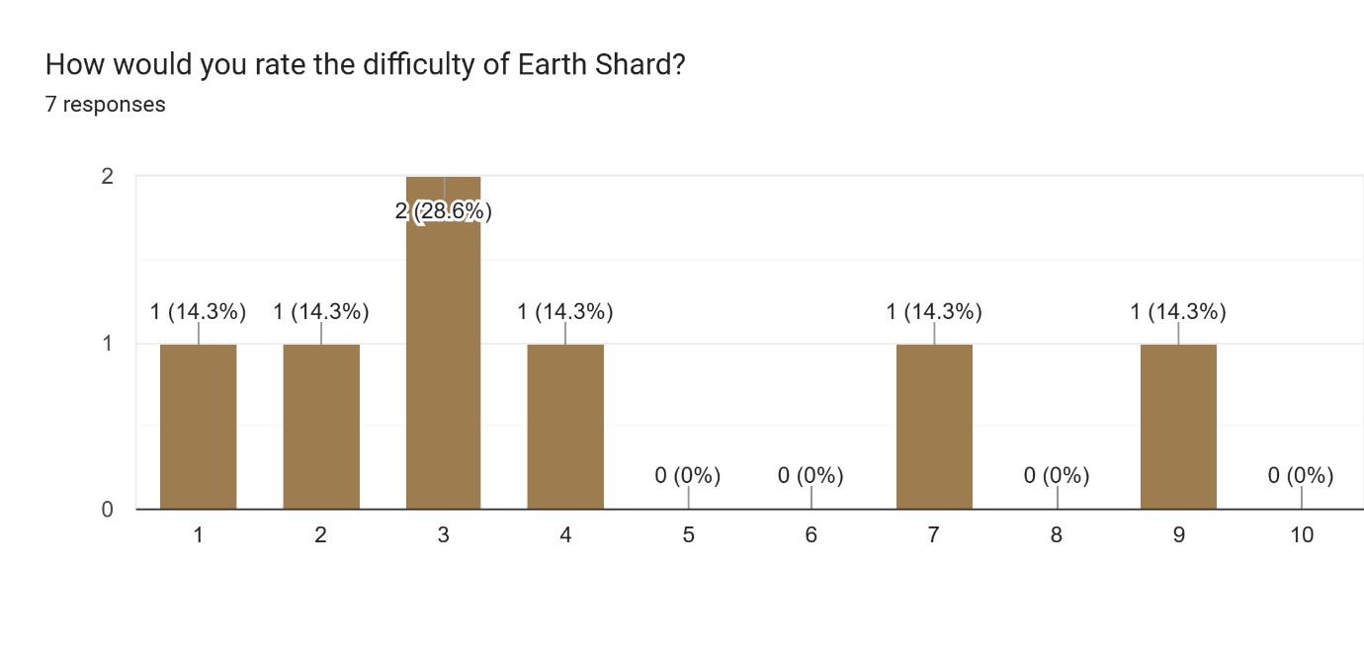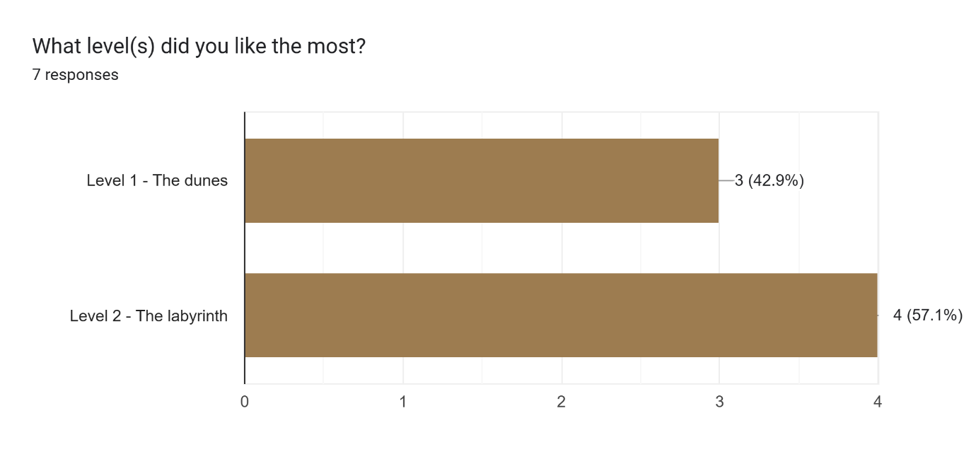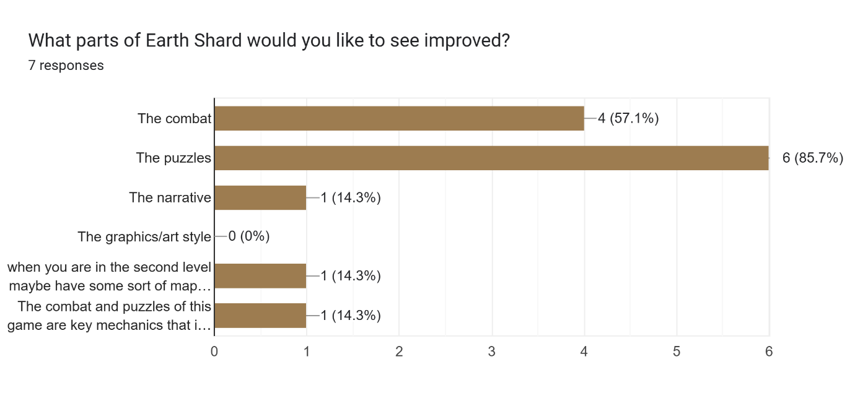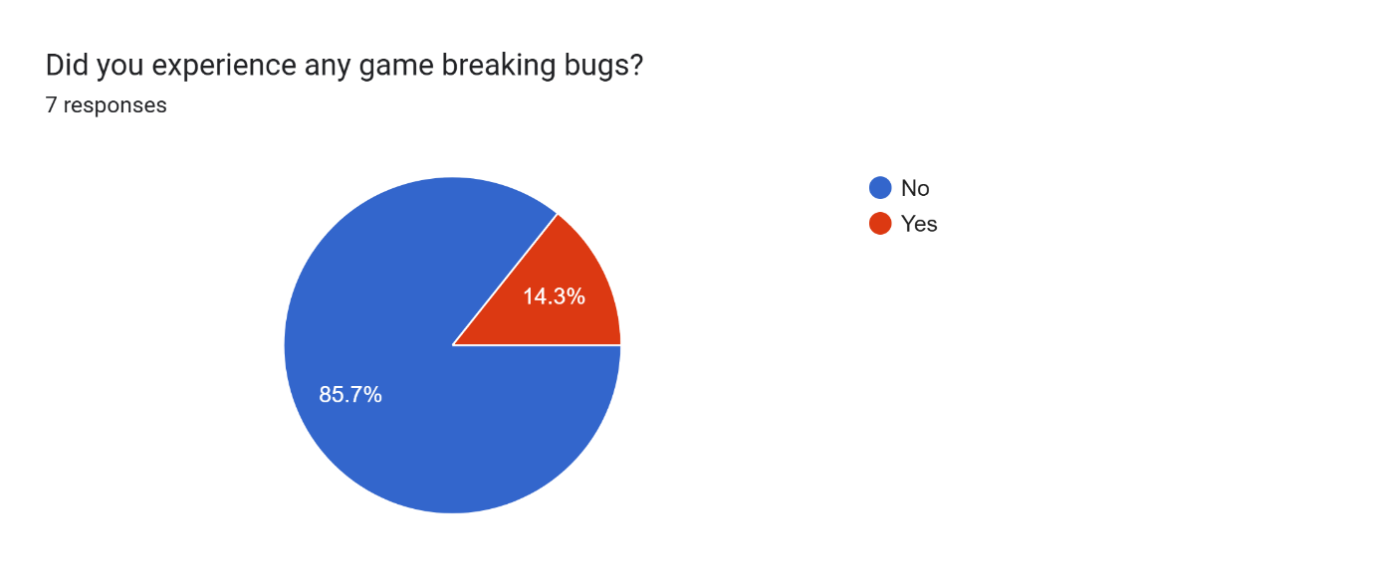
Related to last chart
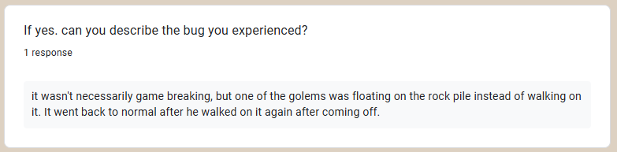

Question and answers
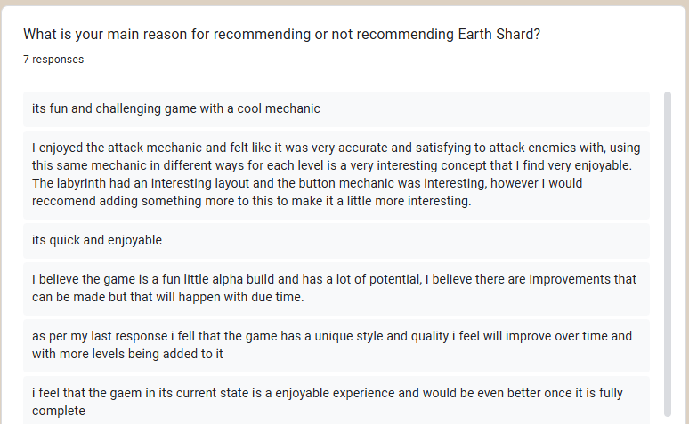
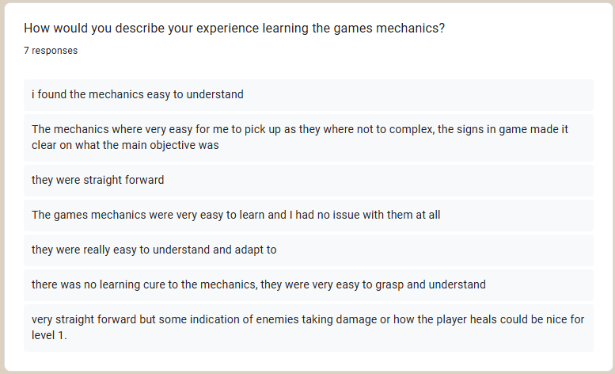
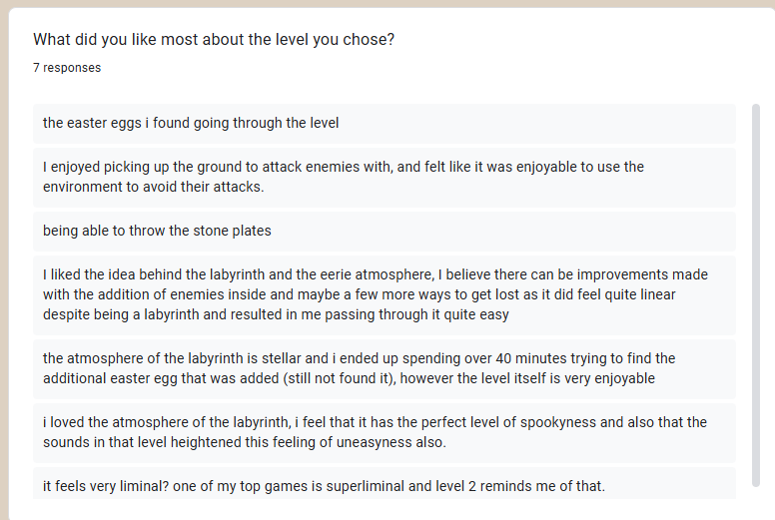
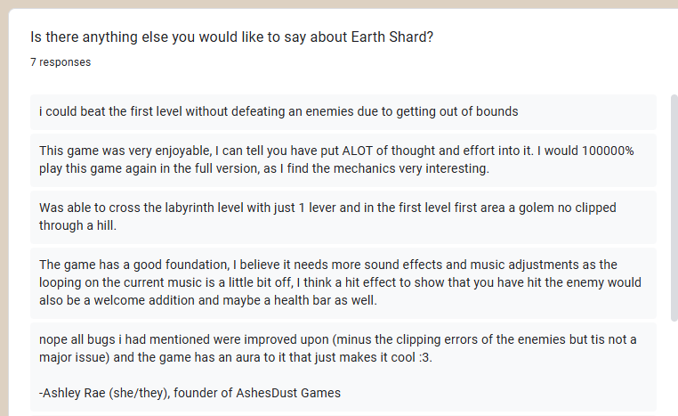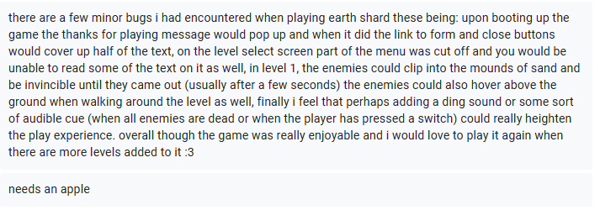

Evaluating feedback
This encapsulates most of the feedback received on Earth Shard. Some feedback was verbal too.
Majority of feedback was from the build v0.2.0-alpha, with maybe 1 or 2 of the responses from build v0.2.1-alpha. The feedback from the first build helped fix a lot of bugs for the second. The biggest bug found by was an issue with UI scaling. I had been testing my game at home and in college, and both computers I use have 2k monitors so I had forgotten to test other resolutions. When testers booted the game on 1080p monitors a lot of the menus clipped out the screen. I fixed this by changing the way they rendered. Another major bug pointed out to me was that the door at the end of level 2 was missing a collider which was quickly fixed. A bug I was unable to fix was the AI clipping in and out of objects. This is due to the system the AI and animation is built on. Its not good. Too fix it I’d need to rebuild the system from the ground up, but I don’t have the time too do that. Before the submission date. When I take this game further after the graded unit, I’ll rebuild the system but as of now it works but just not great and it will have to do.
Overall the feedback was mostly positive! a

Links
Released builds that were tested
(build v0.2.1-alpha contains patch notes)
https://github.com/MALEVOLENT-CROW/EarthShard/releases/tag/v0.2.0-alpha
https://github.com/MALEVOLENT-CROW/EarthShard/releases/tag/v0.2.1-alpha

Link to tester form
https://forms.gle/xFZ9V9PG7aDr4Syw8

