

User Manual

Contents
2 Introduction 2
3 Installation guide 2
4 Controls 2
4.1 Keyboard and mouse (stable) 2
4.2 Controller(unstable) 2
5 Main menu 3
6 abilities 4
6.1 rock throw 4
6.2 Ground raise 4
7 levels 5
7.1 The dunes 5
7.2 The labyrinth 5

Introduction
‘You are an Earth elementalists and must face 4 trials to prove yourself to the master of Earth manipulation! You must use your abilities wisely to solve puzzles and defeat foes! Only then will you be able to become a master!’

Installation guide
Download the .zip file and extract them too a folder. After that has been done double click the EarthShard.exe and the game should run!

Controls

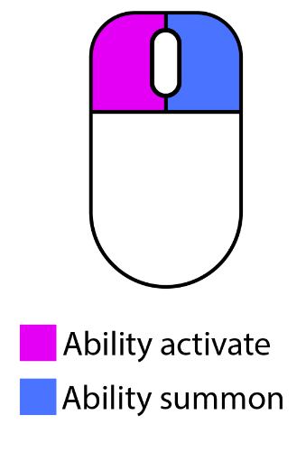
Keyboard and mouse (stable)
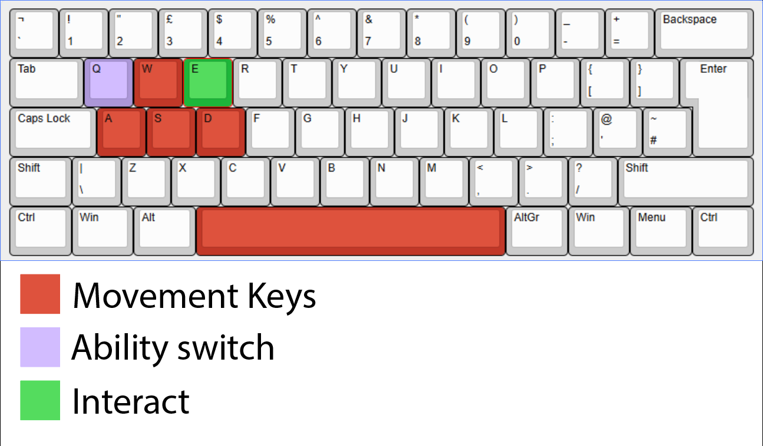
‘Escape’ key will pause the game!

Controller(unstable)
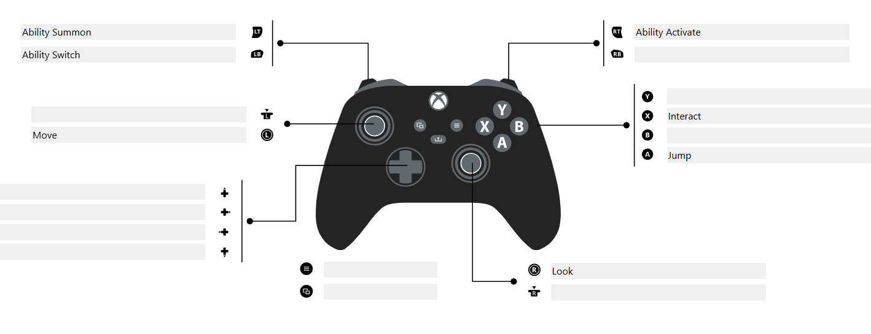
this is not the recommended way to play but it can work but may be unstable!

Main menu
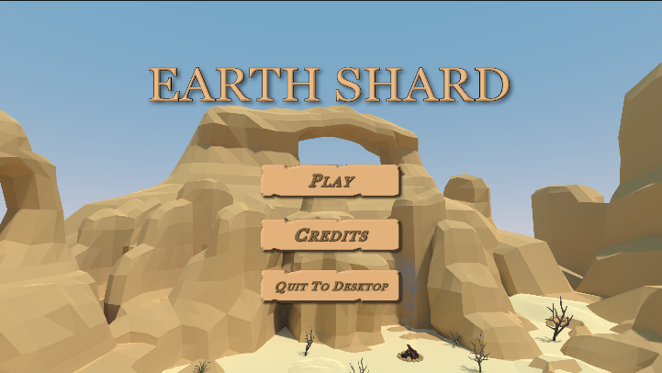
- Play: which will load you into the Level Select screen.
- Credits: which will load you into the Earth Shards credits menu.
- Quit: which will exit the game.
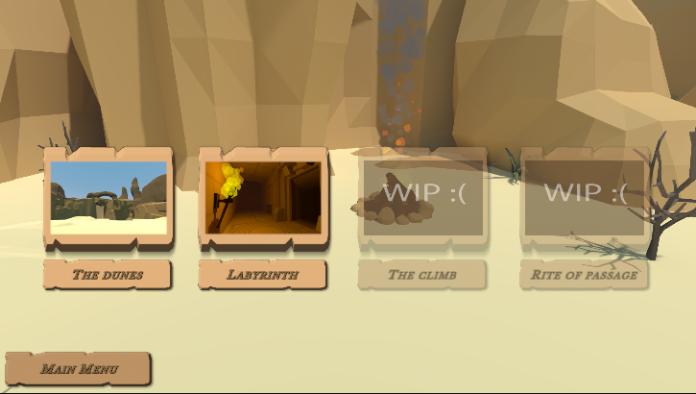
- Allows you to choose between the available levels!

abilities

rock throw
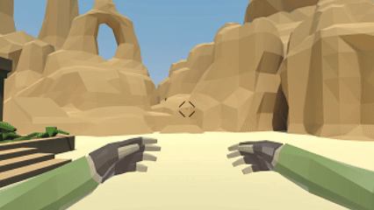
The rock throw ability is the first ability the player can use. The player can with summon the rock with the ability summon click and fire the rock with the ability activate click.

Ground raise
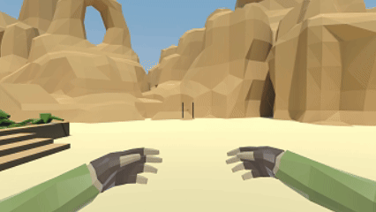
The ground raise is the second ability the player unlocks at level 3. The ground raise ability works by spawning a rock under the player with ability summon click and is raised up ability activate click. The platform that raises the player will raise to maximum of 5 metres and will slow its speed of ascension as the player reaches the max height.

levels

The dunes
Kill enemies in two sections; after killing all enemies in each section a door will open with the last door opening to the entrance of a temple leading to the next level.
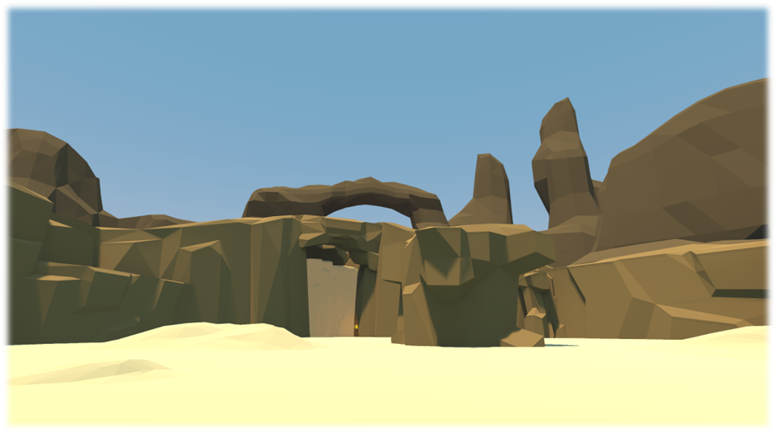

The labyrinth
The main objective of this level is to activate 3 switches hidden throughout the level. Once all 3 switches are activated the door at the end of the level will open!
