**IMAGE RECOGNITION USING IBM CLOUD VISUAL RECOGNITION**

**Step 1:**

After creating the IBM cloud account, we want to get the Visual Recognition service and the API’s which are required.

**1.**Search for the Visual Recognition service in the search catalogue and the results are shown. In the result, select the Visual Recognition service.

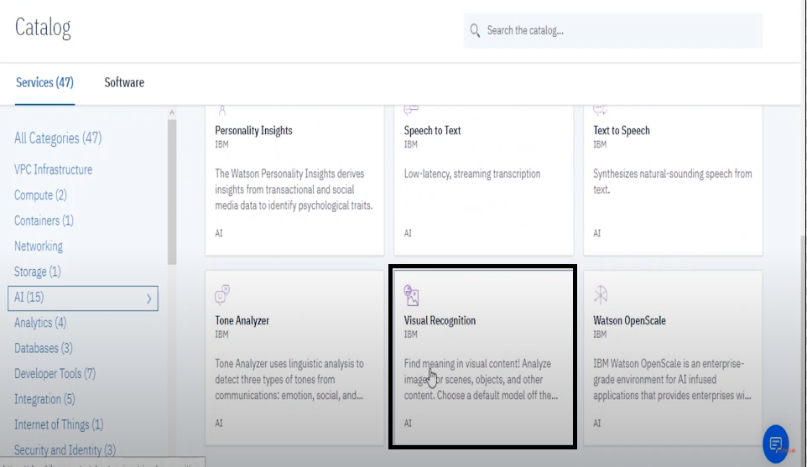

**2.**After that we want set the Region, Service name and Resource group and also select which plan want(free or cost). Then, click the create option to create the service.

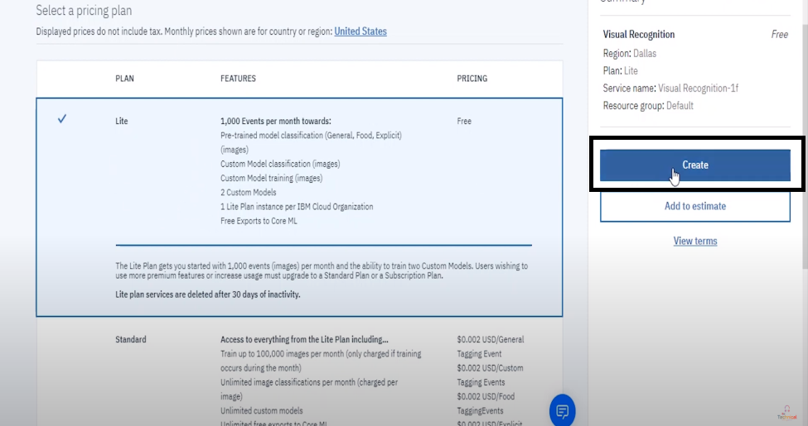

**3.**After created the Visual Recognition service, then you want to create a new project. For that, click the create model option.

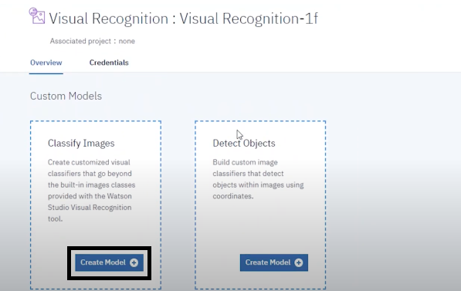

Then, you want to specify the project name, project description, storage and Watson visual recognition. After specified all the details click the create option.

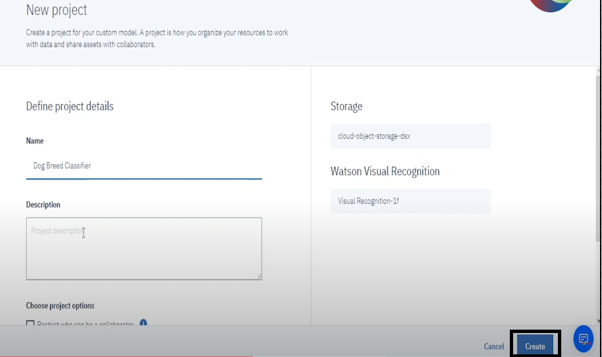

**Step 2:**

**1.**After created the project, then we want to train the model of the dataset. For that, first we want the upload the different images to train the model. Click the browse option, then upload the images.

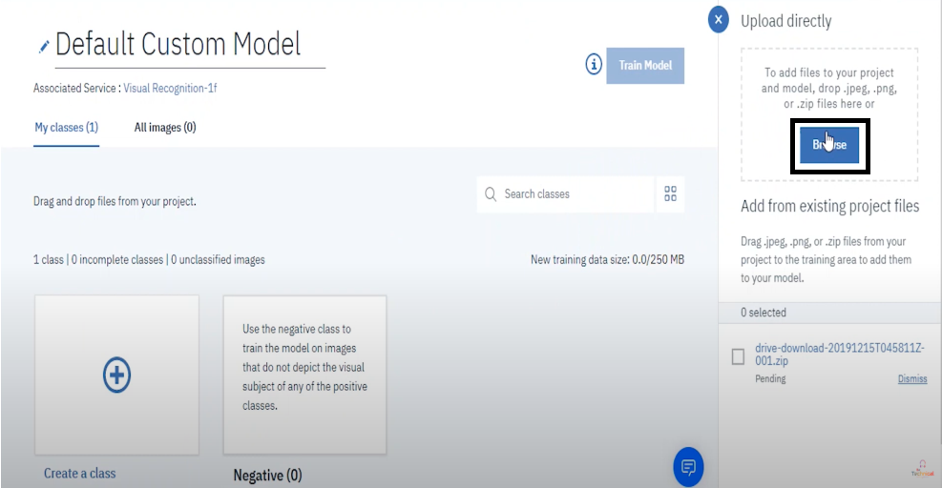

**2.**After the images are uploaded, then we want to train the model. For that, click the Train model option in the top right corner.

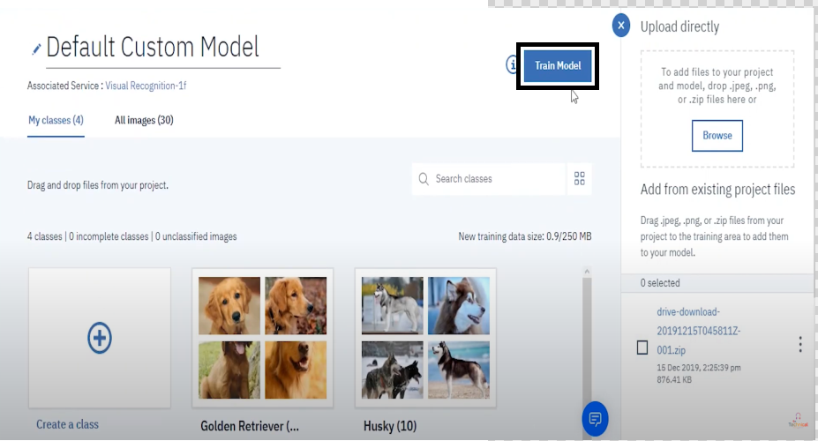

**Step 3:**

After the model was trained, the interface should bee like this.

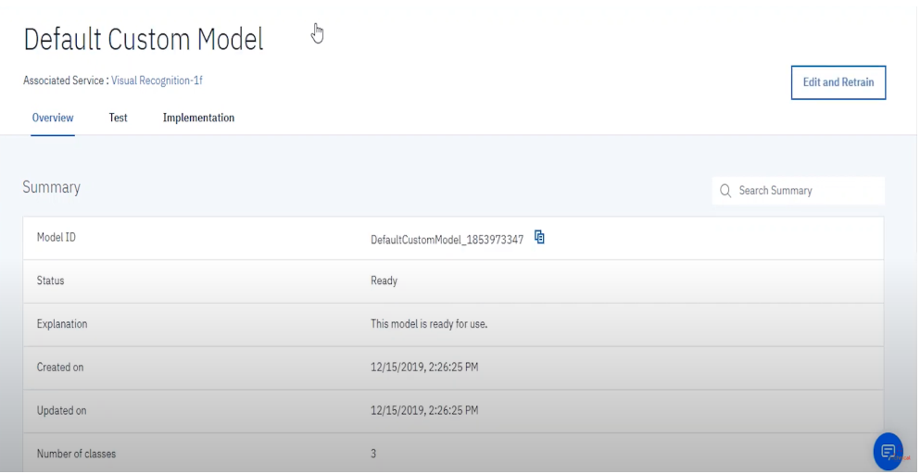

**Step 4:**

Next, we want to test the model to check whether the trained model is correct or wrong. Click test in the menu bar. After that, insert the images which you want to test.

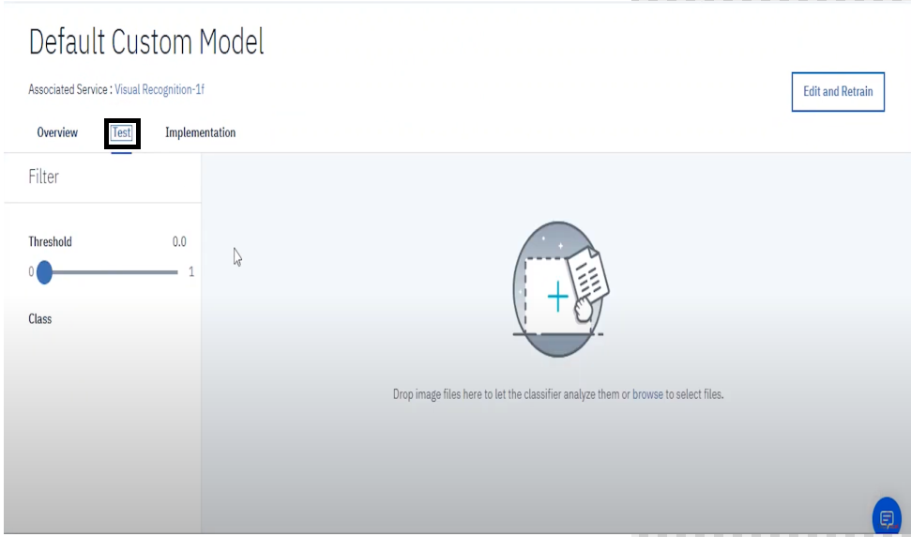

**Step 5:**

In last step, the output of the test model was displayed. By analyse the result, we can check that our trained model was recognize the images accurately or not.

**OUTPUT:**

